**Inside this issue:**

Notes from the President

[Member Feature](#Memberfeature)

[Military Trivia](#Militarytrivia)

[Guest Speaker](#Guestspeaker)

[Membership](#Membership)

[Board of Directors/Officers](#Boardofdirectors)

[Working Committees](#Workingcommittees)

[Meetings/Events Calendar](#Meetingsevents)

[Announcement Corner](#Announcementcorner)

[Books/Articles Published by Mbrs.](#Booksarticles)

[From the Editor](#Fromtheeditor)

[Light Side](#Lightside)

[Trivia Answer](#Triviaanswer)

***Editor’s Note:***

**Notice:**

If you have moved or changed your address, PLEASE notify us immediately! Contact: Dave Lyons, Membership Chair

E-mail: [Snoyldavid@centurylink.net](mailto:Snoyldavid@centurylink.net)

Phone:  303 690 8776

###### COPYRIGHT NOTICE: In accordance with Title 17 U.S.C. Section 107, any copyrighted material in this newsletter is distributed under fair use without profit or payment to those who have expressed a prior interest in receiving the included information for nonprofit use and educational purposes only.

******This version of the newsletter is in Microsoft Document (.DOCX) format so that the links will work. Put your cursor over the link, depress your Control Key (ctrl) and depress your left mouse button and it will take you to the listed link position. PDF format, the links will not work.

The comments and editorial input does not necessarily reflect the opinion of the membership of our chapter. I would appreciate any feedback that you might have, items you liked or if you find offensive or derogatory in anyway. ([bobrotruck73@gmail.com](mailto:bobrotruck73@gmail.com)) Thank you for allowing me to be your editor.

***Notes from the President***

Lee White

HEADS UP!!!

I’m sure most of our chapter members have read in the latest edition of “The Veteran” (March/April 2019) about the two Working Groups (Working Group I & Working Group II) to decide the future of VVA.

Working Group I - is tasked with the dissolution (shut down) of corporate VVA and Group II is charged with a possible transition to some other veteran organization in order to keep our legacy for the future.

So far, Working Group I has submitted a 70 page report that will be presented to the national board of directors for their review at the upcoming convention in July.

Working Group II has a 12 page report and are still hard at work trying to preserve something so we as an organization will “Never again will one generation of veterans abandon another!”

Both Groups are charged to present ideas and proposals to the national board and the national board will decide how we go forward.

For the time being, we as a Chapter have plenty to work on and support our veterans.

More to come!!

***“Member Feature”***

A. Robert (Bob) Easter, U.S. Army, Specialist 4th Class. I proudly wore the National Defense Service Medal, Good Conduct Medal, and Vietnam Campaign Medal. I was born and raised in Kansas City, MO. I enlisted in the Army, Sept 9th, 1968 and was sent to Fort Dix, NJ for Basic Training. Nov ’68, I was transferred to Fort Sill, OK for Advanced Individual Training (AIT) in artillery. Apr, ’69, I was ordered to Fort Lewis WA In preparation for deployment to Vietnam.

I processed in-country at Cam Ranh Bay and eventually was assigned to Alpha Battery, 7th Battalion, 9th Artillery, II Field Force, Military Assistance Command Vietnam (MACV). My tour of duty began June, ’69. Alpha Battery was located at Fire Support Base St. Barbara, Tay Ninh Province, III Corps and consisted of six 105mm towed Howitzers.

My job as Field Artillery Operator and Intelligence Assistant in the Fire Direction Center (FDC) required radio communication with various 1st and 25th Infantry Division units on search and destroy missions as well as calculating and executing fire missions when requested by the same infantry units. Our other mission was to secure our base of operations against enemy attack and included supporting/protecting two large (175mm; 6.9 inch caliber) guns and two 8 inch howitzers, all track mounted, self-propelled equipment.

In June ’70, the 7th Battalion, 9th Artillery was deactivated and I was transferred to Headquarters 23 Artillery group, Long Binh Vietnam, U.S. Army Republic of Vietnam (USARV). I received promotion to Specialist 4th Class (Spec 4) and released from active duty July 6, 1970 and returned to the U.S.A (“The World”) to process out at Oakland, CA Personnel Center. I returned home to Kansas City, MO, but remained on inactive reserve duty until May 13, 1974.

***Military Trivia***

**Digies?**

[Click here for end of the Newsletter Trivia Answer](#Triviaanswer)

***Special Guest - March***

Alysaa Carver – Archivist and Project Manager for the **Veterans History Project**.

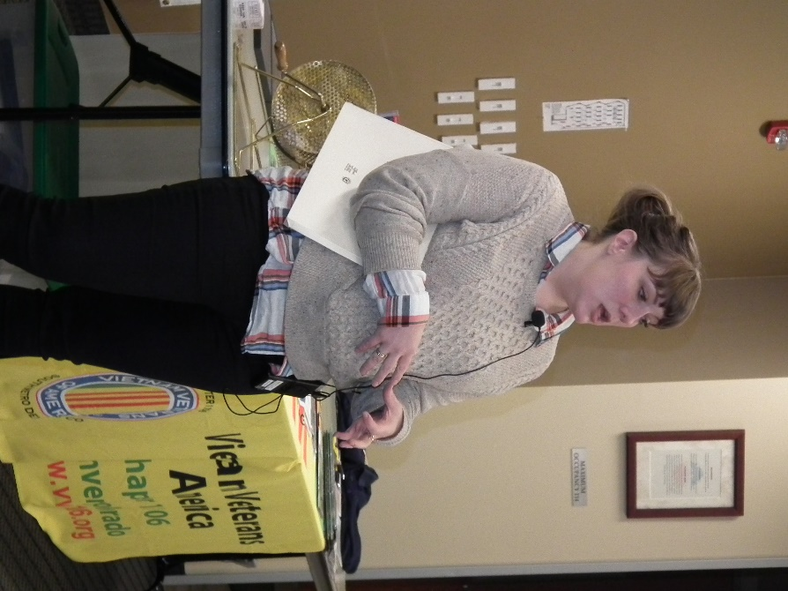

The Douglas County Libraries department of Archives & Local History is collecting oral history interviews with military veterans for eh American Folklife Center at the Library of Congress. Oral History lets us preserve and share real-life experiences, and hearing the voices of veterans may help future generations better understand the realities of war. Alyssa says, “If you are veteran or family member of one with a story to tell, please get in touch. You can listen to the collection of recorded interview at: [archives.dcl.org/digital/collection/doh](http://www.archives.dcl.org/digital/collection/doh). For more information about the project, go too Library of Congress: <www.loc.gov/vets>.

***Special Guest – April***

**VTC Mentor Program Mission Statement**

The Colorado Veterans Treatment Court Mentor Programs provide overall support, advocacy, and mentorship for military veterans involved in the criminal justice system to increase their chances of successful rehabilitation and community reintegration by pairing trained mentors with participants to help with their transition out of the criminal justice system

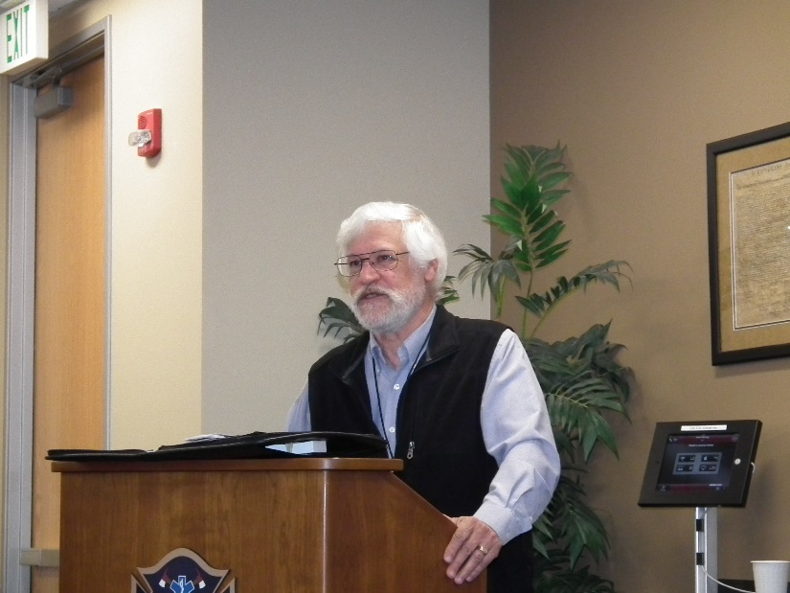

Chapter Member Bruce Arndt, M.A., US Army (RET) Veteran Mentor Coordinator

**Why Mentoring?**

Veteran treatment courts are a type of problem-solving court serving military veterans struggling with alcohol and substance use disorders, mental health disorders, and traumatic brain injuries. Veteran courts present an alternative to incarceration, as they divert veterans away from the traditional criminal justice system and instead offer a program that provides tailored treatment plans to participating veterans. A team of legal and treatment professionals collaborate to provide veteran participants with the essential tools necessary for them to be successful with both maintaining sobriety and reducing the likelihood for reoffending.

Each veteran court in Colorado includes a dedicated team of volunteer mentors as part of their overall court team. Mentor programs were established to offer social support to participating veterans by linking them with a volunteer mentor. Volunteer mentors regularly assist with transportation, emotional support, and connecting veterans with VA resources (healthcare & benefits). Volunteers receive training across a variety of fields designed to equip them with the essential tools to be successful in their mentoring activities. If you are interested in becoming a mentor, please complete an [application](#VTC) (Click application!) and email to the Lead Peer Mentor Coordinator ([LPMC](mailto:bruce.arndt@judicial.state.co.us?subject=Judicial%20Veterans%20Court%20Volunteer)) in the district you are interested in volunteering with. An LPMC will be in contact with you to discuss

**NAVY FEDERAL CREDIT UNION**

Jeannette Luppes, Member Service Representative, spoke to the chapter about the benefits of being a member of the NFCU. Navy Federal Credit Union is the world's largest credit union, catering to military, veterans and their families.  We have awesome certificate rates right now and are a full service Credit Union. The location where I work is: 1125 S. Tower Rd. Aurora, CO. 80017, across from Buckley AFB.

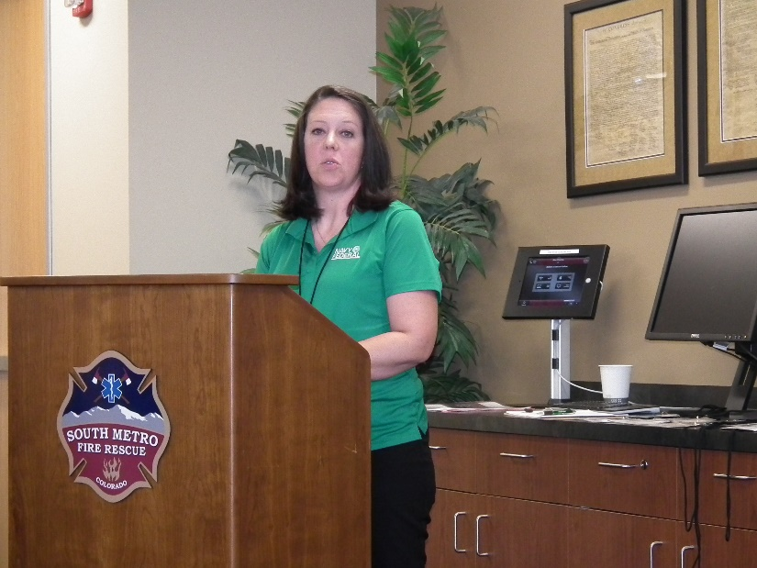

Jeannette Luppes, NFCU

***Membership!***

VVA Chapter 1106 Membership: (4-14-2019)

VVA - 131

AVVA -   31

Total: 162

**Welcome New Lifetime Members:**

Ron Newlander

Jim Bishop

Charles Luley

Ed Vigil

**Welcome New AVVA Members:**

Alexis Winemiller

Leann Stelzer

***Board of Directors/Officers***

Lee White - President

Bob Easter - Vice-president

Joe Plant - Treasurer

Glen Payne - Secretary

Board Members - Milt Omoto, Patti Ehline, Dave Lyons, Tom Werzyn

Ron Smith

***Special Chapter Positions***

Chaplain – Rev. Garry Turks

Government Affairs – Tony Nickerson

Sergeant-at-Arms – Rob Senatore

***Working Committees***

* Agent Orange/PTSD – Patti Ehline
* Color Guard – Tony Nickerson - Command Sergeant, Dave Lyons, Don McNeely, Dan Green, Clarence Rebolledo, Robert Senatore, Ron Smith, Bob Larson
* Fundraising/Grants - Milt Omoto
* Marketing/Media/Events – Tom Werzyn
* Membership – Dave Lyons – Chair, Lee White, Tom Werzyn
* Mental Health: Patti Ehline, Warren Harrison, Joe Plant
* Newsletter Editor - Bob Rotruck
* POW/MIA – **Open**
* Scholarship Program - Mike Karsh – Co-Chair, Jim Marcille – Co-Chair, Glen Payne, John Vargas, Brian Karsh (supporter)
* Social –Barry Fiore, Glen Payne, Milt Omoto, Mike Karsh
* Speakers Bureau – Bob Easter, Donna Chaney, Roger Lanphier, Bob Mallin, Tom Werzyn, Glen Payne
* Veteran Emergency Assistance Committee - Joe Plant, Lee White, Dave Lyons
* Webmaster – Bob Rotruck
* Women Veterans - Patti Ehline

**Meetings/Events Calendar - 2018**

May 4 - VVA Chapter 1106 Monthly Meeting

May 18 - Bike Show Fundraiser - Littleton, CO

May 25 - Poppy Drive - 4 King Soopers locations

June 1 - VVA Chapter 1106 Monthly Meeting

June 8 - CO State Council Meeting - Castle Rock, CO

June 20-23 "The Wall That Heals" - Arvada, CO

June 30 - Rockies & LA Dodgers Baseball Game - Coors Field

July 15-20 – VVA National Convention-Spokane, WA

June 20 – 23 – **The Wall That Heals** - Vietnam Veterans Memorial Fund, has selected VVA Chapter 1071 to host The Wall That Heals at the Faith Bible Chapel campus near West 64th Avenue and Ward Road Arvada, CO. The opening ceremony is June 20th and closing ceremony is June 23rd. The new Wall That Heals exhibit features a three-quarter scale replica of the Vietnam Veterans Memorial in Washington, D.C. and mobile Education Center that gives visitors a better understanding of the legacy of The Wall and educates about the impact of the Vietnam War. The website of [VVMF.org](http://www.vvmf.org) has information on the new Wall

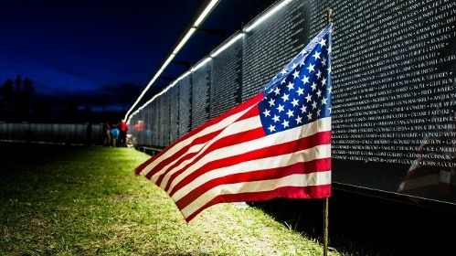

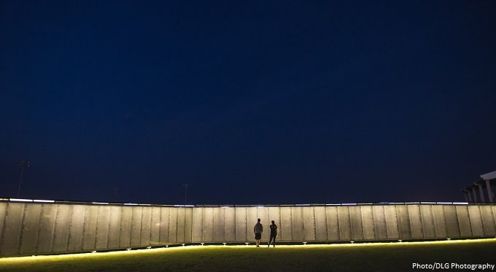

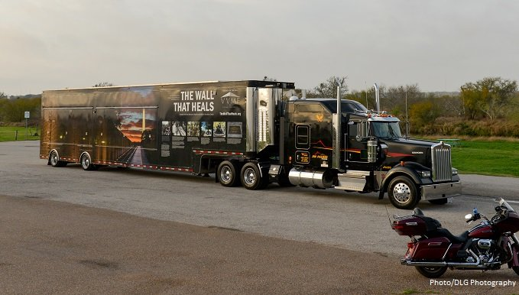

**Vietnam Veterans Day Commemoration**

Submitted by Suzanne Sigona

The event was organized by the American Vietnamese Community to recognize all veterans on Vietnam Veterans Day, March 29, 2019. Prior to the ceremony, the veterans gathered and mingled. Lee White has joined a group of Navy veterans US and South Vietnamese Navy Veterans.

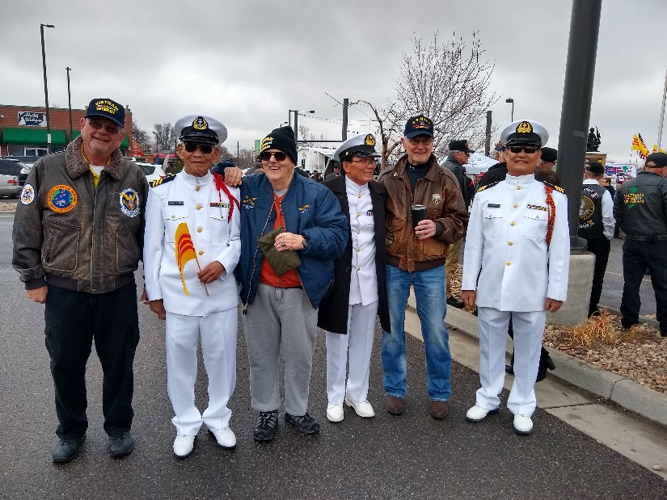

The Vietnamese Chaplain for the Denver Police Department has declared it the first annual. The memorial dedicated to the US and Vietnamese military effort was dedicated about 5 years ago. The location is on the property of Alameda Square and located at Zuni and Alameda.

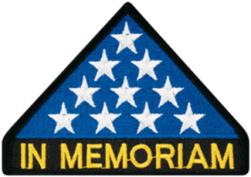

***In Memoriam***



As of: 4/13/2019

Total Funeral Homes Visited - 2,327

Cremains Found - 19,364

Veterans Cremains Identified - 4,234

Veterans Interred - 3,920

***Announcement Corner***

**VVA Chapter 1106 Celebrates 4th Anniversary - February 2015-2019**

The Chapter celebrated its 4th Charter Anniversary with VVA National. Here are the original chartering members:

Group One - Currently active within the chapter:

Lee White, Joe Plant, Milt Omoto, Jack Hunter, Patti Ehline, Jerry Liechti, Robert Lee, John McMaster, Ernest Ledvina, John Williams

Group Two - Still members, but have moved, not active, or deceased:

Gary Fortner, Pat Surrena, Hazel Simeon, Mort Anderson, William Blackstone, Linus Leppink, Joe Lonigro, William Cheyne, Joe DiLeonardo, George Nolly, William Purcell, Michael Grathwohl, Douglas Henning, Alfred Super, Nick Szychowski (Deceased), John Wigle, Paul Seppo, Jerry Simmons, Marty Smith, Stan VonFeldt

Total of 30 on the Chapter Petition to Charter submitted to VVA National on December 13, 2014.

Picture taken at the March meeting of some of the original chapter members.

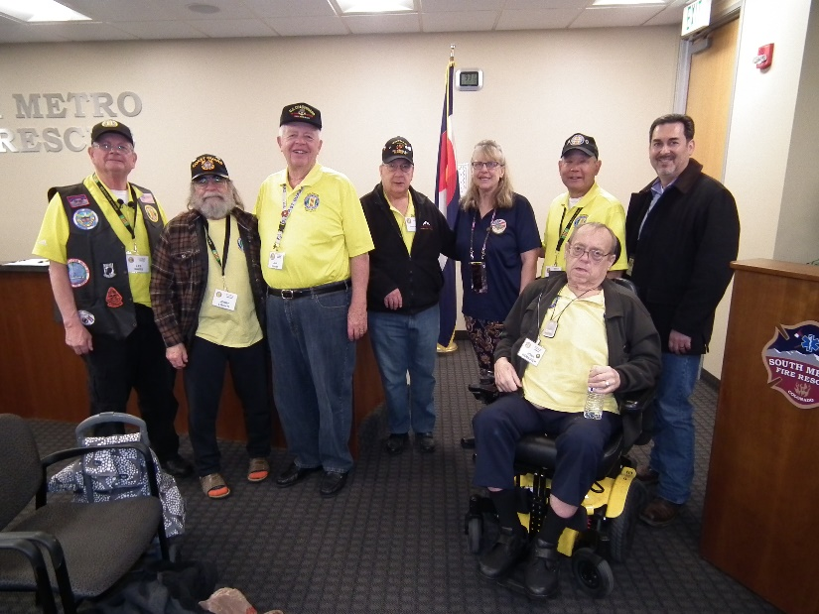

L to R: Lee White, Jerry Liechti, Jack Hunter, John Williams, Patti Ehline, Milt Omoto, Daniel Plant (Joe Plant’s son, filling in for Joe), John McMaster (wheelchair)

**Vietnam War Veterans Health Issues**

Submitted by: Patti Ehline

It's important to understand the health care needs of Vietnam War veterans because of the long-term effects of military service during the Vietnam War era. If you served during the Vietnam War, you may be at risk of certain health conditions. Understanding these needs will allow you to receive better care. Learn about these conditions and what to do next to take care of your health.

Health risks related to Vietnam War:

* Diseases related to Agent Orange: A toxic chemical used to clear trees and plants that can cause long-term health effects
* Hepatitis C: A disease that can harm your liver
* Hearing problems caused by noise: Harmful sounds from guns, explosives, rockets, heavy weapons, jets and aircraft, and machinery that can cause or add to hearing loss and ringing in the ears
* Illnesses or injuries caused by job-related hazards: Chemicals, paints, radiation, and other hazards you may have come across

What you can do now! Take these steps to make sure you're taking care of your health:

* Talk to your primary health care provider or your local VA environmental health coordinator about other health concerns related to your military service. Remember, you can use Secure Messaging (login required) to send a private note to your doctor if you have any questions or worries.
* Ask your local VA environmental health coordinator about getting a free Agent Orange Registry health exam.
* Find out if you can get benefits from any illness or injury caused, or made worse, by your active-duty service, such as illness-related to agent orange or contact with hazardous materials.
* Be sure your doctor knows if you have a history of Agent Orange exposure. Because of the possibility of increased cancer risk, your doctor may suggest cancer screening tests and to report any symptoms as soon as they appear.

Veterans are at risk for many types of cancer just like everyone else, even if they haven't been exposed to Agent Orange. You can lower your risk of cancer and other diseases by quitting smoking, staying at a healthy weight, getting regular physical activity, and eating a healthy diet.

If you have a My Health Vet Premium account, you can easily reach out to your health care teams with Secure Messaging about taking steps to improve your health.

**Getting to Know Chapter Members**

G. David (Dave) Lyons - US Navy 1967 – 1971, Dave has been deeply involved with the chapter since joining several years ago. He is on our board of directors and serves as membership chair and assist with helping veterans in need. Thanks Dave!

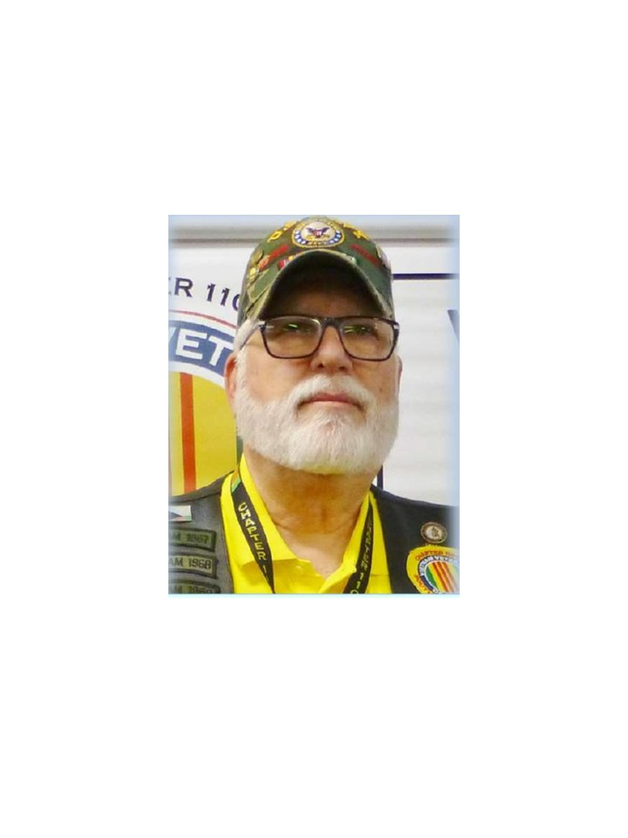

Mike Karsh – US Navy 1967 – 1971. Mike is co-chair of the Scholarship Committee and his son, Brian, has made several large contributions to the Scholarship Fund. Mike is also on the Social Committee and has always participated in the Poppy Fundraiser. Thanks Mike!

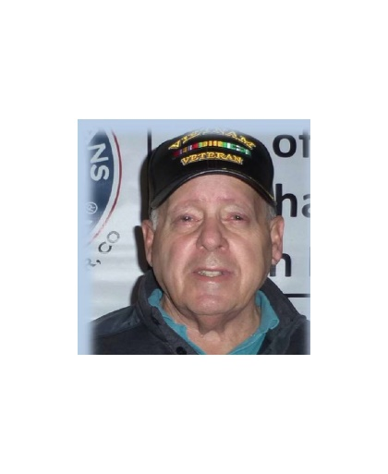

Ted Hanfelder - US Air Force 1973-1979 has stepped up to the plate to a volunteer with the Poppy Fundraisers for the chapter. His friendly handshake and smile make people want to drop money into the donation jugs. Thanks Ted!

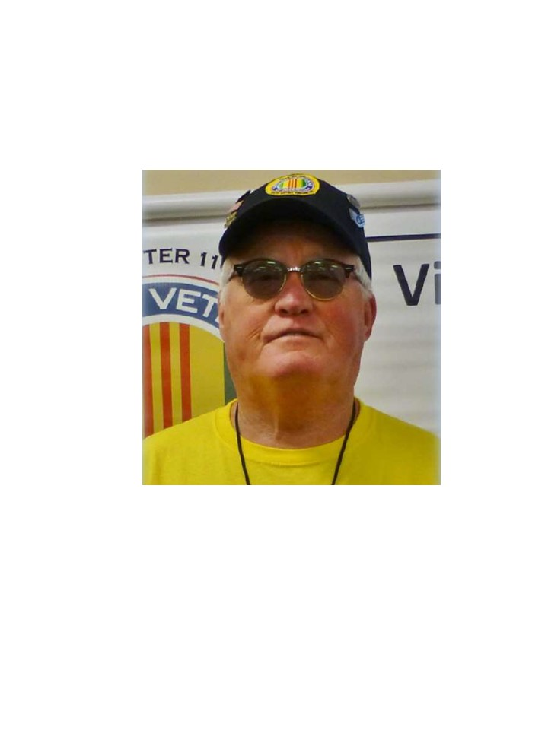

William (Bill) Pine - Colonel US Air Force 1965 – 1991 is one of the original members of the Chapter Scholarship Committee which has become very successful in our chapter. Thanks Bill!

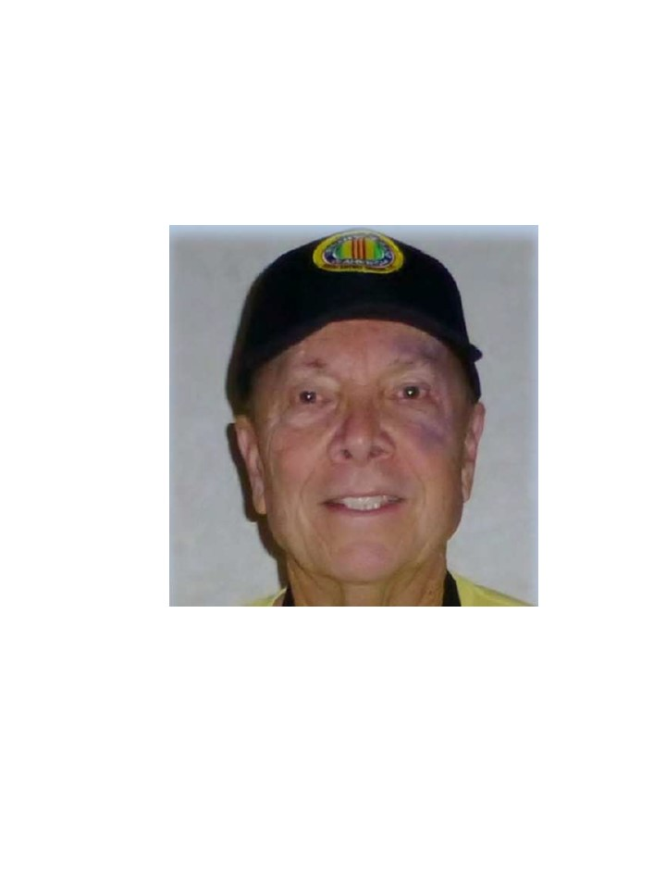

Clarence Robelledo - US Air Force 1969 – 1973 is a fairly new member but when the Chapter Color Guard was established, Clarence jumped on board. Thanks Clarence!

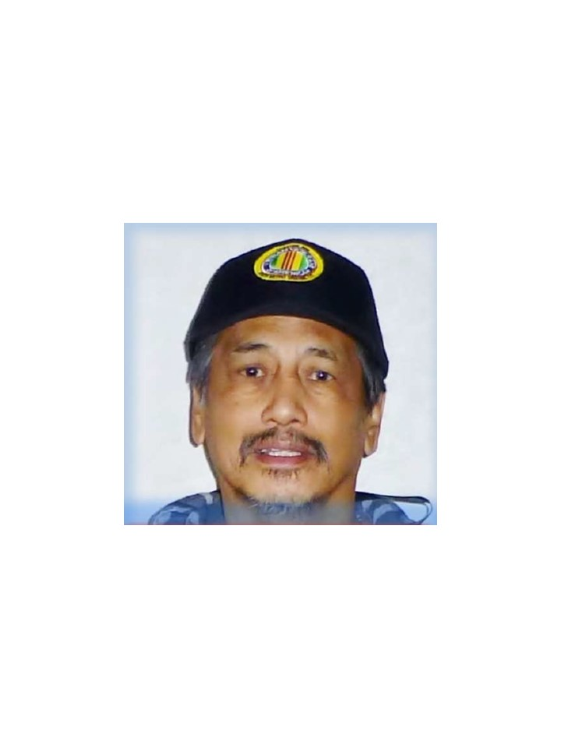

***Books/Articles Published by Members***

**Assistance Without Boundaries**

Eric W. Kritz, a US Army Veteran, suffered a couple of strokes that left him paralyzed with no mobility in his legs and little use of his right arm. This proud First Lieutenant and Intelligence Officer found himself alone and searching for answers, but asking for help was not in his vocabulary! Adding to his dilemma, short-term memory was also slipping. Twice within a year’s time, I contacted the Sonoma County Sheriff’s department to perform Welfare Checks and now he now requires and has 24-hour home care!

His diligent neighbor, Jane Eagle, called me and explained the difficult time Eric was having trying to maneuver his standard wheelchair. His self-esteem and comments to continue life became a concern to those few that know him. The immensity of red tape from the VA made it almost impossible to get a motorized wheelchair in a reasonable time, so I sent an alarm-type email to local Veteran organizations requesting assistance. Within 24 hours Commander John Durant of MOPH 1041 called to say they located an electric wheelchair. The very next day it was taken to the Runge Tool Company here in Denver. Mr. Runge and his staff cleaned the chair and added a new battery. In addition, they placed the wheelchair on a pallet and bubble wrapped it for shipment. There was no charge for this service! Ryan Demming from Freightquote, Kansas City, handled all the paperwork, picked up and transportation to Petaluma, California. Just a few miles from Eric’s home in Graton.

Meanwhile, after a few emails and telephone conversations with MOPH Department of California Commander Charles Earthman and Bob Evans, Santa Rosa MOPH Chapter 78, and Paul Naivalurua (Eric’s Caregiver) volunteered to assist. There was no hesitation, no request for compensation and no winded explanations. They received Eric’s electric wheelchair at a local Fed X terminal. Shortly thereafter and upon delivery, the smile on Eric’s face was well worth the effort by “A Village of Veterans” willing to help another Veteran in need. \*Pictures are worth a thousand words! (see the attached photos)

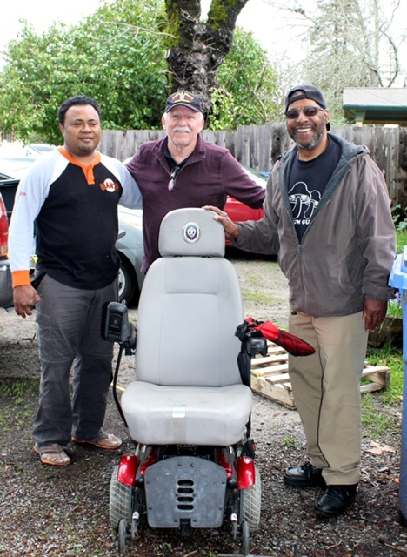

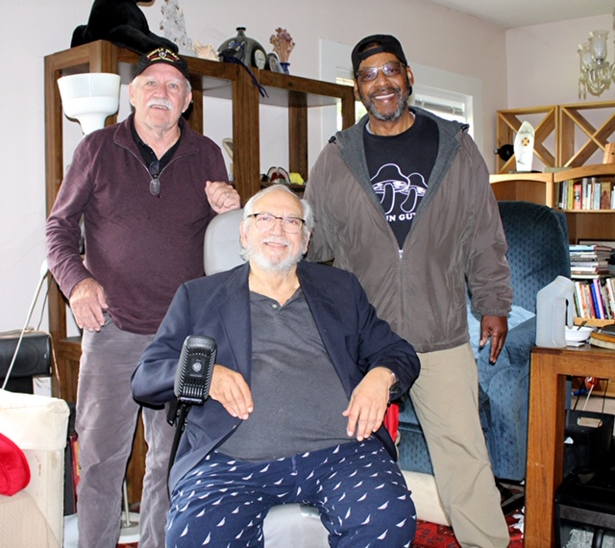

A Denver high altitude of thanks goes out to Cliff Butler, Patti Ehline, Mike Lovette, Jim Marcille, Frank Mireles, Richard Lewis, Glen Payne, and John Vargas, and the two MOPH Commanders, all who donated time, manpower and helped defray the shipping tariffs. This was a prime example of Veterans helping another Veteran regardless of distance, costs, man hours and weather challenges. Well done and “Mission Accomplished”

You should all be as proud of yourselves as I am of you!

Thank you, thank you, thank you,

John A. Vargas

Member VVA 1106

Adjutant MOPH 1041

**Military Order of World Wars**

Dr. Bob Mallin writes a column for the MOWW magazine every issue and responds to current issues. This is one of his articles.

**“WHEN ARTHUR’S COMES TO GET ME”**

I heard this saying from a while ago from an aged piano player in New Orleans, as a response as to when he, at 82, planned to retire. He meant, of course, he’d not quit until arthritis finally immobilized his fingers.

Though “arthritis” comes in many forms, such as Gout, syphilitic, and others there are only 2 main types of arthritis. The Rheumatoid or Auto Immune type which can start to happen at any age (I’ve been told that RA can start, in some women as early as ages 18-24.) and Osteoarthritis (OA) which has a mechanical cause.

When A Musician’s refers to aches and pains he is usually referring to Osteoarthritis (OA), the kind that comes on after repeated joint use, and mechanical wearing a way of joint contents. This can take years or several decades. It is a loss of padding between the bones letting them grind on each other like a car engine without lubricant. Long time baseball pitchers and lifelong runners can “catch” this one too.

Osteoarthritis is the most common form of “arthritis” (“joint inflammation illness”) occurring when the joint wears down. Hips, knees, fingers, hands and the spine commonly suffer. Often there is a history of repeated stress. The old horse cavalry had this problem along with hemorrhoids and rashes… (No, no not john Wayne.) The condition gets more symptomatic with time: pain, swelling, tenderness, and stiffness especially after nonuse. “That early morning stiffness.” As once put to words by an anonymous Prussian student at Heidelberg University “when you are young only one joint is stiff…when you are old all joints are stiff, but one.” (Wish you wouldn’t edit it out!!) One can occasionally hear “crepitus” (a grinding sound) diagnosis may include: x-rays, rheumatic arthritis blood tests and/or removal of fluid from the joints.

Repeated minor or major trauma increases the chances of OA especially in younger men under 45 and women over 45. Mal alignment and obesity affect the joints to a greater degree.

Rheumatoid arthritis (RA) is an autoimmune disease where the body fights itself. Any or all joints may be affected. The linings are attacked as if they were a foreign substance. The pain, stiffness and inflammation may be present along with deformities and loss of function. The disease is ongoing with occasional bad and good times. Rarely, the blood system or eyes can react to this immune phenomen. So check out symptoms when you suspect joint problems. Some develop rheumatoid nodules under the skin (about 25 %.) causes of RA are essentially unknown. There does, however, seem to be a genetic (hereditary) component that certain people have which can lead to trouble under the right conditions. It is not catching. Interestingly, when RA destroys all the joints lining it stops. So some older people have deformity and some loss of function, but the progress of the disease and the pain are gone. It is “burnt out.”

Diagnosis may include blood tests, x-rays, fluid removal from the joints. As the course and treatment of OA and RA are different it is important to differentiate the two.

There is no way to replace the lost cartridge or tissue, all though some artificial substances may be used to try and restore the padding’s function. But there are ways to treat symptoms and slow down the progress, especially when life style change is “impossible”

Medications: (even “over the counter-nonprescription-medications should be cleared with your health care professional.)

Topical creams and lotions can actually work to relieve symptoms

Acetaminophen relives pain (especially in OA) it does not however, affect the inflammation of RA

Steroids and non-steroid medications can greatly help RA. Sometimes heavy drugs (narcotics) are prescribed.

At one time suspended gold was injected for RA with some success

Your part: keep fit; keep informed, check symptoms out---the earlier the better. Have an expert prescribe an exercise regimen to best keep motion without stressful elements.

Bob Mallin

**In honor of all those who served during the Viet Nam War. We must always remember to Honor and Praise those who served.**

Written by: John Kurowski

Have you ever wondered if you should go see the Wall,

The Wall is black, shiny, and a little tall,



Whether it is cloudy, windy, hot, cold, snowy, warm or rain,

It is likely you feel some emotional pain,

As you stand by the Wall and begin to cry,

You may ask the question, why oh why,



At first I wondered why the Wall is black,

Then I thought; it is because so many never came back,

Many were called Dad, Pop or Father,

Their family and friends met at the wall to gather,

To remember the man whose name is etched in the Wall,

And many said “we can no longer hear him say "Let’s play some ball”,

And thousands still come to see the Wall and their own reflections,

Many just stand and think of something to say, but hold on to their mentions,

It is hard to describe what it means when one reaches out to the Wall to touch,

We shudder and cry because we loved them so very much,



Many had that dream of owning a car built for speed,

Some of those cars are still stored in an old barn waiting for someone’s need,



Sons and Daughters were lost in this War,

And they will be missed forever more.

(From the editor: Thank you John for those beautiful words!)

***Light Side***

**Are you smarter than a 60 year old?**

This may be harder than you may think.

The answers will be on the tip of your tongue, but you just can't quite remember the correct answer. Don't look below for the answers until you have tried to figure it out.

A test for 'older' kids. I was picky about printing this. It had to be for those who might actually remember. So have some fun my sharp-witted friends. This is a test for us 'older kids'! The answers are printed below, (after the questions) but don't cheat! Answer them first.....

\*\*\*\*\*\*\*\*\*\*\*\*\*\*\*\*\*

01. After the Lone Ranger saved the day and rode off into the sunset, the grateful citizens would ask, who was that masked man? Invariably, someone would answer, I don't know, but he left this behind. What did he leave behind?\_\_\_\_\_\_\_\_\_\_\_\_\_\_\_\_.

02. When the Beatles first came to the U.S. In early 1964, we all watched them on The \_\_\_\_ \_\_\_\_\_\_\_\_\_\_\_ Show.

03. 'Get your kicks, \_\_ \_\_\_\_\_\_\_\_\_ \_\_\_\_\_\_\_.'

04. 'The story you are about to see is true. The names have been changed to \_\_\_\_\_ \_ \_\_\_\_\_.'

05. 'In the jungle, the mighty jungle, \_\_\_\_ \_\_\_\_ \_\_\_\_ \_\_\_\_.'

06. After the Twist, The Mashed Potato, and the Watusi, we 'danced' under a stick that was lowered as low as we could go in a dance called the '\_\_\_\_\_.'

07. Nestle's makes the very best.... \_\_\_\_\_\_\_\_\_.'

08. Satchmo was America's 'Ambassador of Goodwill.' Our parents shared this great jazz trumpet player with us. His name was

\_\_\_\_\_\_ \_\_\_\_\_\_\_\_\_\_\_.

09. What takes a licking and keeps on ticking? \_\_\_\_\_\_\_.

10. Red Skeleton's hobo character was named \_\_\_\_\_\_ \_\_\_ \_\_\_\_\_\_\_\_ and Red always ended his television show by saying, 'Good Night, and '\_\_\_\_\_\_\_\_ \_\_\_\_\_\_\_\_ '11. Some Americans who protested the Vietnam War did so by burning their \_\_\_\_\_\_ \_\_\_\_\_\_\_.

12. The cute little car with the engine in the back and the trunk in the front was called the VW. What other names did it go by? \_\_\_ & \_\_\_\_\_\_\_.

13. In 1971, singer Don MacLean sang a song about, 'the day the music died.' This was a tribute to \_\_\_\_\_\_\_ \_\_\_\_\_\_\_\_\_\_\_\_.

14. We can remember the first satellite placed into orbit. The Russians did it. It was called \_\_\_\_\_\_\_\_\_\_.

15. One of the big fads of the late 50's and 60's was a large plastic ring that we twirled around our waist. It was called the \_\_\_\_\_\_ \_\_\_\_.

16. Remember LS/MFT \_\_\_\_\_ \_\_\_\_\_/\_\_\_\_\_ \_\_\_\_\_ \_\_\_\_\_?

17. Hey Kids! What time is it? It's \_\_\_\_\_ \_\_\_\_\_\_ \_\_\_\_\_!

18. Who knows what secrets lie in the hearts of men? Only The \_\_\_\_\_ Knows!

19. There was a song that came out in the 60's that was "a grave yard smash". Its name was the \_\_\_\_\_\_ \_\_\_\_\_\_!

20. Alka Seltzer used a "boy with a tablet on his head" as its Logo/Representative. What was the boy's name? \_\_\_\_\_\_\_\_

ANSWERS:

01. The Lone Ranger left behind a silver bullet.

02. The Ed Sullivan Show

03. On Route 66

04. To protect the innocent.

05. The Lion Sleeps Tonight

06. The limbo

07. Chocolate

08. Louis Armstrong

00. The Timex watch

10. Freddy, The Freeloader and 'Good Night and God Bless.'

11. Draft cards (Bras were also burned. Not flags, as some have guessed)

12. Beetle or Bug

13. Buddy Holly

14. Sputnik

15. Hoola-hoop

16. Lucky Strike/Means Fine Tobacco

17. Howdy Doody Time

18. Shadow

19. Monster Mash

20. Speedy

Send this newsletter to your 'older' friends, (better known as **Seniors**.) It will drive them crazy! And keep them busy and let them forget their aches and pains for a few minutes.

**The Mechanic and The Heart Surgeon**

Submitted by John Vargas

A Lexus mechanic was removing a cylinder head from the motor of a LS460 sedan when he spotted a well-known cardiac surgeon in his shop.

The surgeon was there waiting for the service manager to come and take a look at his car when the mechanic shouted across the garage, "Hey, Doc, want to take a look at this?"

The cardiac surgeon, a bit surprised, walked over to where the mechanic was working. The mechanic straightened up, wiped his hands on a rag and asked, "So Doc, look at this engine. I opened its heart, took the valves out, repaired or replaced anything damaged and then put everything back in and, when I finished, it worked just like new. So, how is it that I make $48,000 a year and you make $1.7m when you and I are doing basically the same work?

The cardiac surgeon paused, leaned over and then whispered to the mechanic……..

"Try doing it with the engine running!"

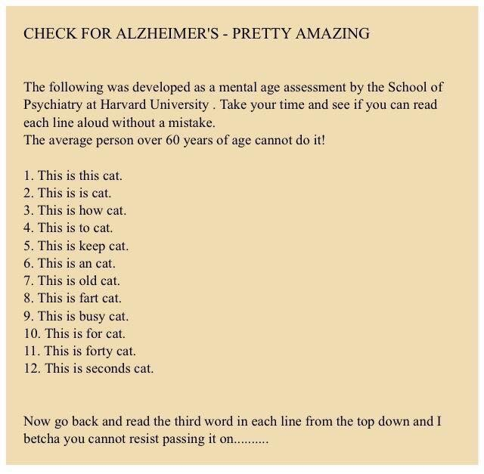

Submitted by Lou Zoghby – WWII Veteran

**Old Words**

Don't know who wrote this but I like the word supper too! I think it meant we got to set down (to a wonderful meal) for a few minutes before doing chores! As a side note, if we had cell phones, there would be no looking at them while we ate. That would have been disrespectful to the good meal Mother put on the table!

Oh my! FENDER SKIRTS AND SUPPER

I know some of you will not understand this message, but I bet you know someone who might. I came across this phrase yesterday. 'FENDER SKIRTS.'

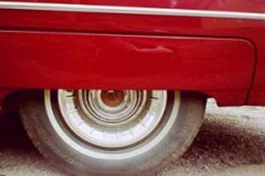

A term I haven't heard in a long time, and thinking about 'fender skirts' started me thinking about other words that quietly disappear from our language with hardly a notice like 'curb feelers.'

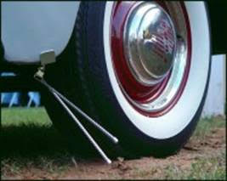

And 'steering knobs.' (AKA) 'Suicide knob,' 'neckers knobs.'

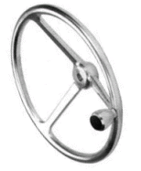

Since I'd been thinking of cars, my mind naturally went that direction first. Any kids will probably have to find some older person over 50 to explain some of these terms to you. Remember ‘Continental kits?' They were rear bumper extenders and spare tire covers that were supposed to make any car as cool as a Lincoln Continental.

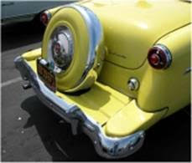

When did we quit calling them ‘emergency brakes? At some point 'parking brake' became the proper term. But I miss the hint of drama that went with 'emergency brake.'

I'm sad, too, that almost all the old folks are gone who would call the accelerator the 'foot feed.' Many today do not even know what a clutch is or that the dimmer switch used to be on the floor. For that matter, the starter was down there too.

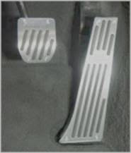

Didn't you ever wait at the street for your daddy to come home, so you could ride the 'running board' up to the house?



Here's a phrase I heard all the time in my youth but never anymore - 'store-bought.' Of course, just about everything is store-bought these days! But once it was bragging material to have a store-bought dress or a store-bought bag of candy.

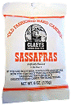

'Coast to coast' is a phrase that once held all sorts of excitement and now means almost nothing. Now we take the term 'worldwide' for granted. This floors me.



On a smaller scale, 'wall-to-wall' was once a magical term in our homes. In the '50s, everyone covered his or her hardwood floors with, wow, wall-to-wall carpeting! Today, everyone replaces their wall-to-wall carpeting with hardwood floors. Go figure.



When was the last time you heard the quaint phrase 'in a family way?' It's hard to imagine that the word 'pregnant' was once considered a little too graphic, a little too clinical for use in polite company, so we had all that talk about stork visits and 'being in a family way' or simply 'expecting.'

Apparently 'brassiere' is a word no longer in usage. I said it the other day and my daughter cracked up. I guess it's just 'bra' now. 'Unmentionables' probably wouldn't be understood at all.

I always loved going to the 'picture show,' but I considered 'movie' an affectation.



Most of these words go back to the '50s, when many men were nursing a stomach ulcer, but here's a pure '60s word I came across the other day 'rat fink.' Ooh, what a nasty put-down!



Here's a word I miss - 'percolator.' That was just a fun word to say. And what was it replaced with 'Coffee maker.' How dull... Mr. Coffee, I blame you for this.



I miss those made-up marketing words that were meant to sound so modern and now sound so retro. Words like 'Dyna Flow' and 'Electrolux' and 'Frigidaire'. Introducing the 1963 Admiral TV, now with 'Spectra Vision!'



Food for thought. Was there a telethon that wiped out lumbago? Nobody complains of that anymore. Maybe that's what Castor oil cured, because I never hear mothers threatening kids with Castor Oil anymore.



Some words aren't gone, but are definitely on the endangered list. The one that grieves me most is 'supper.' Now everybody says 'dinner.' Save a great word. Invite someone to supper. Discuss fender skirts.

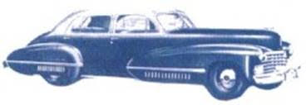

**New Medical Invention**

A married couple went to the hospital to have their baby delivered. Upon their arrival, the doctor said he had invented a new machine that would transfer a portion of the mother's labor pain to the father. He asked if they were willing to try it out. They were both very much in favor of it. The doctor set the pain transfer dial to 10% for starters, explaining that even 10% was probably more pain than the father had ever experienced before.

But as the labor progressed, the husband felt fine and asked the doctor to go ahead and bump it up a notch. The doctor then adjusted the machine to 20% pain transfer. The husband was still feeling fine. The doctor checked the husband's blood pressure and was amazed at how well he was doing. At this point they decided to try for 50%. The husband continued to feel quite well. Since it was obviously helping out his wife considerably, the husband encouraged the doctor to transfer ALL the pain to him. The wife delivered a healthy baby with virtually no pain.

She and her husband were ecstatic. When they got home, the mailman was dead on their porch.

**When you’re over 70, who cares??!!**

Submitted by Tom Werzyn

I was standing at the bar at the VFW one night minding my own business. This FAT ugly chick came up behind me, grabbed my behind and said, "You're kinda cute. You gotta phone number?" I said, "Yeah, you gotta pen?" She said, "Yeah, I got a pen". I said, "You better get back in it before the farmer misses you." Cost me 6 stitches...but, when you’re over seventy.............who cares?

I went to the drug store and told the clerk "Give me 3 packets of condoms, please." Lady Clerk: "Do you need a paper bag with that, sir?” I said "Nah... She's purty good lookin'....." When you’re over seventy.............who cares?

I was talking to a young woman in the VFW last night. She said, "If you lost a few pounds, had a shave and got your hair cut, you'd look all right.” I said, “If I did that, I'd be talking to your friends over there instead of you.”; Cost me a fat lip, but... When you’re over seventy.............who cares?

I was telling a woman in the Club about my ability to guess what day a woman was born just by feeling her breasts. "Really" she said, "Go on then... try." After about thirty seconds of fondling she began to lose patience and said, "Come on, what day was I born?" I said, "Yesterday." Cost me a kick in the nuts, but... When you’re over seventy..............who cares?

I got caught taking a pee in the swimming pool today. The lifeguard shouted at me so loud, I nearly fell in. When you’re over seventy.............who cares?

I went to our VFW last night and saw a BIG woman dancing on a table. I said, "Good legs." The girl giggled and said, "Do you really think so?" I said, "Definitely! Most tables would have collapsed by now. Can't see out of my right eye, but... "When you’re over seventy.............who cares?

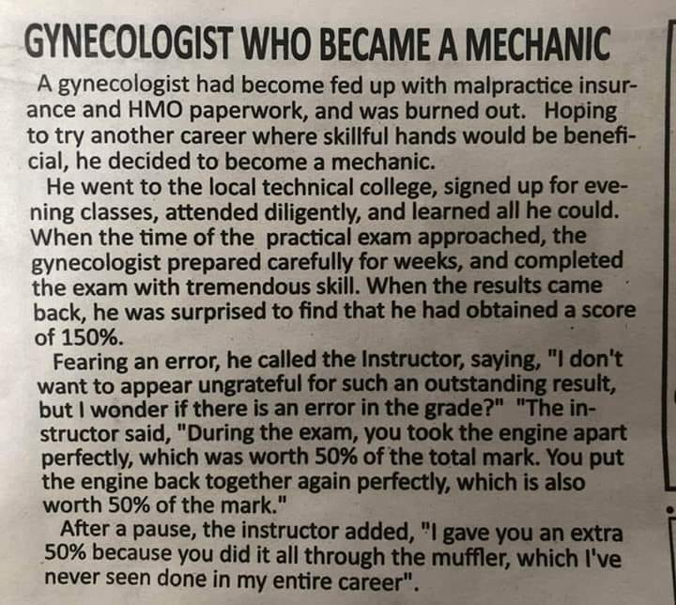

Submitted by John Vargas

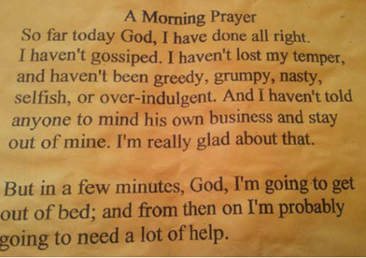

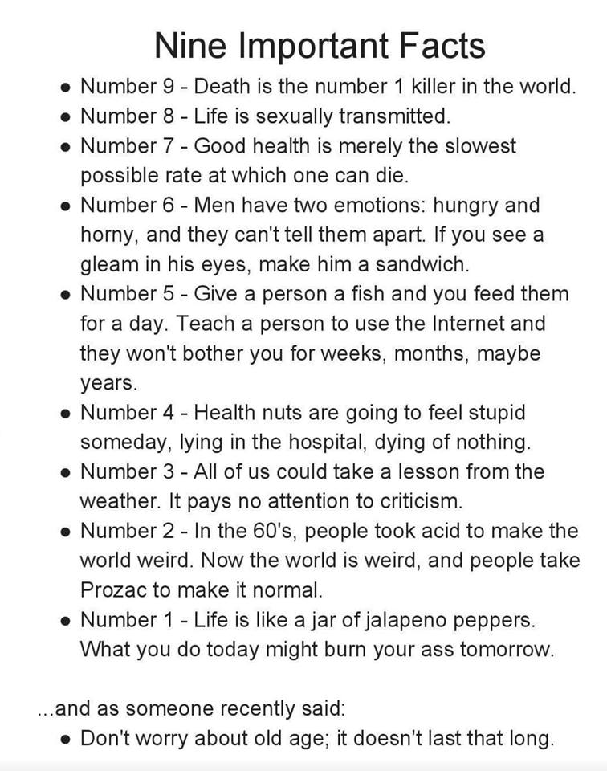

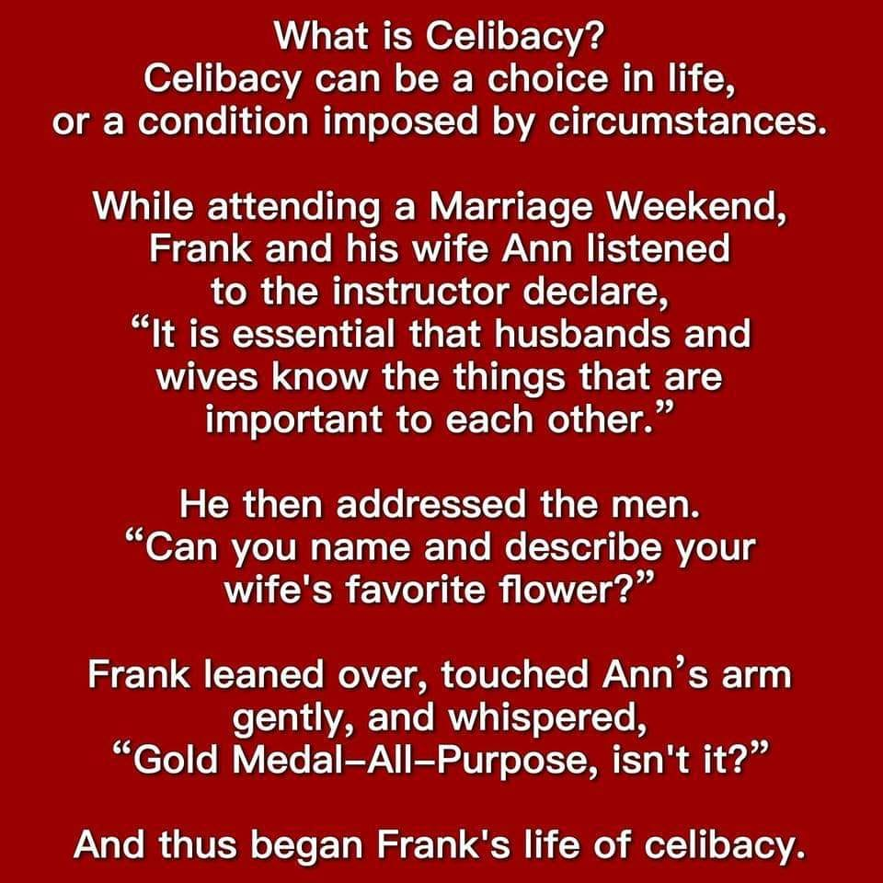

**“Lawyers”**

One afternoon a lawyer was riding in his limousine when he saw two men along the roadside eating grass. Disturbed, he ordered his driver to stop and he got out to investigate. He asked one man, "Why are you eating grass?"

"We don't have any money for food," the poor man replied. "We have to eat grass.

"Well, then, you can come with me to my house and I'll feed you," the lawyer said.

"But sir, I have a wife and two children with me. They are over there eating grass under that tree”

"Bring them along," the lawyer replied.

Turning to the second poor man he stated, "You may come with us, also."

The other man, in a pitiful voice, then said, "But sir, I also have a wife and six children with me!"

"Bring them all as well," the lawyer answered.

They all entered the car, which was no easy task, even for a car as large as the limousine.

Once underway, one of the poor fellows turned to the lawyer and said,

"Sir, you are too kind. Thank you for taking all of us with you."

The lawyer replied, "Glad to do it. You'll really love my place. The grass is almost a foot high."

Come on . . . did you really think there was such a thing as a heartwarming lawyer story?

Look at Congress -- over 300 Lawyers...!!!!



***Trivia Answer***

**Digies** – Digital camouflage worn by Soldiers and Marines.



|  |
| --- |
| **COLORADO VETRANS TREATMENT COURT**  **VOLUNTEER PEER MENTOR APPLICATION** |

## CONTACT INFORMATION

|  |  |
| --- | --- |
| Name |  |
| Street Address |  |
| City, State, Zip Code |  |
| Phone |  |
| E-Mail Address |  |
| Preferred Contact Method |  |
| Emergency Contact Name & Phone |  |

## MILITARY SERVICE

Have you ever served in the US Armed Forces? Choose an item.

Branch of Service (check all that apply): Choose an item.

Dates of Service: From: Click or tap to enter a date. To: Click or tap to enter a date.

Did you serve in a combat zone? Choose an item.

What was your job in the US Armed Forces? Click or tap here to enter text.

## SPECIAL SKILLS OR QUALIFICATIONS

### Summarize any skills and/or qualifications you have acquired from employment, previous volunteer work, or through other activities, including hobbies or sports that would be relevant to volunteering as a peer mentor.

|  |
| --- |
| Click or tap here to enter text. |

## PREVIOUS VOLUNTEER EXPERIENCE

### Summarize your previous volunteer experience.

|  |
| --- |
|  |

## VTC MENTOR QUESTIONS

Why would you like to volunteer with Veterans Treatment Court?

|  |
| --- |
|  |

How did you learn about volunteering with Veterans Treatment Court?

|  |
| --- |
|  |

Do you consent to a criminal background check? Choose an item.

## REFERENCES

Please provide the name and contact information for 2 non-family members who would be able to speak to your ability to perform as a volunteer peer mentor.

|  |  |
| --- | --- |
| Name |  |
| Phone |  |
| Email Address |  |
| Name |  |
| Phone |  |
| Email Address |  |

## SIGNATURE

|  |  |
| --- | --- |
| Name (printed) |  |
| Signature |  |
| Date |  |

**FRIENDS OF CHAPTER 1106**

|  |  |
| --- | --- |
| **ERC Management, LLC**  791 Southpark Dr., Suite 600  Littleton, CO 80120  [720.328.3299](tel:720.328.3299)  [www.FreddysUSA.com](http://www.freddysusa.com/) | |
| **Panera Bread**  9579 S. University Blvd. Highlands Ranch, CO 80126  720-348-1112 | **American Legion Post 1260**  **E:\Documents\ALP1187\images\AmericanLegion_logo.jpg** |
| **Spradlin Printing, Inc.**  11903 S. Parker Road Parker, CO 80134 | **South Metro Denver Fire & Rescue**  9195 E Mineral Ave  Centennial, CO 80112 |
| Monthly Membership Meetings VISITORS ARE ALWAYS WELCOME!   3rd Saturday of each month at 10:00a.m.   Our meetings are held at: [VFW Post 2461](http://www.vfwpost2461.com/) 1350 S Broadway, Denver, CO 80210 | A FULL-SIZE REPLICA OF THE HONOR BELL  **The Honor Bell Foundation**  PO Box 1432  Englewood CO 80150  720.282.9182  [www.honorbell.org](http://www.honorbell.org/) |
| 9137 E Mineral Cir Ste 100  Englewood, CO 80112-3422 | Logo of The Home Depot  **Home Depot Foundation**  8477 S Yosemite St  Lone Tree, CO 80124 |
| King Soopers logo.svg  King Soopers  9551 S. University Blvd., Highlands Ranch, CO 80126 | http://www.cruisin1430.com/sites/g/files/giy711/f/KEZW_Header_Large_Logo_0.png  **STUDIO 1430 Main Office:** 4700 South Syracuse Street, Suite 1050 Denver, CO 80237 |
| https://scontent.fapa1-2.fna.fbcdn.net/v/t31.0-8/10575197_682186265194110_4051472928662048560_o.jpg?oh=2630b186dcf3a20f1d7fc8fa25e0a5ba&oe=5A17C4AB  **Military Order of Purple Heart**, Chapter 1041, Arvada, CO | Golden Corral  **Golden Corral**  15775 E. Arapahoe Rd  Centennial, CO 80016 |