**Inside this issue:**

Notes from the President

[Member Feature](#Memberfeature)

[Military Trivia](#Militarytrivia)

[Guest Speaker](#Guestspeaker)

[Membership](#Membership)

[Board of Directors/Officers](#Boardofdirectors)

[Working Committees](#Workingcommittees)

[Meetings/Events Calendar](#Meetingsevents)

[Announcement Corner](#Announcementcorner)

[Books/Articles Published by Mbrs.](#Booksarticles)

[From the Editor](#Fromtheeditor)

[Light Side](#Lightside)

[Trivia Answer](#Triviaanswer)

**Notice:**

If you have moved or changed your address, PLEASE notify us immediately! Contact: Dave Lyons, Membership Chair

E-mail: [Snoyldavid@centurylink.net](mailto:Snoyldavid@centurylink.net)

Phone:  303 690 8776

###### COPYRIGHT NOTICE: In accordance with Title 17 U.S.C. Section 107, any copyrighted material in this newsletter is distributed under fair use without profit or payment to those who have expressed a prior interest in receiving the included information for nonprofit use and educational purposes only.

***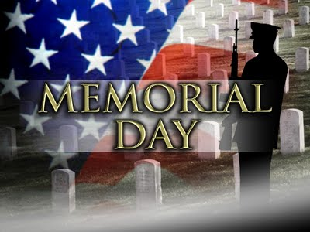*Facebook: Vietnam Veterans of America Chapter 1106**

***Editor’s Note:***

This version of the newsletter is in Microsoft Document (.DOCX) format so that the links will work. Put your cursor over the link, depress your Control Key (ctrl) and depress your left mouse button and it will take you to the listed link position. PDF format, the links will not work.

The comments and editorial input does not necessarily reflect the opinion of the membership of our chapter. I would appreciate any feedback that you might have, items you liked or if you find offensive or derogatory in anyway. ([bobrotruck73@gmail.com](mailto:bobrotruck73@gmail.com)) Thank you for allowing me to be your editor.

***Notes from the President***

Lee White

Some 45 days ago most of us were completely unaware of what was about to "turn the world upside down,” COVID-19. I hope all our members, and families are safe and healthy. All we can do is to take this on a day to day basis, and this shall pass. As you know this coronavirus has caused many schedule changes and concerns for our chapter. Our next scheduled chapter monthly meeting will be conducted via a conference call on Saturday, May 2. 2020 starting at 0900. Elections will be conducted at this meeting. (Call in information/details forthcoming). Our next scheduled monthly meeting will be on Saturday, June 6, 2020, and I hope our meeting room at South Metro F & R, Boardroom, will be available. (Presently, all "community rooms" are closed!)

"We are all in this together, and shall overcome this pandemic". Stay the course and stay healthy.

***“Member Feature”***

No Member Feature this issue!

 **FACEBOOK**

Do you know our Chapter has a Facebook account where we put news and information that you should be made aware of in a timely fashion?? We have had this account over three years and have 485 followers to date and only about **10 are chapter members** and some of those are no longer with us! All you have to do is open your FB account and SEARCH: **Vietnam Veterans of America Chapter 1106** and then hit the **FOLLOW** button! I hope to see a lot of new chapter names on there by the end of June!!! Editor

***Military Trivia***

**AWR** [Click here for end of the Newsletter Trivia Answer](#Triviaanswer)

***Guest Speakers – March***

Cancelled

***Special Speaker – April***

Cancelled

**March Bio Speaker -** Cancelled

**April Bio Speaker -** Cancelled

***Membership!*** (As of 4-13-20)

VVA 150

AVVA 38

Total: 188

Welcome New Members:

**VVA**

Joe Robinson

**AVVA**

Detlef Schaper

***Board of Directors/Officers***

Lee White - President

Dave Lyons - Vice-president

Mike Huber – Treasurer

**Vacant** – Secretary (acting Lee White)

Board Members - Milt Omoto, Patti Ehline, Dave Lyons, Tom Werzyn, Ron Smith, John Vargas, Dan Green, Joe Plant

***Special Chapter Positions***

AVVA Liaison to chapter Board of Directors - Litta Plant-Schaper

Chaplain – Rev. Garry Turks

Government Affairs – Tony Nickerson

Sergeant-at-Arms – Rob Senatore

Chapter Nurse – Patti Ehline

Chapter Historian - OPEN

***Working Committees***

* Agent Orange/PTSD – Patti Ehline
* Color Guard – Jay Quiring (Command Sergeant), Don McNeely, Dan Green, Thom Frey, Clarence Rebolledo, Robert Senatore, Tony Nickerson, Ron Smith, Leann Stelzer, Alexis Winemiller
* Event Coordinator – Ron Smith – Chair, Lee White, Michelle Mallin
* Fundraising/Grants – Milt Omoto
* Marketing/Media/Events – Tom Werzyn, Michelle Mallin
* Membership – Dave Lyons – Chair, Lee White
* Mental Health: Patti Ehline, Warren Harrison, Joe Plant
* Name Tags – Litta Plant-Schaper
* Newsletter Editor - Bob Rotruck
* Promotional Items: Leann Stelzer, Clarence Rebolledo
* Refreshments: Alexis Winemiller, Jason Longmore
* Scholarship Program - Jim Marcille, Chairs, Glen Payne, (supporter) John Vargas, Brian Karsh (supporter), Bob Mallin (supporter)
* Social –Barry Fiore, Glen Payne, Milt Omoto, Mike Karsh, John Vargas
* Speakers Bureau – Tom Werzyn – Chair, Bob Easter, Bob Mallin, Glen Payne, Roger Lanphier, Donna Chaney
* Veteran Emergency Assistance Committee - Joe Plant, Dave Lyons, Dan Green, Bruce Arndt, Lee White
* Voices for Veterans - Warren Harrison
* Webmaster – Bob Rotruck
* Women Veterans - Patti Ehline

**Meetings/Events Calendar - 2020**

May 2, 2020 - VVA Chapter 1106 Monthly Meeting via tele/conference call/video

May 23, 2020 - Memorial Day Poppy Drive - To Be Determined

June 6, 2020 - VVA Chapter 1106 Monthly

June 13, 2020 - State Council Meeting - Castle Rock

June 13, 2020 - Chapter "Motorcycle Fundraiser" - Pending.

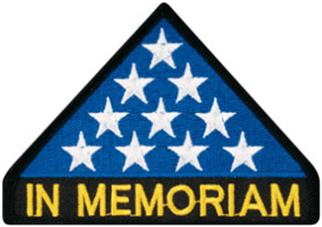

***In Memoriam***

**Christiane Omoto (1985-2020)**

Christiane was an Associate member of Chapter 1106. She had a heart for helping veterans. While a law student at the Denver University School of Law, she volunteered her time assisting veterans at the Daniels Veteran Services Center with their legal matters. She passed away on April 4th. She is now at peace with our Lord. If you so desire, you can provide a small contribution to a Chapter scholarship fund in her memory. A PayPal page has been established for this purpose:

<https://paypal.me/pools/c/8oeTDIqjap>



As of: 4/14/2020

Total Funeral Homes Visited - 2,398

Cremains Found – 20,653

Veterans Cremains Identified - 4,907

Veterans Interred – 4,542

***Events:***

**Suzanne Sigona Fundraiser**

“I received a message from Sister Modestine regarding the use of the funds. Let me know how we can share this. It can be summarized or it might be sweet to print it as it is written. I have some photos.

Dear Suzie,

How are you? Are you isolated? Hope virus corona will not come to you. We’re praying for you and your country! Here, in Nha Trang we’re still safe, however we isolate our self, not going out, too much.

Here are pictures we had last Saturday March 21rst, we went to highland people (where they had nothing to eat) with rice, noodles, sugar, oil, salt..., soap and towels. There are 75 families with 250 kids. The poor kids received bread, milk, cookies, and sausage...They were very happy...Regretting that you couldn’t come. A lot of thanks to you and your friends.

May God bless you and your friends with His peace and good health. Pray for us and our country, too.

Bye

Sr. Modestine

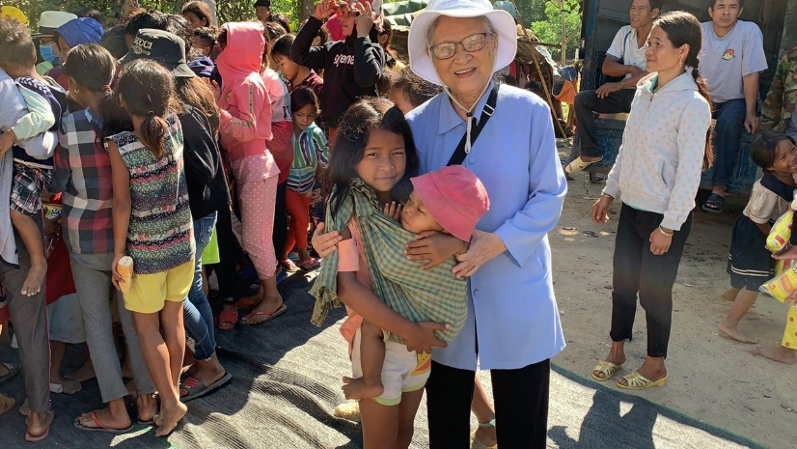

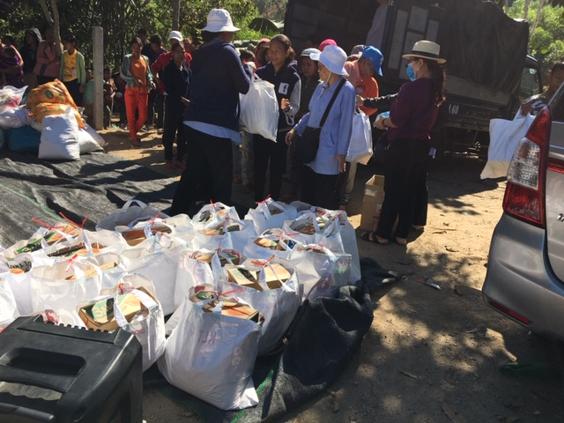

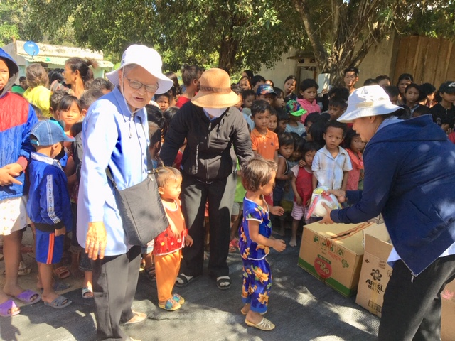



On March 11th, there was awards made to local veterans that never received what they earned and deserved! The Forgotten Heroes Campaign is a nonprofit organization founded in 1998 that directs searches for veterans who have honorably served their country, and present them or their family member(s): medals; awards; ribbons and badges earned but never received. A public ceremony is held to present the awards to the deserving veteran. The Forgotten Heroes Campaign also supports other Veteran’s organizations.

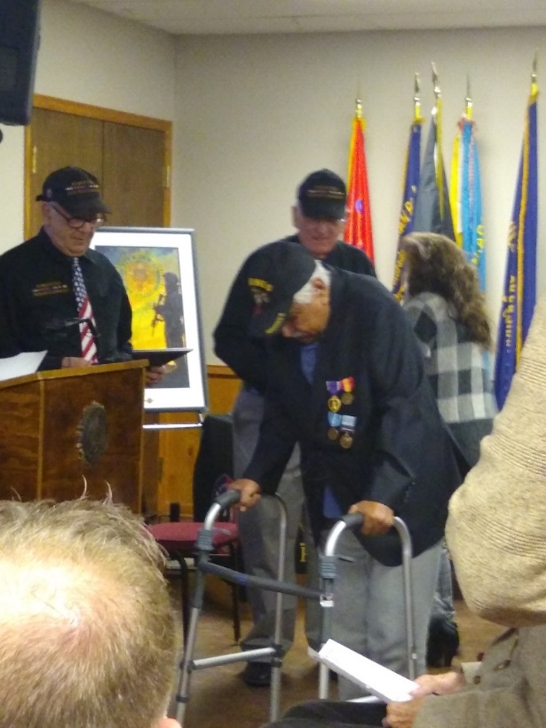

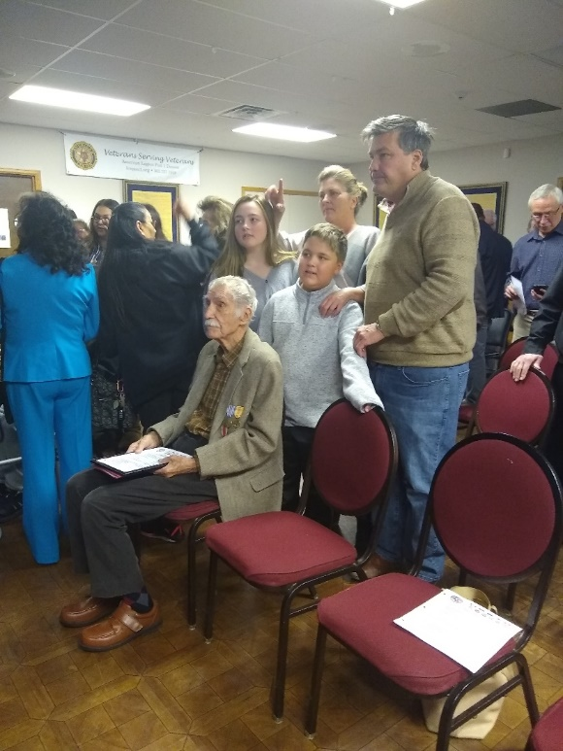

***Announcement Corner***

***Books/Articles Published by Members***

**Sharing the Foxhole – Joseph Daniel Plant**

By John Vargas

On a sunny morning and just before an approaching Denver snowstorm I met Joe Plant for breakfast at his favorite Village Inn located in Parker, Colorado. He was patiently waiting with a warm smile, strong handshake and a cup of hot java for me.

Joe Plant is the elite treasurer and admirable pillar of VVA 1106, Centennial Colorado and along with five other Veterans, was one of the original founding fathers. His dedication and selfless acts of kindness and generosity to the Veteran Community is unheralded.

First, let me give you a small sample about Veteran Plant. He was born in St. Clemens Michigan. Normal childhood with a few wrinkles! At 12, Joe was a newspaper boy who bought his own clothes. He was on the high school football team but, due to his rambunctious attitude, he was not invited back. At 18, he worked from 2am-8am cleaning a bar for $65.00 per week. Joe was also an expert horseman. He decided to join the Navy and spent 42 months at sea. He was then sent to Eniwetok Nuclear Test Grounds to pick up some boat people. They had to set up “Decon” stations on the ship, monitoring for radio activity. They took on about 16 survivors and used radiation monitors to check the contamination. They then took them to Taiwan and turned them over to authorities.

Joe joined the Army during the Cuban crisis in October of 1962. Basic training at Ft. Ord, California. While in AIT was trained as a Fire Control Tech for Nike Hawk Missiles at Ft. Bliss, Texas.

In October 1963 he met Dora. A beautiful young lady that was a resident at an Orphanage and returned to payback the kindness they had done for her. Joe’s buddies pulled a prank on him! The told him that a certain hacienda was filled with beautiful girls! They convinced him to knock on their front door. Being young and dumb, he did! To his speechless dismay it was a nun. Oops! Bad joke with a good result. Joe began to volunteer at this orphanage on weekends and that’s where he met Dora! Instantly he was attracted to her and they wed-on February 10, 1964. Then, just two weeks into his new marriage he received orders to go to Okinawa. They were separated for 13 months and finally Dora and son joined him Okinawa. He reenlisted for four more years and was sent to artillery OCS at Ft. Sill. While in Okinawa, he, Dora and son survived a Typhoon that devastated most of the island.

Joe was honorably discharged from Navy in 1962 and from the Army in 1969. In civilian life he was a HVAC Service and owned his company called Plant Engineering for 8 years and also worked as a Stationary Engineer.

In 2012 he was a founding member of 1071 in Lakewood, Colorado, and named treasurer in 2013. His friend Lee White was a bit tired of driving twice a month for regular Chapter and Board meetings from Franktown. Joe assisted Lee to form the now very successful VVA 1106 (over 160 strong and growing) Chapter. He has been the Treasurer for over five years.

In addition to his duties as Chapter Treasurer, Joe Chairs the Veteran’s Assistance Program. He works closely with VA social workers and assist needed Veterans with food, lodging and travel expenses. He also collects regular and motorized wheelchairs and at times, ramps and hospital beds. After some minor repairs they are also donated those Veterans in need. Somehow, this man still finds time to visit the lonely and often times very ill Veterans at various hospitals.

Joe Plant has and always will be a credit to his family, the Community, fellow Veterans.

I would share a foxhole with this man anytime!

**High School Classmate to Vietnam War Vet**

(Editor’s note: Recently reconnected with Ken (Kenny in HS) Torreyson who was in my wife’s Gaithersburg High School class of 1960, I was class of ’59, but in our small town and high school, everybody knew everybody. He sent the following with his email, an attachment of his 2019 Holiday newsletter. We had not connected since HS days. His newsletter touched me and I got his permission to publish in this NL.)

**Reflections at Christmas Time and the New Year 2019 By Ken Torreyson**

“It is the dignity of the soul to hold on to the past; it is the dignity of the spirit to take hold of the future.” by Rabbi Harold Schulweis

Christmas and the advent of a new year is a special time to pause and reflect on the welfare of my life and expectations for the future. The first lights of Christmas glow brightly in the shops and streets of Atlanta as I watch and listen to the holiday season awaken. I know that I should be overjoyed; however, I don’t always feel it in my heart. I feel wistful thinking of times past. Memories of Mom and Dad, brother Joe, Aunt Mary and many other family members and close friends. All are gone. Too soon their lives were over. The holidays bring forth melancholy, worry, loneliness and a yearning very deep inside for the missed opportunities of the past, meaningful relationships and a more perfect world. God bless the memories and souls of our departed loved ones and friends. They are like stars whose memories light the world after they have passed from it. They shine in the darkest night and illuminate for me the path. I grew up in a pastoral environment. As a youth, I experienced many hours of the day exploring over the silent woods and fields of my grandfather’s farm near Potomac, Maryland and dreaming of the future as I sat on the banks of the muddy branch creek that flowed through the meadows of the farm. A bright light glowed within me with great optimism, and I pledged my early understanding of God to live my life with courage, and determination amid the tempests of the changing years ahead. I did not imagine that some short years later I would be fighting an unjust war in a faraway place called Vietnam. I knew little about Vietnam, much less why we were involved. I spent the loneliest Christmas of my life near the Cambodian border and took part in some of the worst fighting during the Tet Offensive. The war was frightening, tough and gut wrenching to all the young men who, just a few years earlier, were experiencing the challenges of high school, college, playing sports and hoping to be accepted by their peers. I felt my country had betrayed me but I am proud that I answered the call, the bronze star awarded to me for actions in combat, and being selected to serve as an aide-de-camp to a senior level general. I have come to realize these things are insignificant in comparison to the thousands of young men who lost their lives, the grief encountered by their families, and the pain endured by our country. I am fortunate that God spared me from physical injury and bitterness and from the sharp passions of unguarded moments during that time. I survived and returned home to my family and friends and began a business career; one of the lucky ones. Though the world knows me not, my thoughts and actions have kept me friendly within myself over the years. I have not complained nor followed the clamor of the world. I have walked calmly down my own path. I have done it my way. I am now somewhat wiser, less self-serving but still have my share of flaws and shortcomings. I try to focus my life on making the world a better place. I give more attention to my passion and thirst for love, peace and hope that cannot be denied me. I search for more joy in my heart, hope and faith in God, the love to forgive others, and the courage to confront racial and ethnic prejudice. I wish for bread for the hungry, clothes for the naked, justice for the oppressed, love for the forgotten, healing for the ill, and protection for our children and wisdom for our young people. This new year I hope that I can make new and endearing relationships and that my family and friends will love me for what I am and will be patient with my wandering steps that lead to the light of hope and dreams for the world. Though age will someday overtake me and I may not come within sight of all my goals, hopes and dreams, I am thankful for my life and blessed by a loving family and olden memories that are good and sweet. As this year fades into the past and a new one begins, may the evening’s twilight find you and me still gentle souls and may we join hands to serve the needy and improve an imperfect world.

**Landlocked Sailor**

Colorado sailor, so far from the sea,

No salt in the air or ocean to see.

It was good to stand on the bow underway,

In heavy seas with a face covered in salt spray.

To feel the wind blowing against your life vest,

Checking to be sure it is tight on your chest.

Turning your back on the onslaught of wind,

Facing aft at aircraft fighting off the din.

Watching young men in shirts of yellow, green, and blue,

Quite a rainbow for the old salt eyes to view.

And there were the red shirts at their fire station,

Praying there would not be a break in the operation.

Purple shirts scurrying about with fuel lines taut,

Giving airplanes a pure drink without any salt.

And flight deck safety would always come first,

Men in white shirts watching for a burst.

And up on the bridge the skipper watched intent,

Making sure the men were earning their free rent.

I was just one man, on that sea going city,

And now it is all done, what a sorrowful pity.

I served my country twenty wonderful years,

But when I think of it I burst into tears.

For men and women still go out to sea,

Keeping our nation as free as can be.

All I can do is remember the past,

And wish that it would just last and last.

God bless our sailors that stand tall in the wind,

**Our country is the greatest and it will never end.**

ROTRUCK - 2010

**What IMPACT can YOU make?**

(From the Editor)



***Light Side***













From John Vargas

**CORONAVIRUS HELP**

When you’re out trying to find a store that still has toilet paper to sell you might better stock up on some old JACK D. too! I figure three or four 5ths should do the trick.

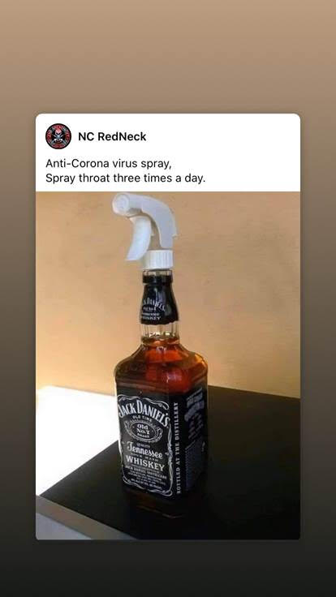



**For my friends who are golfers, and those that just need a laugh**!

(From Terry Boyer AT2, USN, who used to work for me in VA-65 on the USS Kitty Hawk 1968-69 – Editor)

An American goes to a club in Ireland and says I need to play your best player. The secretary says that will be Murphy I will give you his phone number. He phones Murphy and he says I will be there at 9:00 am but I could be half an hour late. Murphy turns up at 9:00 and he has a left handed set of clubs. They tee off and Murphy wins. The American says we must have a rematch tomorrow. Murphy says I will be here at 9:00 but I could be half an hour late. Murphy turns up at nine with a set of right handed clubs. They tee off and Murphy wins again. The American says we must play again tomorrow. What time will you be here and what clubs will you be using? Murphy says well it's like this, when I wake up in the morning I look to see what side the wife is laying on, the left side I use left handed clubs, the right side I use right handed clubs. What if she is on here back the American asks? Well that's when I will be half an hour late says Murphy

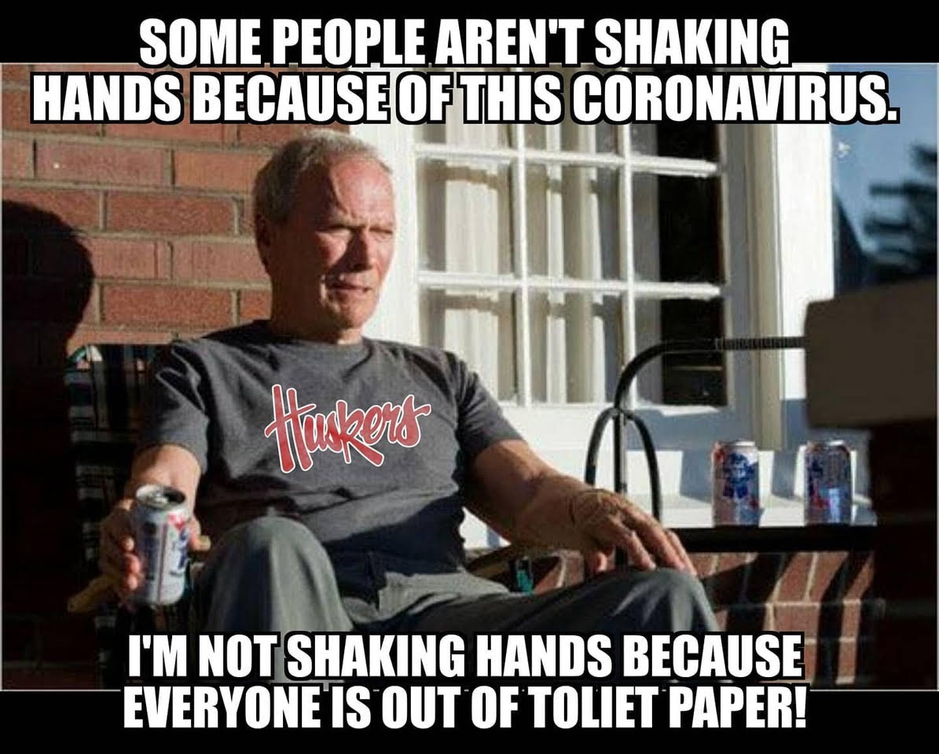

Submitted by: Tom Werzyn

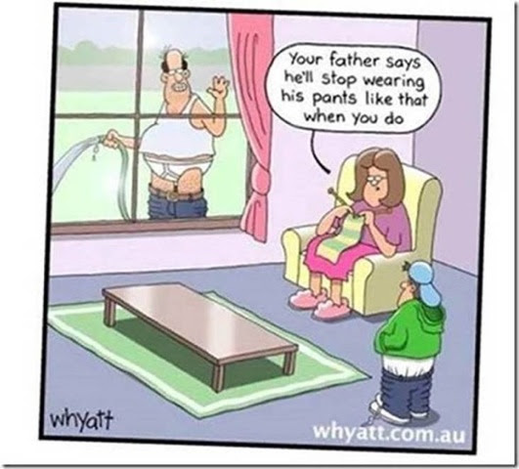

Submitted by: John Vargas

**COVID-19**

(Submitted by Jim Henderson)

A plane carrying Dr. Fauci, Hillary, President Trump and a 12 year old girl had lost its engines. With only 3 parachutes on board, Dr. Fauci said "I need one as I have to save the world from COVID-19" and he grabbed one and out the door he went.

Hillary said "Since I am the smartest woman in the world I need to be saved for the sake of the world" and she put a pack around her shoulders and out the door she went.

President Trump looked at the young girl and said "Young lady, I have lived a good life. You take the last parachute and go get a good education and have a great life" The girl took his hand and said "It's ok Mr. President. We have 2 parachutes left. The smartest woman in the world used my school backpack!"



**The Woman Marine Pilot**

The teacher gave her fifth grade class an assignment: Get their parents to tell them a story with a moral at the end of it.

The next day, the kids came back and, one by one, began to tell their stories. There were all the regular types of stuff: spilled milk and pennies saved.

But then the teacher realized, much to her dismay, that only Janie was left. "Janie," she asked, "Do you have a story to share?"

"Yes ma'am. My daddy told me a story about my Mommy. She was a Marine pilot in Syria, and her plane got hit. She had to bail out over enemy territory, and all she had was a flask of whiskey, a pistol, and a survival knife. She drank the whiskey on the way down so the bottle wouldn't break, and then her parachute landed her right in the middle of 20 ISIS troops. She shot 15 of them with the pistol, until she ran out of bullets, killed four more with the knife, till the blade broke, and then she killed the last ISIS fighter with her bare hands.

"Good Heavens," said the horrified teacher. "What did your Daddy tell you was the moral to this horrible story?"

"Stay away from Mommy when she's been drinking!"



***Trivia Answer***

**AWR –** (Alpha Whiskey Romeo) Allah's Waiting Room

**Upcoming Events of Interest**

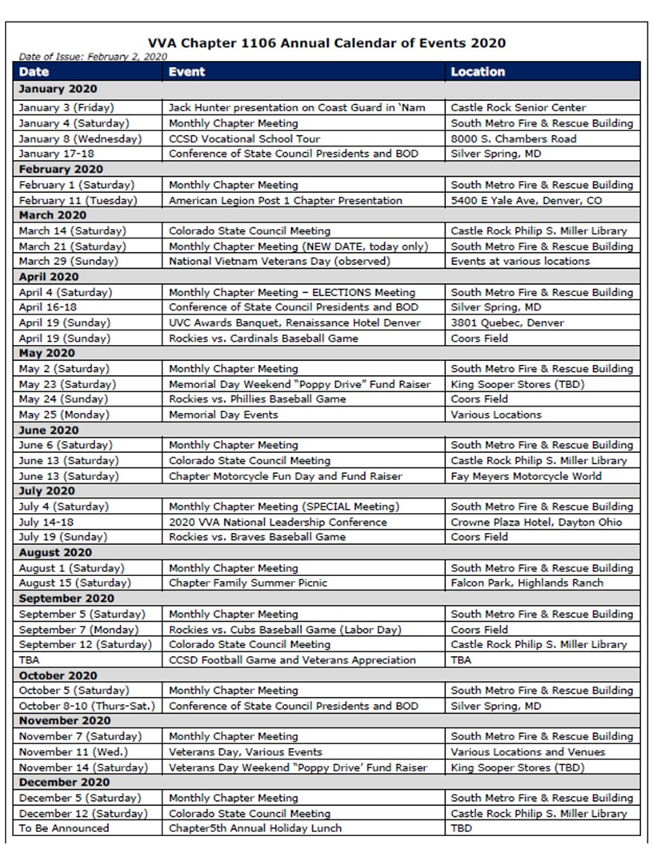

**FRIENDS OF CHAPTER 1106**

|  |  |
| --- | --- |
| **Panera Bread**  9579 S. University Blvd. Highlands Ranch, CO 80126  720-348-1112 | **American Legion Post 1260**  **E:\Documents\ALP1187\images\AmericanLegion_logo.jpg** |
| **Spradlin Printing, Inc.**  11903 S. Parker Road Parker, CO 80134 | **South Metro Denver Fire & Rescue**  9195 E Mineral Ave  Centennial, CO 80112 |
| American Family Insurance  3989 E. Arapahoe Road #20  Centennial, CO 80122  720-361-0155 | A FULL-SIZE REPLICA OF THE HONOR BELL  **The Honor Bell Foundation**  PO Box 1432  Englewood CO 80150  720.282.9182  [www.honorbell.org](http://www.honorbell.org/) |
| 9137 E Mineral Cir Ste 100  Englewood, CO 80112-3422 | Logo of The Home Depot  **Home Depot Foundation**  8477 S Yosemite St  Lone Tree, CO 80124 |
| King Soopers logo.svg  King Soopers  9551 S. University Blvd., Highlands Ranch, CO 80126 | http://www.cruisin1430.com/sites/g/files/giy711/f/KEZW_Header_Large_Logo_0.png  **STUDIO 1430 Main Office:** 4700 South Syracuse Street, Suite 1050 Denver, CO 80237 |
| https://scontent.fapa1-2.fna.fbcdn.net/v/t31.0-8/10575197_682186265194110_4051472928662048560_o.jpg?oh=2630b186dcf3a20f1d7fc8fa25e0a5ba&oe=5A17C4AB  **Military Order of Purple Heart**, Chapter 1041, Arvada, CO | ZILLOW GROUP  10771 E. Easter Ave  Centennial CO 80112 |
| American Home Agents  Brian Karsh, Broker Associate  720-327-1562 | PARKER MEDICAL  SUPPLY STORE  9845 S Parker Rd  . Parker, CO 80134  303-840-4444 |