**Inside this issue:**

Notes from the President

[Member Feature](#Memberfeature)

[Military Trivia](#Militarytrivia)

[Guest Speaker](#Guestspeaker)

[Membership](#Membership)

[Board of Directors/Officers](#Boardofdirectors)

[Working Committees](#Workingcommittees)

[Meetings/Events Calendar](#Meetingsevents)

[Announcement Corner](#Announcementcorner)

[Books/Articles Published by Mbrs.](#Booksarticles)

[From the Editor](#Fromtheeditor)

[Light Side](#Lightside)

[Trivia Answer](#Triviaanswer)

**Notice:**

If you have moved or changed your address, PLEASE notify us immediately! Contact: Dave Lyons, Membership Chair

E-mail: [Snoyldavid@centurylink.net](mailto:Snoyldavid@centurylink.net)

Phone:  303 690 8776

###### COPYRIGHT NOTICE: In accordance with Title 17 U.S.C. Section 107, any copyrighted material in this newsletter is distributed under fair use without profit or payment to those who have expressed a prior interest in receiving the included information for nonprofit use and educational purposes only.

**Facebook: Vietnam Veterans of America Chapter 1106**

***Editor’s Note:***

This version of the newsletter is in Microsoft Document (.DOCX) format so that the links will work. Put your cursor over the link, depress your Control Key (ctrl) and depress your left mouse button and it will take you to the listed link position. PDF format, the links will not work.

The comments and editorial input does not necessarily reflect the opinion of the membership of our chapter. I would appreciate any feedback that you might have, items you liked or if you find offensive or derogatory in anyway. ([bobrotruck73@gmail.com](mailto:bobrotruck73@gmail.com)) Thank you for allowing me to be your editor.

***Notes from the President***

Lee White

I don’t know about you, but I’m so looking forward to fall. It’s been a hot, stressful summer for all.

In September there is a special recognition day, “POW/MIA Recognition Day”, on Friday, September 18, 2020 (always on the 3rd. Friday in September). “You are not forgotten” is the central reason behind the POW/MIA remembrance movement which honors America’s prisoners of war, those who are still missing in action and their families. In 1979, congress and the president passed resolutions making it official.

POW/MIA by the numbers:

130,201 WWII service members were imprisoned, 14, 072 died

7,140 Korean war service members were imprisoned. 2,701 died

725 Vietnam war service members were imprisoned. 64 died.

37 service members were imprisoned during conflicts since 1991

MIA/still missing

73,515 from WWII

7,841 from Korean war

1,626 from Vietnam war

126 from Cold War

6 from conflicts since 1991

Total: 83,114 (more than 41,000 are presumed “lost at sea”)

If you have a POW/MIA Flag, let’ fly it on Friday, September 18, 2020.

Resource: military.com

***“History Corner”***

By Chapter Historian: John Vargas

I cannot think of a better way to start this information series than writing about our “Skipper” (nautical term), Lee White, Yeoman First Class, US Coast Guard, 1965-1969.

Lee is from the rolling hills of central Pennsylvania. His family’s home had wood floors, an outhouse, no running water, and electricity arrived later. After completing high school and having worked at various odd jobs, his future was in limbo. So, he decided to join the US Air Force. The recruiter was some 30 miles away and he had seldom ventured that far from home. As luck would have it, the Air Force recruiter was at lunch! Across the hall a welcome to the Coast Guard sign caught his eye. Lee walked in and said, sign me up. I think the draft board is on my tail.

After completing 12 weeks of basic at Cape May, NJ, Lee was assigned to the Coast Guard Cutter “Spencer” (WHEC 36) a weather/search & rescue ship. Off to ocean Station “Bravo” some 200 miles off the coast of Greenland in February. It was just a bit cold watching for Ice flows and icebergs.

His next assignment was to report to Yeoman School in Groton, CT for 16 weeks. Then it was on to the Coast Guard Cutter Half Moon (WHEC 378) docked at St. George, Staten Island, NY before heading to Guantanamo Bay, Cuba (Refresher Training with the Navy) and then to Vietnam in April 1967. The sailing took us down the East Coast, passage through the Panama Canal, onward to Pearl Harbor, Hawaii, and finally arrived in Subic Bay, Philippines. Temporary homeport while not on patrol in the southern waters of South Vietnam.

After 10 months of boarding and searching sampans and trawlers, for contraband from the North and to support gunfire missions in the Nha Trang-Vung Tau area, the ship and crew were relieved. After 45 days at sea, they reached Staten Island, NY, March 1968. After our Vietnam deployment, all the crewmembers were given priority selection for their next duty station. He was more than ready for a land locked assignment and selected the C.G. Group Admin Office in Atlantic City, NJ as a Group Yeoman.

He worked two jobs. One with the Coast Guard, and the second at a convenience store. That’s when he met Cookie. Fifty “50” years later and they still enjoy a loving marriage. They have a beautiful daughter, Wendy, that has her father’s integrity and drive and Cookie’s good looks. With an honorable discharge he waived farewell to the Coast Guard on October 9, 1969.

Lee has never turned away from hard work! His first back to civilian life job was as a front desk clerk at a major hotel in Atlantic City, NJ. Starting as a management trainee he worked for the next nine plus years with the 84 Lumber Company. Over that timeframe, he managed locations in Lancaster, PA, Albany, NY, Denver, CO, Los Angeles, CA (land development), and Houston, TX

In 1979, Lee was hired by Boise Cascade as an assistant manager in Aspen, Colorado. He held various management positions in both retail and wholesale distribution, as Sales Manager, Operations Manager, and Purchasing Agent. His last 18 years was at the Boise Cascade Distribution Center in Denver. He retired after 37 years in 2007. There is no slowing down for this high energy “Coastie” Vietnam Veteran and leader. To his credit here are just a few of his volunteer efforts:

\*VP of Operations for the Rocky Mountain Honor Flight – 2008-2012

\*Forgotten Heroes Campaign (Secretary)

\*Douglas County Veterans Monument Foundation

\*Secretary at VVA 1071 in 2012-2014

\*Founded VVA 1106 in 2014-15

\*Joined the Honor Bell Foundation – Tolling the H.B. at Ft. Logan

\*Currently, President of VVA 1106 (over 190 Members).

\*President VVA State Council – 2016-2019

I hope this gives you some insight into the life of our “Skipper” VVA Chapter 1106, President and Coast Guard Yeoman.

\*Yeoman, an enlisted rating in the Navy/Coast Guard having chiefly clerical duties and problem solvers for officers.

***Military Trivia***

**APC** [Click here for end of the Newsletter Trivia Answer](#Triviaanswer)

***Guest Speakers – Aug* -** Cliff Lawson – Portraits

Showing our Chapter Recruitment Video

***Special Speaker – Sep* -** "Qualified Listeners" - Greg Goettsch

**July Bio Speaker - None**

**Aug Bio Speaker - None**

***Membership!*** (As of 8-21-20)

VVA - 156

AVVA - 39

Total - 195

Welcome New Members:

**VVA**

Ben Wolfe

William Graft

Cliff Lawson

Mike Vallow

**AVVA**

Daniel Plant

***Board of Directors/Officers***

Lee White – President

Dave Lyons – Vice-president

Mike Huber – Treasurer

Secretary – Milt Omoto

Board Members – Patti Ehline, Glen Payne, Tom Werzyn, Ron Smith, John Vargas, Dan Green, Joe Plant

***Special Chapter Positions***

AVVA Liaison to chapter Board of Directors – Litta Plant-Schaper

Chaplain – Rev. Garry Turks

Chapter Historian – John Vargas

Database/Audio – Jack Hunter

Government Affairs – Tony Nickerson

Sergeant-at-Arms – Rob Senatore

Chapter Nurse – Patti Ehline

***Working Committees***

* Agent Orange/PTSD: Patti Ehline
* Color Guard: Jay Quiring (Command Sergeant),
* Don McNeely, Dan Green, Thom Frey, Clarence Rebolledo, Robert Senatore, Tony Nickerson, Ron Smith, Leann Stelzer, Alexis Winemiller
* Event Coordinator: Ron Smith – Chair, Lee White, Michelle Mallin
* Fundraising/Grants: Milt Omoto
* Marketing/Media/Events: Tom Werzyn, Michelle Mallin
* Membership: Dave Lyons – Chair, Lee White
* Mental Health: Patti Ehline, Warren Harrison, Joe Plant
* Name Tags: Litta Plant-Schaper
* Newsletter Editor: Bob Rotruck
* Promotional Items: Leann Stelzer, Clarence Rebolledo
* Refreshments: Alexis Winemiller, Jason Longmore
* Scholarship Program: Mike Karsh and Jim Marcille – Co-chairs, Glen Payne, John Vargas
* Social –Barry Fiore, Glen Payne, Milt Omoto, Mike Karsh, John Vargas
* Speakers Bureau Tom Werzyn – Chair, Bob Easter, Bob Mallin, Glen Payne, Roger Lanphier, Donna Chaney
* Veteran Emergency Assistance Committee: Joe Plant, Dave Lyons, Dan Green, Bruce Arndt, Lee White
* Voices for Veterans: Warren Harrison, Patti Ehline, Joe Plant, John Vargas
* Webmaster: Bob Rotruck
* Women Veterans: Patti Ehline

**Meetings/Events Calendar - 2020**

Sept. 5, 2020 - VVA Chapter 1106 Membership Meeting (Zoom)

Sept. 12, 2020 - CO State Council Meeting - Castle Rock

Sept. 18, 2020 - Nat'l POW/MIA Recognition Day (3rd. Friday of September Annually)

Oct. 3, 2020 - VVA Chapter 1106 Membership Meeting (Zoom)

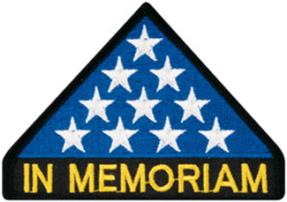

***In Memoriam***

**John A. McMaster**

John A. McMaster, 73, of Aurora, Colorado, passed away on Thursday, July 16, 2020. John was born on December 2, 1946 to C. Fulton and LaVonna McMaster, in Des Moines, Iowa. He was one of five children. John joined the United States Army, and, during his service, deployed to Vietnam and was awarded a Purple Heart. He would go on from that time to develop a passion for serving veterans of all eras. John was deeply involved in VVA and VFW organizations, eventually starting the John O’Brian Post 6331, and serving as its commander for many years. John earned his associate degree, and held many professional positions, finally working in Oil Remediation. John is survived by his siblings, Louise Abel and Carol Cullen; significant other, Dottie Bartlett; stepchildren, Mary Jo Munoz (Mark Munoz) and Roger Miller; and grandchildren, Ethan Munoz, Faith Miller, Adam Miller. John was preceded in death by his parents, C. Fulton and LaVonna; wife, Irene McMaster; daughter, Kelly Jo McMaster; and siblings, Roy and Dale McMaster.

**John A. McMaster**

**1946 - 2020**

We buried John

today-

on a day of a deep blue afternoon-

a pilot’s dream.

More than a dozen comrades-in-arms

came to honor, and salute, and assist-

Standing tall and bright;

Remembering a fallen brother

as he was laid to his final rest,

at the end of his flight line.

Family and friends together, remembering

who John was,

what he greatly accomplished,

and who he helped while here with us.

Sad, proud words- offered and shared

with us all.

When a flier severs these surly bonds,

we salute, and remain confident he will be waiting,

circling, patrolling, prepping that last LZ for the rest to follow.

A life full of friends, family, children, fellow veterans

And so, so much more;

Exampling for all of us how to serve

and return the goodness bestowed upon himself.

Rest easy, young man ..

we’ll all see you as we come through the mist

to that final, soft-skid landing …

……..

**Tom Werzyn – 7-30-2020**

**On the burial ceremonies at Ft. Logan National Cemetery**

**For our comrade, John A. McMaster**



As of: 8/21/2020

Total Funeral Homes Visited - 2,402

Cremains Found – 21,501

Veterans Cremains Identified – 5,043

Veterans Interred – 4,625

***Events:***

**July 4th**

John and Kathleen Vargas placed VVA mailing stickers on these small USA Flags. Then we placed them on the lawns of our cul-d-sac neighbors. It was our 4th of July tribute. It was well received.

**Vietnam Veterans Memorial Fund**

From Suzanne Segona

During this challenging time for our nation, nothing is more important to VVMF than the health and well-being of our Vietnam veterans and their families. We want to keep our visitors updated on openings/closings and events as the situation evolves.

While the National Park Service has not closed the national mall or The Wall, the D.C. region is still in the early phases of its COVID recovery plan and no volunteers are on duty at The Wall.

For the safety of our visitors, volunteers and staff, VVMF has made the difficult decision to cancel the remainder of The Wall That Heals 2020 tour. This decision was not made lightly as we know that our 2020 site host committees have worked incredibly hard and put forth hundreds, if not thousands, of hours in their efforts to host the exhibit. We are working with these communities to reschedule visits in 2021.

We originally postponed our 2020 In Memory ceremony to September but we have now made the decision to cancel our 2020 ceremony. We look forward to honoring our 2020 In Memory honorees when we are able to safely host more than 2,000 people on site in D.C.

Like all of you, we hope this national health crisis ends soon but we must take the necessary precautions to keep our visitors safe at this time. We look forward to welcoming you all back in large numbers soon. We appreciate your understanding during this difficult time.

***Did You Know***

Each newsletter, you will see a different service branch to help you know the naming differences between the different services!

**Army Officer Ranks**

Second Lieutenant (1LT) (01)

First Lieutenant (2LT) (02)

Captain (CPT) (03)

Major (MAJ) (04)

Lieutenant Colonel (LTC) (05)

Colonel (COL) (06)

Brigadier General (BG) (07)

Major General (MG) (08)

Lieutenant General (LTG) (09)

General (GEN) (010)

General of the Army (GA) (Special1)

General of the Armies (GAS) (Special)

**Warrant Officer Ranks**

Warrant Officer (WO1)

Chief Warrant Officer (CWO2)

Chief Warrant Officer (CWO3)

Chief Warrant Officer (CWO4)

Chief Warrant Officer (CWO5)

**Army Enlisted Ranks**

Private (E1)

Private Second Class (E2)

Private First Class (E3)

Corporal (E4)

Sergeant (E5)

Staff Sergeant (E6)

Sergeant First Class (E7)

First Sergeant (E8)

Sergeant Major (E9)

***Announcement Corner***

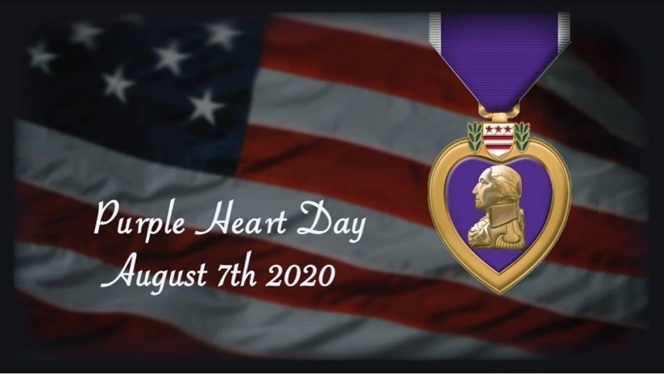

***Books/Articles***

**What Is Your Story?**

From the Editor

What is your story? Yes, you **all** have special stories about your time in the military, serving our country! Some are happy and some profoundly serious. I know you have stories because I hear you sharing them before and after our meetings. It is time you shared those stories with all of us. If you will just take the time to sit down at your computer or use your “smart” phone or even a pencil and paper and write your story and send or hand it to me, you will end up with a $5.00 gift card for a cup of coffee!

**We Are Veterans.**

Author unknown

We left home as teenagers, or young men, for an unknown adventure.

We loved our country enough to defend it and protect it with our own lives.

We said goodbye to friends and family and everything we knew.

We learned the basics and then we scattered in the wind to the far corners of the Earth.

We found new friends and new family.

We became brothers and sisters regardless of color, race or creed.

We had plenty of good times, and plenty of bad times.

We didn’t get enough sleep.

We drank too much.

We picked up both good and bad habits.

We worked hard and played harder.

We didn’t earn a great wage.

We experienced the happiness of mail call and the sadness of missing important events.

We didn’t know when, or even if, we were ever going to see home again.

We grew up fast, and yet somehow, we never grew up at all.

We fought for our freedom, as well as the freedom of others.

Some of us saw actual combat, and some of us didn’t.

Some of us saw the world, and some of us didn’t.

Some of us dealt with physical warfare, most of us dealt with psychological warfare.

We have seen and experienced and dealt with things that we can’t fully describe or explain, as not all of our sacrifices were physical.

We participated in time honored ceremonies and rituals with each other, strengthening our bonds and camaraderie.

We counted on each other to get our job done and sometimes to survive it at all.

We have dealt with victory and tragedy.

We have celebrated and mourned.

We lost a few along the way.

When our adventure was over, some of us went back home, some of us started somewhere new and some of us never came home at all.

We have told amazing and hilarious stories of our exploits and adventures.

We share an unspoken bond with each other, that most people don’t experience, and few will understand.

We speak highly of our own branch of service, and poke fun at the other branches.

We know however, that, if needed, we will be there for our brothers and sisters and stand together as one, in a heartbeat.

Being a veteran is something that had to be earned, and it can never be taken away.

It has no monetary value, but at the same time it is a priceless gift.

People see a veteran and they thank them for their service.

When we see each other, we give that little upwards head nod, or a slight smile, knowing that we have shared and experienced things that most people have not.

So, from myself to the rest of the veterans out there, I commend and thank you for all that you have done and sacrificed for your country.

Try to remember the good times and forget the bad times.

Share your stories.

But most importantly, stand tall and proud, for you have earned the right to be called a Veteran.

**This is why I no longer watch NFL football!**

If I have brain cancer, I don’t ask my dentist what I should do. If my car has a problem, I don’t seek help from a plumber! Why do you think the public cares what a football player thinks about politics? If we want to know about football, then depending on the information we seek, we might consult with you, but even a quarterback doesn’t seek advice on playing his position from a defensive tackle! You seem to have this over inflated view of yourselves, thinking because you enjoy working on such a large-scale stage, that somehow your opinion about everything matters. The NFL realizes the importance of its “image” so it has rules that specify the clothes and insignia you can wear, the language you use, and your “antics” after a touchdown or other “great” play. But somehow you and your employer don’t seem to care that you disgrace the entire nation and its 320 million people in the eyes of the world by publicly disrespecting this country, its flag, and its anthem! The taxpaying citizens of this country subsidize your plush work environments, yet you choose to use those venues to openly offend those very citizens.

Do you even understand what the flag of this country means to so many of its citizens before you choose to “take a knee” in protest of this “country" during our national anthem?

You may think because you are paid so much that your job is tough, but you are clueless when it comes to tough.  Let me show you those whose job is really tough.

You are spoiled babies who stand around and have staff squirt GatorAid in your mouths, sit in front of misting cooling fans when it’s warm, and sit on heated benches when it's cold. That’s not “tough” that's pampered. You think that you deserve to be paid excessively high salaries, because you play a “dangerous" game where you can incur career ending injuries. Let me show you career ending injuries!

You think you that you deserve immediate medical attention and the best medical facilities and doctors when injured. Let me show you what it’s like for those who really need and deserve medical attention.

You think you have the right to disrespect the flag of the United States, the one our veterans fought for, risked limbs and mental stability to defend, in many cases died for. Let me show you what our flag means to them, their families, and their friends.

You believe you are our heroes, when in reality you are nothing but overpaid entertainers, who exist solely for our enjoyment! Well, your current antics are neither entertaining nor enjoyable, but rather a disgrace to this country, its citizens, all our veterans and their families, and the sacrifices they have made to ensure this country remains free. You choose to openly disgrace this country in the eyes of the rest of the world, yet with all your money, still choose to live here rather than in any other country. People with even the slightest amount of “Class” will stand and respect our flag. Where does that put you? You want to see heroes… here are this countries heroes!

You can protest policies, the current government, or anything else you choose, that is your right. But when you “protest” our flag and anthem, you are insulting the nation we all live in and love, and all those who have served, been injured, or died to keep it free. There is nothing you can do or say that can make your actions anything more than the arrogance of classless people, who care about themselves more than our country or the freedoms for which our veterans and their families have sacrificed so much, to ensure you have the “right” to speak freely. Our country is far from perfect, but if you can point to any other country where your freedom and opportunities are better than they are here, then you just might want to go there and show respect for their flag!

**SHARING THE FOXHOLE**

**JAMES DALE BISHOP**

By John Vargas 7/2020

At times we meet a person while going about our daily business when a little voice whispers in your ear “Get to know this individual”. Eventually, I was able to sit down for a nice chat with Jim. I have a tendency to give people nicknames and after our fact filled sit-down, I quickly came up with one for him “Crash”.

James Dale Bishop was born on June 17, 1949 in Dearborn, Michigan. He attended St. Luke’s Elementary and then graduated from Detroit Cathedral. He was somewhat of a math wizard! Jim later studied Business Law, Franchising Law Commercial and Real-Estate Law.

He and Karen have been married since May 21, 1976. They have two children, Anthony, two girls Emma (3) and Evie (1), and Lauren has two boys, Conner (13) and Liam (10). Knowing Jim and Karen they’re very spoiled grandchildren!

This fascinating man has a few hobbies. He is an avid train collector that are displayed in a large room filled with bustling trains. Jim enjoys drawing cartoon characters. He gives these sketches to kids in hospitals, his family and drew one for each of a Group of 14 NAM Vets called Band of Brothers. Somehow, he still finds the time to be a coin collector. Ask him about PCGS or NGC.

His military adventures began by being drafted and had to report on Thanksgiving Day in November of 1967. The day after he arrived on base, he walked into the NCO Club by mistake and noticed a flyer about flight school. Just then a crusty Master Sergeant, said to Jim, What the hell are you doing in here? Soooo sorry sir! Big mistake! “On Monday, Jim approached the drill sergeant and asked”, Sir, I want to take the test for flight school. Without hesitation, there was a nose touching his nose and in very loud words he could hear, don’t call me Sir, I work for a living! Now drop and give me 50 push-ups. He was lucky enough to meet a 2nd lieutenant who helped him take a written test and just like that, Jim was on his way to Ft. Polk, Louisiana to complete his eight weeks of Basic. Then it was onto Ft. Walters, Texas for six months of flight school. On his first solo flight he had a little trouble. The engine failed and he set down his chopper very close to the tower. Not a crash, but a bit of a hard landing.

In January 1970, he was assigned to the 1st Aviation Brigade, 162 Assault Helicopter company in Vietnam. During Jim’s first mission, spraying “Agent Orange”, they were spotted by an armed sampan. They immediately began firing at Jim’s helicopter. Fortunately, a Gun Ship with multiple mini and M60’s came to their rescue and blew the sampan out of the water. That assault left 18 holes in the chopper., but all returned safely.

Jim had a slight tendency to have “hard landings”. While flying a General, Jim had a hard landing in a rice paddy in enemy territory. He quickly radioed flight control that Volture49 was going down and that he had an Oscar 8 on board. Not long after that call, a few gunships arrived, picked up the General and they left Jim behind!

Jim was honorably discharged on January 19, 1971. In addition to the Air Medal, he was awarded the Bronze Star. The toll of agent orange paid heavily on Jim’s future health.

Upon his return to civilian life he and four other partners opened a records and tape store in Wayne, Michigan. That’s where he met a cute “red head” that later become his wife. He and his partner owned that one for 10 years before opening a second store. They also opened a nightclub called Players. He and Karen moved to Dallas in December 1991. Jim became a restaurant broker and was a founding member of the Texas and International Business Brokers Association. He then went to work with various restaurant companies that included Little Caesar’s and Western Sizzlin. Jim and Karen received job offers in Denver and relocated in 1995. In 1998, he joined Quiznos when they only had 100 stores. When he left, there were over 3500 stores and another 1800 were being built.

Jim and Karen are philanthropists. They have a Bishop Charity Fund. The give to Habitat for Humanity, the Wounded Warriors and donated two thousand dollars to the VVA 1106 Scholarship Fund for this year and years to come. As a result of Agent Orange, Jim is confined to a wheelchair, has had multiple leg surgeries, and had a small sausage size blood clot dissolved in his head. Yet you never hear him complain. Yes, he is a curmudgeon, but one that continues to light up a room with his smile and humor.

Jim, aka “Crash” is someone you should meet for an everlasting memory and a Veteran to be admired!

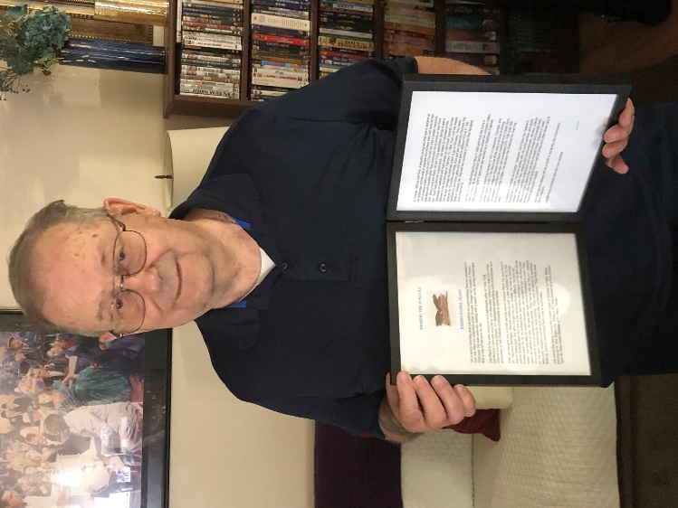

Pictured above is Joe Plant with a personalized and framed copy of “Sharing the Foxhole” an article written about him. You can read his story in our last VVA 1106 Newsletter.

**A Medical Dilemma**.

Submitted by Lou Zoghby – WWII Vet

Medical experts were asked if it is time to ease the lockdown. Allergists were in favor of scratching it, but Dermatologists advised not to make any rash moves. Gastroenterologists had sort of a gut feeling about it, but Neurologists thought the government had a lot of nerve. Obstetricians felt certain everyone was laboring under a misconception, while Ophthalmologists considered the idea short-sighted. Many Pathologists yelled, "Over my dead body!" while Pediatricians said, "Oh, grow up!" Psychiatrists thought the whole idea was madness, while Radiologists could see right through it. Surgeons decided to wash their hands of the whole thing and pharmacists claimed it would be a bitter pill to swallow. Plastic Surgeons opined that this proposal would "put a whole new face on the matter." Podiatrists thought it was a step forward, but Urologists were pissed off at the whole idea. Anesthesiologists thought the whole idea was a gas, and those lofty Cardiologists didn’t have the heart to say, “No”. In the end, the Proctologists won out, leaving the entire decision up to the assholes.

***Light Side***

**Did I read that sign correctly?**

TOILET OUT OF ORDER. PLEASE USE FLOOR BELOW

In a Laundromat:

AUTOMATIC WASHING MACHINES: PLEASE REMOVE ALL YOUR CLOTHES WHEN THE LIGHT GOES OUT

In a London department store:

BARGAIN BASEMENT UPSTAIRS

In an office:

WOULD THE PERSON WHO TOOK THE STEP LADDER YESTERDAY PLEASE BRING IT BACK OR FURTHER STEPS WILL BE TAKEN

In an office:

AFTER TEA BREAK STAFF SHOULD EMPTY THE TEAPOT AND STAND UPSIDE DOWN ON THE DRAINING BOARD

Outside a secondhand shop:

WE EXCHANGE ANYTHING - BICYCLES, WASHING MACHINES, ETC. WHY NOT BRING YOUR WIFE ALONG AND GET A WONDERFUL BARGAIN?

Notice in health food shop window:

CLOSED DUE TO ILLNESS

Spotted in a safari park:(I sure hope so)

ELEPHANTS PLEASE STAY IN YOUR CAR

Seen during a conference:

FOR ANYONE WHO HAS CHILDREN AND DOESN'T KNOW IT, THERE IS A DAY CARE ON THE 1ST FLOOR

Notice in a farmer's field:

THE FARMER ALLOWS WALKERS TO CROSS THE FIELD FOR FREE, BUT THE BULL CHARGES.

Message on a leaflet:

IF YOU CANNOT READ, THIS LEAFLET WILL TELL YOU HOW TO GET LESSONS

On a repair shop door:

WE CAN REPAIR ANYTHING. (PLEASE KNOCK HAR

D ON THE DOOR - THE BELL DOESN'T WORK)



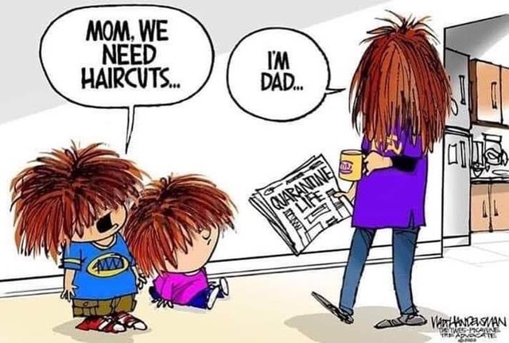

**First Time Sex**

Submitted by John Vargas

A girl asks her boyfriend to come over Friday night to meet and have dinner with her parents. Since this is such a big event, the girl announces to her boyfriend that after dinner, she would like to go out and make love for the first time.

The boy is ecstatic, but he has never had sex before, so he takes a trip to the pharmacist to get some condoms. He tells the pharmacist it's his first time and the pharmacist helps the boy for about an hour. He tells the boy everything there is to know about condoms and sex

At the register, the pharmacist asks the boy how many condoms he'd like to buy, a 3-pack, 10-pack, or family Pack. The boy insists on the family pack because he thinks he will be rather busy, it being his first time and all.

That night, the boy shows up at the girl's parents house and meets his girlfriend at the door. "Oh, I'm so excited for you to meet my parents, come on in!"

The boy goes inside and is taken to the dinner table where the girl's parents are seated. The boy quickly offers to say grace and bows his head. A minute passes, and the boy is still deep in prayer, with his head down. 10 minutes pass, and still no movement from the boy. Finally, after 20 minutes with his head down, the girl friend leans over and whispers to the boyfriend, "I had no Idea you were this religious."

The boy turns, and whispers back, "I had no idea your father was THE pharmacist."



**Am I Getting To THAT Age???**

Submitted by Lou Zoghby WWII Veteran

I found this timely, because today I was in a shoe store that sells only shoes, nothing else. A young girl with a tattoo and green hair walked over to me and asked, "What brings you in today? I looked at her and said, "I'm interested in buying a refrigerator." She didn't quite know how to respond, had that deer in the headlights look.

I was thinking about old age and decided that old age is when you still have something on the ball, but you are just too tired to bounce it.

When people see a cat's litter box they always say, “Oh, have you got a cat?" I just say, "No, it's for company!"

Employment application blanks always ask who is to be called in case of an emergency. I think you should write, "An ambulance."

The older you get the tougher it is to lose weight because by then your body and your fat have gotten to be really good friends.

The easiest way to find something lost around the house is to buy a replacement.

Have you ever noticed: The Roman Numerals for forty (40) are XL.

The sole purpose of a child's middle name is so he knows when he's really in trouble.

Did you ever notice that when you put the 2 words "The" and "IRS" together it spells "Theirs?"

Aging: Eventually you will reach a point when you stop lying about your age and start bragging about it.

Some people try to turn back their "odometers." Not me. I want people to know why I look this way. I've traveled a long way and a lot of the roads were not paved.

You know you are getting old when everything either dries up, sags or leaks.

Ah! Being young is beautiful but being old is comfortable.

Lord, keep your arm around my shoulder and your hand over my mouth.

May you always have:

Love to share,

Cash to spare,

Tires with air,

And friends who care

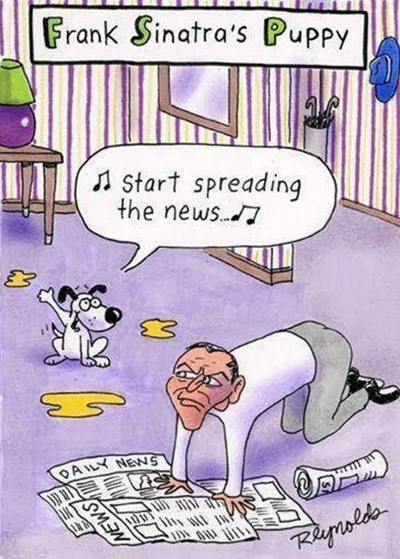

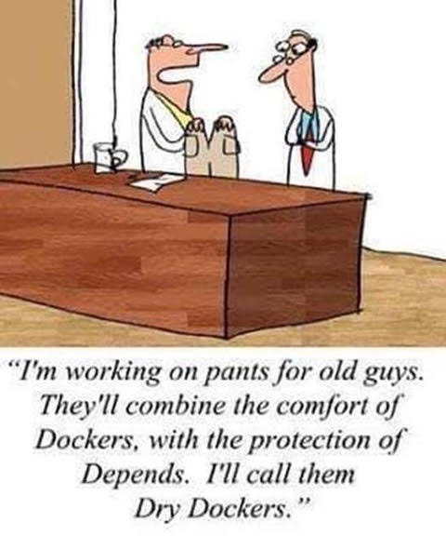

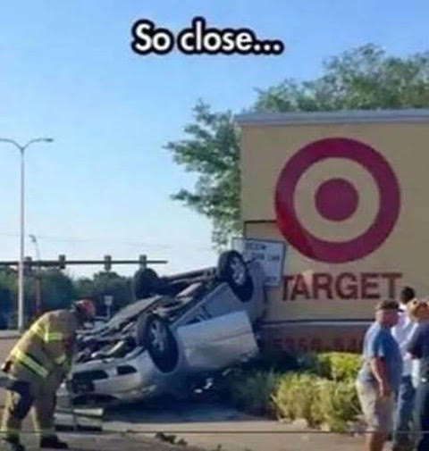

**Technology**

***Trivia Answer***

**APC**: Armored Personnel Carrier

**Upcoming Events of Interest**

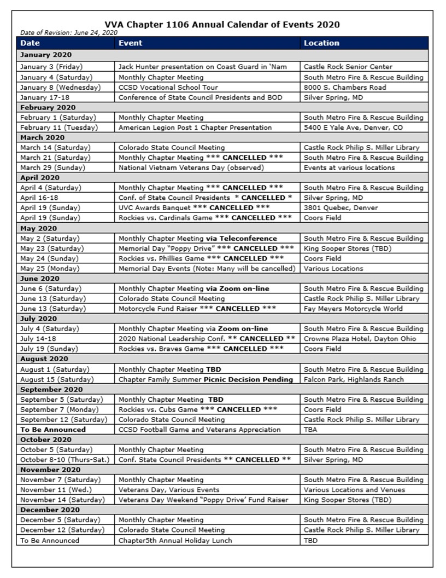

**FRIENDS OF CHAPTER 1106**

|  |  |
| --- | --- |
| **South Metro Denver Fire & Rescue**  9195 E Mineral Ave  Centennial, CO 80112 | **American Legion Post 1260**  **E:\Documents\ALP1187\images\AmericanLegion_logo.jpg** |
| **Spradlin Printing, Inc.**  11903 S. Parker Road Parker, CO 80134 |  |
| American Family Insurance  3989 E. Arapahoe Road #20  Centennial, CO 80122  720-361-0155 | A FULL-SIZE REPLICA OF THE HONOR BELL  **The Honor Bell Foundation**  PO Box 1432  Englewood CO 80150  720.282.9182  [www.honorbell.org](http://www.honorbell.org/) |
| 9137 E Mineral Cir Ste 100  Englewood, CO 80112-3422 | Logo of The Home Depot  **Home Depot Foundation**  8477 S Yosemite St  Lone Tree, CO 80124 |
| King Soopers logo.svg  King Soopers  9551 S. University Blvd., Highlands Ranch, CO 80126 | http://www.cruisin1430.com/sites/g/files/giy711/f/KEZW_Header_Large_Logo_0.png  **STUDIO 1430 Main Office:** 4700 South Syracuse Street, Suite 1050 Denver, CO 80237 |
| https://scontent.fapa1-2.fna.fbcdn.net/v/t31.0-8/10575197_682186265194110_4051472928662048560_o.jpg?oh=2630b186dcf3a20f1d7fc8fa25e0a5ba&oe=5A17C4AB  **Military Order of Purple Heart**, Chapter 1041, Arvada, CO | ZILLOW GROUP  10771 E. Easter Ave  Centennial CO 80112 |
| American Home Agents  Brian Karsh, Broker Associate  720-327-1562 | PARKER MEDICAL  SUPPLY STORE  9845 S Parker Rd  . Parker, CO 80134  303-840-4444 |