**Inside this issue:**

Notes from the President

[Member Feature](#Memberfeature)

[Military Trivia](#Militarytrivia)

[Guest Speaker](#Guestspeaker)

[Membership](#Membership)

[Board of Directors/Officers](#Boardofdirectors)

[Working Committees](#Workingcommittees)

[Meetings/Events Calendar](#Meetingsevents)

[Announcement Corner](#Announcementcorner)

[Books/Articles Published by Mbrs.](#Booksarticles)

[From the Editor](#Fromtheeditor)

[Light Side](#Lightside)

[Trivia Answer](#Triviaanswer)

***Editor’s Note:***

**Notice:**

If you have moved or changed your address, PLEASE notify us immediately! Contact: Dave Lyons, Membership Chair

E-mail: [Snoyldavid@centurylink.net](mailto:Snoyldavid@centurylink.net)

Phone:  303 690 8776

###### COPYRIGHT NOTICE: In accordance with Title 17 U.S.C. Section 107, any copyrighted material in this newsletter is distributed under fair use without profit or payment to those who have expressed a prior interest in receiving the included information for nonprofit use and educational purposes only.

******This version of the newsletter is in Microsoft Document (.DOCX) format so that the links will work. Put your cursor over the link, depress your Control Key (ctrl) and depress your left mouse button and it will take you to the listed link position. PDF format, the links will not work.

The comments and editorial input does not necessarily reflect the opinion of the membership of our chapter. I would appreciate any feedback that you might have, items you liked or if you find offensive or derogatory in anyway. ([bobrotruck73@gmail.com](mailto:bobrotruck73@gmail.com)) Thank you for allowing me to be your editor.

***Notes from the President***

Lee White

Veterans Day is rapidly approaching, Monday, November 11th. It seems the correct time to remember the ‘Little Red Flower” the Buddy Poppy.

It all began in war devastated France in world War I. The red poppy growing in Flanders Fields memorialized the deaths of American and Allied soldiers. Anna E. Guerin, founder of the American and French Children’s League spoke at servicemen’s organizations and always requested the same thing: Please wear a silk red poppy flower to honor the fallen.

In April 1919, the “Poppy Lady” as she was known, arrived in the United States. She turned to the VFW, after American Legion declined, in May 1922, and they conducted the first nationwide distribution of the poppies. The need for more poppies to distribute in 1923 started a business in which disabled and needy American veterans made and assembled the poppies in Pittsburgh, Pennsylvania. In remembrance of their “buddies” who never came back from the “Great War”, hence the “Buddy Poppy”.

****

**In Flanders Fields**

BY JOHN MCCRAE

In Flanders fields the poppies blow

Between the crosses, row on row,

That mark our place; and in the sky

The larks, still bravely singing, fly

Scarce heard amid the guns below.

We are the Dead. Short days ago

We lived, felt dawn, saw sunset glow,

Loved and were loved, and now we lie,

In Flanders fields.

Take up our quarrel with the foe:

To you from failing hands we throw

The torch; be yours to hold it high.

If ye break faith with us who die

We shall not sleep, though poppies grow

In Flanders fields.

***“Member Feature”***

Warren Harrison, 1st Lieutenant, U.S. Army. I served two years active duty 1969-1970 and three years in the reserves 1979-1973. I was awarded the Bronze Star, National Defense Service Medal, Vietnam Service Medal with two bronze stars, Vietnam Campaign Medal, and 1 O/S Var. I served in Phuoc Long Province, Song Be village (the Province Headquarters), attached to MACV Team 67 March-August 1969, 2nd Civil Affairs Company at 2 Field Forces at Plantation, Bien Hoa, traveled to support Civil Affairs Platoons in all of 3 and 4 Corps. August 69- Jan 70.

MOS: 1331 Combat Engineer: at Belvoir, VA 5 was added 51331 The 5 denotes Atomic Demolition Munitions (ADM).

Served 2 years in Reserves as a Heavy Equipment Platoon Leader at Engineer Company stationed at Rocky Mountain Arsenal. I sponsored a Vietnamese family when I lived in a small town in the Appalachians of Virginia. My most memorable experience was getting a brass bell for a refugee Christian village. I am glad I have made many connections as part of our VVA Chapter.

***Military Trivia***

**BCGs?**

[Click here for end of the Newsletter Trivia Answer](#Triviaanswer)

***Speaker – September***

John “Lambo” Lamb, Colorado Tuskegee Airman

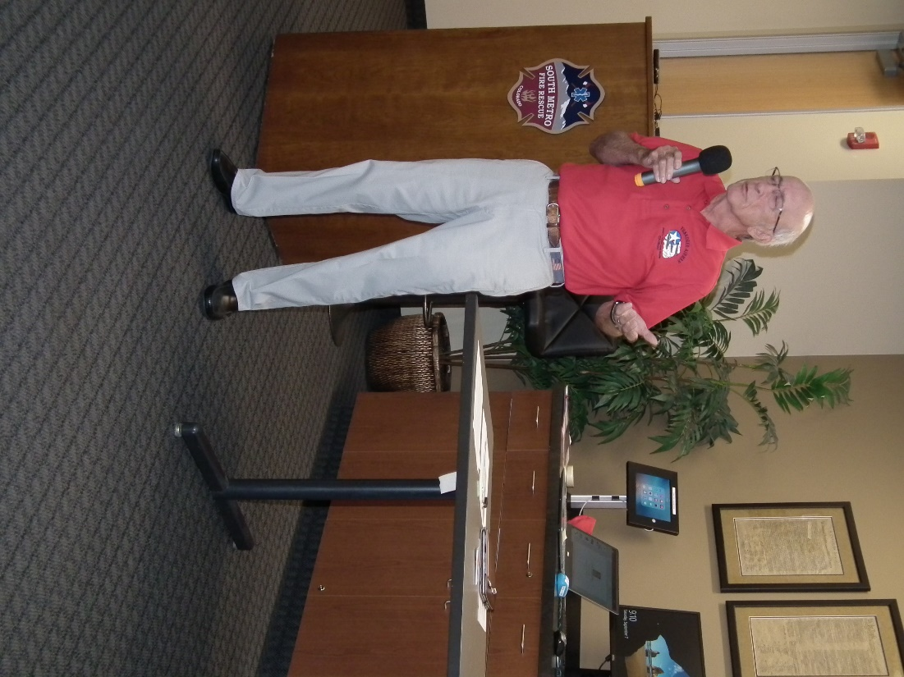

***Speaker – October***

Tom Werzyn introduced our guest speaker, Lindsey Fair of Rock the Reformer by Potomac Pilates.

RTR Pilates, a boutique reformer Pilate’s studio located in the Highlands Ranch Village Center, is the destination for fun group fitness and reformer Pilates classes. RTR Pilates classes feature dynamic yet safe reformer Pilates workouts that challenge both mind and body. The RTR Pilates method is a contemporary approach to Pilates and

provides engaging reformer Pilates exercises that can strengthen the body, help to alleviate back pain and joint pain, and increase flexibility.

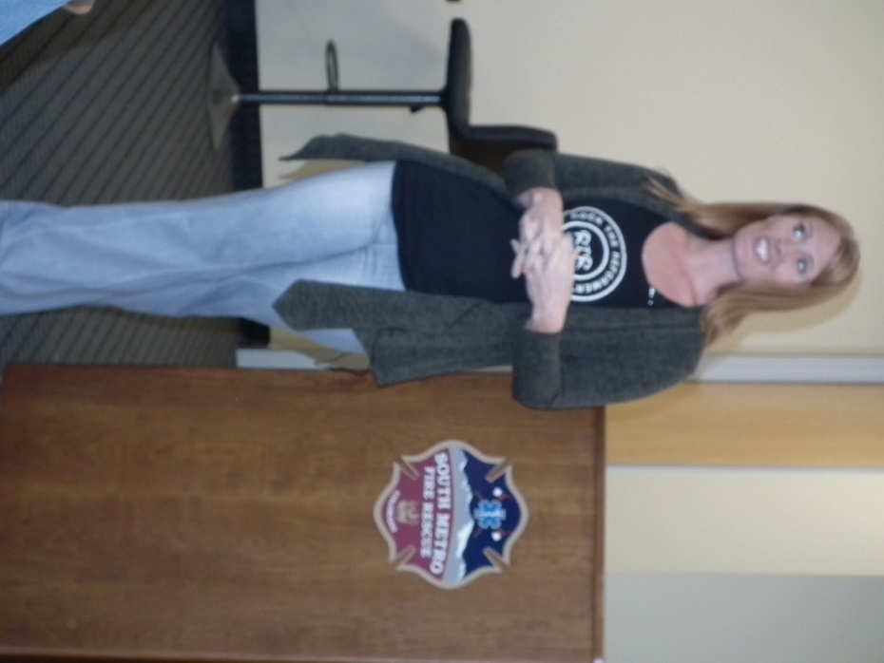

Lindsey Fair

Located in the Highlands Ranch Village Center at 9567 S University Blvd, Highlands Ranch, CO 80126 near S. Highlands Ranch Parkway and E. University Boulevard. Situated between the Verizon store and Parry's Pizza. Ample parking is available in the parking lot directly in front of the Pilates studio. This is the most convenient Pilates studio to Highlands Ranch, Lone Tree, Denver, Castle Pines, Castle Rock, Centennial, Greenwood Village, Aurora & The Denver Tech Center.

***Membership!*** (As of 10-12-19)

VVA 139

AVVA 33

Total: 172

Welcome New Members:

**VVA**

Alexander Brown

Bernard Busby

**AVVA**

Christiane Omoto

Gwendolyn Wilson

***Board of Directors/Officers***

Lee White - President

Dave Lyons - Vice-president

Joe Plant – Treasurer (need volunteer replacement)

Glen Payne - Secretary

Board Members - Milt Omoto, Patti Ehline, Dave Lyons, Tom Werzyn, Ron Smith, John Vargas, Dan Green

***Special Chapter Positions***

AVVA Liason to chapter Board of Directors - Litta Plant-Schaper

Chaplain – Rev. Garry Turks

Government Affairs – Tony Nickerson

Sergeant-at-Arms – Rob Senatore

***Working Committees***

* Agent Orange/PTSD – Patti Ehline
* Color Guard – Tony Nickerson - Command Sergeant, Don McNeely, Dan Green, Clarence Rebolledo, Robert Senatore, Ron Smith
* Event Coordinator – Ron Smith, Lee White, Michelle Mallin
* Fundraising/Grants - Milt Omoto
* Marketing/Media/Events – Tom Werzyn, Michelle Mallin
* Membership – Dave Lyons – Chair, Lee White
* Mental Health: Patti Ehline, Warren Harrison, Joe Plant
* Newsletter Editor - Bob Rotruck
* POW/MIA – **Position Open**
* Scholarship Program - Mike Karsh – Co-Chair, Jim Marcille – Co-Chair, Glen Payne, John Vargas, Brian Karsh (supporter)
* Promotional Items: Leann Stelzer, Clarence Rebolledo
* Refreshments: Alexis Winemiller
* Social –Barry Fiore, Glen Payne, Milt Omoto, Mike Karsh, John Vargas
* Speakers Bureau – Bob Easter, Donna Chaney, Roger Lanphier, Bob Mallin, Tom Werzyn, Glen Payne
* Veteran Emergency Assistance Committee - Joe Plant, Lee White, Dave Lyons, Dan Green
* Voices for Veterans - Warren Harrison
* Webmaster – Bob Rotruck
* Women Veterans - Patti Ehline

**Meetings/Events Calendar - 2019**

Nov. 2, 2019 - VVA Chapter 1106 Monthly Meeting

Nov. 9, 2019 - VVA CHAPTER 1106 - Poppy Drive

Nov.11, 2019 - Veterans Appreciation Day: Ben Franklin Academy

Nov. 28, 2019 - THANKSGIVING

Dec. 7, 2019 - Bi-Monthly Honors - Ft. Logan

Dec. 7, 2019 - Pearl Harbor Day

Dec. 14, 2019 - VVA Chapter 1106 - Annual Holiday Luncheon

**VETERANS DAY – NOVEMBER 11, 2019**



NEVER FORGET!!!



**Fort Logan National Cemetery Director Retired August 30**

UVC Newsletter Editor - Steve Bender

The U.S. Department of Veterans Affairs (VA) announced today that Mat Williams, Director of Fort Logan National Cemetery in Denver, will retire Friday August 30 after more than 32 years of Federal service.

Williams, an Army veteran, started with VA in 1992 at the VA Medical Center in Seattle. He transferred to Tacoma National Cemetery in 1997, initially serving as a Cemetery Caretaker then later as a Cemetery Repre-sentative. In 2009 Williams graduated from VA’s Cemetery Director Intern Program and was assigned to Wood National Cemetery in Milwaukee, Wisc. Williams went on to serve at Fort Bliss National Cemetery in El Paso and Houston National Cemetery before coming to Denver in February 2018 as the director at Fort Logan National Cemetery.

With more than thirty-two years of Federal service, twenty-six of them with the National Cemetery Administration (NCA), Williams has proven himself to be a dedicated employee. His willingness to serve Veterans and their families has been commendable. His constant professionalism and dedication to duty has been a tremendous asset to the Department, the NCA and Fort Logan National Cemetery. Mat Williams’s leaves behind an admirable legacy to be proud of. Kevin Johnson, Assistant Director of Fort Logan National Cemetery, will serve as Acting Director. For more information about Fort Logan National Cemetery please visit <https://www.cem.va.gov/cems/nchp/ftlogan.asp>.

**Cherry Creek School District Again Honoring Veteran and Active Duty Military and Families**

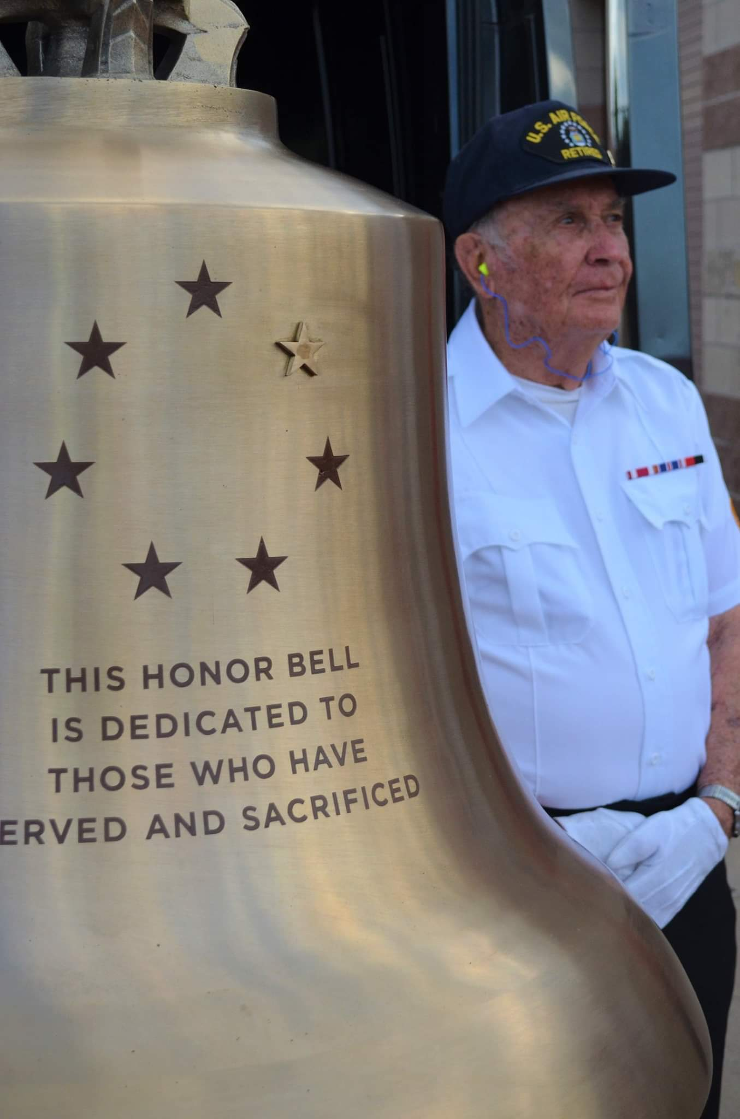

Cliff Butler, soon to be 88 yreas young, tolling The Honor Bell at the annual Cherry Hills District football game.

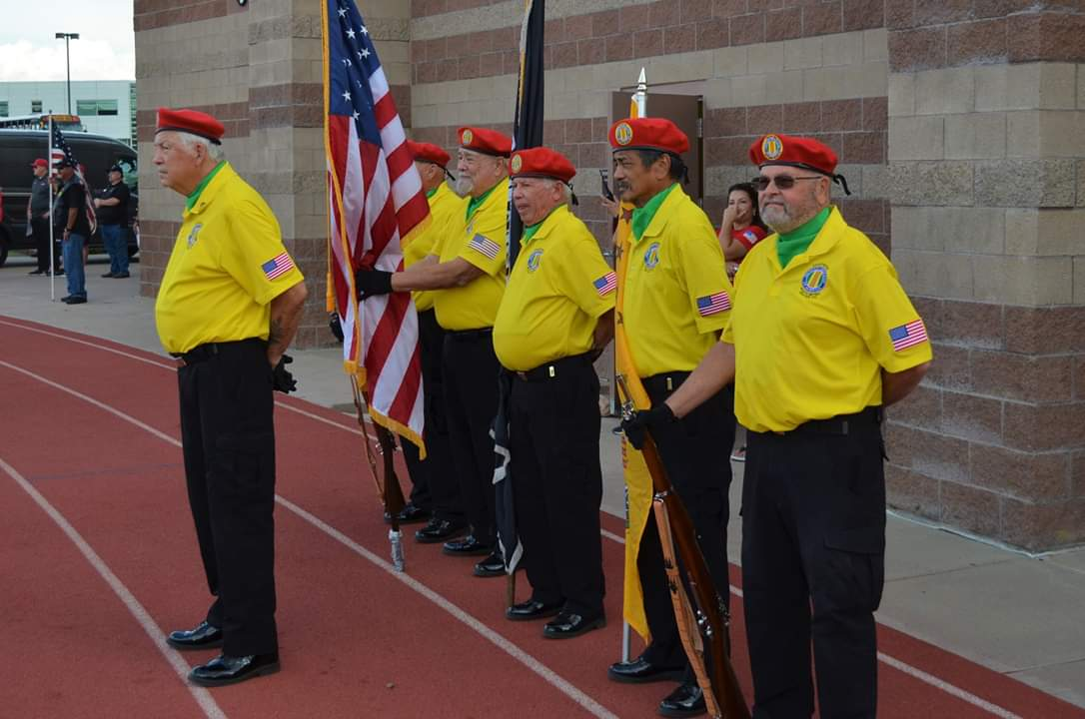

Chapter Honor Guard renders honors before the game.



**Dragon Man's Military Museum**

Mel "Dragon Man" Bernstein is a Vietnam-era vet from Brooklyn. He runs several businesses from his compound: a paintball park, several firing ranges, a go-kart track. He's also a licensed machine gun dealer. We were unaware that we could buy machine guns, but Mel assured us that if our records were clean, we could. He showed us an assault rifle while a monitor displayed his brother roasting a car with a flamethrower. "I'm really living my dream," Mel said.

September 18th, several members from our chapter made a group trek to Colorado Springs to visit the museum. Richard Lewis, Carl Sanchez, Mike Karsh, Gary Steinhoff, Dan Graham, Bruce Arndt, Jim McGrevey, Jim Marcelle, John Vargas, Ron Smith, Tony Nickerson, Joe Plant, and Lee White. Ron Smith stated at the October 4th meeting, “This is the most incredible military museum and display that I have ever visited.”

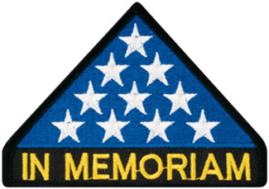

***In Memoriam***

**Maj. Victor Apodaca Jr.**

Submitted by: Kay Howard – Englewood High School Veterans Memorial Advocate

From the Denver Post.

Sunday, September 16, 2001 - AIR FORCE ACADEMY - As thousands waited for their missing loved ones in New York City to come home, the wait ended for two sons whose father disappeared in Vietnam. It took 34 years, but Maj. Victor Apodaca Jr., a 1961 graduate of the Air Force Academy, was finally laid to rest Saturday in Air Force Academy Cemetery.

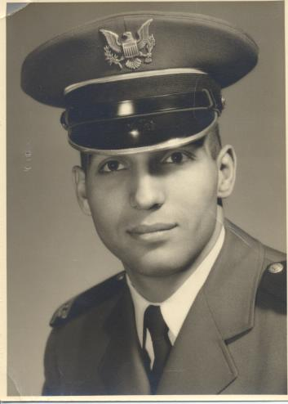

Apodaca was shot down June 8, 1967, while on a reconnaissance mission over North Vietnam.

On Saturday, friends and families and those who didn't even know Apodaca stood in a flag-speckled cemetery to pay tribute. An honor guard gave a 21-gun salute. A bugler played taps. The cadet 10th Squadron - the one Apodaca was in when he graduated - came in dress blues and white gloves.

Apodaca's remains had been kept at the Central Identification Laboratory in Hawaii since 1988, until they were identified in the spring through DNA.

The family planned for the memorial this weekend - the 40th reunion of the Class of 1961.

But getting the remains from Hawaii to Colorado took the brotherhood of the military. On Monday, one of Maj. Apodaca's sons, Robert Apodaca, 36, of Orlando, Fla.,

boarded a commercial flight and began escorting his father's remains back to the Air Force Academy. At 6 a.m. Tuesday, the plane landed in Minneapolis. A couple of hours later,

all flights were grounded because of the terrorist attacks in New York and Washington. "We made it as far as Minneapolis, and all of the flights were shut down,"

said Robert Apodaca, who was stranded with thousands of other American travelers. Robert noticed a Minneapolis Air National Guard Unit nearby so he called the academy for help. He waited for more than a day without any word. Then his phone rang at 3 a.m. Thursday. "They said 'Be on the flight line at 7 a.m. Your dad is going home,'" Apodaca said. "And then, I'm flying up in the air in a C-130 and I'm listening to the pilots," he said. ". . . And as soon as everyone heard on the radio that they were bringing him home, the fighter jets all wanted to stop by and escort. They wanted to honor him." The plane landed Thursday at Peterson Air Force Base with a welcome from an honor guard.

At Saturday's service, a man wearing a Navy uniform came to pay his respects. Dave Niegocki, a Colorado Springs firefighter, never met Apodaca, who was from Sheridan, but he had worn a POW-MIA bracelet engraved with Apodaca's name for 25 years. "Until they got home, I never took it off," said Dave Niegocki of Colorado Springs. Niegocki then gave the bracelet to Victor Apodaca III, one of the major's sons.

"It's just kind of touching. I feel like I gave part of myself because I had it so long," Niegocki said. Victor Apodaca placed the bracelet given to him on the wrist of his

Daughter, Julia Apodaca, 16. After the service ended, the youngest Victor Apodaca, 11, stood next to the Cherrywood casket and lined up seven POW-MIA bracelets in a row that had been given to him that day. "We're going to bury the bracelets with dad," said Robert Apodaca. "I always had one on, and it is in the casket with my father. I feel naked without it."



As of: 10/11/2019

Total Funeral Homes Visited - 2,363

Cremains Found - 19,983

Veterans Cremains Identified - 4,537

Veterans Interred – 4,194

**Uniting for Suicide Postvention**

Last week marked the launch of the website Uniting for Suicide Postvention at:

[https://www.mirecc.va.gov/visn19/postvention/](https://www.mirecc.va.gov/visn19/postvention/%20)



Suicide prevention is a commonly used and understood term. However not everyone recognizes suicide postvention. Suicide postvention builds upon prevention efforts by providing immediate and ongoing support to those impacted by a suicide loss.

Postvention is critical for healing after suicide. Uniting for Suicide Postvention (USPV) provides resources and support for everyone touched by suicide loss. The site has 3 main sections:

Providers: Given their line of work, providers may experience the suicide loss of one of their patients. The Providers’ section provides information about the personal and professional impacts of suicide loss. Visit the Provider section.

Community: It is common to know someone who has died by suicide. The Community section provides more on suicide loss, including ways to find and provide support. Visit the Community section.

Workplace: When suicide loss touches a workplace, it is critical to support employees. The Workplace section is here for you to learn more about how suicide postvention fits into the workplace. Visit for Workplace section.

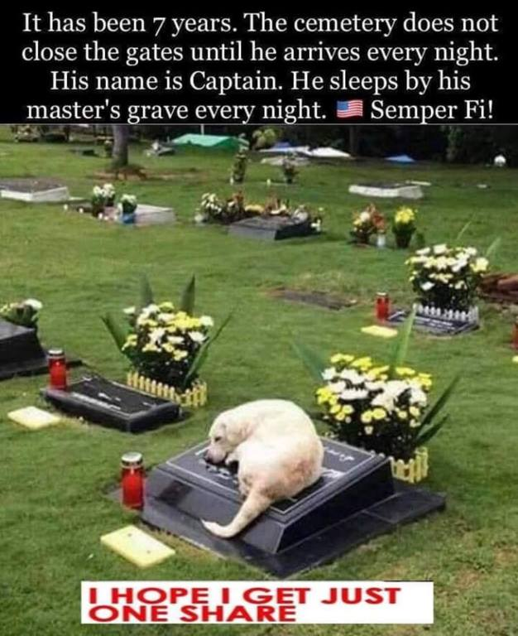

***Announcement Corner***

**CO State Council Award at the National Convention**



Accepting the award: Stan Paprocki, President, VVA Chapter 1071 at the VVA National Convention in July.

**Jim Hemphill – Moving to Texas**

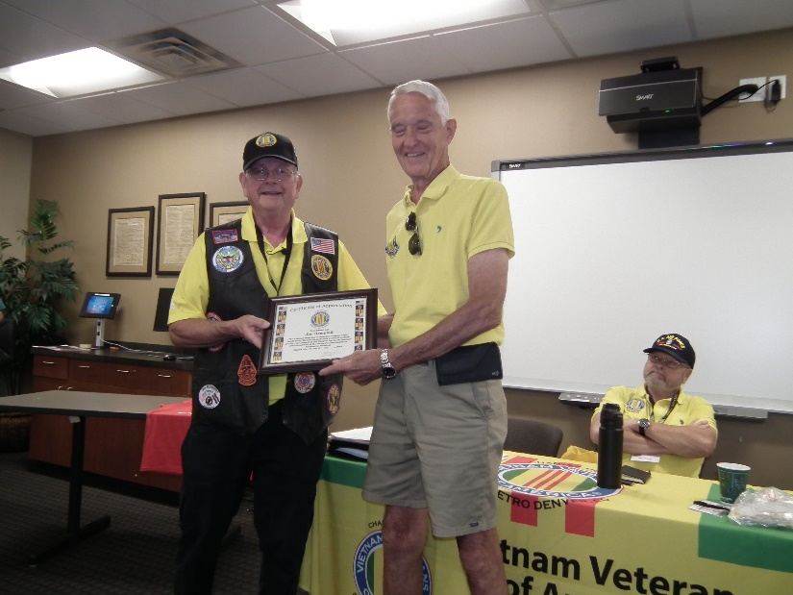

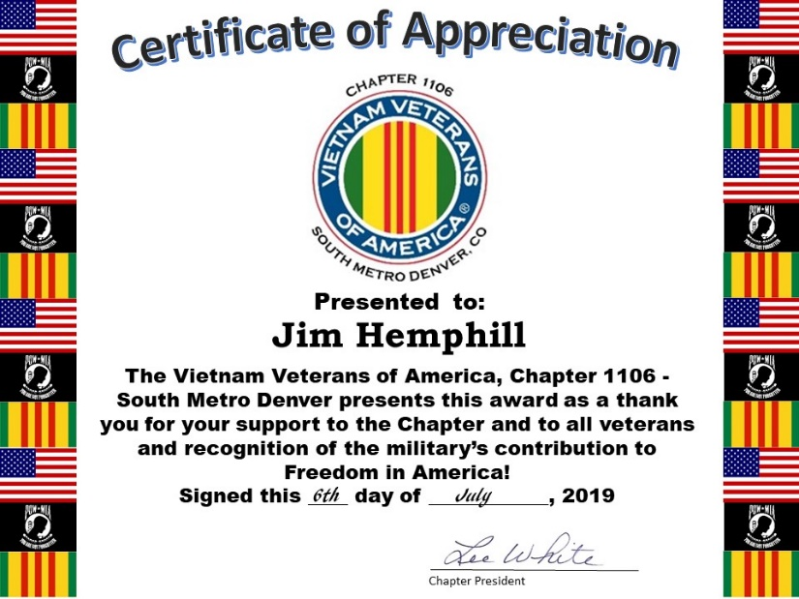

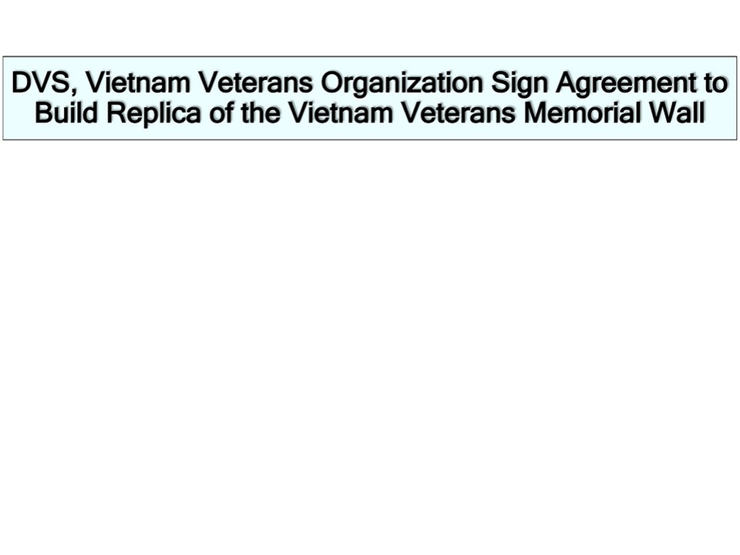

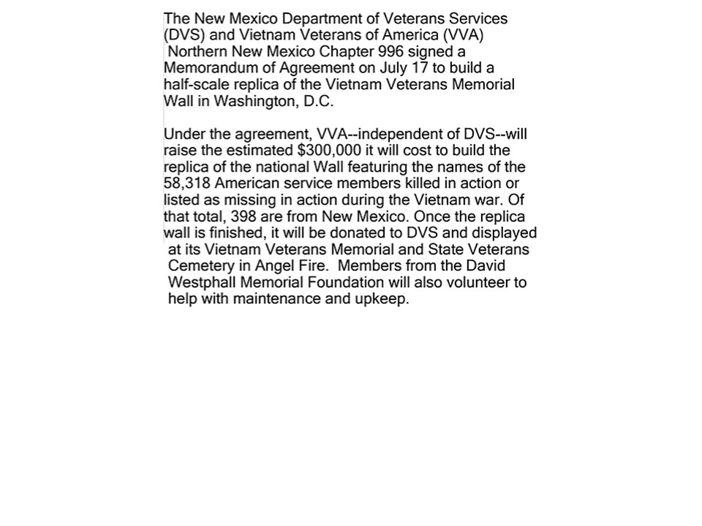

**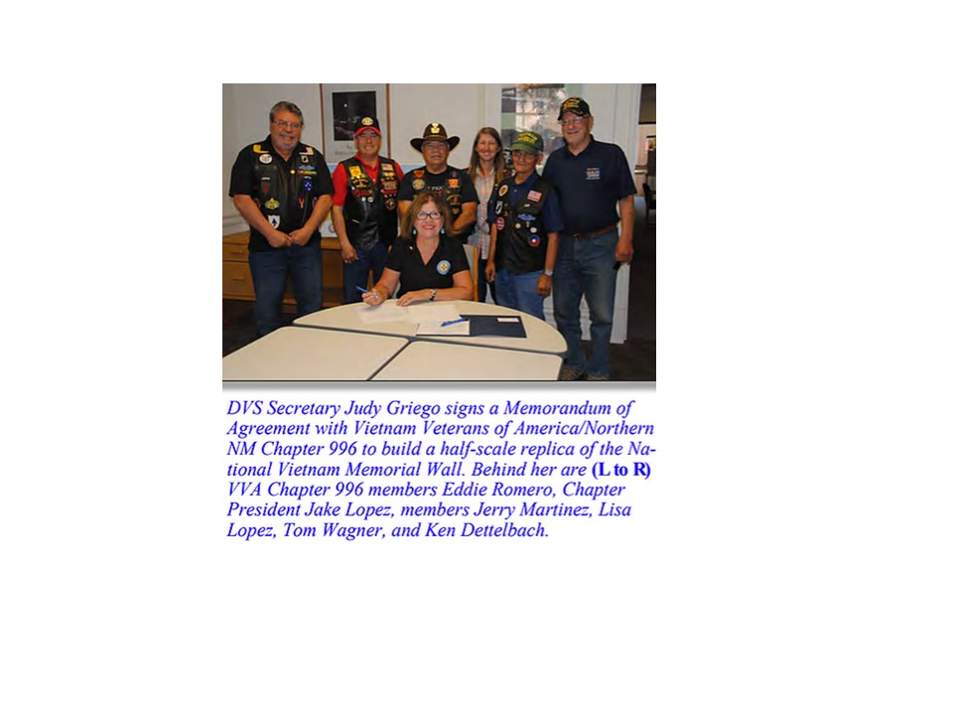**

**To make a donation to VVA Chapter 996**

**VVA Northern New Mexico Chapter 996 is a Congressionally chartered 501(c))19 non-profit corporation. Donations to its fundraising to build the replica Wall can be made by going to the chapter’s website dedicated to the wall effort at** [**www.vietnammemorial.net**](http://www.vietnammemorial.net)**. Donations are tax deductible.**

***Books/Articles Published by Members***

From LTCOL Dave Pruett - USMC

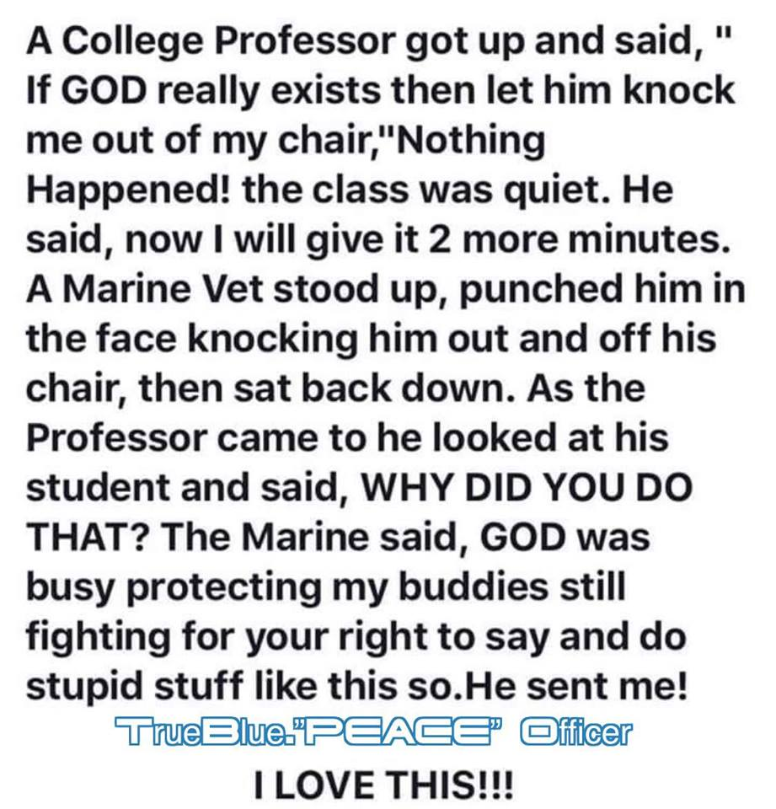

**Who Was Betsy Ross?**

Submitted by: Gary Bentzen

She was a Quaker (she didn't own slaves). She married a man her family disapproved of. So they disowned her.

She learned a trade. Upholstery. She and her husband opened a store. Then war broke out and her husband left to fight for the colonies. He died in battle. She kept the store running by making regimental flags for the war effort. She married again. This time to a man who was fighting the British by sea. He also died. She kept sewing and running the store. Her home was taken over by the British when they occupied Philadelphia. She was a patriot. She lost two husbands to the war and at that time in history, she learned a trade and was able to take care of herself and her children. So that flag represents the birth of our country and in the case of Ross, early feminism!! She's a female icon!! This flag has nothing to do with slavery. Nike made the wrong move. Again! And Kaepernick is still an ignorant a..hole.

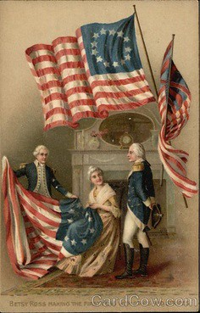

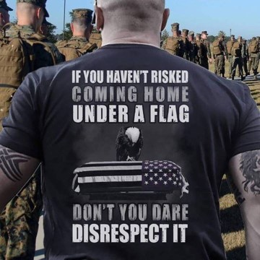

**Four military working dogs given nation's top award for their service!**

Submitted by: Suzanne Sigona

Four military working dogs were honored for their service at American Humane's fourth annual K-9 Medal of Courage awards ceremony in Washington, D.C., on Tuesday.

One of them was Sgt. Yeager, a black lab trained as an improvised explosive detection dog who was on patrol with his handler, Lance Cpl. Abraham Tarwoe, on April 12, 2012, when an IED exploded. Sgt. Yeager survived, but Tarwoe did not.

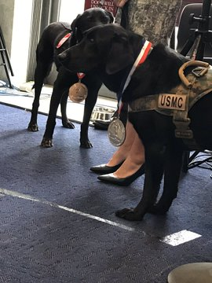

Sgt. Yeager

Sgt. Yeager had been on three combat tours in Iraq and Afghanistan, participating in over 100 patrols, when the attack took away his handler and part of his ear. Suffering from shrapnel wounds, the black lab was brought back to the U.S. to recover and later given a Purple Heart. He was retired from the Marine Corps and adopted by a family in North Carolina.

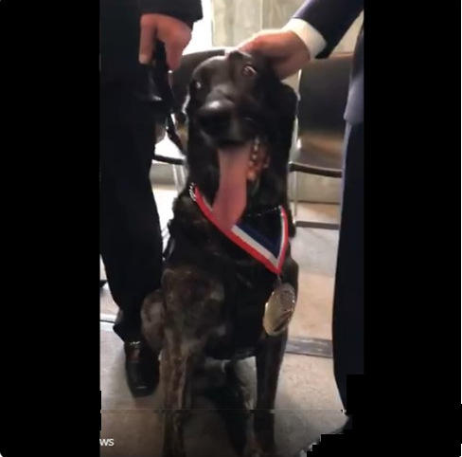

"I think this ceremony allows all Americans a chance to have a glimpse into what these heroes do every day. These heroes as explosive detection dogs, they allow so many mothers and fathers, sons and daughters to return to the front lines because they're able to sniff out enemy weapons and enemy positions," American Humane President and CEO Dr. Robin Ganzert told the Washington Examiner.

Other dogs given the country's top award for military dogs include Troll, a Dutch Shepherd who served in the Air Force with his handler Tech. Sgt. Robert Wilson, who has since adopted him. Troll and Wilson conducted 89 combat missions together. During a four-day battle, Troll discovered three IEDs and a tunnel filled with weapons and explosives.

Niko, another Dutch Shepherd, had deployed to Afghanistan in 2012 and stayed in the country until he retired in 2016. During his time in Afghanistan, Niko went on over 600 missions, sniffing out IEDs while also protecting embassies and U.S. dignitaries.

Black lab Emmie went on three tours to Afghanistan from 2009 to 2012 as an IED detection dog. While she is no longer in the military, she now works to protect the Pentagon by searching cars and conducting random sweeps in the surrounding parking lots with the Pentagon Police.

Even at home, Emmie helps her handler's family. Eric Harris told the Washington Examiner she helps his autistic son calm down when he gets upset.

"She gotta, let's say a gift, that kind of helps smooth things out when [he has] meltdowns and at times when he can get a little heated or things aren't going right for him. She just kind of steps right in, put her head underneath his hand as a way to calm him down," Harris said.

Each of the dog's families are happy to have their dog's service recognized in the nation's capital.

"It's really a powerful message because we do take for granted what these animals do," Caroline Zuendel, Sgt. Yeager's owner, said. "I don't think you could come up with a metric to figure out how many lives they have saved...all of the Marines and sailors lives that he would have saved, but add in to that innocent civilians."

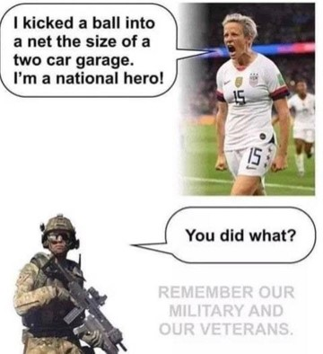

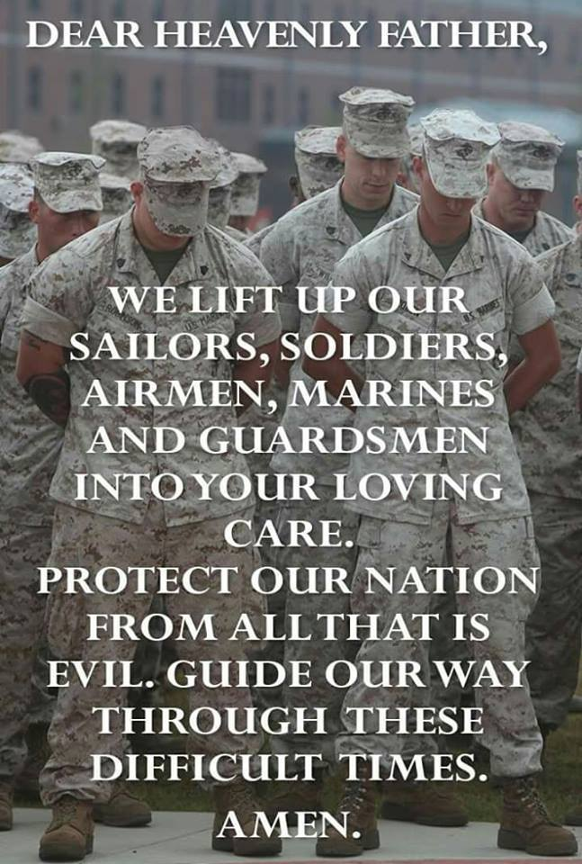

**THE LANDLOCKED SAILOR**

By Bob Rotruck, CWO3, USN (ret)

**Angry Once**

In my twenty year Navy career, there were times when I was upset or disappointed at the outcome of a situation or when a specific condition occurred. However, in all of that time, only once was I angry enough to physically strike another person. I was a Chief Warrant Officer attached to RVAW-120 at Norfolk Naval Air Station, VA. RVAW-120 is the training squadron for pilots and aircrew for the VAW squadrons that go aboard aircraft carriers with the E-2C aircraft which provides the eyes and ears for the carrier task force. I was assigned the position of Aircraft Division Officer. The sailors that worked for me were the Aviation Machinist Mates (turbo prop engine mechanics), Aviation Metalsmiths (maintenance of aircraft structures, hydraulics, and environmental systems), and Parachute Riggers (you can figure that one out for yourself).

I had a young Third Class Machinist Mate (AD3) that was routinely in a small amount of trouble, like always showing up for work five or ten minutes late or taking an extended lunch break. His Chief and I had discussed his performance on several occasions. He was a capable mechanic who did a good job in his specialty. However, his Chief suspected that the young man was developing an alcohol problem and we discussed how we might try to help him.

On one particular morning, the AD3 missed morning muster and didn’t show up for thirty minutes. His Chief in frustration brought him out to my office. There he stood across from my desk looking a little disheveled and a little unsteady. My first question to him was, did he have a drink that morning before coming to work. He stated that he had “one beer” before he left the barracks. I continued to talk to him about his work and the importance he played on the team to keep our airplanes flying safely. About ten minutes into the conversation, I asked him how many “beers” he had before coming to work and he said three or four. He had lied to me! This was one trait that I could not tolerate in any person. You had to know my Dad to appreciate my sensitivity to telling the truth.

I quickly jumped to my feet, jumped up on my desk, and was ready to leap on this man and pound him into the deck. Thankfully, the Chief made a career saving move for me by jumping in between us. He yelled at me, “Mr. Rotruck, you don’t want to do this!” I screamed at that young AD3 to get out of my sight and to get his stuff together. For public readership purposes, I refrain from using the actual language I used during the verbal altercation. The frightened young man instantly disappeared out of my office while the Chief put his strong hands against both of my shoulders. I thanked the Chief for his bravery at preventing my rage from obliterating what had been a great Navy career. But I told the Chief, I can tolerate a lot of things, but I will not tolerate a liar. I asked the Chief if he knew the difference between a thief and a liar. He shrugged and I said, “You can trust a thief!”

Fair winds and smooth seas!

***Light Side***

If anybody finds my joke posts offensive, please do not look at them! The Editor!







**Mom’s in Group Therapy**

Submitted by: John Vargas

A psychiatrist was conducting a group therapy session with four young Mothers and their small children. "You all have obsessions," he observed.

To the first mother, Mary, he said, "You are obsessed with eating. You've even named your daughter Candy."

He turned to the second Mom, Ann: "Your obsession is with money. Again, it manifests itself in your child's name, Penny."

He turned to the third Mom, Joyce: "Your obsession is alcohol. This too shows itself in your child's name, Brandy."

At this point, the fourth mother, Kathy, quietly got up, took her little boy by the hand and whispered, "Come on, Dick, this guy has no idea what he's talking about. Let's go pick up Peter and Willy from school and go get dinner."

**THOUGHTS FOR THE DAY**

Limit all US politicians to two terms:

- One in office

- One in prison.

*Apparently, Illinois already does this, and it seems to be working for them alright.*

Only in America ... do drugstores make the sick walk all the way to the back of the store to get their prescriptions while healthy people can buy cigarettes at the front.

Only in America...do people order double cheeseburgers, large fries, and a diet coke.

Only in America ... do banks leave vault doors open and then chain the pens to the counters.

Only in America ... do we leave cars worth thousands of dollars in the driveway and put our useless junk in the garage.

Only in America ... do we buy hot dogs in packages of ten and buns in packages of eight.

Only in America ... do they have drive-up ATM machines with Braille lettering.

EVER WONDER .... Why the sun lightens our hair, but darkens our skin?

Why can’t women put on mascara with their mouth closed?

Why don't you ever see the headline 'Psychic Wins Lottery'?

Why is 'abbreviated' such a long word?

Why is it that doctors call what they do 'practice'?

Why is lemon juice made with artificial flavor, and dish washing liquid made with real lemons?

Why the man who invests all your money is called a broker?

Why is the time of day with the slowest traffic called rush hour?

Why isn't there mouse-flavored cat food?

Why didn't Noah swat those two mosquitoes?

Why do they sterilize the needle for lethal injections?

You know that indestructible black box that is used on airplanes? Why don't they make the entire plane out of that stuff?

Why don't sheep shrink when it rains?

Why are they called apartments when they are all stuck together?

If con is the opposite of pro... is Congress the opposite of progress?

If flying is so safe, why do they call the airport the terminal?

Now that you've smiled at least once, it's your turn to spread the stupidity.

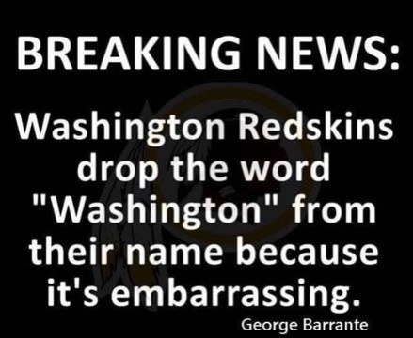



**Georgia Grandma**

Submitted by: LCOL David Pruett, USMC

Lawyers should never ask a Georgia grandma a question if they aren't prepared for the answer.

In a trial, a Southern small-town prosecuting attorney called his first witness, a grandmotherly, elderly woman to the stand. He approached her and asked, 'Mrs. Jones, do you know me?' She responded, 'Why, yes, I do know you, Mr. Williams. I've known you since you were a boy, and frankly, you've been a big disappointment to me. You lie, you cheat on your wife, and you manipulate people and talk about them behind their backs. You think you're a big shot when you haven't the brains to realize you'll never amount to anything more than a two-bit paper pusher. Yes, I know you.'

The lawyer was stunned. Not knowing what else to do, he pointed across the room and asked, 'Mrs. Jones, do you know the defense attorney?'

She again replied, 'Why yes, I do. I've known Mr. Bradley since he was a youngster, too. He's lazy, bigoted, and he has a drinking problem. He can't build a normal relationship with anyone, and his law practice is one of the worst in the entire state. Not to mention he cheated on his wife with three different women. One of them was your wife. Yes, I know him.'

The defense attorney nearly died.

The judge asked both counselors to approach the bench and, in a very quiet voice, said,

'If either of you idiots asks her if she knows me, I'll send you both to the electric chair.’

**Interesting Words**

Our wedding was so beautiful, even the cake was in tiers.

I wouldn't buy anything with Velcro: it's a total rip-off.

What do you call cheese that isn't yours: NACHO CHEESE

Did you hear about the restaurant on the moon? Great food, no atmosphere.

Why did the scarecrow win an award? Because he was outstanding in his field.

Did you hear about the kidnapping at school? Its fine, he woke up.



**A conversation amongst close friends!**

Submitted by John Vargas

SYLVIA: Hi! Wanda.

WANDA: Hi! Sylvia. How'd you die?

SYLVIA: I froze to death.

WANDA: How horrible!

SYLVIA: It wasn't so bad. After I quit shaking from the cold, I began to get warm & sleepy, and finally died a peaceful death. What about you?

WANDA: I died of a massive heart attack. I suspected that my husband was cheating, so I came home early to catch him in the act. But instead, I found him all by himself in the den watching TV.

SYLVIA: So, what happened?

WANDA: I was so sure there was another woman there somewhere that I started running all over the house looking. I ran up into the attic and searched, and down into the basement. Then I went through every closet and checked under all the beds. I kept this up until I had looked everywhere, and finally I became so exhausted that I just keeled over with a heart attack and died.

SYLVIA: Too bad you didn't look in the freezer---we'd both still be alive.



**Why common sense is critical?**

**What could possibly go wrong?**

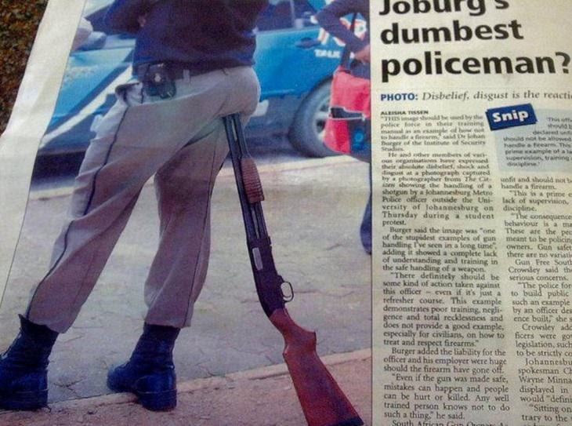

**Timber**



**This man's got his priorities straight**

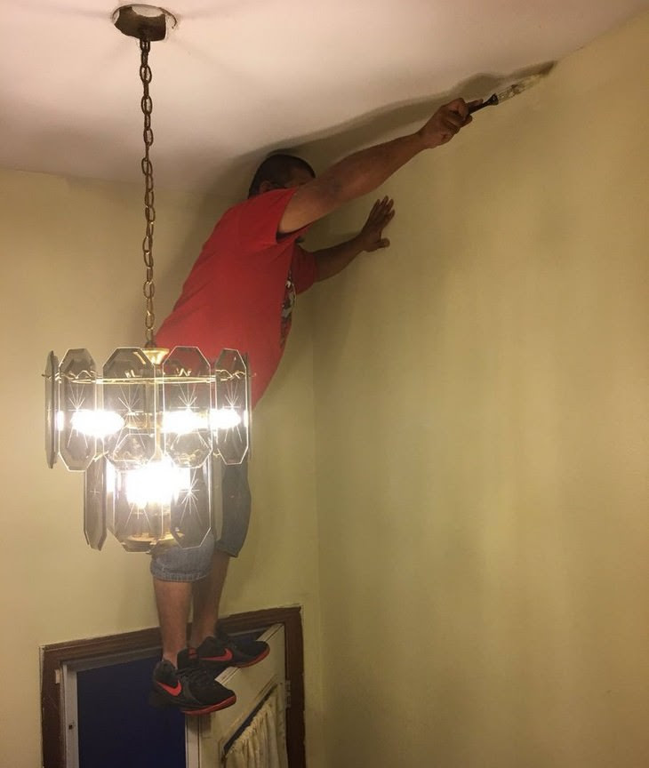

**The Pastor's Ass**

Submitted by: John Vargas



The Pastor entered his donkey in a race and it won!! The Pastor was so pleased with the donkey that he entered it in the next race, and it won that race too.

The local paper read: PASTOR'S ASS OUT FRONT.

The Bishop was so upset with this kind of publicity that he ordered the Pastor not to enter the donkey in another race.

The next day the local paper headline read: “BISHOP SCRATCHES PASTOR'S ASS”.

This was too much for the Bishop, so he ordered the Pastor to get rid of the donkey. The Pastor decided to give it to a Nun in a nearby convent.

The local paper, hearing of the news, posted the following headline the next day: NUN HAS BEST ASS IN TOWN!!

The Bishop fainted…! He informed the Nun that she would have to get rid of the donkey as soon as possible.

So she sold it to a local farmer for $10.

The next day the paper read: “NUN SELLS ASS FOR $10”.

This was too much for the Bishop so he ordered the Nun to buy back the donkey, and take it to the plains where it could run wild.

The next day the headlines read: NUN ANNOUNCES HER ASS IS WILD AND FREE.

The Bishop was buried the next day.

The moral of the story is being concerned about public opinion can bring you much grief and misery, even shorten your life. So be yourself and enjoy life. Stop worrying about everyone else's ass and you'll be a lot happier and live longer!

***Trivia Answer***

**BCGs** - Birth Control Glasses. Military issued eyeglasses, typically first issued in basic training, noted for their unappealing appearance which would prevent attracting members of the opposite sex.

**Upcoming Events of Interest**

|  |  |  |  |
| --- | --- | --- | --- |
| **Event** | **Date** | **Location** | **Detail** |
| Homeless & Veterans Stand Down | 10 OCT | CO Convention Center | This year’s event focuses on all homeless in Denver, not just veterans. Details and opportunities at <https://volunteer.unitedwaydenver.org/event/117636-Project-Homeless-Connect-2019> |
| Aurora Veterans Stand Down | 24 OCT  0800 | Heritage Christian Center, 14401 E Exposition Ave | Limited info available online, for more information contact Vice Chair Watik Aleem at 720.345.2565. |
| Bi-Monthly Honors Ceremony | 12 OCT  1100 | Fort Logan Shelter A | Ceremony for those laid to rest prior 2 months without honors.  0800 Breakfast TBD  1000 Briefing at Visitors Center  1100 Ceremony Shelter A |
| Army/Air Force Football Game | 2 NOV  1330 | USAF Academy |  |
| Honor Bell Foundation Trivia Night FUNraiser | 5 NOV  1745 | 3880 S Lowell Blvd, Denver | Join us for a great night of trivia, food, and prizes. $25 tickets, cash bar. <https://www.honorbell.org/events> |
| Denver Veterans Ball | 8 NOV  1800 | Wellshire Golf Course | Black tie gala, open to all veterans and active duty. <https://www.warriorbonfireprogram.org/denver-veterans-ball.html> |
| VVA 1106 Poppy Drive | 9 NOV  Time TBD | Assorted King Soopers | See Lee White for locations/assignments. |
| Denver Veterans Day Parade and Festival | 9 NOV  1000 | Civic Center Park | <https://www.denverveteransday.com/> |
| Veterans Day Ceremony | 11 NOV  1100 | Fort Logan National Cemetery | Celebrate the lives and service of Colorado’s veterans. |
| Bi-Monthly Honors Ceremony | 7 DEC  1100 | Fort Logan Shelter A | Ceremony for those laid to rest prior 2 months without honors.  0800 Breakfast TBD  1000 Briefing at Visitors Center  1100 Ceremony Shelter A |
| Wreaths Across America | 14 DEC  Time TBD | Fort Logan National Cemetery | Purchase wreaths, support local charities, volunteer to lay wreaths. |

**FRIENDS OF CHAPTER 1106**

|  |  |
| --- | --- |
| **Panera Bread**  9579 S. University Blvd. Highlands Ranch, CO 80126  720-348-1112 | **American Legion Post 1260**  **E:\Documents\ALP1187\images\AmericanLegion_logo.jpg** |
| **Spradlin Printing, Inc.**  11903 S. Parker Road Parker, CO 80134 | **South Metro Denver Fire & Rescue**  9195 E Mineral Ave  Centennial, CO 80112 |
| American Family Insurance  3989 E. Arapahoe Road #20  Centennial, CO 80122  720-361-0155 | A FULL-SIZE REPLICA OF THE HONOR BELL  **The Honor Bell Foundation**  PO Box 1432  Englewood CO 80150  720.282.9182  [www.honorbell.org](http://www.honorbell.org/) |
| 9137 E Mineral Cir Ste 100  Englewood, CO 80112-3422 | Logo of The Home Depot  **Home Depot Foundation**  8477 S Yosemite St  Lone Tree, CO 80124 |
| King Soopers logo.svg  King Soopers  9551 S. University Blvd., Highlands Ranch, CO 80126 | http://www.cruisin1430.com/sites/g/files/giy711/f/KEZW_Header_Large_Logo_0.png  **STUDIO 1430 Main Office:** 4700 South Syracuse Street, Suite 1050 Denver, CO 80237 |
| https://scontent.fapa1-2.fna.fbcdn.net/v/t31.0-8/10575197_682186265194110_4051472928662048560_o.jpg?oh=2630b186dcf3a20f1d7fc8fa25e0a5ba&oe=5A17C4AB  **Military Order of Purple Heart**, Chapter 1041, Arvada, CO | ZILLOW GROUP  10771 E. Easter Ave  Centennial CO 80112 |