Inside this issue:
Notes from the President
Member Feature
Military Trivia
Guest Speaker
Membership
Board of Directors/Officers
Working Committees
Meetings/Events Calendar
Announcement Corner
Books/Articles Published by Mbrs.
From the Editor
Light Side
Trivia Answer
Editor’s Note:
Notice:
If you have moved or changed your address, PLEASE notify us immediately! Contact: Lee White, Membership Chair
E-mail: mailto:flyboy51@q.com
Phone: 303-519-2252

COPYRIGHT NOTICE: In accordance with Title 17 U.S.C. Section 107, any copyrighted material in this newsletter is distributed under fair use without profit or payment to those who have expressed a prior interest in receiving the included information for nonprofit use and educational purposes only.
This version of the newsletter is in Microsoft Document (.docx) format so that the links will work. Put your cursor over the link, depress your Control Key (ctrl) and depress your left mouse button and it will take you to the listed link position. PDF format, the links will not work.

The comments and editorial input does not necessarily reflect the opinion of the membership of our chapter. I would appreciate any feedback that you might have, items you liked or if you find offensive or derogatory in anyway. (bobrotruck73@gmail.com) Thank you for allowing me to be your editor.

Notes from the President
Lee White
VVA Chapter 1106 is in the process of forming our own Color Guard. Tony Nickerson will be our "Command Sergeant" and be responsible for organizing the group. This will be a five member squad. The Color Guard will perform on special occasions as requested and invited into local high schools to support their veteran events and support our Speakers Bureau.

Our Color Guard uniform will consist of: Yellow polo shirts with our logo, POW/MIA and U. S. Flag patches on the sleeves, black cargo pants, web belt, polished buckle, black beret, patent leather black shoes, and green ascot.

HELP!!! We need additional volunteers so we can have a few "alternates" in order to rotate members. At present, we have Tony Nickerson, Dave Lyons, and Ron Smith. Sign-up NOW!!

“Member Feature”
Donna (Pecka) Chaney, Army, E6-SSGT. 1969---1975
Awards/Commendations: Soldier of the Year Award Medal and Pin down @ the Capitol and Routine ones as well for the time period served. I was stationed at Ft. Carson briefly with NORAD, Army Reserves, Fitzsimmons Army Hospital Colorado with the 5502 Hospital Unit and Ft. Campbell, Kentucky with 101st. Airborne. My MOS was 91C Combat Medic with 101st. Medic 5502. My most memorable experiences during my service time was having the Support, Friendship, Trust, Team working together taking care of Viet Nam wounded and everyone having your back. I worked the ER, OR, Surgical/Medical ICU’s, Autopsy’s once a week, Teaching Medics, and giving injections to the 101st and 82nd, that I also gave injections to other active duty service members as well leaving for Viet Nam. We filled in where needed and covered shifts so all good care was given. One work schedule was a 38 hours straight. A lot of coffee, cigarettes, and maybe ate bites of food and inhaled it as we continued to work as we ran around doing our jobs. Chapter 1106 served me well, with the friendship with all of you plus humor and work you do is great. Thank You.

Military Trivia
Do you know the name of this Navy ship?
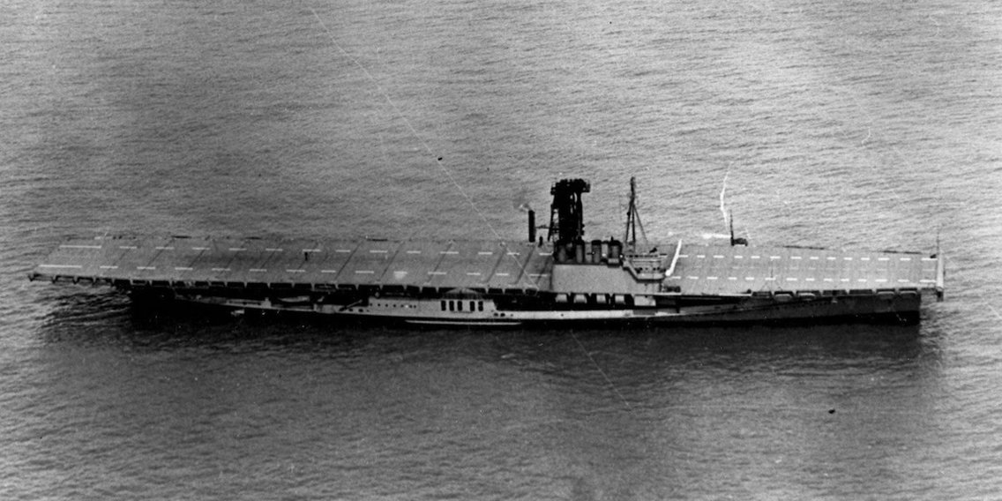
Click here for end of the Newsletter Trivia Answer

Special Guest - July
Lynn Emery, Regent (left) and Carrie Klein, Vice-
Regent from the Daughters of the American Revolution, Piney Creek Chapter that made presentation certificates to many members in appreciation for their service in the Vietnam War.
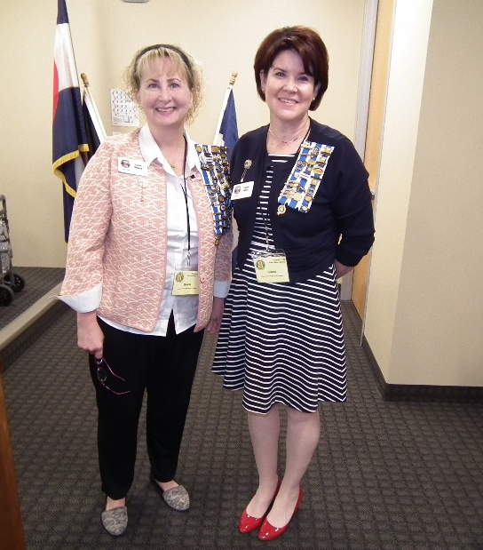
Daughters of the American Revolution, Piney Creek Chapter

Searching for Remains
Sergeant Hahn Le, U.S Air Force was introduced by Tom Werzyn. Ms. Le has been part of a team the past five years to recover remains of US Servicemen. She has personally been on two long Vietnam mountain top trips to locate and dig for US Servicemen remains. In Vietnam, we still have 1,600 men missing.
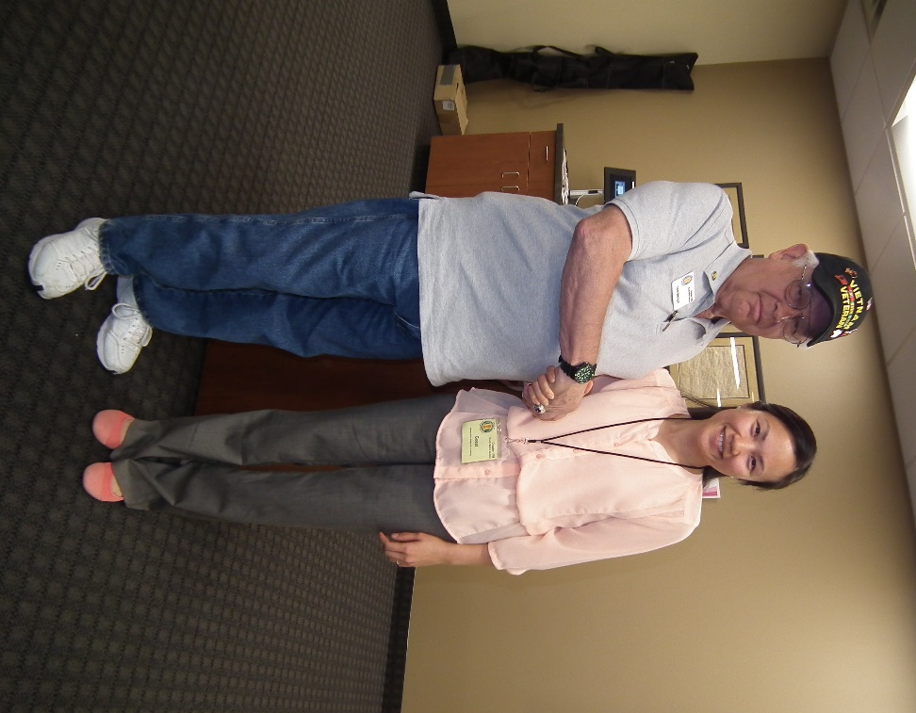
Tom Werzyn and Hahn Le

Special Guest – August
Healing Waters Fly Fishing

Tom Gross is a Vietnam War veteran. He came to Colorado, a landlocked state, in 1992 after completing just over 20 years of active duty in the Navy. After 7 years of sea duty aboard 5 destroyers he longed for high mountain streams and the swish of Nordic skis. He retired as a Supply Corps Lieutenant Commander. Tom and his wife, Linda, celebrated their 45th wedding anniversary in July. He is blessed with 2 children, John and Kate. He also has 2 grandchildren that call him Papi – a 12-year-old granddaughter (Ingrid) and a 2-year-old grandson (Auggie). Tom has been a volunteer for Project Healing Waters Fly Fishing Denver since January 2014.

Project Healing Waters Fly Fishing, Inc. is dedicated to the physical and emotional rehabilitation of disabled active military service personnel and disabled veterans through fly fishing and associated activities including education and outings.
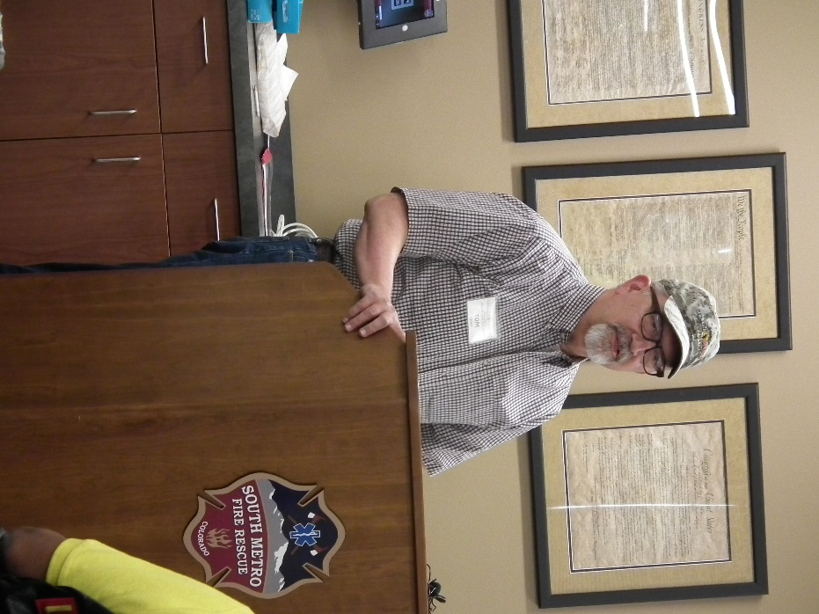
Tom Gross – Project Healing Waters Fly Fishing

Membership!
VVA Chapter 1106 Membership: (8-10-2018)
VVA - 115
AVVA - 25
Total: 140
Welcome New Members:

Welcome new AVVA members:
Michelle Mallin

Board of Directors/Officers
Lee White - President
Bob Easter - Vice-president
Joe Plant - Treasurer
Glen Payne - Secretary
Board Members - Milt Omoto, Patti Ehline, Dave Lyons, Tom Werzyn
John Vargas - Sergeant-at-Arms

Working Committees
Agent Orange/PTSD - Patti Ehline
Color Guard – Tony Nickerson
Membership – Dave Lyons – Chair, Lee White, Tom Werzyn
Mental Health: Patti Ehline, Warren Harrison
Newsletter Editor - Bob Rotruck
Fundraising/Grants - Milt Omoto
Marketing/Media/Events – Tom Werzyn
POW/MIA – Gary Meyers
Webmaster – Robert Senatore, Bob Rotruck
Women Veterans - Patti Ehline
Scholarship Program - Mike Karsh – Co-Chair, Jim Marcille – Co-Chair, John Vargas, Glen Payne, Hazel Simeon, Brian Karsh (supporter)
Veteran Emergency Assistance Committee - Joe Plant, Bob Rotruck, Lee White, Dave Lyons
Speakers Bureau – Bob Easter, Glen Payne, Bob Mallin, Tom Werzyn
Social – John Vargas, Barry Fiore, Glen Payne, Milt Omoto, Hazel Simeon
Government Affairs – Tony Nickerson

Meetings/Events Calendar - 2018
September 1st – Chapter monthly meeting.
September 8th – Colorado State Council – Castle Rock
October 6th – Chapter monthly meeting
October 13, 2018 - VVA Chapter Membership Breakfast - Tentative
October 17-20, 2018 - Conference of State Council Presidents 40th. VVA Anniversary Celebration

2018 Scholarship Winners – Congratulations
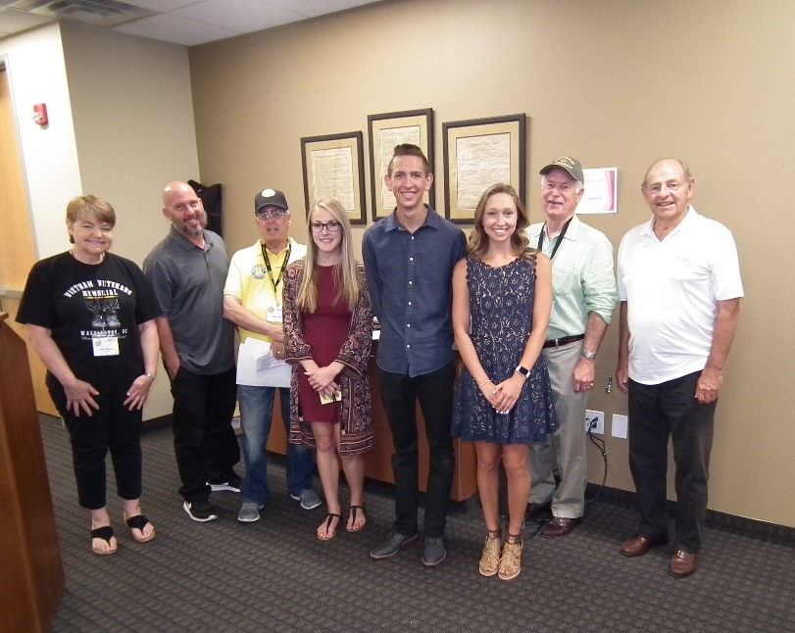
L to R: Winners: Amanda Taylor, David Walker, Clara Krause

Fourth winner, Kathleen Laughton, was out of town and not able to attend. The “senior citizens” behind the students are part of the Scholarship Committee.
Amanda, David, and Clara
(Editor: Based on their essays they read at the meeting, I’m guessing they are going to highly succeed in their education and future!)

Highland Ranch July 4th Parade – Thanks for those that participated!

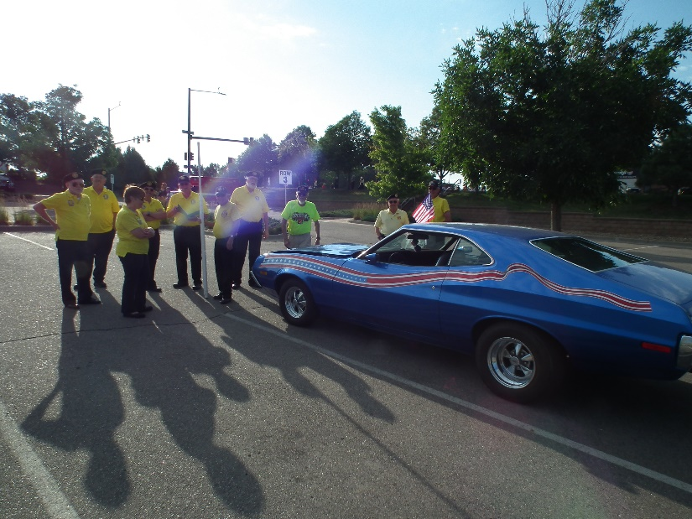
Prepping!

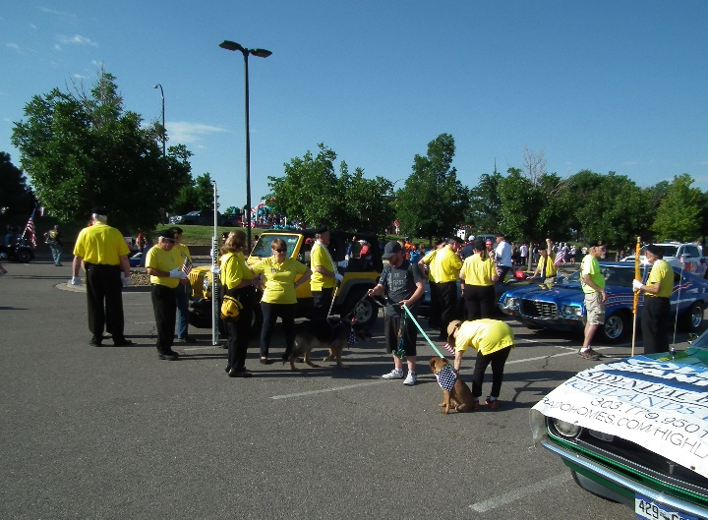
Nice doggy!!!

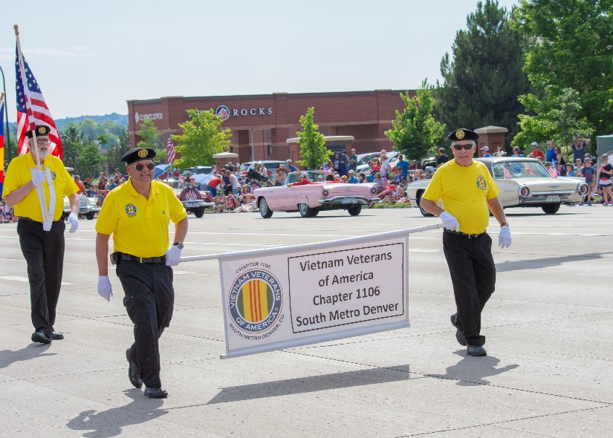
Banner carriers!

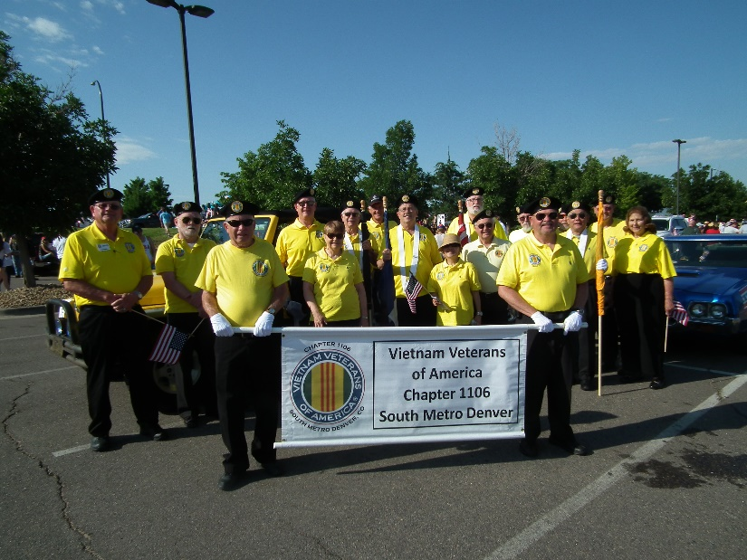
The crew!

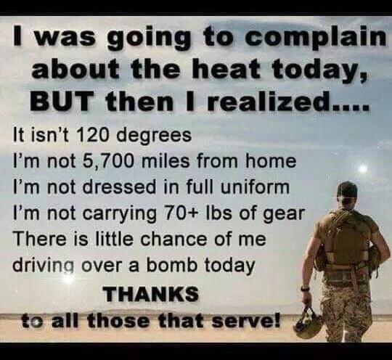

Military Nurses
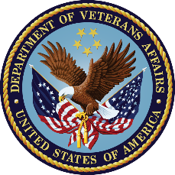
U.S. Department of Veterans Affairs
Were you or a loved one a nurse during the Vietnam War? Today’s #VeteransOfTheDay is dedicated to the women who risked their lives to care for this country’s wounded and dying during the Vietnam War.

Combat nurses usually worked 12-hour shifts, six days a week, in hospitals and field units across Southern Vietnam. When a major battle raged somewhere in Vietnam, and mass casualties were airlifted in, those days could turn into 24 to 36-hour shifts.

Despite encountering more patients who were more severely wounded than previous conflicts, 98 percent of service members who were wounded and made it to a hospital survived.

The Vietnam Women’s Memorial in Washington, D.C., now honors these women, the majority of who were nurses. The 15-foot bronze memorial structure depicts three uniformed women with a wounded service member. It is located on the National Mall, short distance south of the Vietnam Wall.

Thank you for your service and sacrifice.

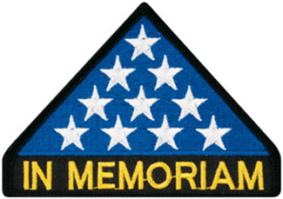

In Memoriam
Louis Olivera - June 20, 1964 ~ July 12, 2018
Born in San Jose, California, Resided in: Wheat Ridge, Colorado.

The Honor Bell Foundation is deeply saddened to share the loss of our Founder, Executive Director, and dear friend, Louis Olivera, who passed away on July 12, 2018. Lou served admirably as a US Army Ranger. He was highly decorated and received two Purple Heart Medals for injuries sustained during a combat mission in Panama.
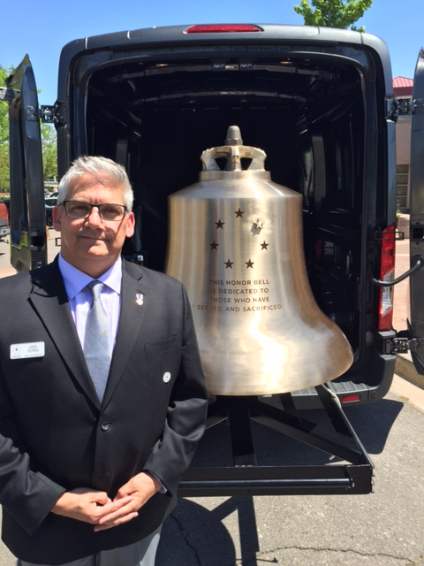
In 2014, Lou had a vision to forge an instrument that would be used to honor veterans at their passing. In June of that year, he created the Honor Bell Foundation. Leading a small but passionate team, he oversaw the creation of the country’s first bell designed specifically for that purpose. The Honor Bell was cast in May of 2016 and dedicated on Memorial Day at Fort Logan National Cemetery. Since that time, Bell Honors have been rendered over 1000 times — the majority by Lou himself.

Lou’s service, kindness, generosity, and passion for supporting veterans touched many people and he will be incredibly missed. He leaves behind a loving wife and daughter, his nine siblings, countless friends, and fellow veterans. The mission of the Honor Bell will continue as his legacy.

2018 Fall Picnic
Thanks to the Social Committee and the volunteer cooks, the picnic was well attended and a great success.
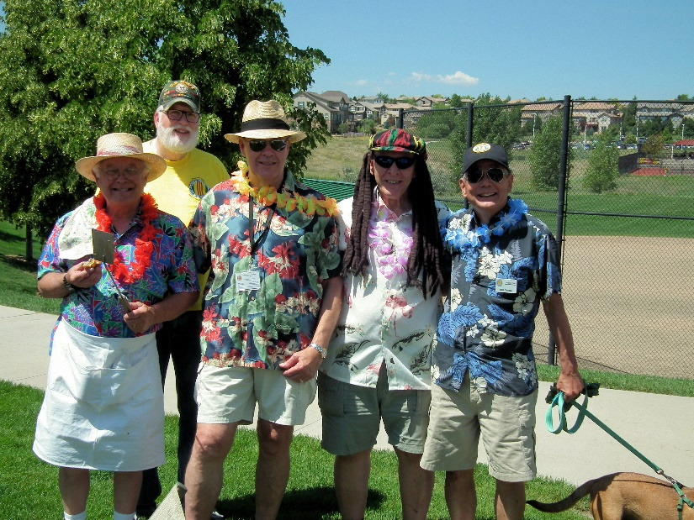
L to R: Tom Werzyn, Dave Lyons, John Vargas, Barry Fiore, Milt Omoto (The dog was just finishing a hotdog!)

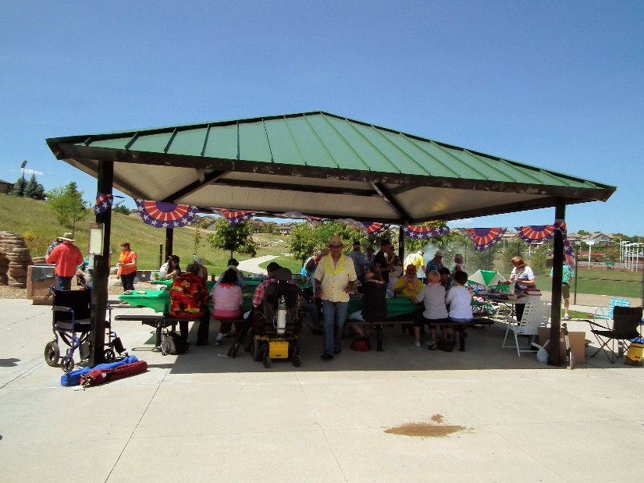
Great venue for the picnic!
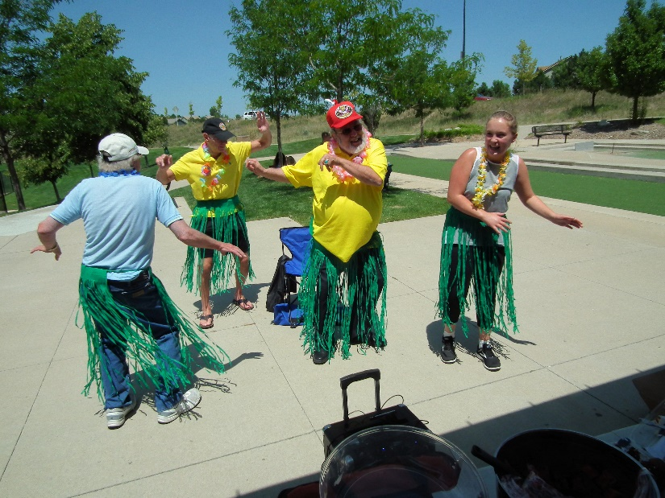
Volunteer hula dancers!
(Editor’s note: The gentleman on the left was later picked by the FBI through a derriere recognition scan!)

Grand Junction and Fruita – Are you READY?
Are you ready for our Chapter 1106 arrival August 17th? Apparently they were because those of us that were able to make the trip had a great time. The first event was Friday night, our invasion of Outback Steakhouse! They were wonderful to arrange tables together for all but one group of five (they came late☺), but they sat at a booth right next to the big group. Saturday morning, 0700, we invaded IHOP and they gave us their enclosed dining area. (Your newsletter editor had the colossal Colorado omelette and ate the whole thing along with a side of hash browns. Several chapter members had to carry him out to his car! Thanks!) At 0900, we were at the Veterans Memorial Cemetery of Western Colorado.
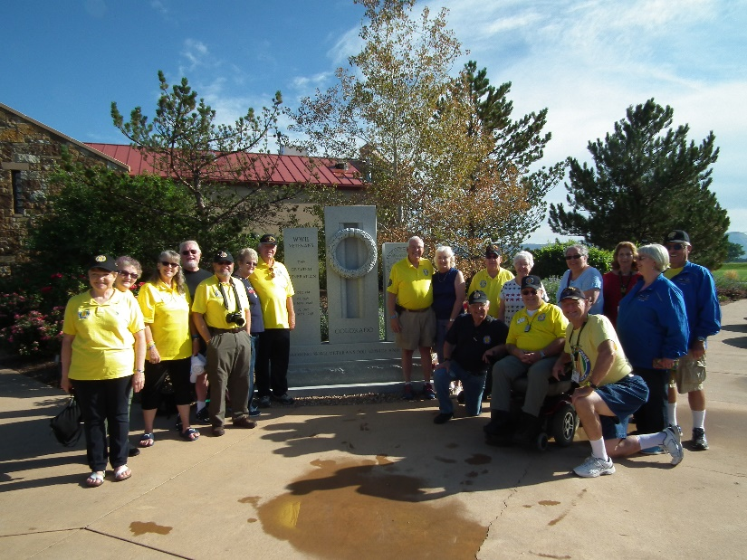
Photo courtesy Bob Rotruck
We had a wonderful tour of that beautiful tribute to our veterans and their families that have gone before us.
Our tour guide, Joanne Iglesias – Director, did a wonderful job of telling us the history and development of the cemetery.
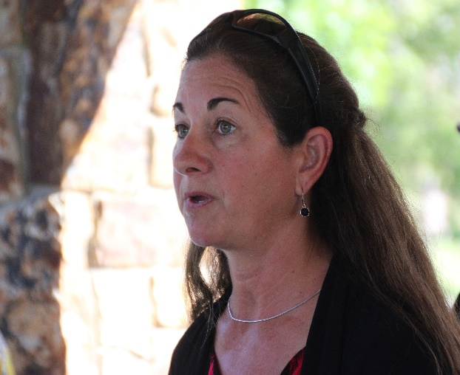
Photo courtesy Bob Rotruck
The Veterans Memorial Cemetery of Western Colorado was authorized by the Colorado Legislature in 1999 to honor Colorado veterans. Construction began in June, 2001 and was completed on September 4, 2002. The Cemetery officially opened on September 5, 2002. A total of three interments occurred on that day with the first being that of Aidan J. Quinn, a World War I veteran who was interred in Columbarium 1.

The Veterans Memorial Cemetery of Western Colorado is located on ~ 22.5 acres at 2830 Riverside Parkway, Grand Junction, Colorado, just east of the Grand Junction Regional Center. It has a capacity of 3,337 units, including 1,758 units for casketed remains and 1,579 units for cremated remains (of which 861 are columbarium wall niches). Additionally, there are 775 memorial garden plots available for veterans whose remains were not recovered or were donated to science or are otherwise unavailable for interment.

The Veterans Memorial Cemetery of Western Colorado is intended to be a dignified final resting place for Colorado.

There are memorial walks on either side of the creek running northeast to southwest through the Cemetery. These walks pass by each of the five columbaria in front of which are benches for visitors.

There are landscaped areas for in-ground interments that are characterized by thoughtful placement of trees, shrubs, and other plantings. These areas provide additional places for individual reflection.
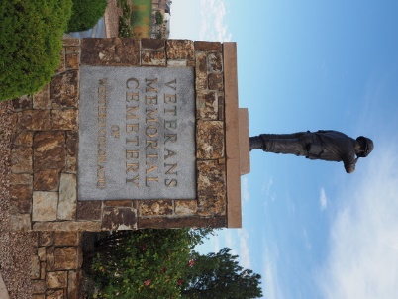
Picture courtesy Ron Smith
The Veterans Memorial Cemetery of Western Colorado conveys the appreciation of the people of Colorado to its veterans for answering the call of duty and faithfully and honorably serving the United States of America and the State of Colorado.
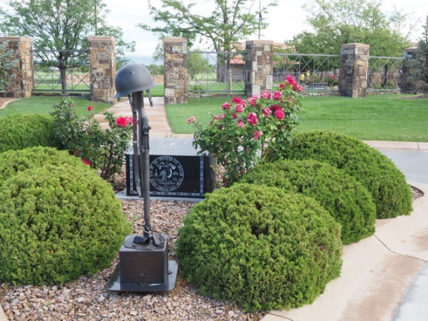
Picture courtesy Ron Smith
Eligibility for burial in the cemetery is the same as for Department of Veterans Affairs (VA) national cemeteries but includes a residency requirement.
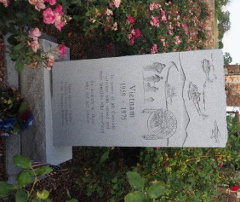
Picture courtesy Ron Smith
Following the cemetery tour, our group went to the Veterans Art Center in Grand Junction. Operation Revamp, Inc. is committed to raising public awareness of the hidden wounds of war and the difficulties facing our returning veterans.
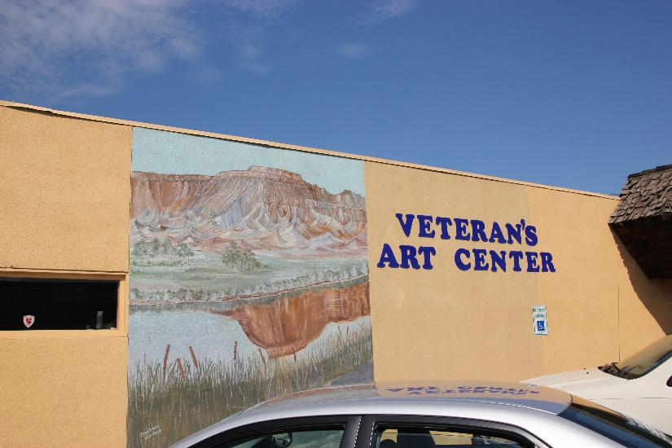
Mission Statement: At Operation Revamp we believe art heals hidden wounds and our mission is to provide art and related opportunity to aid in healing mental health issues for Veterans, military family members and others suffering from trauma related mental injuries in functional creative art studios; to raise awareness of psychological scarring and benefits of artistic practices in healing; and to provide resources for those suffering from the hidden wounds of trauma in partnership with other agencies and non-profits.
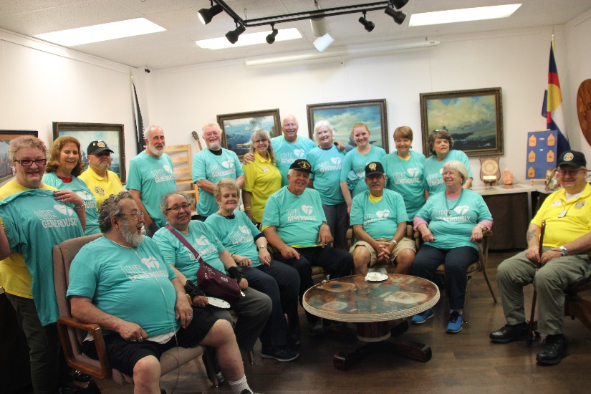
Part of Veteran’s Art Center Display Area
Group photo – Photo courtesy Tom Werzyn
Most of the group slipped on a Thrivent tee because of Thrivent’s financial support to our chapter.

Following this visit, many of our entourage made it to the Palisade Peach festival under the blazing sun. Peach ice cream was wonderful. Sunday morning found our group in Fruita visiting the Western Slope Vietnam War Memorial. Jim Doodey was our tour guide and primary developer of the WSVWM. His brother, Thomas, died in the Vietnam War and Jim wanted to honor his brother in a special way. It was beautiful and tugged at our hearts.
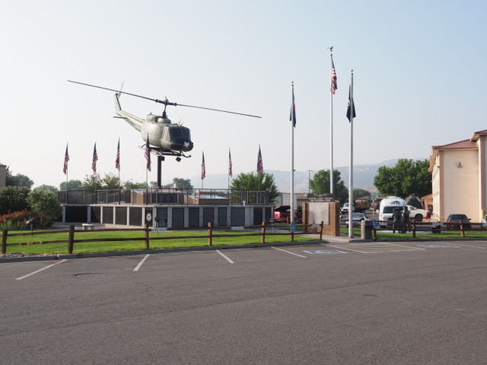
Picture courtesy Ron Smith
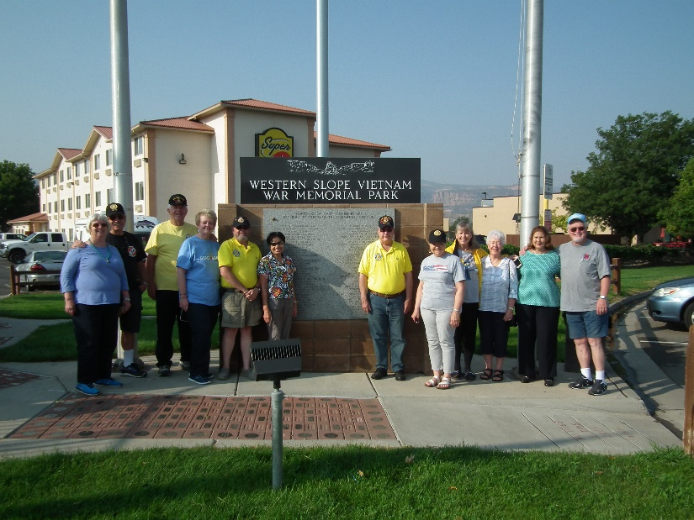
Group photo – Photo courtesy Bob Rotruck

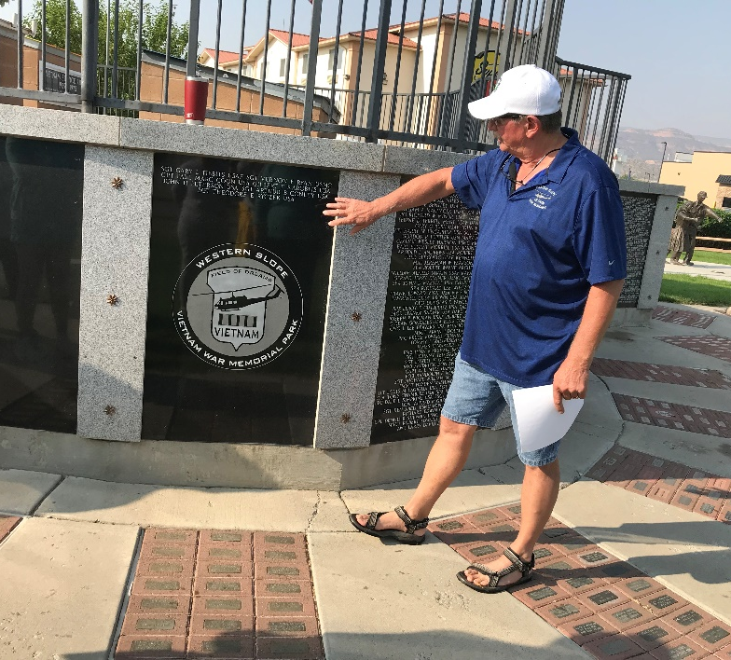
Curator and tour guide – Jim Doodey
Picture courtesy Patti Ehline
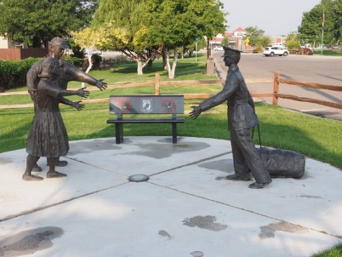
Welcome home sculpture – Picture courtesy Ron Smith

Announcement Corner

Chapter 1106 Receives Membership Growth Award
Chapter 1106 received a Membership Growth Award at the recent VVA Leadership and Education Conference held in Palm Springs California, July 24 to 28, 2018. Chapter President, Lee White, accepted the award on behalf of the Chapter. The Award is presented to Chapters that demonstrate the most growth in membership during a period of time. Chapter 1106 was in the 50 to 100 member category. Thank you to all members for your efforts to recruit new members to our Chapter. BRAVO ZULU
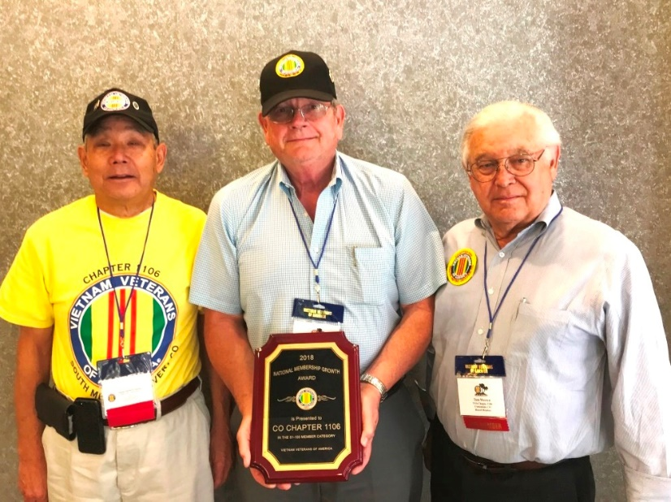
L to R: Milt Omoto, Lee White, Tom Werzyn

Book/Articles Published by Members

SHARING THE FOXHOLE
By John Vargas

“Time for a Coastie” A Man of the Seas.

On one of the hottest days in July, I visited the lovely, cool and comfortable home of Jack and Claudia Hunter in Centennial Colorado. The Hunter’s have lived in this home for over 39 years and celebrated 53 wonderful years of marriage in May! They have a daughter Kim (twin boys), who works for the Jefferson County District Attorney and a son Glen (two girls) a State Trooper in Grand Junction. Jack has three siblings, two brothers, Lynn, Larry and a sister Darene. His brothers reside in Colorado and sister in Utah.

Jack was born on August 26, 1943 in Oklahoma City. His father worked for Douglas Aircraft during WWII. After the war, no requirement for aircraft and living in California they relocated to Beulah, Colorado in 1947. They moved to where the current Pueblo Aircraft Museum/Airport is currently located (then it was the Pueblo Airbase) in 1951. Moving to Littleton Colorado in 1956 when Martin Aircraft (now Lockheed Martin) also moved to Littleton.

He attended Littleton High School and graduated in 1961. He worked at a local gas station during HS and with OK Rubber Welders in Littleton until joining the Coast Guard. Jack is a total “Hands On” a can do anything man! He and a friend joined the Coast Guard mainly due to the influence of the Coast Guard icebreakers featured on television back in the 1950’s. After boot camp, he attended Gunners mate School in Groton, Connecticut in 1963. After GM school he went on board the *USCGC Minnetonka. On December 17, 1967, they sailed and arrived in Vietnam waters on January 25, 1968. This was just a few days before the TET offensive.

Upon his return, Jack spent the next three years in Yorktown, VA as an Instructor. In 1971, as an E-7, he reported to the *USCGC Jarvis in Hawaii, a new cutter, spending 4 years there and left as an E-8. He moved to the Coast Guard District 8 Office in New Orleans. He was the Ordnance and Weapons training officer from Panama City, Florida to Brownsville, Texas.

Advancing to E-9, in 1979, he went to Governor’s Island as the Master Chief at Gunners Mate School. Three classes consistently running and 11 instructors under his watch and command. He retired in 1982. Jack and Claudia returned to the home they purchased in 1979.

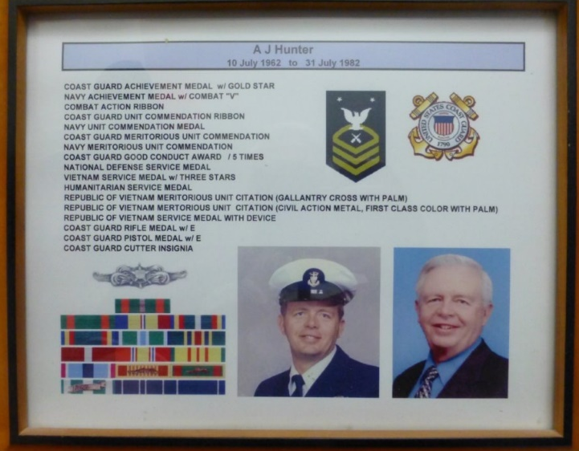

In civilian life, Jack was not your ordinary (20) year mail carrier! Always an innovator and hands on man, he was instrumental in “Setting-Up” the Bar Code that today we see in all our incoming mail.
This extraordinary Coast Guard Vietnam War Veteran, computer wizard, husband, father and grandfather is a proud member and one of the Founding Fathers of our VVA 1106 Chapter. Jack Hunter is a true Coastie, a Nam Vet, and is continued to be held in high esteem by family, friends and fellow Veterans.

*USCGC Minnetonka, named after a lake in Minnesota, is one of twelve, two hundred fifty-five-foot High Endurance Cutters in the Coast Guard. She was built in San Pedro, California and launched in November of 1944. It housed 164-man crew. 16 Commission Officers, 16 Chief Petty Officers and 132 Enlisted men. With 4,000-shaft horsepower, she can cruise 5,300 nautical miles at a maximum speed of 18.4 knots and 13,600 nautical miles at a cruising speed of 11 knots.

*USCGC Jarvis (WHEC-725) was a Hamilton-class cutter of the US Coast Guard. She was launched on 24 April 1971 and commissioned on August 4 1972.

The History of Dog Tags
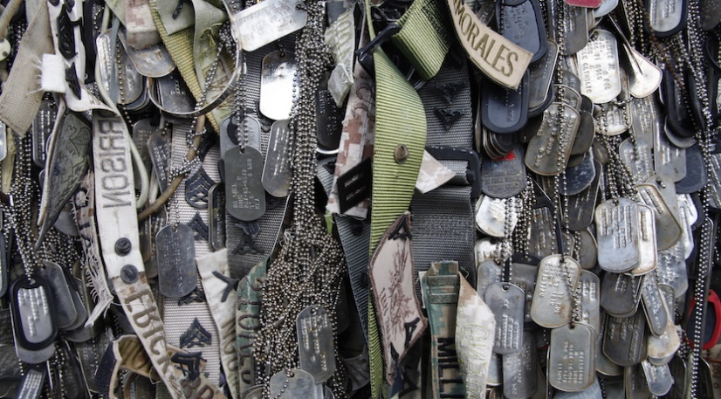
The use of the iconic form of identification has its roots in the Civil War.
During the Civil War, the inability of the military to identify battlefield casualties created the need for a soldier identification method.

According to the U.S. Army Quartermaster Foundation, prior to the Battle of Mine Run in northern Virginia 1863, Gen. George Meade’s troops wrote their names and unit designations on paper tags and pinned them to their clothing. At the same time, other soldiers created prototype identification tags out of pieces of wood, perforating one end so that they could be worn on a string around their necks.

Between 1862 and 1913, while the military considered a number of options for identifying soldier remains on the battlefield, individual soldiers continued to utilize makeshift identification methods. In 1906, a circular aluminum disc was presented. By 1913, identification tags were made mandatory by the military.

The circular tags, hand stamped with name, rank, serial number, unit, and religion were used during World War I.

Dog tags, name tapes and memorabilia are displayed at the top of Mount Suribachi in Iwo To, formerly known as Iwo Jima, Japan, Dec. 17, 2014.

By World War I, soldiers wore two tags. “One tag remained with the body, tied around the legs or ankles or feet,” Luther Hanson, curator at the U.S. Army Quartermaster Museum, told The New York Times in a 2013 interview.
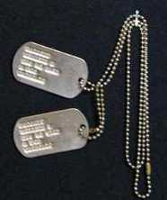
Around World War II, the circular tag was replaced by the more oval shape used by the military today. Its resemblance to dog collar tags led to the designation of “dog tag.” The tags used during World War II were stamped by a machine and had a rectangular shape with round ends and a notch on one side.

A gruesome rumor circulated that the notch was put in the tag so that the tag could be placed in a dead soldier’s mouth hold it open to prevent the body from gaseous bloating. However, the real reason for the notch was that the stamping machine required it to hold the tag in place during embossing.

The point of the tag ultimately is to be left around the neck of a casualty, staying with the remains at all times.
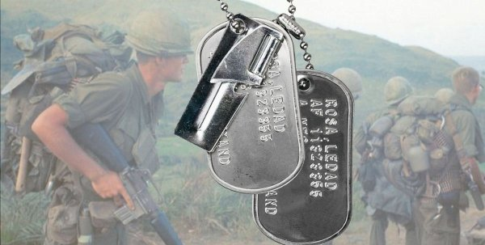
According the Library of Congress, during the Vietnam War, “changes were made to the information on dog tags. The dog tags went from the earlier eight digits with their prefix to the current nine digit Social Security number. You could have both stamped on your tag if you wanted; but, from this point on, the Social Security number was the main identifying number.”

Additionally, tags worn by the Marine Corps had a variety of additions including the size of their gas mask. A number of religions were added and full names were spelled out as well.

Current dog tags still utilize a two-tag system, with one on a long chain around the neck and one interlinked by a smaller chain. The point of this method is to have one that remains around the neck and another for the toe for the coroner’s purposes.

Though the dog tag has remained largely unchanged since the Vietnam War, the Army is currently developing and testing several new dog tags known by various names including the soldier data tag, individually carried record, medi-tag, and the personal information carrier.

The new dog tags will contain microchip or USB technology, which will hold a soldier’s medical and dental records, reported The New York Times.

Tidbits about the Coast Guard
(Editor’s note: In case Lee White didn’t know this!!!)
1790 George Washington signed the Tariff Act that authorizes the construction of 10 vessels, referred to as “Cutters”, to enforce federal tariff and trade laws to prevent smuggling. 1915 The Revenue Cutter Service merged with the US Life-saving Service and its renamed the Coast Guard.

The Coast Guard defends more than 100,000 miles of US coastline. It is the only branch within the Department of Homeland Security. Over 56,000 strong, fleet of 243 cutters, 201 fixed and rotary wing aircraft, and over 1,600 boats. Coast Guard Headquarters is located on the St. Elizabeth Campus in Washington D.C.

From the Editor!
From the desk of The Landlocked Sailor
Bob Rotruck, CWO3, USN (RET)
Deal With It, Some Can’t
It is extremely difficult for those of us that live in the comfort of these United States to appreciate the sacrifices of our military personnel. We are protected from the outside world from the kinds of stresses and horrors our military personnel face on a day-to-day basis. We are not talking about the physical scars from roadside IEDs or from bullets of enemy weapons. We are talking about the mental scars from watching your comrade get his leg blown off or seeing your military brother lying beside you with his life’s blood pouring out of a bullet wound that is taking his life. The scar inflicted when he sees his comrade’s lifeless eyes wide open when he has taken his last breath. Think about walking down a dirty, dusty road and seeing an Iraqi or Afghani child lying lifeless from a roadside bomb their own countrymen set to kill Americans and NATO forces.
These are the kinds of horrors that our American military men and women face daily and then must try to sleep at night (or when they can). Finally the day arrives and they have their orders to come home, back to the land of the free. Back to civilization as they remember it! But, what the average U.S. citizen does not carry everyday are those memories of the horrors of war. How do these brave men and women deal with what they have witnessed? How do they try to erase the sadness and guilt of being a part of this tragic war?

Thankfully, the greatest percentage of them somehow come to grips with it, but there is a small percentage that just cannot let it go. It eats away at them like a terrible disease. Their minds become continually twisted and tormented until they reach the breaking point. Mental therapy helps many, but there are a few that cannot find a way out of the twisted mental environment their mind has put them in. The only way out is to end the torment with suicide. Such tragedies are happening far too often for our heroes. Pray for them and their families. God bless our American military men and women and God bless America!

Old Sailors
By Charles Noble
Old sailors sit and chew the fat about things that used to be,
Of the things they've seen,
The places they've been,
When they ventured out to sea.

They remembered friends from long ago, the times they had back then.
The money they spent, The beer they drank,
In their days as sailing men.

Their lives are lived in days gone by, with thoughts that forever last.
Of bell bottom blues, Winged white hats,
And good times in their past.

They recall long nights with a moon so bright
Far out on a lonely sea.
The thoughts they had as youthful lads,
When their lives were wild and free.

They knew so well how their hearts would swell
When old glory fluttered proud and free.
The underway pennant such a beautiful sight
As they plowed through an angry sea.

They talked of the chow ol' cookie would make
And the shrill of the bosun's pipe.
How salt spray would fall like sparks from hell
When a storm struck in the night.

They remember old shipmates already gone who forever hold a spot in their heart,
When sailors were bold,
And friendships would hold,
Until death ripped them apart.

They speak of nights spent in bawdy houses on many a foreign shore,
Of the beer they'd down
As gathering around,
Telling jokes with a busty whore.

Their sailing days are gone away, never again will they cross the brow.
They have no regrets,
They know they are blessed,
For honoring a sacred vow.

Their numbers grow less with each passing day as the final muster begins,
There's nothing to lose,
All have paid their dues,
And they'll sail with shipmates again.

I've heard them say before getting underway that there's still some sailing to do,
They'll say with a grin
That their ship has come in
And the lord is commanding the crew.

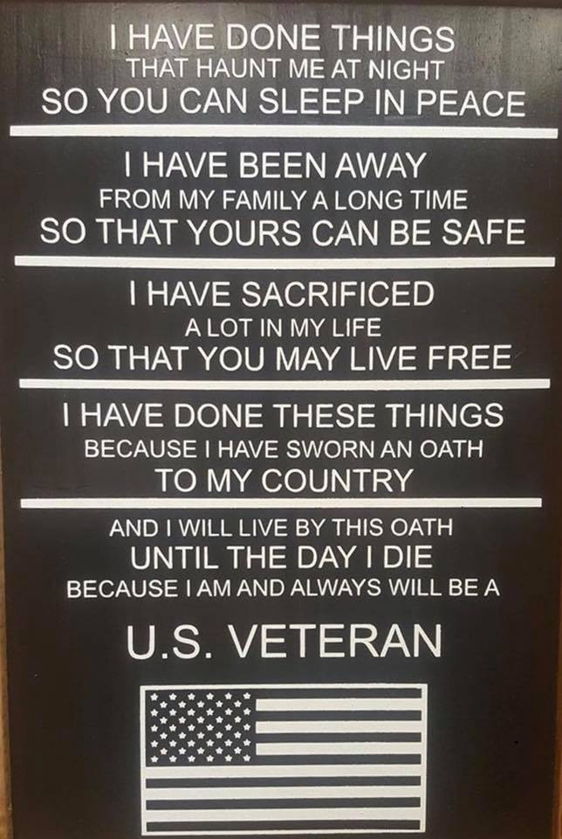

At Sequoia National Park - Thankfully, no loggers took it down, nor forest fires or earthquakes! Just a quiet life in a California forest for all these years.... 3,200! Not every tree has a nickname, but 'The President' has earned it. This giant sequoia stands at 247 feet tall & is estimated to be over 3,200 years old. Imagine, this tree was already 700 years old during the height of ancient Greece's civilization and 1200 years old when Jesus lived and Rome was well into its rule of most of the western world and points beyond. The man standing near the trunk of the tree is a good indicator of the tree's size. Incredible, isn't it? There is also a man near the top of the tree wearing red.

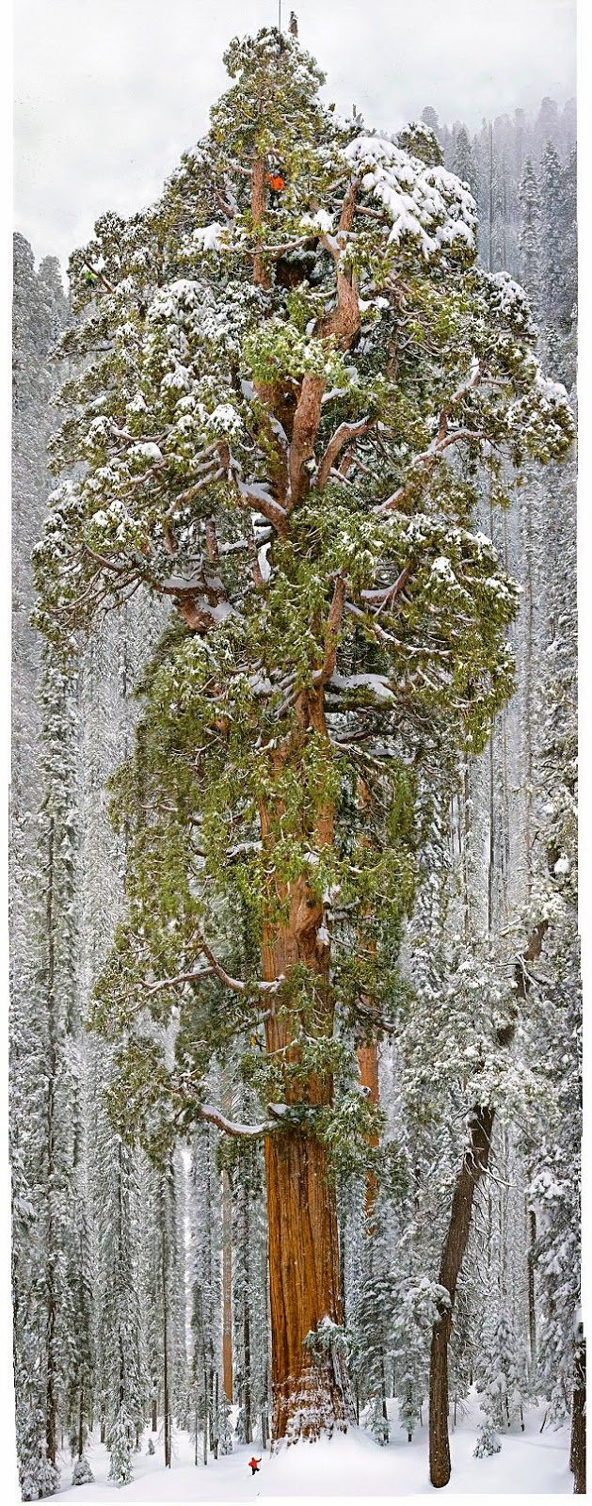

Light Side
Real Puns from Businesses
Submitted by Tom Werzyn
A SIGN IN A SHOE REPAIR STORE IN VANCOUVER READs:
We will heel you,
We will save your sole,
We will even dye for you.
A SIGN ON A BLINDS AND CURTAIN TRUCK:
“Blind man driving.”
Sign over a Gynecologist’s Office:
"Dr. Jones, at your cervix.”
In a Podiatrist's office:
"Time wounds all heels.”
On a Septic Tank Truck:
“Yesterday's Meals on Wheels!”
At an Optometrist's Office:
"If you don't see what you're looking for,
You've come to the right place.”
On a Plumber's truck:
"We repair what your husband fixed.”
On another Plumber's truck:
"Don't sleep with a drip. Call your plumber.”
At a Tire Shop in Milwaukee:
"Invite us to your next blowout.”
On an Electrician's truck:
"Let us remove your shorts.”
In a Non-smoking Area:
"If we see smoke, we will assume you are on fire and will take appropriate action.”
On a Maternity Room door:
"Push. Push. Push.”
At a Car Dealership:
"The best way to get back on your feet - miss a car payment.”
Outside a Muffler Shop:
"No appointment necessary. We hear you coming.”
In a Veterinarian's waiting room:
"Be back in 5 minutes. Sit! Stay!”
At the Electric Company:
"We would be delighted if you send in your payment on time.
However, if you don't, YOU will be de-lighted.”
In a Restaurant window:
"Don't stand there and be hungry; come on in and get fed up.”
In the front yard of a Funeral Home:
"Drive carefully. We'll wait.”
At a Propane Filling Station:
"Thank Heaven for little grills.”
In a Chicago Radiator Shop:
"Best place in town to take a leak.”
And the best one for last…Sign on the back of another Septic Tank Truck:
“Caution - This Truck is full of Political Promises”

The very first ever Blonde Guy joke..... And well worth the wait!!!!
(Submitted by John Vargas)
(Editors note: John Vargas is a natural blonde but dyes his hair for his own protection!)
An Irishman, a Mexican and a Blonde Guy were doing construction work on scaffolding on the 20th floor of a building. They were eating lunch and the Irishman said, 'Corned beef and cabbage! If I get corned beef and cabbage one more time for lunch, I'm going to jump off this building.'

The Mexican opened his lunch box and exclaimed, 'Burritos again! If I get burritos one more time I'm going to jump off, too.'

The blonde opened his lunch and said, 'Bologna again! If I get a bologna sandwich one more time, I'm jumping too.'

The next day, the Irishman opened his lunch box, saw corned beef and cabbage, and jumped to his death. The Mexican opened his lunch, saw a burrito, and jumped, too. The blonde guy opened his lunch, saw the bologna and jumped to his death as well.

At the funeral, the Irishman's wife was weeping. She said, 'If I'd known how really tired he was of corned beef and cabbage, I never would have given it to him again!'

The Mexican's wife also wept and said, 'I could have given him tacos or enchiladas! I didn't realize he hated burritos so much.'

Everyone turned and stared at the blonde's wife. The blonde's wife said, 'Don't look at me. He makes his own lunch!

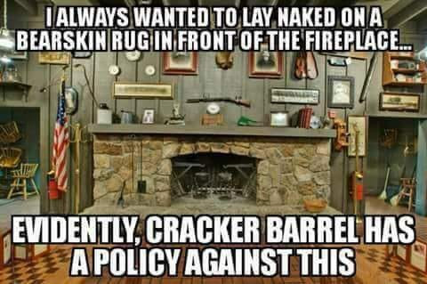

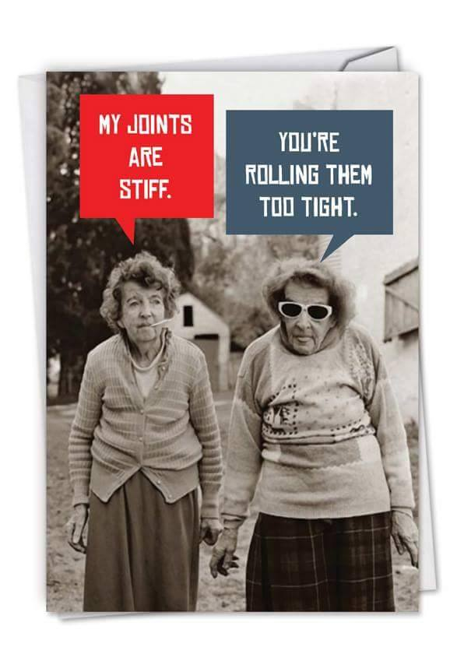
(Editor: For those of you that haven’t figured the picture out or your vision is impaired so you don’t see the “Joint” (cigarette) she has in her mouth!!!)

I Love You Sweetheart
A group of 12 women were at a seminar on how to live in a loving relationship with their husbands. The women were asked, "How many of you love your husband?" All the women raised their hand.

Then they were asked, "When was the last time you told your husband you loved him?" Some women answered today, a few yesterday, and some couldn't remember.

The women were then told to take out their cell phones and text their husband... "I love you, sweetheart."

Next the women were instructed to exchange phones with another woman and read aloud the text message they received in response to their message.

Below are 12 actual replies from their husbands. If you have been married for quite a while, you understand that these replies are a sign of true love.....

Who else would reply in such a succinct and honest way?

1. Who the hell is this?
2. Hey, mother of my children, are you sick or what?
3. Yeah, and I love you too. What's wrong?
4. What now? Did you wreck the car again?
5. I don't understand what you mean.
6. What the hell did you do now?
7. Are you sure this is for me?
8. Don't beat about the bush, just tell me how much you need?
9. Am I dreaming?
10. If you don't tell me who this message is actually for, someone will die.
11. I thought we agreed you wouldn't drink during the day.
12. Your mother is coming to stay with us, isn't she?

Cleric Collar
A little boy got on the bus, sat next to a man reading a book, and noticed he had his collar on backwards. The little boy asked why he wore his collar that way. The man, who was a priest, said, "I am a Father."

The little boy replied, "My Daddy doesn't wear his collar like that."

The priest looked up from his book and answered, "I am the Father of many."

The boy said, "My Dad has 4 boys, 4 girls and two grandchildren and he doesn't wear his collar that way."

The priest, getting impatient, said, "I am the Father of hundreds" and went back to reading his book.

The little boy sat quietly thinking for a while, then leaned over and said, "Maybe you should wear your pants backwards instead of your collar."

Trivia Answer
The picture is the USS Wolverine lying at anchor in Lake Michigan on 6 April 1943.
It was originally a side-wheel steamer called the SS Seeandbee that was used for luxury cruises on the Great Lakes. But it got a second career when it was bought by the US Navy in 1942 and converted to a carrier landing trainer as the service rapidly stood up a carrier force to answer Japanese aggression. It was based at Navy Pier in Chicago so that it could operate in Lake Michigan, but it lacked many features that combat carriers have, such as elevators and hangar decks.

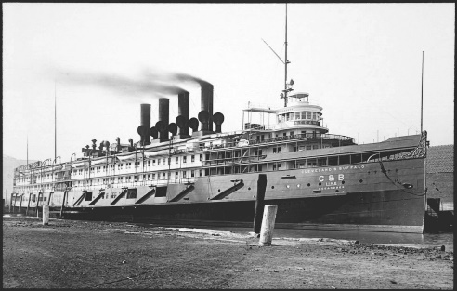
SS Seeandbee.
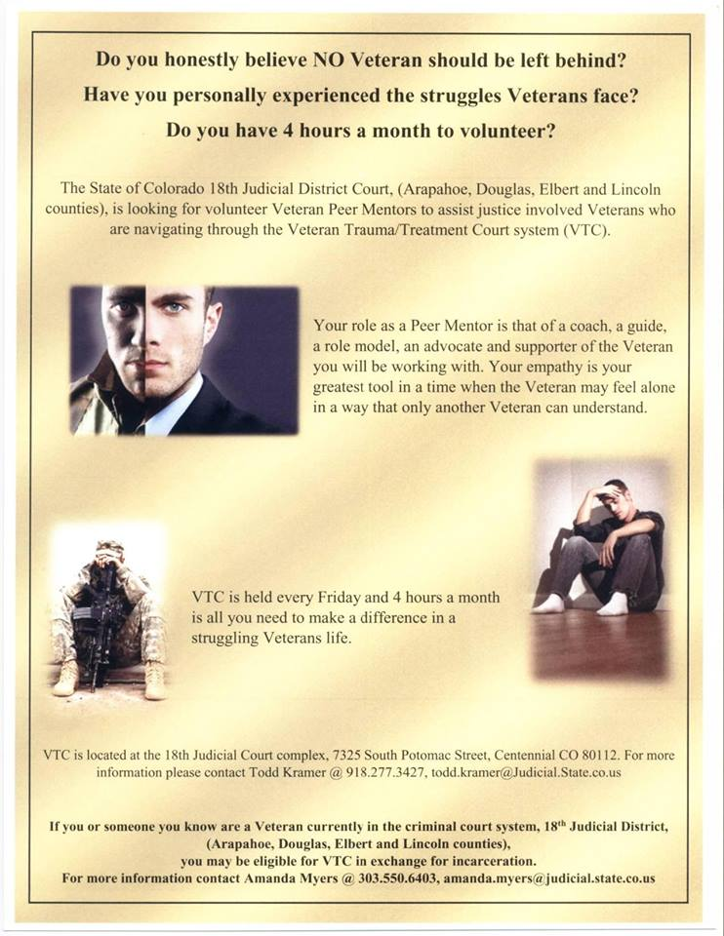
FRIENDS OF CHAPTER 1106

ERC Management, LLC
791 Southpark Dr., Suite 600
Littleton, CO 80120
720.328.3299
www.FreddysUSA.com
Panera Bread  9579 S. University Blvd.  Highlands Ranch, CO 80126  720-348-1112 | American Legion Post 1260  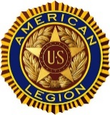
Spradlin Printing, Inc.  11903 S. Parker Road  Parker, CO 80134 | 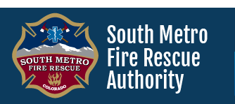  South Metro Denver Fire & Rescue  9195 E Mineral Ave  Centennial, CO 80112
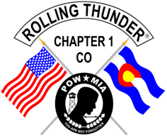  Monthly Membership Meetings  VISITORS ARE ALWAYS WELCOME!  3rd Saturday of each month at 10:00a.m.  Our meetings are held at: VFW Post 2461  1350 S Broadway, Denver, CO 80210 | 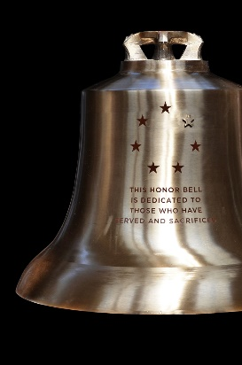  The Honor Bell Foundation  P.O. BOX 12400  DENVER, COLORADO 80212  720.282.9182
9137 E Mineral Cir Ste 100  Englewood, CO 80112-3422 | Home Depot Foundation  8477 S Yosemite St  Lone Tree, CO 80124
King Soopers  9551 S. University Blvd., Highlands Ranch, CO 80126 | STUDIO 1430 Main Office:  4700 South Syracuse Street, Suite 1050  Denver, CO 80237
Military Order of Purple Heart, Chapter 1041, Arvada, CO | Golden Corral  15775 E. Arapahoe Rd  Centennial, CO 80016

