**Inside this issue:**

Notes from the President

[Member Feature](#Memberfeature)

[Military Trivia](#Militarytrivia)

[Guest Speaker](#Guestspeaker)

[Membership](#Membership)

[Board of Directors/Officers](#Boardofdirectors)

[Working Committees](#Workingcommittees)

[Meetings/Events Calendar](#Meetingsevents)

[Announcement Corner](#Announcementcorner)

[Books/Articles Published by Mbrs.](#Booksarticles)

[From the Editor](#Fromtheeditor)

[Light Side](#Lightside)

[Trivia Answer](#Triviaanswer)

**Notice:**

If you have moved or changed your address, PLEASE notify us immediately! Contact: Dave Lyons, Membership Chair

E-mail: [Snoyldavid@centurylink.net](mailto:Snoyldavid@centurylink.net)

Phone:  303 690 8776

###### COPYRIGHT NOTICE: In accordance with Title 17 U.S.C. Section 107, any copyrighted material in this newsletter is distributed under fair use without profit or payment to those who have expressed a prior interest in receiving the included information for nonprofit use and educational purposes only.

**Facebook: Vietnam Veterans of America Chapter 1106**

***Editor’s Note:***

This version of the newsletter is in Microsoft Document (.DOCX) format so that the links will work. Put your cursor over the link, depress your Control Key (ctrl) and depress your left mouse button and it will take you to the listed link position. PDF format, the links will not work.

The comments and editorial input does not necessarily reflect the opinion of the membership of our chapter. I would appreciate any feedback that you might have, items you liked or if you find offensive or derogatory in anyway. ([bobrotruck73@gmail.com](mailto:bobrotruck73@gmail.com)) Thank you for allowing me to be your editor.

***Notes from the President***

Lee White

**Happy New Year – 2020**

I hope everyone has a safe, happy holiday season.

A brief review of Chapter events in 2019:

March 29, 2019 - Vietnam Veterans Day - Memorial Dedication/Celebration

May 18, 2019 - VVA chapter 1106 fundraiser sponsored by Litta Plant-Schaper and family

May 25, 2019 - Memorial Day Poppy Drive

June 21, 2019 - “Wall that Heals”

July 4, 2019 - Highlands Ranch Parade

July 18-20, 2019 - VVA National Convention – Spokane, WA

August 10, 2019 - VVA Chapter 1106 Summer Picnic

September 7, 2019 - Cherry Creek H/S Football Game & Veteran Appreciation Day

November 9, 2019 - Veterans Day Poppy Drive

December 14, 2019 - VVA Chapter 1106 Christmas Luncheon

Membership growth:

2018 - VVA 126 2019 - 143

2018 - AVVA 27 2019 - 36

Thanks to all our members, we look forward to 2020!!

***“Member Feature”***

Joe Plant – 2 years USA and 1 year USN – 1958 to 1969. During my years, I was stationed 4 years on the USS Carter Hall (LSD-3), stationed at Ft. Bliss, TX, Okinawa, Ft. Sill, OK, and Murnau, W. Germany. I was a Machinist Mate Second Class (MM2) in the Navy and a Track Vehicle Repair (63H) Army Instructor. My most memorable military experience was watching and 18 year old sailor get killed by a shark in the waters off the coast of Haha AFB off the peninsula of Okinawa! Sharks and Sailors don’t mix well. Being a chapter member of the VVA has helped me in many ways where I obtained much needed info on PTSD. I like that our chapter has planned and executed many trip to Vietnam Veteran Memorials and I have been honored to be our Chapter’s Treasurer.

***Military Trivia***

**Chest Candy.** [Click here for end of the Newsletter Trivia Answer](#Triviaanswer)

***Guest Speakers – November***

Elizabeth Escobedo and Carol Helstosky Associate Professors from the University of Denver History Department, spoke to us of their Veterans Legacy Program. The Veterans Legacy Program (VLP) is National Cemetery Administration’s educational outreach initiative. Our mission is to memorialize our nation's Veterans through sharing their stories of service and sacrifice. For the last three years, the U.S. Department of Veterans Affairs has been approaching universities and asking their students to help tell these stories through extracurricular research. On Memorial Day 2016, the National Cemetery Administration established the Veterans Legacy Program, encouraging academics to learn more about their local veterans and their families.

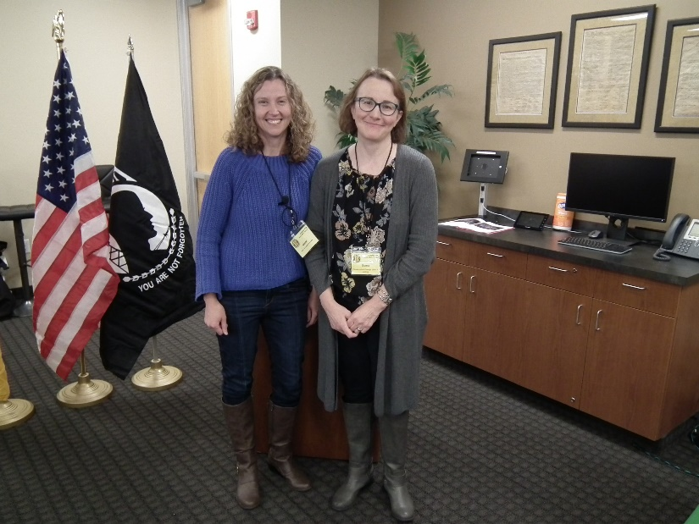

L/R: Elizabeth Escobedo and Carol Helstosky

***Special Speaker – December***

Tom Werzyn spoke about the National Archives and Records Administration and how easy it is to research your personnel records or search for others. Contact Tom for more details:

Email: [werzyn@comcast.net](mailto:werzyn@comcast.net)

Phone: (720) 339-3428 • Mobile

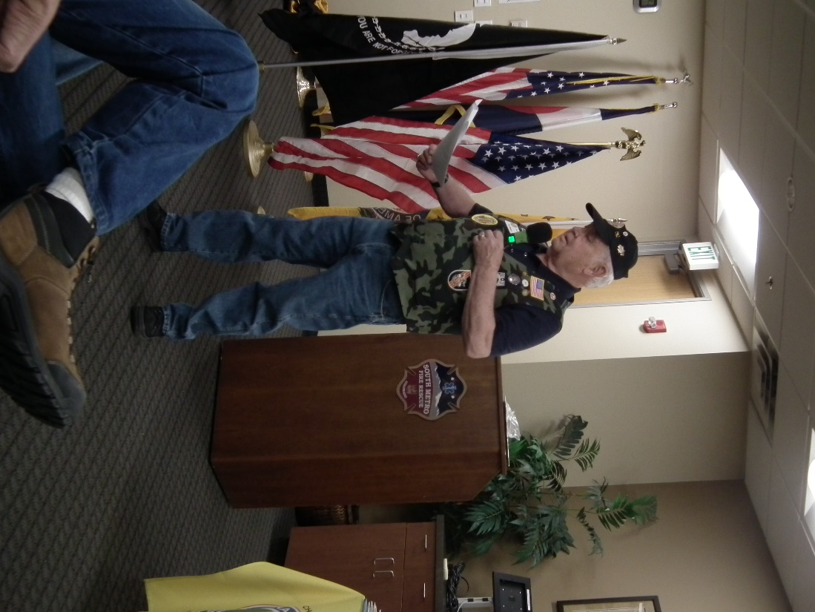

**November Bio Speaker - Clarence Rebolledo**

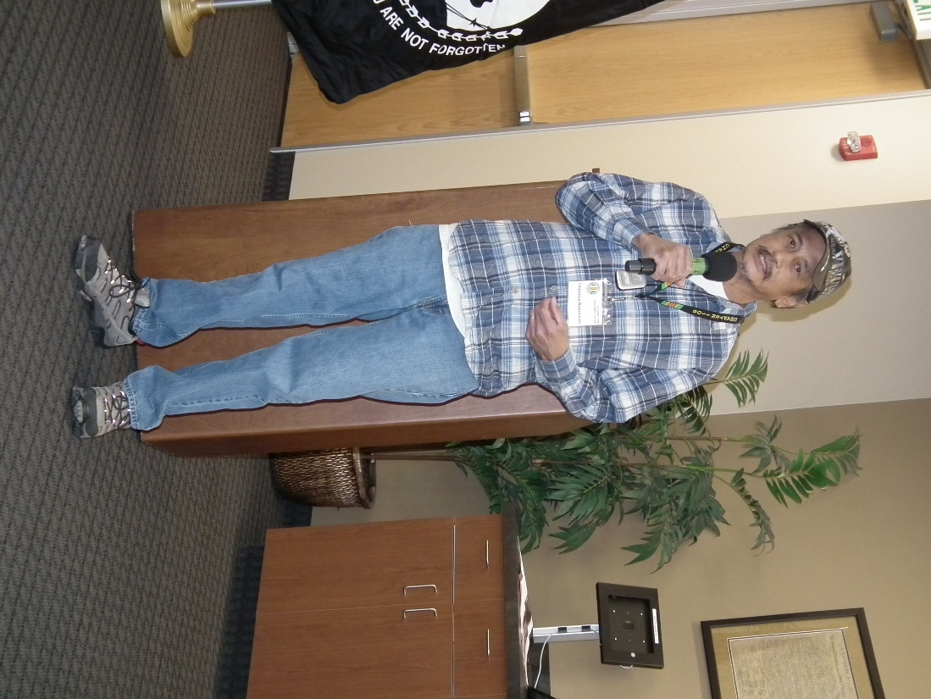

**December Bio Speaker – Richard Lewis**

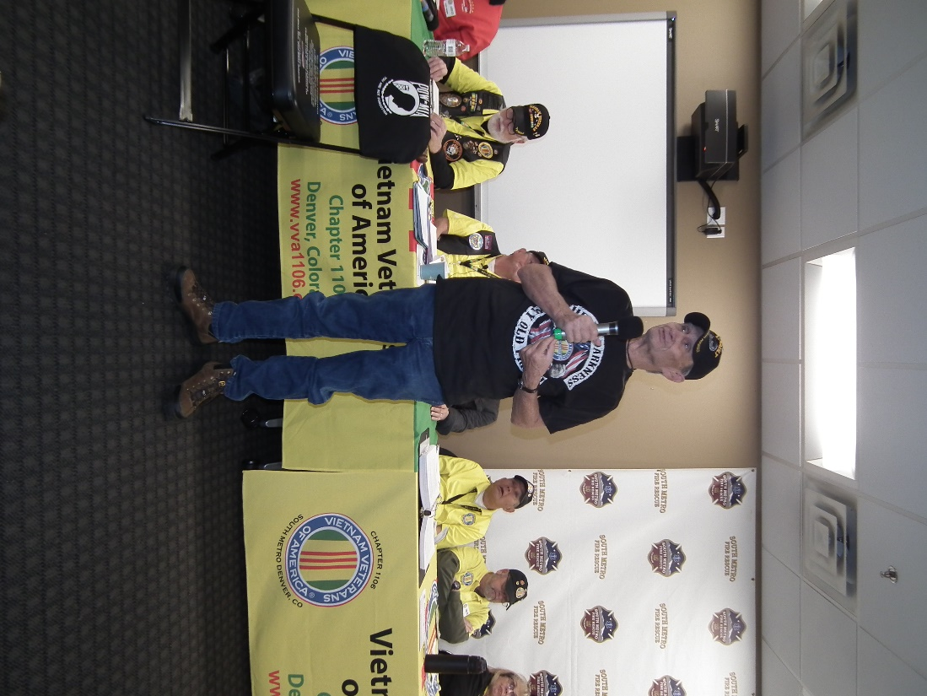

***Membership!*** (As of 12-15-19)

VVA 143

AVVA 36

Total: 179

Welcome New Members:

**VVA**

Donald Boswell

Nolan Hargrave

Dominic Milo

Lou Grounds

Gary Weston

**AVVA**

Alice Boswell

Jason Longmore

Natalie Gates

***Board of Directors/Officers***

Lee White - President

Dave Lyons - Vice-president

Joe Plant – Treasurer (need volunteer replacement)

Glen Payne - Secretary

Board Members - Milt Omoto, Patti Ehline, Dave Lyons, Tom Werzyn, Ron Smith, John Vargas, Dan Green

***Special Chapter Positions***

AVVA Liason to chapter Board of Directors - Litta Plant-Schaper

Chaplain – Rev. Garry Turks

Government Affairs – Tony Nickerson

Sergeant-at-Arms – Rob Senatore

***Working Committees***

* Agent Orange/PTSD – Patti Ehline
* Color Guard – Jay Quiring (Command Sergeant), Don McNeely, Dan Green, Thom Frey, Clarence Rebolledo, Robert Senatore, Tony Nickerson, Ron Smith
* Event Coordinator – Ron Smith, Lee White, Michelle Mallin
* Fundraising/Grants – Milt Omoto
* Marketing/Media/Events – Tom Werzyn, Michelle Mallin
* Membership – Dave Lyons – Chair, Lee White
* Mental Health: Patti Ehline, Warren Harrison, Joe Plant
* Newsletter Editor - Bob Rotruck
* POW/MIA – **Position Open**
* Scholarship Program - Mike Karsh – Co-Chair, Jim Marcille – Co-Chair, Glen Payne, John Vargas, Brian Karsh (supporter)
* Promotional Items: Leann Stelzer, Clarence Rebolledo
* Refreshments: Alexis Winemiller, Jason Longmore
* Mike Karsh and Jim Marcille, Co-Chairs, Glen Payne, (supporter) John Vargas, Brian Karsh (supporter), Bob Mallin (supporter)
* Social –Barry Fiore, Glen Payne, Milt Omoto, Mike Karsh, John VargasSpeakers Bureau – Tom Werzyn, Chair, Bob Easter, Bob Mallin, Glen Payne, Roger Lanphier, Donna Chaney
* Veteran Emergency Assistance Committee - Joe Plant, Dave Lyons, Dan Green, Bruce Arndt, Lee White
* Voices for Veterans - Warren Harrison
* Webmaster – Bob Rotruck
* Women Veterans - Patti Ehline

**Meetings/Events Calendar - 2020**

Jan. 4, 2020 - VVA Chapter 1106 Monthly Meeting

Jan. 16-18, 2020 - Conference of State Council Presidents - Silver Spring, MD

Feb. 1, 2020 - VVA Chapter 1106 Monthly Meeting

Feb. 8, 2020 - Bi-Monthly Honors - Ft. Logan

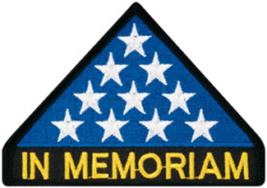

***In Memoriam***



As of: 12/05/2019

Total Funeral Homes Visited - 2,376

Cremains Found – 20,000

Veterans Cremains Identified - 4,553

Veterans Interred – 4,243

***Events:***

**Chapter Color Guard**

**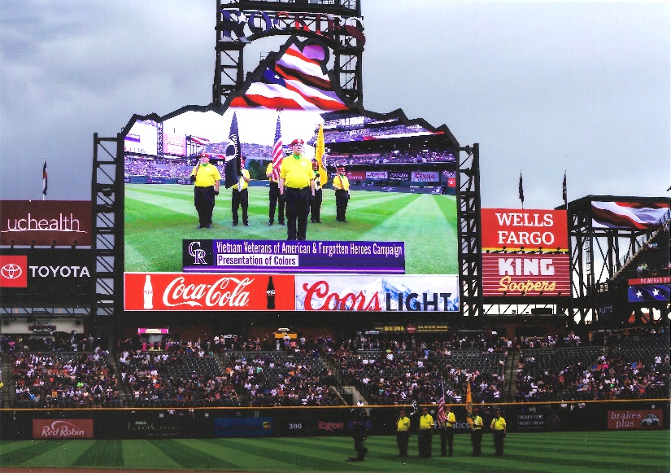**

Rockies Game - July 14, 2019

**Color Guard at the Zillow Group**

I'd like to express my sincere gratitude to our VVA 1106 Color Guard for devoting their time to honor Veterans Day with us at Zillow Group! It was fulfilling to work side-by-side with you all in reminding our colleagues of the men and women who carried the burden of safeguarding our freedom. The time we were able to spend with our Vietnam Veterans was much more than we could've hoped for! You really set the tone in our office that was both inspiring and personal to many. Zillow Group's Veteran Network is grateful for all that you do for us and we are honored to be a part of your cause, "Never Again will one generation of veterans abandon another."

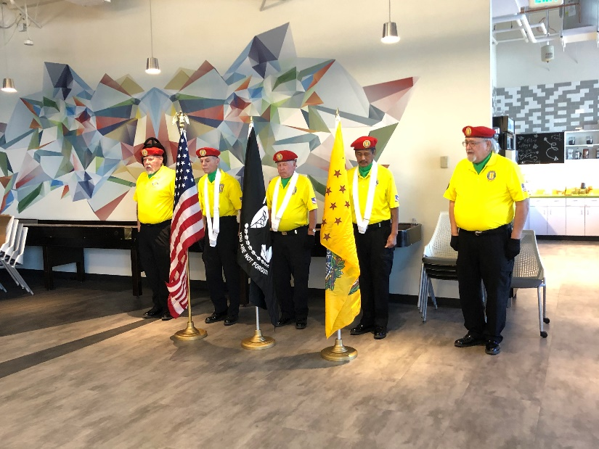

Photo by: Alexis Winemiller, Veteran Affinity Network Leader - Zillow Group

**November Poppy Drive**

Landing Zone 1 Donations of: $648.00

Iliff & Buckley

Landing Zone 2 Donations of: $1163.00

Buckley & Quincy

Landing Zone 3 Donations of: $1140.00

Smokey Hill & E-470

Landing Zone 4 Donations of: $1785.00

Parker Road

Total: $4736.00

Editor’s note: Pictures from LZ1 where blocked do to an order from the FBI, CIA, NSA, and the Douglas County Sheriff’s Office! ☺☺☺☺

**LZ2**

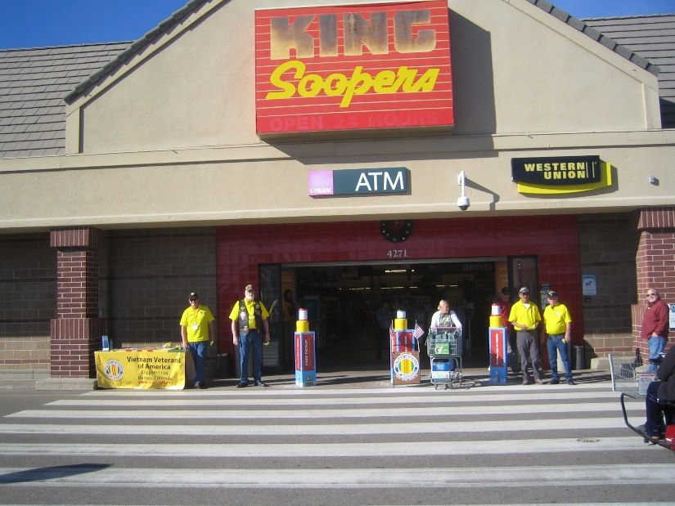

L to R: Mike Sizemore, Dave Lyons, Clarence Rebolledo, Dan Green

**LZ3**

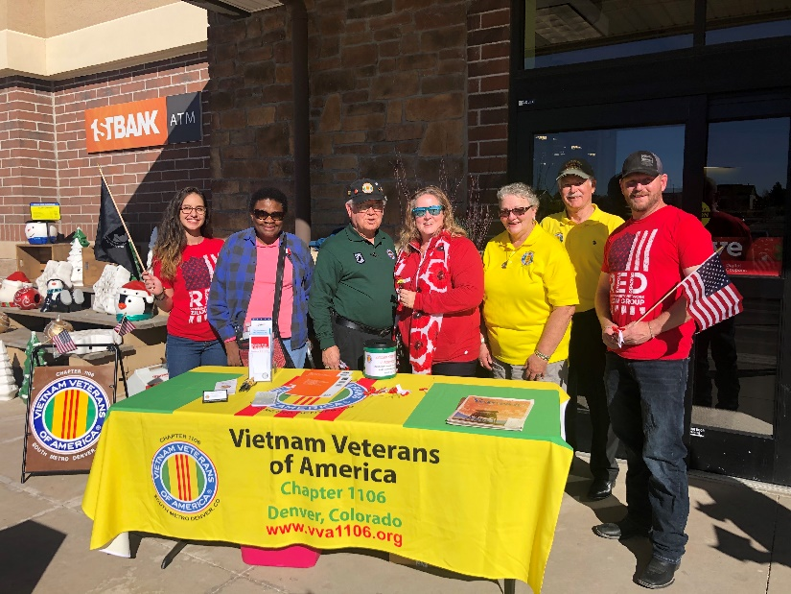

L to R: Alxis Winemiller, Gwen Wilson, Tom Werzyn, Natalie Gates, Donna Chaney, Glen Payne, Jason Longmore

**LZ4**

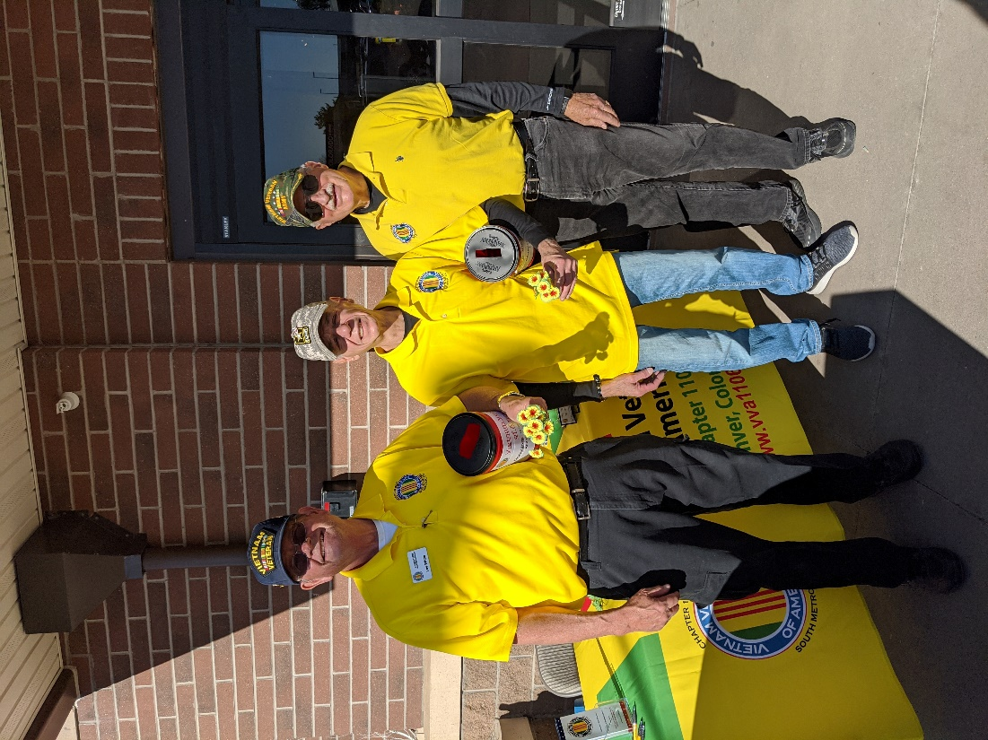

LtoR: Lee White, Rob Senatore, Mike Huber

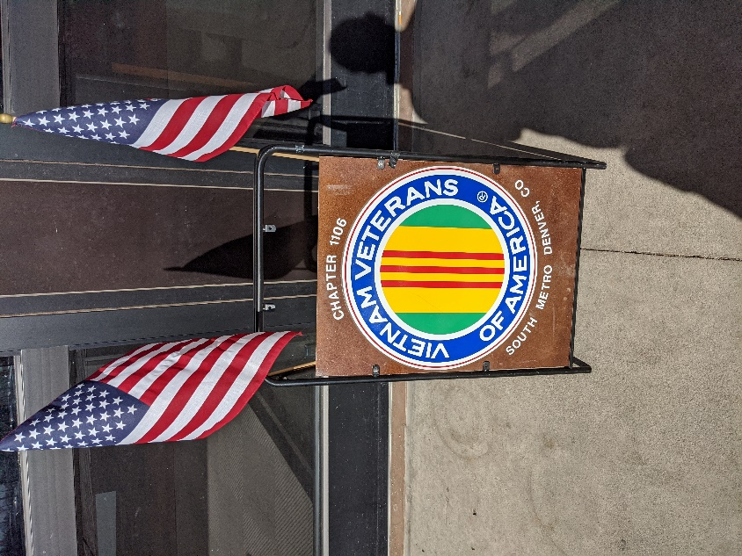

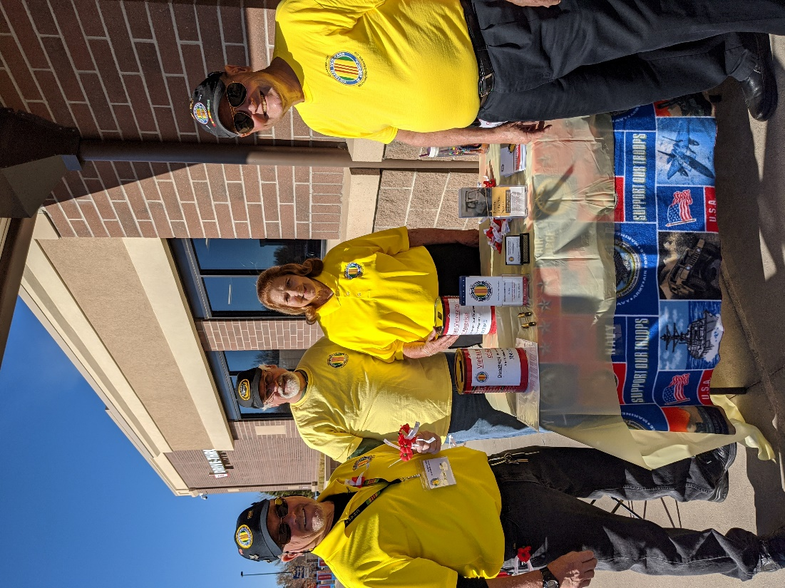

LtoR: Bob Crago, Dave Arndt, Barbara and Bob Rotruck

Editor’s note: It was requested that Dave Arndt (AKA Joe Biden) remove his arm from around the Editor’s wife!!!! ☺☺☺

**Fall at the Wall**

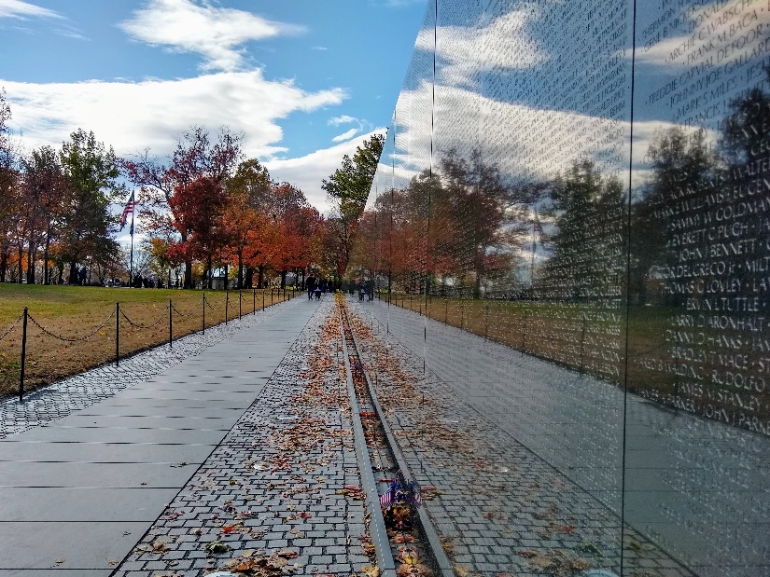

Photo by: Suzanne Sigona

**Christmas at The Wall**

Thank you Suzanne Sigona for the beautiful Christmas ornament you made for The Wall and The Wall pics!

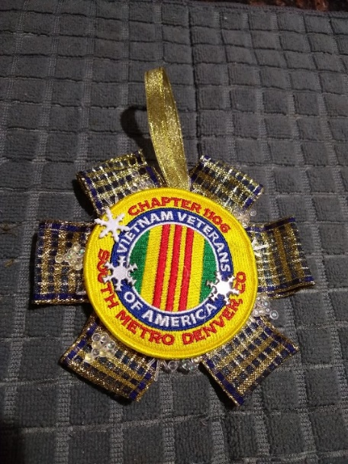

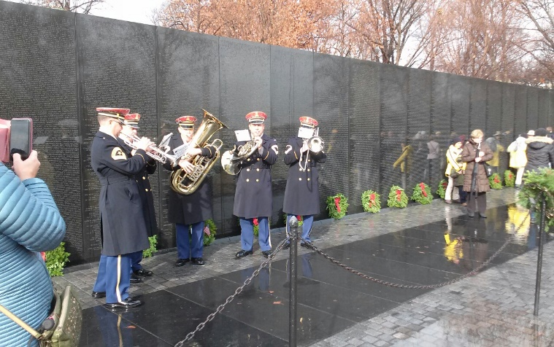

 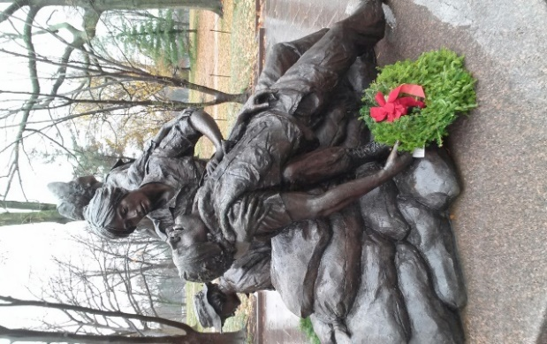

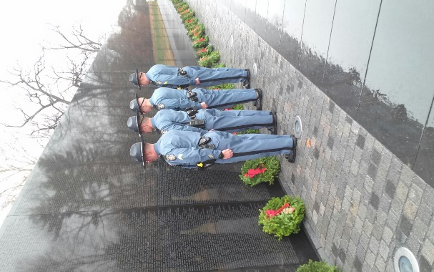 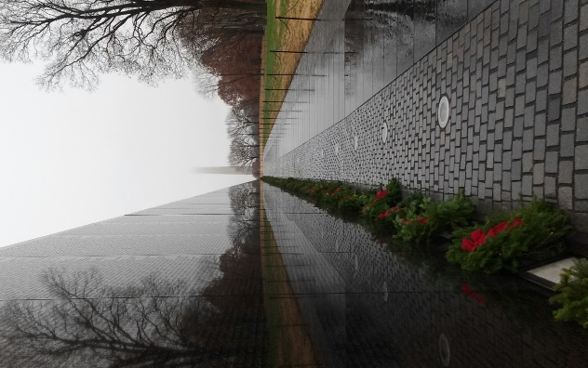

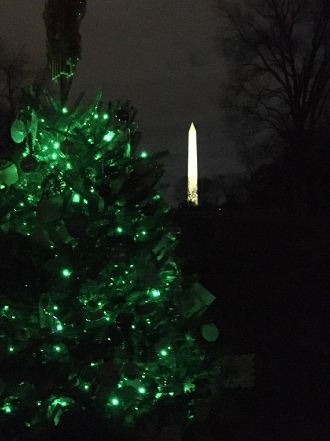

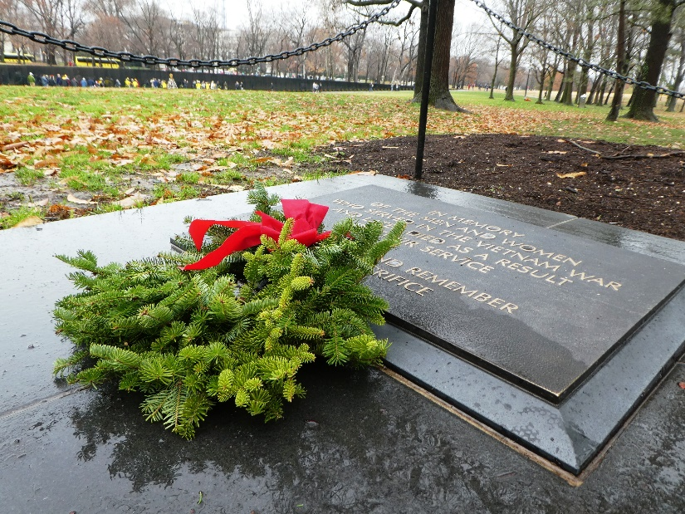

There was no wreath here so when the lady that was putting out wreaths left the area, Suzanne found extras for the Women’s Statue and the In Memory Plaque. The wreath for “In Memory” was placed by a daughter who lost her father after his return.

***Announcement Corner***

**Veteran Administration Fiscal Year 2020 Budget**

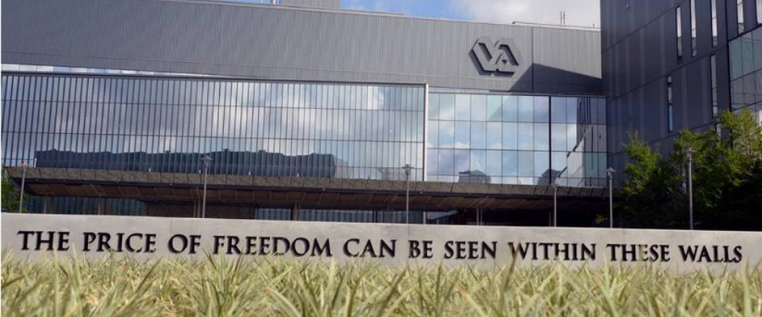Earlier this year in March, the Veterans Administration submitted their fiscal year (FY) 2020 budget. The Senate passed the budget bill and it was signed into law by President Trump in August. The VA’s FY 2020 budget is $220.2 Billion Dollars, an increase of 9.6% over the FY 2019 budget. Of interest is increases in mental health services, woman’s health and veteran homelessness funding. The budget goes into effect December 1, 2019. Attached is a VA Budget Fast Facts Sheet.

For those interested in this type of thing, you can download the entire budget from the VA’s website: https://www.va.gov/budget/products.asp. It is in four volumes and 1,665 pages! There’s also a number of other documents. Of interest is their FY 2018 - 2024 Strategic Plan which was refreshed May 31, 2019.

***Books/Articles Published by Members***

**Thoughts on My War... ruminations on viewing**

Tom Werzyn

Apocalypse, Now …

For the umpteenth time …

alone, on the road …

This is PBR StreetGang,

calling Almighty,

come in, calling Almighty ..

We forgive you.

Perhaps all they saw there at home

was this,

and heard only what Walter told them,

night after night.

When we came back alone, all

hoping Mom and Dad didn’t see

in our faces,

the fear, and the confusion

of being the youngest warriors to go,

and, in so many ways,

the oldest to come back.

PBR StreetGang,

this is Almighty,

standing by,

do you copy ? over ..

The horror, the horror;

Kurtz was right,

maybe more than he thought,

but well more

than he knew.

Somehow, we couldn’t translate

it all; at least not ‘till later,

when we sat alone, watching,

waiting.

Maybe now

To heal,

and hope that

This is Almighty, standing by ….

“…come on baby, take a chance with us,

… and meet me at the back of the blue bus..”

The Doors ..

**A Veteran Died Today**

Author unknown.

He was getting old and paunchy

His hair was falling fast,

And he sat around the Legion,

Telling stories of the past.

Of a war that he once fought in

And the deeds that he had done,

In his exploits with his buddies;

They were heroes, every one.

And 'tho sometimes to his neighbors

His tales became a joke,

All his buddies listened quietly

For they knew where of he spoke.

But we'll hear his tales no longer,

For ol' Joe has passed away,

And the world's a little poorer

For a Veteran died today.

He won't be mourned by many,

Just his children and his wife.

For he lived an ordinary,

Very quiet sort of life.

He held a job and raised a family,

Going quietly on his way;

And the world won't note his passing,

'Tho a Veteran died today.

When politicians leave this earth,

Their bodies lie in state,

While thousands note their passing,

And proclaim that they were great.

Papers tell of their life stories

From the time that they were young,

But the passing of a Veteran

Goes unnoticed, and unsung.

Is the greatest contribution

To the welfare of our land,

Some jerk who breaks his promise

And cons his fellow man?

Or the ordinary fellow

Who in times of war and strife,

Goes off to serve his country

And offers up his life?

The politician's stipend

And the style in which he lives,

Are often disproportionate,

To the service that he gives.

While the ordinary Veteran,

Who offered up his all,

Is paid off with a medal

And perhaps a pension, small.

It is not the politicians

With their compromise and ploys,

Who won for us the freedom

That our country now enjoys.

Should you find yourself in danger,

With your enemies at hand,

Would you really want some cop-out,

With his ever-waffling stand?

Or would you want a Veteran

His home, his country, his kin,

Just a common Veteran,

Who would fight until the end.

He was just a common Veteran,

And his ranks are growing thin,

But his presence should remind us

We may need his likes again.

For when countries are in conflict,

We find the Veteran's part,

Is to clean up all the troubles

That the politicians start.

If we cannot do him honor

While he's here to hear the praise,

Then at least let's give him homage

At the ending of his days.

Perhaps just a simple headline

In the paper that might say:

"OUR COUNTRY IS IN MOURNING,

A VETERAN DIED TODAY."

**HONOR**

Submitted by John Vargas

1982 Photo: 86-year-old World War I veteran Joseph Ambrose attends a parade for the Vietnam Veterans Memorial. In his hands, he holds the flag that covered his son's casket, who was killed fighting in Korea.

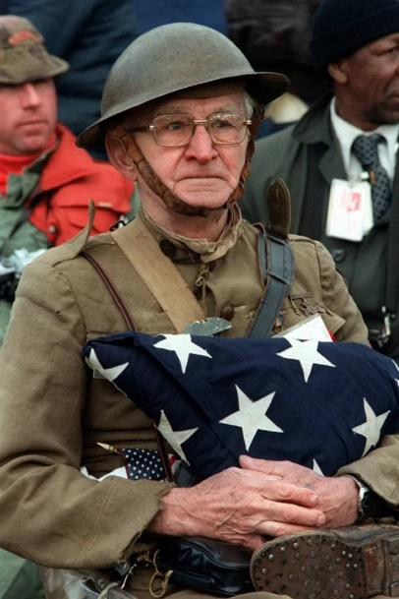

**A Memorial Day Speech by Ray Bentzen**

Submitted by: Gary Bentzen

Let me begin by saying that it is an honor to appear before you today. Given that I have no military service background myself, I’m not sure that I am the most qualified or traditional of Memorial Day speakers. But when Dale Nicolaus, in cahoots with my Mom, asked me to speak, I said “yes”. And I hope that by the end of my remarks that just maybe that willingness to say “yes” will have a little more relevance in terms of why we are gathered here today.

Most of us know that Memorial Day, often called Decoration Day in the early years, began in some parts of the country a few years after the Civil War and became more firmly entrenched as a nationwide event following World War I, finally becoming an official national holiday in 1971.

Originally a day to remember, honor, and celebrate those Americans who died in combat, Memorial Day has gradually come to also serve as an opportunity to honor all veterans and current members of the armed forces.

In 1986, President Ronald Reagan spoke at Arlington National Cemetery on Memorial Day. While reflecting on those buried at Arlington, he noted, “All of these men were different, but they shared this in common: They loved America very much . . . And they loved with the sureness of the young. It’s hard not to think of the young in a place like this, for it’s the young who do the fighting and dying when a peace fails and a war begins.”

Reagan continued speaking of those who answered the call to serve in Vietnam, “It was often our poor who fought . . . it was the un-pampered boys of the working class who picked up the rifles and went on the march. They learned not to rely on us; they learned to rely on each other. . . They seized certainty from the heart of an ambivalent age; they stood for something.”

From this, Reagan concluded, “And we owe them something, those boys. We owe them first a promise: That just as they did not forget their missing comrades, neither, ever, will we.”

And so that is why we are here today--to remember the fallen and all who served.

But how best to remember, how best to not forget? Depending on which records you consult, and how you do your counting, close to one and a half million Americans are among our war dead beginning with the War for Independence and continuing through ongoing conflicts in Afghanistan and Iraq--one and a half million fathers and mothers and brothers and sisters and neighbor kids and friends who did not come home.

The names of those dead Americans are etched in stone and bronze in cemeteries across this nation and around the world. Often Memorial Day celebrations will include a reading of the names of local heroes, but how do we read the names of one and a half million such heroes? How do we remember and honor the sacrifices made? And, of equal importance, how do we take meaning from those sacrifices and apply that meaning to our own lives?

Those are big questions, and I’m not sure I have any big answers. So I’d like to approach the matter by remembering and talking about just four of our fallen soldiers, two from World War II and two from Operation Iraqi Freedom. And from those four stories, I hope that maybe, just maybe, we will see at least the outlines of something bigger.

Let us first pay tribute to Purple Heart recipient First Lieutenant Frederick D. Funderberg, a young man from Jasper County, Georgia. An enlisted member of the 301st Fighter Squadron seeing action in Europe, Frederick claimed the first victory for his squadron by shooting down two enemy fighters in aerial combat in June of 1944. Six months later, while flying escort duty for a bomber squadron near Munich, his plane was shot down. Frederick’s body, along with those of his fellow crew members, was never recovered.

As an African-American, Frederick would have had every reason not to answer the call to service. He grew up in an era where he was confronted with segregated bathrooms, water fountains, restaurants, public transportation, schools, and more, including his service as a member of the Tuskegee Airmen, a military unit whose very existence was the result of segregation. Worse yet, from 1877 to 1950, 589 African-Americans were lynched in Georgia with 20 lynchings in Jasper County alone. Despite the inequities and injustices under which he grew up, Frederick said “yes” when his nation called.

Today, we remember and honor Frederick D. Funderberg.

And now let us consider Medal of Honor recipient Private First Class Joe M. Nishimoto. A California boy, Joe enlisted in the Army in October of 1943. A little over a year later, Joe and his squad from the 100th Infantry Battalion were engaged in a four day fight with the enemy to take a ridge in France. Joe’s single handed heroics removed three machine gun emplacements from action and opened the way for the Americans to advance. A week later Joe was killed in action.

As a Japanese-American during World War II, Joe would have had every reason not to answer the call to service. Joe and his family had been removed from California and interned in a camp in Arkansas as part of the government’s forced relocation of Japanese-Americans following Pearl Harbor. The lives that Joe and his family had built for themselves in California, their American dreams, were gone forever. Despite the inequities and injustices he experienced, Joe said “yes” when his nation called.

Today, we remember and honor Joe M. Nishimoto.

A little over sixty years later, we come to the life of Purple Heart recipient Corporal Kareem Rashad Sultan Khan. Kareem enlisted in the Army upon graduation from a New Jersey high school in 2005 and found himself in Iraq just a year later. Roughly a year into his tour in Iraq, Kareem and three squad mates from the 2nd Infantry Division were killed when a bomb exploded in a house they were clearing.

As an American Muslim, Kareem would have had every reason not to answer the call to service. Even though the attacks of September 11 were directed by a terrorist from Saudi Arabia and carried out by terrorists from Saudi Arabia, anti-Muslim sentiment in post-9/11 America affected American kids like Kareem deeply and continue to do so through today. Despite the unjust anger directed toward him and those of his faith, Kareem said “yes” when his nation called.

Today we remember and honor Kareem Rashad Sultan Khan.

The final American hero I will talk about today is Specialist Dustin L. Workman II. From Greenwood, Nebraska, Dustin enlisted in the Army upon graduation from high school in 2005. After advanced training in Fort Carson, Colorado, Dustin deployed to Iraq. In early July of 2007, Dustin and four fellow soldiers from the 2nd Infantry Division were attacked by insurgents in Baghdad. All five died of wounds sustained from improvised explosive devices. Dustin was nineteen years old.

I was Dustin’s middle school and high school principal for six years for grades seven through twelve. My youngest daughter was one of Dustin’s classmates at Ashland-Greenwood High School. While she was preparing for a study abroad experience at Oxford after her sophomore year of college, Dustin was dying in Iraq. I went to Dustin’s memorial service and saw and shared the pain felt by his mother and brother and sister, knowing that the hugs and words of condolence I offered were not enough. Dustin’s death was and is personal for me.

As an eighteen year old, barely out of childhood, Dustin would have had every reason not to answer the call to service, including his mother trying to talk him out of it. But Dustin was a stubborn kid and had his mind set, so he said “yes” when his nation called.

Today we remember and honor Dustin L. Workman II.

So we have an African-American growing up in a segregated America, a Japanese-American forcibly relocated because of his race, an American Muslim dealing with pervasive animosity toward his religion, and a small town Nebraska kid ignoring his mom’s advice. These four young men sound like they are about as different as they could be, but I’d argue that what they have in common outweighs all differences.

President Barack Obama, while still a senator from Illinois, addressed the 2004 Democratic National Convention and said, “...there is not a liberal America and a conservative America — there is the United States of America. There is not a black America and a white America and a Latino America and an Asian America — there's the United States of America.” Frederick, Joe, Kareem, and Dustin did not serve as an African-American or a Japanese-American or an American Muslim or a small town Nebraska boy--they served and died as Americans.

This is as true for the past as it is today. Consider, for example, the Naper 28. Those twenty-eight young men who died when their Army Air Force transport crashed southwest of Naper in 1944 came from sixteen different states, from California to New York, from Arkansas to Oregon. They were America.

More recently, the soldiers who died with Dustin Workman in Baghdad in 2007 had last names of Martinez, Kim, Mendoza, and Hiltz. They, with Dustin, were America.

This notion of unity, of all of working together toward a greater purpose, is embedded in our Pledge of Allegiance. We are indeed one nation, indivisible.

Unfortunately, I think sometimes we forget that greater purpose; our recitations of the Pledge of Allegiance become little more than a display of rote memorization as opposed to something we reflect upon and dedicate ourselves to.

So occasions like Memorial Day are a good time to renew our dedication to American ideals. Remembering and honoring those who sacrificed their lives in war is good and right so long as we do not do so with an end toward glorifying war but in keeping with words offered by President Eisenhower a few months after the end of World War II: “War is a grim, cruel business, a business justified only as a means of sustaining the forces of good against those of evil.”

Sustaining the forces of good involves, as President Eisenhower would remark over a decade later during his Presidency, recognizing that “In vast stretches of the earth, men awoke today in hunger. They will spend the day in unceasing toil. And as the sun goes down, they will still know hunger. They will see suffering in the eyes of their children. . . So long as this is so, peace and freedom will be in danger throughout our world.”

President George H. W. Bush, like Eisenhower someone who had experienced firsthand the grim realities of World War II, said during his inauguration speech: “America is never wholly herself unless she is engaged in high moral principle. We as a people have such a purpose today It is to make kinder the face of the nation and gentler the face of the world.”

President Bush was often ridiculed for his talk of a kinder, gentler nation. Yet I would argue that his assessment of what our overriding purpose as Americans should be remains, if anything, more true and essential today than it was thirty years ago.

In 2011, President Bush offered this advice for Americans: “There could be no definition of a successful life that does not include service to others. Find something to do. Get off the bench. Don’t sit there whining, sucking your thumb, get in the game.”

And that is where we can use this Memorial Day as an opportunity for each and every one of us to get in the game. Just as Frederick, Joe, Kareem, Dustin, and nearly a million and a half other Americans said “yes” to serving America and willingly paid the ultimate price, each of us can say “yes” to being of service to others on a daily basis.

And the beauty of this call to service directed toward all of us is that it is a challenge we rise to almost naturally. As you all know firsthand, every time the rains fall and the floods rise, every time the storm clouds lower and destruction is left behind, every time a spark ignites and homes and lives are changed forever, and every time injury or sickness or accident befalls a neighbor, we reach out and show that we are America, we are the great one nation, indivisible.

And so the next step for all of us, the next challenge we must accept and overcome, is to extend what is instinctive in us to the next level. We must ignore the efforts to divide that are all too common and instead offer a hand of support and an effort at understanding to those who may not look or be like us or even whom we may not like all that much but who are in need. Again, we must do so because we are America, one nation, indivisible.

The relatively obscure American poet Wallace Bruce is not considered one of our most talented or successful writers, but the last few lines of his poem titled “Memorial Day” are what makes Wallace Bruce quotable. In speaking of America’s war dead, Bruce wrote, “Who kept the faith and fought the fight the glory theirs, the duty ours. . .”

As we remember and honor the fallen on this Memorial Day, we must realize that the sacrifices of kids like Frederick, Joe, Kareem, and Dustin mean nothing unless we say ”yes” to the duty those sacrifices impose upon us.

And so as we go forth today, let us do so by embracing the true meaning of “my country right or wrong.” Let us celebrate and acclaim what is right and dedicate our lives to owning and correcting what is wrong.

And let us always remember that, guided by the example of Frederick, Joe, Kareem, Dustin, and of all our fallen, we are America.

Let us be worthy of that birthright, of that duty.

**Book Report**

Submitted by: Milt Omoto

Title: *“What Remains: Bringing America’s Missing Home from the Vietnam War”*

Author: Sarah E. Wagner

Publisher: Harvard University Press, 2019

This book is about America’s missing military members who served in Vietnam and the families and communities that continue to press the government to search for them bring them home. An interesting area of the book is the description of advances in forensic sciences that have provided new and powerful tools to identify the remains of the missing, often from the merest trace―a tooth or bone fragment. These new techniques have enabled military experts to recover, repatriate, identify, and return the remains of lost service members.

The United States is the only country in the world that spends the type of effort it does to locate missing remains from previous conflicts. The author describes an experience where she joined a field team from the Joint POW/MIA Accounting Office (JPAC) to Vietnam in 2012 to locate the remains of a crew that was shot down in the Thira Thien-Hue Province of central Vietnam in 1967. Between 1993 to 2012, JPAC investigated this particular case (REFNO 0746) eleven times and made four excavation trips to Vietnam. On this fourth field activity trip in 2012, the author describes the painstaking steps that successfully located human remains at the crash site. A single tooth, returned to the United States, was identified by the Central identification Laboratory in Hawaii as those of Captain Darrell John Spinler, US Airforce.

If you follow VVA Grant Coates’s POW/MIA Affairs Committee Report in each issue of the Veteran, you will know VVA’s involvement over the past 25 years to help locate US military member remains. There are still 1,596 missing from the Vietnam War.

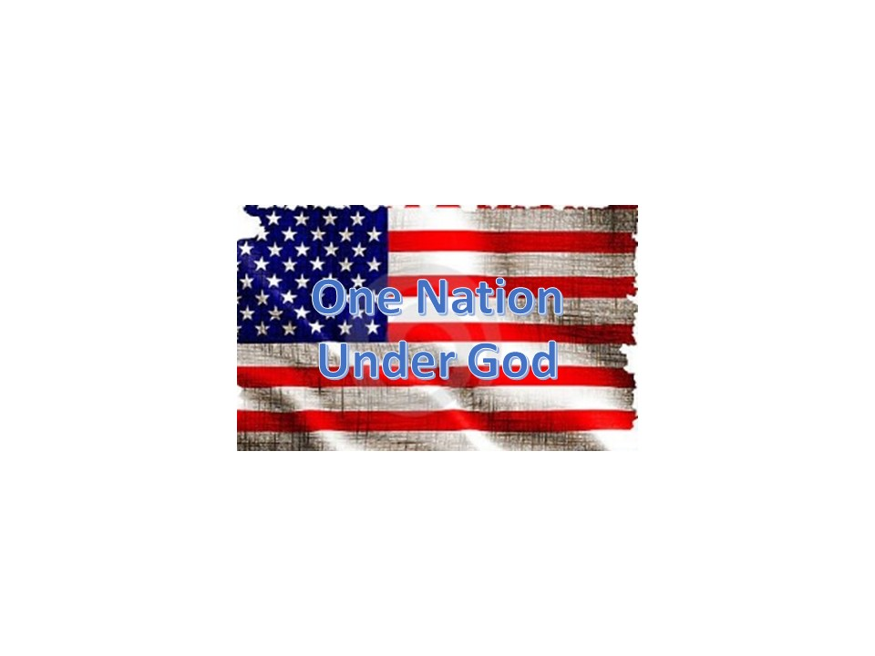

**Morning Glory**

This morning you looked a little blue,

It seemed your color had lost its hue.

Your red looked like fresh blood just shed,

From a wounded soldier now dead.

Your white was stained from many tears,

But because of you we have no fears.

For you are the red, white, and blue,

We will give up our lives to protect you.

For you old glory, brave souls have stood proud,

No leftist, terrorist, or freedom hater allowed.

For brave men and women do stand very tall,

They will defend the American way until they fall.

They will defend lady liberty to the bitter end,

To let old glory fly, no negotiation or bend.

For this is the land of the free,

A home made safe for you and me.

A place to say just what we think,

We can say the politicians do stink.

To go to a church of our own choice,

To be able to express our view with our voice.

A land of public news and a free press,

To tell the readers about a big mess.

Some would tarnish our flag so glorious,

But there it will stand, still victorious.

Because what you can’t see in the flag,

Is the American spirit that is no brag.

God bless our American troops who defend,

And Lord bring them home at war’s end.

I’m proud of our American heritage story,

And our flag makes each morning a day of glory!

ROTRUCK – ‘03

**Winston Churchill Quotes**

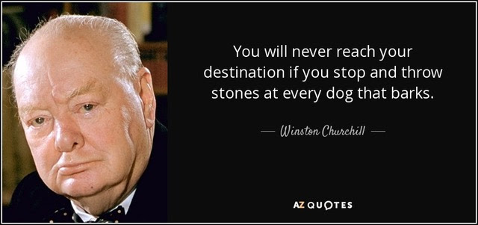

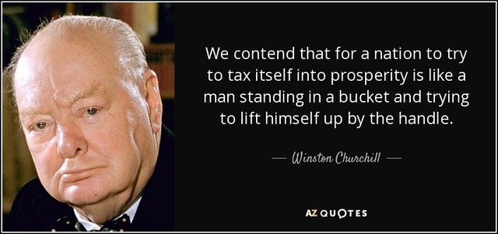

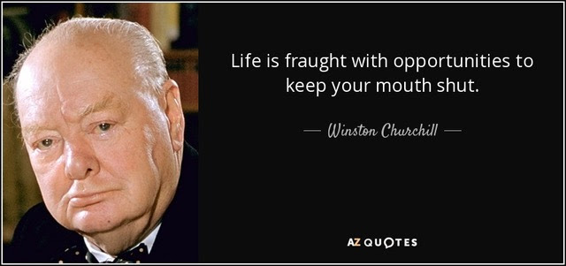

***Light Side***

**Listen Up Skipper**

Submitted by: Lee White

Through the pitch-black night, the captain sees a light dead ahead on a collision course with his ship. He sends a signal: “Change your course 10 degree east.”

The light signals back: “Change yours, 10 degrees west.”

Angry, the captain sends: “I’m a navy captain! Change your course, sir!”

“I’m a seaman, second class,” comes the reply. “Change your course, sir.”

Now the captain is furious. “I’m in a battleship! I’m not changing course!”

There is one last reply. “I’m in a lighthouse. Your call.” Oh My !!!

**

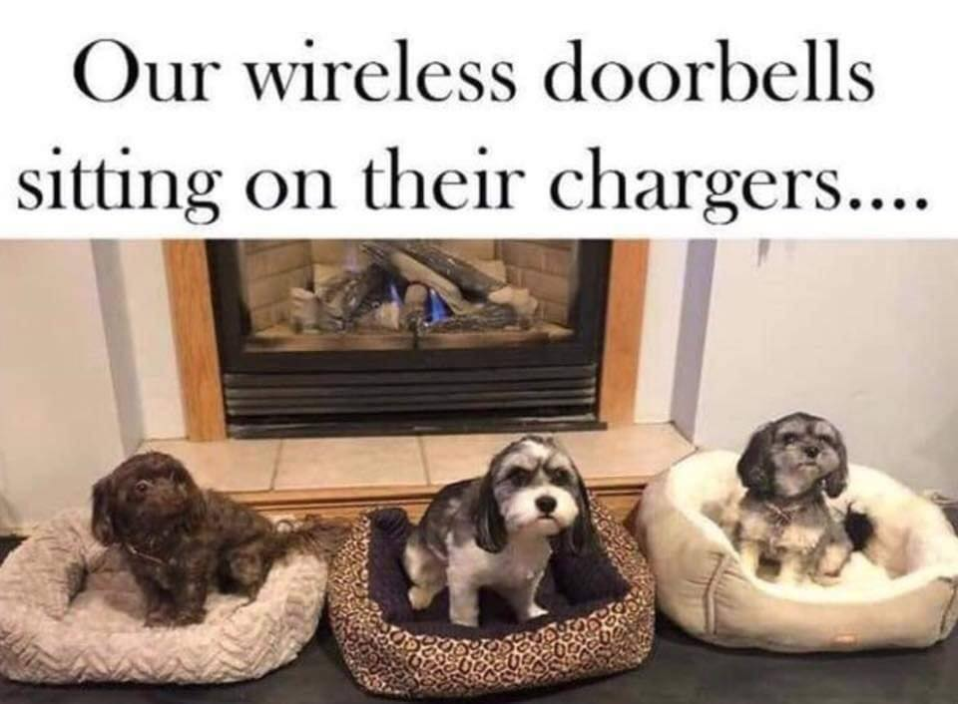

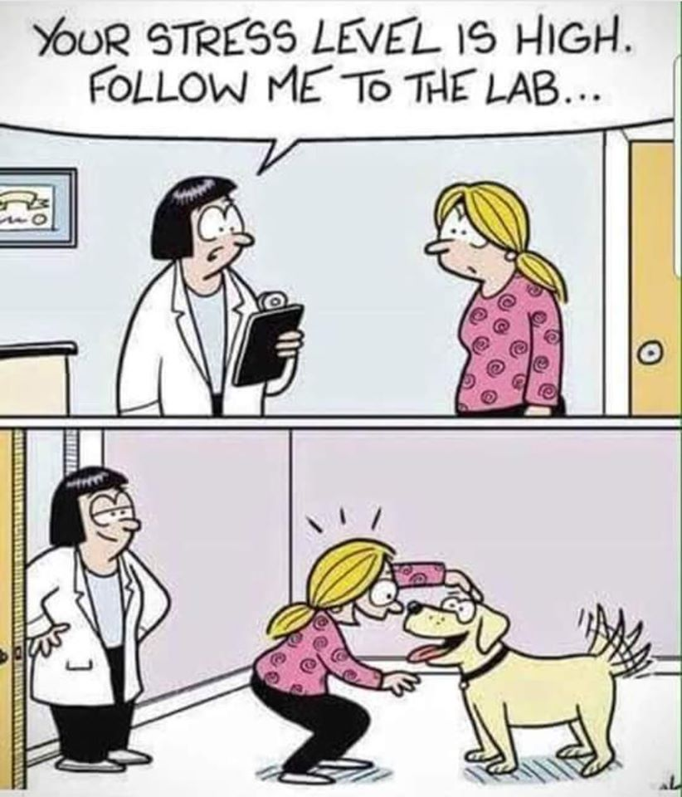

**Irreverent Old Folks**







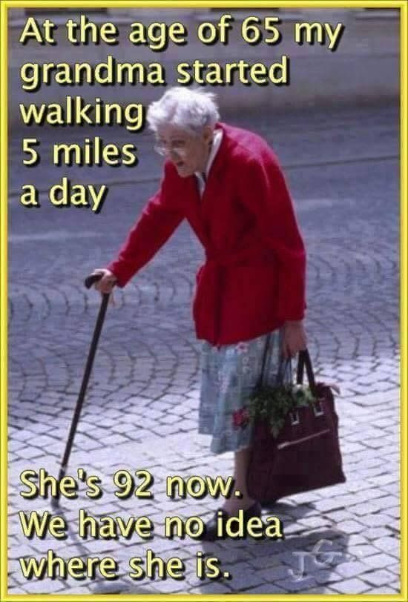



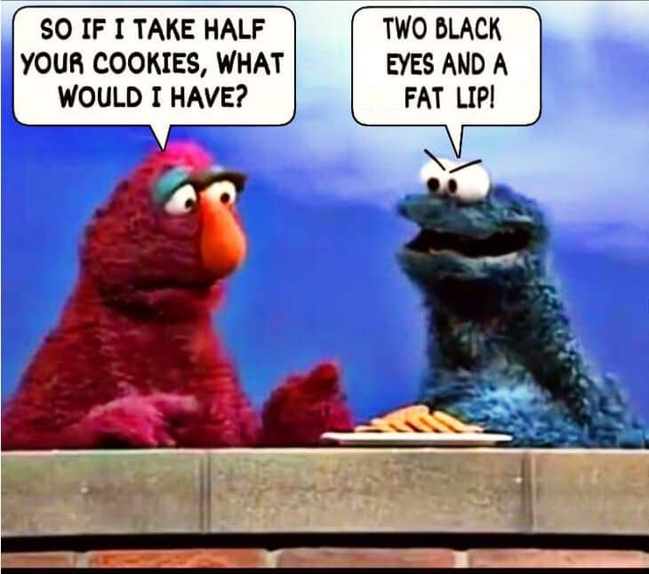



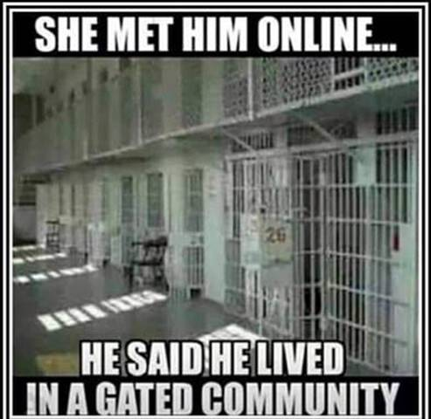

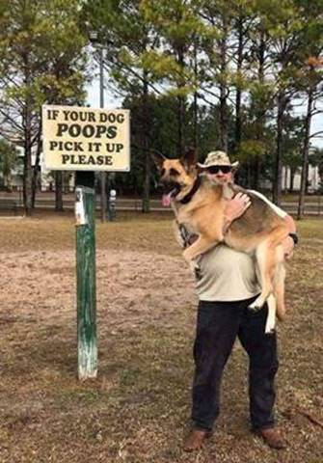

***Trivia Answer***

**Chest Candy –** Slang for ribbons and medals worn on a uniform. Can be insulting or applauding.

**Upcoming Events of Interest**

|  |  |  |  |
| --- | --- | --- | --- |
| **Event** | **Date** | **Location** | **Detail** |
| Chapter Mtg | 1/4/20 | SMDF&RBR |  |
| Chapter Mtg | 2/1/20 | SMDF&RBR |  |
| Chapter Mtg | 3/7/20 | SMDF&RBR |  |
| State Council Mtg | 3/14/20 | TBD |  |
| Chapter Mtg | 4/4/20 | SMDF&RBR |  |
| Chapter Mtg | 5/2/20 | SMDF&RBR |  |
| Chapter Mtg | 6/6/20 | SMDF&RBR |  |
| State Council Mtg | 6/13/20 | TBD |  |
|  |  |  |  |
|  |  |  |  |
|  |  |  |  |
|  |  |  |  |

**FRIENDS OF CHAPTER 1106**

|  |  |
| --- | --- |
| **Panera Bread**  9579 S. University Blvd. Highlands Ranch, CO 80126  720-348-1112 | **American Legion Post 1260**  **E:\Documents\ALP1187\images\AmericanLegion_logo.jpg** |
| **Spradlin Printing, Inc.**  11903 S. Parker Road Parker, CO 80134 | **South Metro Denver Fire & Rescue**  9195 E Mineral Ave  Centennial, CO 80112 |
| American Family Insurance  3989 E. Arapahoe Road #20  Centennial, CO 80122  720-361-0155 | A FULL-SIZE REPLICA OF THE HONOR BELL  **The Honor Bell Foundation**  PO Box 1432  Englewood CO 80150  720.282.9182  [www.honorbell.org](http://www.honorbell.org/) |
| 9137 E Mineral Cir Ste 100  Englewood, CO 80112-3422 | Logo of The Home Depot  **Home Depot Foundation**  8477 S Yosemite St  Lone Tree, CO 80124 |
| King Soopers logo.svg  King Soopers  9551 S. University Blvd., Highlands Ranch, CO 80126 | http://www.cruisin1430.com/sites/g/files/giy711/f/KEZW_Header_Large_Logo_0.png  **STUDIO 1430 Main Office:** 4700 South Syracuse Street, Suite 1050 Denver, CO 80237 |
| https://scontent.fapa1-2.fna.fbcdn.net/v/t31.0-8/10575197_682186265194110_4051472928662048560_o.jpg?oh=2630b186dcf3a20f1d7fc8fa25e0a5ba&oe=5A17C4AB  **Military Order of Purple Heart**, Chapter 1041, Arvada, CO | ZILLOW GROUP  10771 E. Easter Ave  Centennial CO 80112 |
| American Home Agents  Brian Karsh, Broker Associate  720-327-1562 |  |