Chapter 1106 Membership Meeting Minutes

Meeting Date: October 2, 2021 Scheduled Meeting Start Time: 9:00 AM

Meeting Location: South Metro Fire and Rescue Building, Meeting Rooms 1 & 2

Meeting called to order by President Lee White at 9:00 AM

Meeting Topics

1. Welcome to the meeting by President Lee White

2. Invocation Prayer by Chaplain Garry Turks and Moment of Silence

- Prayers for our Chapter members as we conduct our meeting today
- Prayers for Rich Eisenberg and Patti Ehline for continued healing
- Prayers for those in need and for those members who are sick and shut-ins

3. Pledge of Allegiance (all): lead by Lee White

4. POW/MIA Chair Presentation by Dan Green and Moment of Silence

Moment of Silence for those still POW/MIA and for Chapter members who have passed on.

5. Board Member Roll Call

Officers and Board Members Present Roll Call: Officers: Lee White (President), Dave Lyons (Vice President), Mike Huber (Treasurer), Milt Omoto (Secretary); Board Members Present: Reverend Garry Turks (Chaplain), Joe Plant, Patti Ehline, Ron Smith, John Vargas, Joe Dempsey, Tom Werzyn.

6. Members in Attendance (from sign-in sheets)

Ita Dempsey, Claudia Hunter, Jean Jaffe, Litta Plant-Schaper, Suzanne Sigona, Jai Smith, Leann Stelzer, Vieng Vongsakoun, Gwen Wilson, Bruce Arndt, Bob Brown, Cliff Butler, Donna Chaney, Bob Crago, Dale Creason, Steve Curti, Joe Dempsey, Bob Easter, Patti Ehline, Richard Eisenberg, Barry Fiore, Dan Graham, Dan Green, Leo Greunke, Lou Grounds, Ted Hanfelder, Warren Harrison, Mike Huber, Jack Hunter, Alan Jaffe, Marvin Lich, Walt Leuci, Chuck Luley, David Lyons, Bob Mallin, Jim McGrevey, Don McNeely Sr, Harry Montgomery, Tony Nickerson, Milt Omoto, Gary Palka, Ed Phillips, Joe Plant, Steve Robertson, Joseph Robinson,

Clarence Rebolledo, Bob Rotruck, Edward Seiler, John Sheadel, Ron Smith, Charles Smith, Jerome Springs, Gary Steinhoff, Garry Turks, Dan Wagle, Tom Werzyn, Lee White, David Yates.

Note: If your name does not appear on this list but you were there, that is because you did not sign-in

On-line Attendees via Zoom: Michelle Mallin, Jim Williams, Jesse Maldonado.

7. New Members and Guests (including members who have not attended in a while)

Gwen Wilson, Lou Grounds, Jerome Springs, Charles Smith, Don McNeely, Jim Chisel

8. Chapter Meeting Minutes Approval

Minutes of the September 4, 2021 Chapter Membership meeting were emailed to each member.

Motion 1. Motion to approve the VVA Chapter 1106 Minutes dated September 4, 2021, made by Dave Lyons and second by Tony Nickerson; the minutes were approved.

9. Special Presentation: Dr. Nickie-Rivale Bell, CCSD

The Cherry Creek School District (CCSD) provided a breakfast to meeting attendees. Dr. Bell extended appreciation to military and veterans for their sacrifice and service to the Country. Chapter members appreciate what CCSD does in support of active military and veterans in the community.

10. President’s Report: Lee White

- The October Poppy Drive is set for Saturday, October 9th at four King Soopers locations; each LZ leader have been provided with material for their location; additional participants are needed at certain locations;
- Lee is working with Texas Roadhouse in Parker for a November fund raiser; the restaurant will provide free lunch to veterans on Veterans Day, November 11th; Lee and Milt will be meeting with the restaurant on Wednesday, October 6th;
- Committee members are needed for the following Committees: (a) Speakers Bureau, 2-3; (b) Social Committee; (c) Scholarship Committee;
- Please support the King Soopers Community Rewards Program; we need more participants; Litta and Milt are available to assist you in signing up;
- Our Christmas Luncheon is scheduled for Saturday, December 18th; more information will be provided by John Vargas;
- The Promotional Committee includes Joe Dempsey, Ita Dempsey and Leann Stelzer; they can order additional Chapter yellow Polo shirts as requested; orders must be paid in advance.

11. Vice President’s Report: Dave Lyons

- Dave nothing to report.

12. Treasurer’s Report: Mike Huber (on Zoom)

- The Treasurer’s Report was presented by Mike Huber;
- The scholarship fund currently has $250.

Motion 2. Motion to approve the Treasurer’s Report made by Bob Rotruck; the report was approved.

14. Secretary’s Report: Milt Omoto

- Please support the Chapter Poppy Drives; participating in Chapter Poppy Drives is a great way for Chapter members to interact with the community in addition to being an important fund raiser;
- Information on how to link your King Sooper’s Rewards Card to our Chapter is provided on the back table; contact Milt if you need instructions at omoto.milt@gmail.com;
- Please continue to support the VVA Household Goods Program; the monthly amount that each Colorado Chapter receives from this program increased recently;
- The National VVA Convention s is November 2-6 in Greensboro NC; the candidates for election are pretty much the same as the current slate of Officers and Directors, all are up for re-election; there are a number of Convention Resolutions and Proposed Amendments; many resolutions relate to the future of VVA (being a “last man” standing organization), issues on agent orange, the Veterans Administration, POW/MIA, veteran benefits, women veterans and homelessness;
- There are 19 proposed amendments to the VVA National Constitution that will be discussed and voted on; some of the amendment changes relate to conducting on-line meetings due to COVID issues; there are several amendments proposing changes to the organization name and HQ location; Milt submitted an amendment (#09) that proposed to change the required number of members to start a new Chapter from 25 to 15; Amendment – 09 is attached at the end of these minutes.

15. Board Member and Committee Reports

- Membership (David Lyons): Dave reported on the current total number of VVA members and AVVA members for National;
- Veterans Emergency Assistance Program (Joe Plant): The Chapter assisted three veterans in the month of September to get them off the street; the program spends about $1,000 per month helping veterans in need;
- Chaplain’s Report (Rev. Garry Turks): Chaplain Turks continues with his Chaplain calls to members; please let Chaplain Turks know of those who are sick, shut-in and in need of Chaplain services; he continues to pray for Michelle Mallin;

- Speakers Bureau (Tom Werzyn): The Speakers Bureau is active for the current academic year; during the meeting, Dave Lyons and Lou Grounds volunteered to be on the Speakers Bureau; let Tom know if you are interested in becoming part of the Speakers Bureau;
- Grants and Fundraising (Milt Omoto): nothing further to report;
- Events Coordinator (Ron Smith): Ron reported that we are fully staffed for the Chapter Poppy Drives scheduled for October 9th;
- October 9th (Saturday): There will be four Poppy Drive locations; Smoky Hill & E470, Buckley and Quincy, Parker and Highlands Ranch;
- November 13th (Saturday): There will be five Poppy Drive locations (the ones above plus the store at Smoky Hill and S Himalaya in Centennial; we will need volunteers for these November locations;
The Poppy Drives run from 9:00AM to 1:00PM;
- Scholarship Committee (Jim Marcelle): Absent
- Social Committee (John Vargas): John reported that caregivers who provide care and support to loved ones have a difficult task and are in need of support and appreciation; he encouraged everyone to “never give up!”; John provided a cupcake with a candle to celebrate Rich Eisenberg’s birthday; members sang happy birthday to Rich, who came up to the podium and blew out the candle; our end of year Holiday Lunch is December 18th at Maggiano’s from 11:00Am to 1:00PM; cost is $20/person and we request registration and payment in advance, with no walk-ups allowed on the day of the event; no children under the age of 18 and attendees are encouraged to dress in holiday attire; also, Joe Plant and Clarence Rebolledo agreed to join the Social Committee to assist John;
- Voices for Veterans (Warren Harrison): Warren reported that the VA mental health program has a change in management with a new Chairperson; Warren will continue to be involved with the program; the VA is encouraging peer-to-peer groups;
- Women Veterans, Veterans Health, PTSD, Agent Orange (Patti Ehline): Nurse Patti encouraged everyone to get their booster shots; you can get it at a number of locations including the VA, Safeway, Walgreens, King Soopers, CVS as well as certain drive through locations; Patti expressed appreciation for prayers for healing of her back, which has improved significantly; she also lost weight to protect her spine; she participated in the Voices for Veterans Mental Health Summit; she continues to work with the VA on Community Care program issues to improve the system (let her know if you have issues); Patti encouraged everyone to get a VA Health Card even if you are on Medicare and/or a private health care program; she recently provided lap blankets to the Cancer Center at Sky Ridge Medical Center; Patti encouraged everyone to talk to each other to find out more about others; she sited an example of a discussion with Chaplain Garry and discovered that they were both at Chu Lai at the same time, and that Garry, after being wounded, was sent to the ER where Patti worked; finally, she stated that you can get your flu and booster shots at the same time;
- Veterans Treatment Court: No current activity; however, David Yates, who participates in this program, encouraged member involvement with the Veterans Treatment Court; Chaplain Garry also indicated that he is involved with the program;
- AVVA Chapter Liaison (Litta Plant-Schaper): Nothing to report;
- Webmaster and Newsletter (Bob Rotruck): Bob reported that Barbara continues to heal from her surgery and is in therapy; the November/December newsletter is coming along nicely; please send articles to Bob;

- Government Affairs (Tony Nickerson): Tony reported that there are 75 veterans in the House of Representatives and 16 in the Senate; some are still serving in the Reserves or National Guard; there are also women veterans;
Tony reported on a number of key Bills introduced:
- Modify reimbursement to third-party service providers; the veteran is still responsible for payment and it is important to notify the VA when this happens;
- Reinstate criminal charges to those providers that charge unauthorized fees;
- There are over 2,000 bills introduced that affect or impact veterans;
- The VA is required to study the financial condition of veterans experiencing housing instability;
- A Colorado Constitutional Bill is being considered that will impact service connected disability ratings for tax reduction purposes; currently, a rating of 100% enables a veteran to reduce their property tax by 50%; this Bill will enable veterans with a rating of 50% or more to get this benefit; the Bill is HCR 21-1001;
- S.189 is the Veterans' Compensation Cost-of-Living Adjustment Act of 2021; the VA must increase the amounts by the same percentage as the cost-of-living increase in benefits for Social Security recipients that is effective on December 1, 2021;
- A five year rule gives the VA the authority to assess the disability rating on a 5-year basis to adjust the rating if required; the 10-year rating rule states that the VA cannot change the disability rating if the rating has been in effect for 10 or more years unless the disability improves; permanent disability is regarded as permanent.
- Color Guard (Tony Nickerson): The Color Guard participated in the CCSD Veterans Appreciation event and football game; they will be at the Ben Franklin Veterans Day event on November 11th.

16. Roundtable

- Suzanne Sigona reported on the Wall That Heals (Brighton); she stated that the President of the Vietnam Veterans Memorial Fund (VVMF) was in attendance and was impressed by the number of veterans assisting at the event; Clarence Rebolledo shared his experience as a volunteer at the event; he has never been to DC to visit the Wall; at the Wall in DC there is a plaque for those Vietnam veterans who returned from the war but died from service connected issues; the plaque reads: “In Memory of the men and women who served in the Vietnam War and later died as a result of their service. We honor and remember their sacrifice;” VVMF also has a In Memory Program; there are 58,281 names on the Wall after an audit corrected errors;
- If you are missing a medal that is shown on your DD214, contact Barry Fiore and his organization, The Forgotten Heroes Campaign, will get the award for you; they put the medal in a shadow box and present it to you in a formal ceremony; several Chapter members received their missing medals from this program;
- If you were awarded a medal that is not shown on your DD214, you must submit a written request for a correction (DD Form 215) to the Department of Defense, Army Review Boards Agency (ARBA);
- Alan Jaffe asked for contact information of all Chapter members; Lee stated that due to privacy concerns, the Chapter roster contact information is not provided to all; anyone wishing to contact another member should get hold of a Board member for contact information;

17. Drawings (Ron Smith)
- Pictures of the Wall That Heals were raffled;
- A “goody bag” from the CCSD veterans appreciation event was raffled;
- The 50/50 Drawing had a total of $79 was won by a Chapter member.

18. Announcements

- A Chapter Fund Raiser is scheduled for November 11th at the Texas Roadhouse in Parker;
- The Ben Franklin Academy Veterans Day event is November 11th at 8:45AM;
- The next Vietnam Veterans War lapel pin presentation is December 4th at our Membership meeting;
- The Chapter Holiday lunch is December 18th;
- The November speaker may be a representative of TREA.

19. Membership in Sickness or in Need of Support

- Please continue to keep Michelle Mallin and Rich Eisenberg in your prayers;
- Please pray for Cookie White for healing and restoration of her health;
- Please let Chaplain Garry Turks know of members and family members who are ill or in need of support

20. Schedule

- The next Chapter Board Meeting is scheduled for October 30th at 9:00AM via Zoom;
- The next Chapter Membership Meeting is Saturday, November 6th “live” at the South Metro Fire and Rescue Building; all membership meetings will continue to be held in our new meeting location (Meeting Rooms 1 & 2) through the end of the year;
- The November Poppy Drive is Saturday, November 13th .
The Next Chapter 1106 Membership Meeting is scheduled for November 6, 2021 at 9:00AM – Live! Zoom capability will be provided to those who cannot attend the meeting in person.

The membership meeting was adjourned by declaration with no objections by President Lee White at
10:31 AM

This Chapter Membership Meeting minutes is submitted by Milt Omoto, Chapter Secretary.
____________________
Published: 100321

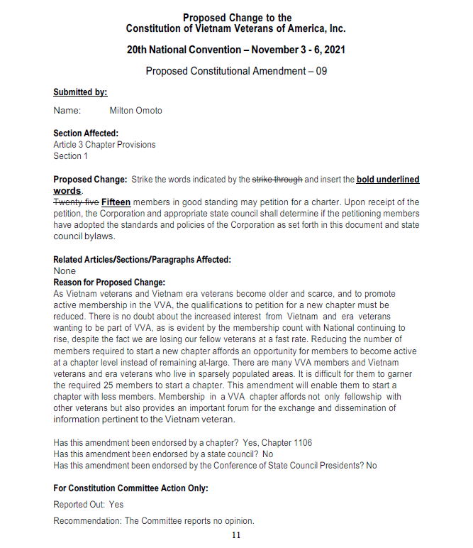
Circulation Notice: These minutes may contain sensitive and/or personal information; therefore, please use discretion when sharing this information with non-VVA members. Note that this is the web version of the meeting minutes posted to the Chapter website.

