**Inside this issue:**

Notes from the President

[Member Feature](#Memberfeature)

[Military Trivia](#Militarytrivia)

[Guest Speaker](#Guestspeaker)

[Membership](#Membership)

[Board of Directors/Officers](#Boardofdirectors)

[Working Committees](#Workingcommittees)

[Meetings/Events Calendar](#Meetingsevents)

[Announcement Corner](#Announcementcorner)

[Books/Articles Published by Mbrs.](#Booksarticles)

[From the Editor](#Fromtheeditor)

[Light Side](#Lightside)

[Trivia Answer](#Triviaanswer)

**Notice:**

If you have moved or changed your address, PLEASE notify us immediately! Contact: Dave Lyons, Membership Chair

E-mail: [Snoyldavid@centurylink.net](mailto:Snoyldavid@centurylink.net)

Phone:  303 690 8776

###### COPYRIGHT NOTICE: In accordance with Title 17 U.S.C. Section 107, any copyrighted material in this newsletter is distributed under fair use without profit or payment to those who have expressed a prior interest in receiving the included information for nonprofit use and educational purposes only.

**Facebook: Vietnam Veterans of America Chapter 1106**

***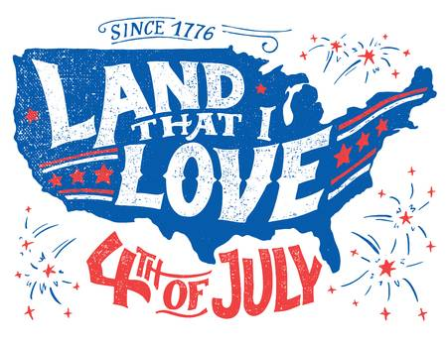Editor’s Note:***

This version of the newsletter is in Microsoft Document (.DOCX) format so that the links will work. Put your cursor over the link, depress your Control Key (ctrl) and depress your left mouse button and it will take you to the listed link position. PDF format, the links will not work.

The comments and editorial input does not necessarily reflect the opinion of the membership of our chapter. I would appreciate any feedback that you might have, items you liked or if you find offensive or derogatory in anyway. ([bobrotruck73@gmail.com](mailto:bobrotruck73@gmail.com)) Thank you for allowing me to be your editor.

***Notes from the President***

Lee White

I can’t believe it’s mid-year already, and enduring current life changes, but moving forward.

VVA chapter 1106 members, even with the fact we can’t meet “face to face”, are conducting chapter business. With 2020-2022 elections over resulting in a new Treasurer, Mike Huber, and a new Secretary, Milt Omoto.

Our Scholarship Committee just completed reviewing some 58+ applications, and have interviewed 12 finalists, with selection of 6 scholarship awardees.

Our chapter began the “buddy check” initiative calling our fellow veteran members to ask on how are they doing and if they need any chapter support.

We all had to step up with learning more about “zoom teleconferencing” to conduct our monthly board and membership meetings. This method of communication has worked well during the past couple meetings and will continue until South Metro Fire & Rescue opens up the “community rooms”. Expectation on when they open, early fall, I hope.

Until we meet again, stay safe, and healthy.

***“Member Feature”***

From Warren Harrison

**The Flag**

From first grade through grade 6 we said Pledge of Allegiance to the flag at the start of each school day. I went to a small intercity school and if you did well in class you got to be a crossing guard or on the Color guard. I was appointed to the Color guard and on good weather days we hoisted the flag on the pole outside of our school. We learned how to fold the flag and how to not let it touch the ground.

In Junior High School I believe we said pledge of allegiance at the start of each period. As many of us boys and girls born through the war we had few dads or fathers at home. I was in the boys YMCA and went to summer camp on a work scholarship in seventh grade and was the mess hall porch sweeper who was also tasked with raising the flag each morning at Camp Chief Ouray near Granby, CO. This was the year when the flag had 48 stars but we had 49 states. We were given allowance to use the 48 star flag until the 50 star flag was designed and authorized.

Also during the school year I participated in the Civil Air Patrol. At the hanger which is now Wings over the Rockies at Lowery Air base I was in the Color Guard for a few events.

In High School I joined ROTC and was a cadet for 1 Semester. I then started wrestling and dropped out of ROTC.

At Colorado School of Mines it was mandatory in the 60’s for all male US citizens to take two years of ROTC. After two years you could then select to take advanced ROTC and enter the Army as an officer after completing 2 years of ROTC classes and one 8 week summer camp.

I dropped out of school for one semester to get money to finish and turned 21 in New Orleans while working in the oil fields. I learned that I was on the list to be drafted so I came back to Colorado and voluntarily enlisted in advanced ROTC at Colorado School of Mines. All students at that time as it was a land grant College, were required to take two years of ROTC. I graduated went to summer Camp the Year after. At summer camp I received my commission as a 2nd lieutenant in the Corps of Engineers. My active duty was delayed and I went to Engineer Officer basic training at Ft Belvoir, VA in March 1968. I served as Platoon leader in an Atomic demolitions unit for 9 months.

I received orders for Viet Nam in March 1969. While in Vietnam I was an Engineer officer in a Civil Affairs Platoon attached to MACV Team 67 at Phuoc Long Province Headquarters at Song Be. While there our MACV team medic was killed during a lunch time mortar attack.He was Hispanic rom Texas and a greatly respected member of the team.

We had a memorial service and at the service I asked the unit commander why we were not flying the stars and stripes at all during the ceremony or at half-mast. He replied that as we were attached to a Vietnamese unit we had to fly the Vietnamese flag during the memorial ceremony.

When I returned to the States I was hired by a Canadian contractor as a shaft engineer for sinking the shaft at the Henderson Mine near Empire Colorado for the Climax Molybdenum Company. I started work there in March of 1970. One day the general superintendent approached me with an American flag and pole in the office and asked that I climb the Headframe stairs (approximately 180 feet) and setup the Flag on top of the Headframe. I asked if the Mechanic or top lander could help me and he said no. So I did it myself and took a picture of the flag flying from the top of the Headframe.

Fast forward forty three years (2013) and I have my own construction company and am doing work to control waste water outflow from the Summitville Mine near South Fork, Colorado. Me and my engineer are staying in Motel in Summitville and an older gentleman asks us at Breakfast if one of us had gone to Colorado School of Mines. I replied that I and my engineer and the inspector who was with us had all gone to mines. He said he was originally from Creede, Colorado and went to Mines and was retired and just completed a book about Creede mines and was writing a book about the Summitville Mine.

After several conversations I asked him if he had worked in the mining Industry. He sat he was a superintendent and Project Manager for Climax and worked at the Henderson Mine.

He told the following story that the operating Engineers Union was going to go on strike on July 4 1970 as there was a rumor that the Canadian contractor crew was going to fly the Canadian flag on top of the No. 2 Shaft Headframe on the 4th of July.

I told him that I was the person who put the American flag on top of the headframe that July. I since gave a copy of the picture I took of the Headframe of Shaft No, 2 that July 1970. In 2014 one of the operating engineers and a Korean War veteran died and I went to the funeral. Several of the attendees were ex Operating Engineers and I asked them if this story was true and they confirmed it.

I also found out later that the General Superintendent a Canadian was a Canadian Army Veteran Paratrooper and participated in the Canadian forces on D-Day in France.

***Military Trivia***

**Hooyah** [Click here for end of the Newsletter Trivia Answer](#Triviaanswer)

***Guest Speakers – May* - None**

***Special Speaker – June* - None**

**May Bio Speaker - None**

**June Bio Speaker - None**

***Membership!*** (As of 6-21-20)

VVA 153

VVA 38

Total: 191

Welcome New Members:

**VVA**

Jessie Maldonado

Richard Eisenberg

James Martindale

**AVVA**

Sandi Maldonado

***Board of Directors/Officers***

Lee White - President

Dave Lyons - Vice-president

Mike Huber – Treasurer

Secretary – Milt Omoto

Board Members - Patti Ehline, Glen Payne, Tom Werzyn, Ron Smith, John Vargas, Dan Green, Joe Plant

***Special Chapter Positions***

AVVA Liaison to chapter Board of Directors - Litta Plant-Schaper

Chaplain – Rev. Garry Turks

Chapter Historian – John Vargas

Database/Audio – Jack Hunter

Government Affairs – Tony Nickerson

Sergeant-at-Arms – Rob Senatore

Chapter Nurse – Patti Ehline

***Working Committees***

* Agent Orange/PTSD – Patti Ehline
* Color Guard – Jay Quiring (Command Sergeant),
* Don McNeely, Dan Green, Thom Frey, Clarence Rebolledo, Robert Senatore, Tony Nickerson, Ron Smith, Leann Stelzer, Alexis Winemiller
* Event Coordinator – Ron Smith – Chair, Lee White, Michelle Mallin
* Fundraising/Grants – Milt Omoto
* Marketing/Media/Events – Tom Werzyn, Michelle Mallin
* Membership – Dave Lyons – Chair, Lee White
* Mental Health: Patti Ehline, Warren Harrison, Joe Plant
* Name Tags – Litta Plant-Schaper
* Newsletter Editor - Bob Rotruck
* Promotional Items: Leann Stelzer, Clarence Rebolledo
* Refreshments: Alexis Winemiller, Jason Longmore
* Scholarship Program – Mike Karsh and Jim Marcille, Co-chairs, Glen Payne, John Vargas, Brian Karsh (supporter), Bob Mallin (supporter)
* Social –Barry Fiore, Glen Payne, Milt Omoto, Mike Karsh, John Vargas
* Speakers Bureau – Tom Werzyn – Chair, Bob Easter, Bob Mallin, Glen Payne, Roger Lanphier, Donna Chaney
* Veteran Emergency Assistance Committee - Joe Plant, Dave Lyons, Dan Green, Bruce Arndt, Lee White
* Voices for Veterans - Warren Harrison, Patti Ehline, Joe Plant, John Vargas
* Webmaster – Bob Rotruck
* Women Veterans - Patti Ehline

**Meetings/Events Calendar - 2020**

July 4, 2020 - VVA Chapter 1106 Monthly Meeting via tele/conference call/video

July 14-18, 2020 National Leadership Conference Cancelled

Aug 1, 2020 - VVA Chapter 1106 Monthly Meeting

Aug 15, 2020 - VVA Chapter 1106 Fall Picnic - maybe

Aug 29, 2020 – Cherry Creek School District – Football Game/Veterans Appreciation Day – Cancelled

Sept 12, 2020 – CO State Council Meeting – Castle Rock

**CITIZEN HERO - LITTA PLANT-SCHAPER**

Submitted by John Vargas

Every now and then our paths are fortunate to come across a person with an abundance of energy and willingness to help others. That’s how many of my fellow VVA 1106 Board Members describe Litta Plant-Schaper. I asked myself a fair question? Who is this lady and what makes her so special? Being a witness certainly helped! Our annual VVA Chapter 1106 family picnic was just a few months away and gaining on our small Social Committee staff. We had the responsibility to attract our members and fill part of Saturday with fun, food, desserts, soft drinks, music, more food and a theme. At one of our monthly Chapter meetings the topic of the picnic was talked about and an attractive dark-haired lady raised her hand and said, “You can count on me to help”. We’ll come back to this!

Litta was born in Munich Germany to Dora and Joseph Plant. She has been married to Detlef for over 24 years. Together they have three children, Desiree, Amber and Michael the youngest. She has five grandchildren ranging from 5 to 16 years of age. She is a US citizen and a graduate of Green Mountain H.S, in Lakewood, Colorado. Litta completed two years of collage at Faith Bible Chapel in 1997. Her passion was always mathematics. A necessary tool if you’re going to have a career as a renowned and highly successful insurance agent. She has over 34 years of experience helping others. She was selected as a top agent on numerous occasions and was rewarded with an all-expense paid trip to Bermuda. Here’s just a few of this cypher’s activities. Traveling, scuba diving, salsa and swing dancing, bowling, sailing, theater and Mahjong! Oh, did I forget, in the year of 2011 she received her motorcycle license.

Back to Litta’s volunteering. Our Western Theme Family Picnic was a big success. She went shopping for food and side dishes. Her and her family helped dress up the picnic area with bales of hay and other western accessories. She personally put together homemade “goodie bags” for all of the attendees. Our Social Committee was thankful for her assistance. Litta is also responsible for hosting, along with Grand Prix Motor Sports, an annual Motorcycle fund raising show. The proceeds were donated to our Chapter. She has taken over the responsibilities as the VVA 1106 sender of Welcome and Holiday Cards and name tag provider for the Chapter members. As a big supporter of Women who have been abused, she collects, clothing, shoes and telephones for these shelters. She is also a strong advocate for Animal Rights. Why am I not surprised! This current Pandemic has not slowed her down! She is helping to organize the Board’s Tel-conferencing calls and future Chapter Zoom meetings. She became an Associated Member of VVA 1106 in March of 2015. Is there anything that this lady cannot do? We are so fortunate to witness her energies to our Chapter, her family and Community. It is with great pleasure and admiration that we recognize Litta Plant-Schaper with this Citizen Hero Award.

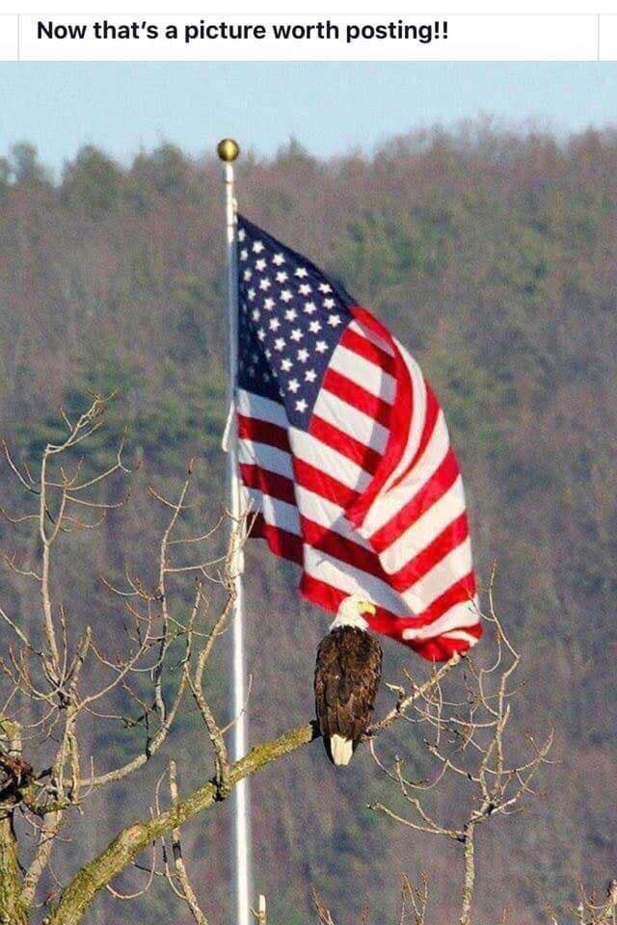

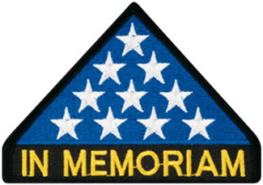

***In Memoriam***

Dear Friends and Volunteers,

I write with deep sorrow for the loss of our dearest friend and gifted sculptor of the Vietnam Women’s Memorial. Glenna Goodacre, 80 years old passed away on April 13, 2020. She is a heroine to Vietnam veteran women for designing and sculpting a monument honoring them and for assuring that their service and bravery be an inspiration for generations to come. This first monument in our nation’s history honoring military women, and civilian women serving in support of our Armed Forces, was dedicated on the National Mall on Veterans Day, 1993.

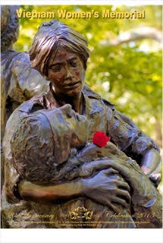

Glenna has left us with these words:

‘My desire to create a lasting tribute to the American women serving during the Vietnam War is founded upon my deep respect for each of them, and my heartfelt prayer for their “hope and healing.” I have been humbled by the enormity of such a task yet incredibly honored by the overwhelming gratitude of the veterans. The emphasis of this tribute is centered on their emotions; thier compassion, thier anxiety, their fatigue, and above all, their dedication. ………That my hands can shape the clay which might touch the hearts and heal the wounds of those who served fills me with humility and deep satisfaction. I can only hope that future generations who view the sculpture will stand in tribute to these women who served during the Vietnam era.” Glenna Goodacre

And now we stand in tribute to Glenna: honoring her legacy with our heartfelt gratitude for creating a lasting monument to help heal the wounds of war. I had hoped that Glenna would soon be reading my book, for release Memorial Day: Healing Wounds, A Vietnam War Combat Nurses’ 10-year Fight to Win Women a Place of Honor in Washington, D.C. Glenna helped us win that fight; she is a prominent part of my story and featured in the hard-fought effort to accomplish our dream to recognize and learn about America's brave women by placing a statue honoring their service near the Wall and the statue of the Three Servicemen. On behalf of the Vietnam Women’s Memorial Foundation, and the thousands of women honored by Glenna’s sculpture, I extend our deepest sympathy to the Goodacre family. May the healing power of her enduring legacies also be healing for them as they proudly remember her contribution to America.

Diane Carlson Evans

Founder, Vietnam Women's Memorial, Washington DC

Chair, Vietnam Women's Memorial/Eastern National Advisory Group

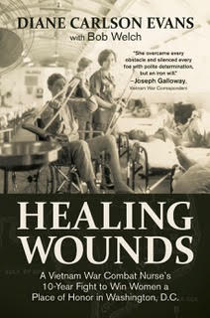

**Together in Spirit**

From Suzanne Segona

The Wall Volunteers normally present a wreath at the Memorial Day ceremonies. We decided that those men and women needed to be remembered by us even more this year than in other years when so many are there to honor them. Through the efforts of local citizens (who were not acting as volunteers), we accomplished our mission.

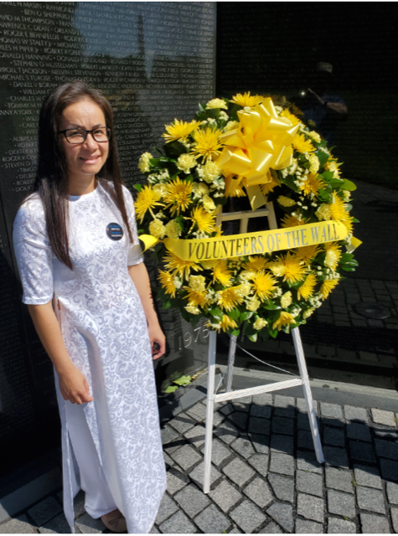

Volunteer Huong Le with Volunteer wreath – Memorial Day weekend 2020

Many thanks to Connie ‘The Flower Girl’ Quickstad for getting an absolutely spectacular Volunteer wreath for The Wall for Memorial Day 2020! And thanks to those who were able to attend our small ceremony at 1000 hours that morning. Bill Walters, Les Davison, Huong Le and Thao Pfung, Annmarie Emmet and Jim Knotts from VVMF. Beautiful weather. Virtually no people.

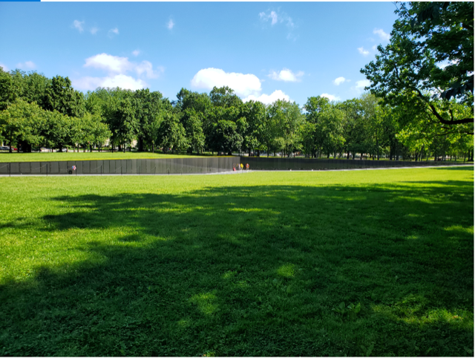

But the Volunteer spirit was there. One of the strangest things…pointed out by Jim…is the silence. Usually there are airplanes into Reagan National every 2-3 minutes. A couple hundred thousand motorcycles. The din of many thousands of voices. But today was silence. I think I saw and heard only 2 aircraft in the 2 hours I was at The Wall. This is ‘Take 10’ of photos for Memorial Day weekend. I’ve got a bunch more to send. If you have any that you would like to share from days past please send them to me and I’ll get them posted. Thanks everyone.

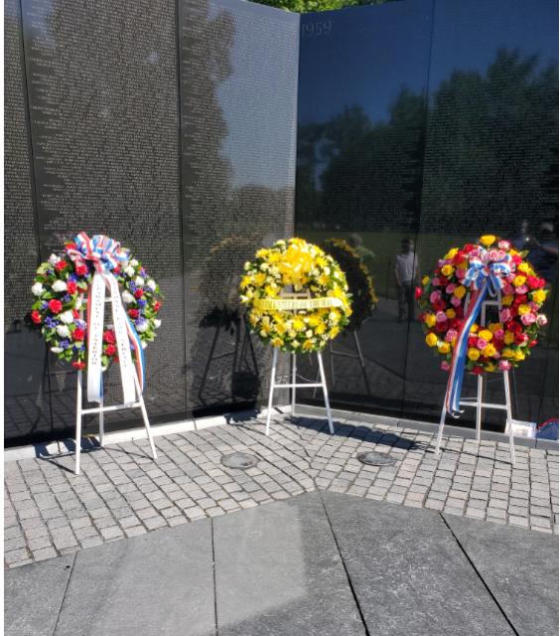

Wreaths (L – R) Department of Interior/NPS, The Volunteer Wreath, SDIT Wreath

**This is a Great True Story**

When baseball greats Babe Ruth and Lou Gehrig went on tour in baseball-crazy Japan in 1934, some fans wondered why a third-string catcher named Moe Berg was included. Although he played with five major-league teams from

1923 to 1939, he was a very mediocre ball player. But Moe was regarded as the brainiest ballplayer of all time. In fact Casey Stengel once said: "That is the strangest man ever to play baseball.” When all the baseball stars went to Japan, Moe Berg went with them and many people wondered why he went with "the team."

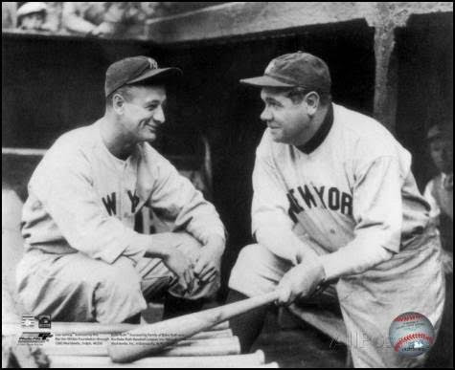

**Lou Gehrig and Babe Ruth**

The answer was simple: Moe Berg was a United States spy, working undercover with the CIA. Moe spoke 15 languages - including Japanese. And he had two loves: baseball and spying. In Tokyo, garbed in a kimono, Berg took flowers to the daughter of an American diplomat being treated in St. Luke's Hospital - the tallest building in the Japanese capital. He never delivered the flowers. The ball-player ascended to the hospital roof and filmed key features: the harbor, military installations, railway yards, etc. Eight years later, General Jimmy Doolittle studied Berg's films in planning his spectacular raid on Tokyo.

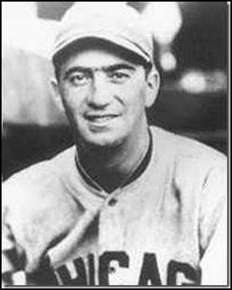

**Moe Berg**

His father disapproved of his baseball career and never once watched his son play. In Barringer High School, Moe learned Latin, Greek and French. Moe read at least 10 newspapers every day. He graduated magna cum laude from Princeton - having added Spanish, Italian, German and Sanskrit to his linguistic quiver. During further studies at the Sorbonne, in Paris, and Columbia Law School, he picked up Japanese, Chinese, Korean, Indian, Arabic, Portuguese and Hungarian - 15 languages in all, plus some regional dialects.

While playing baseball for Princeton University, Moe Berg would describe plays in Latin or Sanskrit.

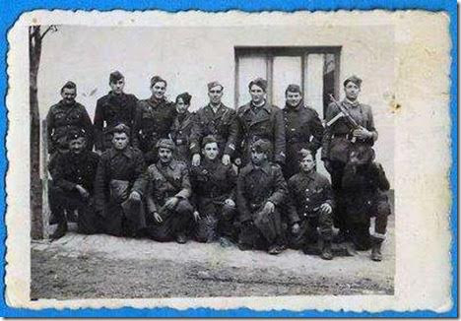

**Tito's partisans**

During World War II, Moe was parachuted into Yugoslavia to assess the value to the war effort of the two groups of partisans there. He reported back that Marshall Tito's forces were widely supported by the people and Winston Churchill ordered all-out support for the Yugoslav underground fighter, rather than Mihajlovic's Serbians. The parachute jump at age 41 undoubtedly was a challenge. But there was more to come in that same year. Berg penetrated German-held Norway, met with members of the underground and located a secret heavy-water plant - part of the Nazis' effort to build an atomic bomb. His information guided the Royal Air Force in a bombing raid to destroy that plant.

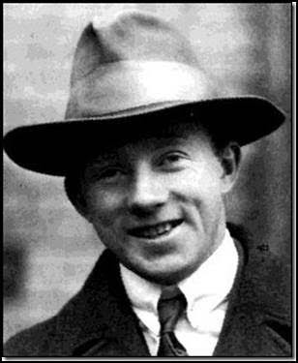

**Werner Heisenberg - he blocked the Nazis from acquiring an atomic bomb.**

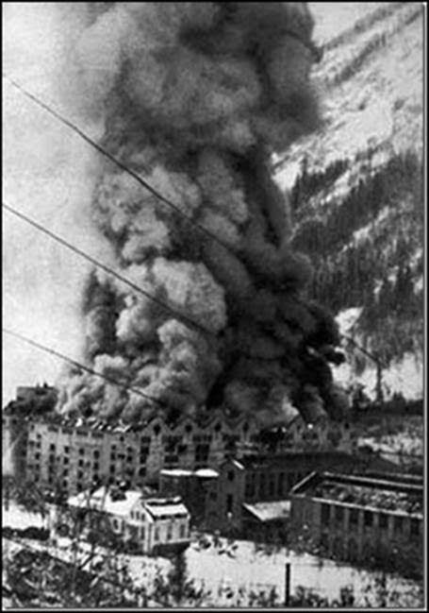

**The R.A.F. destroys the Norwegian heavy water plant targeted by Moe Berg.**

There still remained the question of how far had the Nazis progressed in the race to build the first Atomic bomb. If the Nazis were successful, they would win the war. Berg (under the code name "Remus") was sent to Switzerland to hear leading German physicist Werner Heisenberg, a Nobel Laureate lecture and determine if the Nazis were close to building an A-bomb. Moe managed to slip past the SS guards at the auditorium, posing as a Swiss graduate student. The spy carried in his pocket a pistol and a cyanide pill. If the German indicated the Nazis were close to building a weapon, Berg was to shoot him - and then swallow the cyanide pill. Moe, sitting in the front row, determined that the Germans were nowhere near their goal, so he complimented Heisenberg on his speech and walked him back to his hotel.

Moe Berg's report was distributed to Britain's Prime Minister, Winston Churchill, President Franklin D. Roosevelt and key figures in the team developing the Atomic Bomb. Roosevelt responded: "Give my regards to the catcher.” Most of Germany's leading physicists had been Jewish and had fled the Nazis mainly to Britain and the United States.

After the war, Moe Berg was awarded the Medal of Freedom - America's highest honor for a civilian in wartime. But Berg refused to accept it, because he couldn't tell people about his exploits. After his death, his sister accepted the medal. It now hangs in the Baseball Hall of Fame, in Cooperstown.

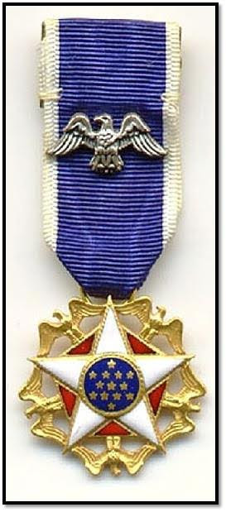

Presidential Medal of Freedom: the highest award given to civilians during wartime.

Moe Berg's baseball card is the only card on display at the CIA Headquarters in Washington, DC.

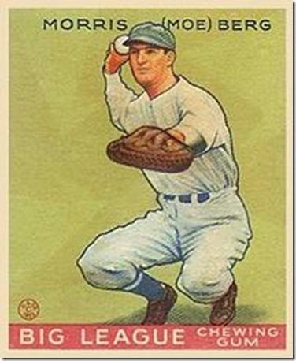



As of: 6/21/2020

Total Funeral Homes Visited - 2,406

Cremains Found – 21,155

Veterans Cremains Identified - 4,980

Veterans Interred – 4,583

***Events:***

**Memories**

The evacuation of Saigon, in which some 45 UH-1 Hueys and one CH-47 Chinook were pushed overboard to make room for others to land (1975).

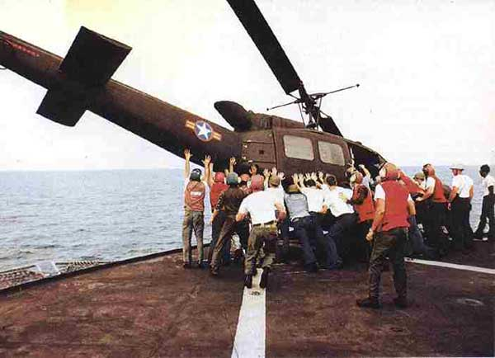

***Did You Know***

Each newsletter, you will see a different service branch to help you know the naming differences between the different services!

**Coast Guard Officer Ranks**

Ensign (ENS) (O1)

Lieutenant Junior Grade (LTJG) (O2)

Lieutenant (LT) (O3)

Lieutenant Commander (LCDR) (O4)

Commander (CDR) (O5)

Captain (CAPT) (O6)

Rear Admiral Lower Half (DRML) (O7)

Rear Admiral (RADM) (O8)

**Coast Guard Enlisted Ranks**

Coast Guard Seaman Recruits currently do not normally bear any uniform rank insignia unless they have been reduced in rank to E-1 for disciplinary reasons.

Seaman Apprentice (E-2)

Seaman (E-3)

Petty Officer Third Class (E-4)

Petty Officer Second Class (E-5)

Petty Officer First Class (E-6)

Chief Petty Officer (E-7)

Senior Chief Petty Officer (E-8)

Master Chief Petty Officer (E-9)

(Editor’s note: Lee White made me do Coasties first!)

***Announcement Corner***

***Books/Articles***

**Written by an Australian Dentist**

**To Kill an American**

You probably missed this in the rush of news, but there was actually a report that someone in Pakistan had published in a newspaper, an offer of a reward to anyone who killed an American, any American.

So an Australian dentist wrote an editorial the following day to let everyone know what an American is. So they would know when they found one. (Good one, mate!!!!)

'An American is English, or French, or Italian, Irish, German, Spanish, Polish, Russian or Greek. An American may also be Canadian, Mexican, African, Indian, Chinese, Japanese, Korean, Australian, Iranian, Asian, or Arab, or Pakistani or Afghan. An American may also be a Comanche, Cherokee, Osage, Blackfoot, Navaho, Apache, Seminole or one of the many other tribes known as Native Americans. An American is Christian, or he could be Jewish, or Buddhist, or Muslim. In fact, there are more Muslims in America than in Afghanistan . The only difference is that in America they are free to worship as each of them chooses.

An American is also free to believe in no religion. For that he will answer only to God, not to the government, or to armed thugs claiming to speak for the government and for God. An American lives in the most prosperous land in the history of the world. The root of that prosperity can be found in the Declaration of Independence, which recognizes the God given right of each person to the pursuit of happiness. An American is generous. Americans have helped out just about every other nation in the world in their time of need, never asking a thing in return.

When Afghanistan was over-run by the Soviet army 20 years ago, Americans came with arms and supplies to enable the people to win back their country! As of the morning of September 11, Americans had given more than any other nation to the poor in Afghanistan.

The national symbol of America, The Statue of Liberty, welcomes your tired and your poor, the wretched refuse of your teeming shores, the homeless, tempest tossed. These in fact are the people who built America. Some of them were working in the Twin Towers the morning of September 11, 2001 earning a better life for their families. It's been told that the World Trade Center victims were from at least 30 different countries, cultures, and first languages, including those that aided and abetted the terrorists.

So you can try to kill an American if you must. Hitler did. So did General Tojo, and Stalin, and Mao Tse-tung, and other blood-thirsty tyrants in the world. But, in doing so you would just be killing yourself. Because Americans are not a particular people from a particular place. They are the embodiment of the human spirit of freedom. Everyone who holds to that spirit, everywhere, is an American.

(Submitted by CDR Shannan Rotruck, NC. USN)

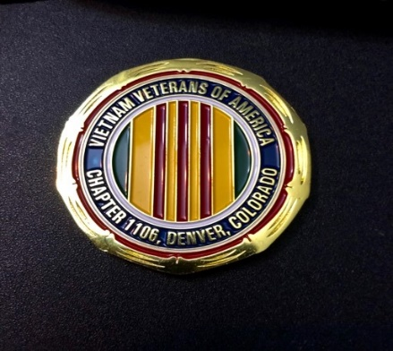

**THE CHALLENGE COIN**

Submitted by John Vargas

There are several stories detailing the origins of the challenge coin. This is one of those stories. The Roman Empire rewarded soldiers by presenting them with coins to recognize their achievements

Challenge coins were also known as "Portrait Medals" during the Renaissance and were often used to commemorate specific events involving royalty, nobility, or other types of well-to-do individuals. The medals would be given as gifts or awards, and people also exchanged them with friends and associates. The most common format was for one side to depict the patron while the other showed something that represented that individual's family, house, lineage, and/or seal.[4]

According to the most common story, challenge coins originated during World War. Before the entry of the United States into the war in 1917 American volunteers from all parts of the country filled the newly formed flying squadrons.

In one squadron, a wealthy lieutenant ordered medallions struck in solid bronze and presented them to his unit. One young pilot placed the medallion in a small leather pouch that he wore about his neck. Shortly after acquiring the medallion, the pilot's aircraft was severely damaged by ground fire. He was forced to land behind enemy lines and was immediately captured by a German patrol. In order to discourage his escape, the Germans took all of his personal identification except for the small leather pouch around his neck. In the meantime, he was taken to a small French town near the front. Taking advantage of a bombardment that night, he escaped. However, he was without personal identification. He succeeded in avoiding German patrols by donning civilian attire and reached the front lines. Eventually, he stumbled onto a French outpost. Saboteurs had plagued the French in the sector. They sometimes masqueraded as civilians and wore civilian clothes. Not recognizing the young pilot's American accent, the French thought him to be a saboteur and made ready to execute him. He had no identification to prove his allegiance, but he did have his leather pouch containing the medallion. He showed the medallion to his would-be executioners and one of his French captors recognized the squadron insignia on the medallion. They delayed his execution long enough for him to confirm his identity. Instead of shooting him they gave him a bottle of wine.

PERHAPS IN OUR NEXT NEWSLETTER WE WILL TELL YOU ANOTHER STORY!

**In The Time of Corona …**

The cat

remains a needful brute-

lithe blackness seeking

warm, quilt-clad human laps

and flowing puddles of morning sun;

such are his domains.

Heedless of the colorful, mumbling heads,

feline days continue filled

with his humans at home and pacing …

food, water, paw-raked litter;

window sills to populate …

no more to ask, or to require.

Would that this calm could be our fate,

or even thin expectation;

we untouched, trapped within homes

and consciousness; half wanting

and fearing excursions to the outside.

Sadly raking in all the stuff that explodes

across that screen-

faking as news and breathless analysis;

the alphabets and animals-

repeated, pointless commentary.

No place to run, to escape

the pounding of the doom-drum;

the strumming of our psyche

and the sweetness of the memories

of just last year.

We can’t see what’s to expect next.

When-

seems the question so unanswered

daily

by all the droll and unsmiling officials

of nothing past their own square

of space on that platform

of slim information.

We are learning

slowly and intuitively

and expectantly

what silence means;

plumbing the distinction ‘tween

solitude- and loneliness;

what illumination comes of standing,

watching our Heavens slowly roll,

with shadows marching

across.

We’ve come to hear ourselves

converse as we think;

to slowly understand what it means

to enjoy a bit of solitude,

to slowly understand what it means

to be able to sort out knotted strings

of thoughts;

to construct

a measure of appreciation

of what the human condition has developed,

listening for a greater power

then we;

however you find it.

Someday this will all end, they suggest-

it will be sorted out

and catalogued, for reference

when we do it again-

to ourselves.

When we do it again-

for economic and political and social gain

over each other.

when we do it again-

For control …

For control of one man over another,

we have caused things to happen-

created occurrences,

developed ways to hurt,

to kill,

made nature different

and hidden it;

For control …

Because

there is fear and hatred and defiance

stalking the land

we all thought we all loved.

And the grey old men silently marvel,

as the masked lines dutifully que-

spaced, subdued, unlively

and unspeaking; shuffling for goods

nearly missing from sources

recently depended upon.

Socially distant, un-gregarious.

supply lines and muttering not seen,

nor expected-

short weeks ago.

As a country, we just don’t que …

And across our wide, greening land,

after all the places are shut down,

sent home to wait and pray and wither,

held back, spaced from daily interaction,

commerce;

who brings what back, when and how.

Are these necessary, draconian controls to be lifted,

stopped,

or just thinly stored- ready, breathing, waiting, eager

to oppress, at whim, again;

by leadership or comradeship or followers

or disciples, authorities led away

from paths we knew as right,

before all this …

he once said, “..trust- but verify !”.

Should not that be enough for us all-

out here in the center of us,

to regain control, readjust, remember, regroup

and move on into what’s left.

Return to our normal,

after the time of Corona.

…..

Tom Werzyn – Centennial, CO - April, 2020 -Rights reserved

**POWERFUL MEMORIAL DAY PIC**

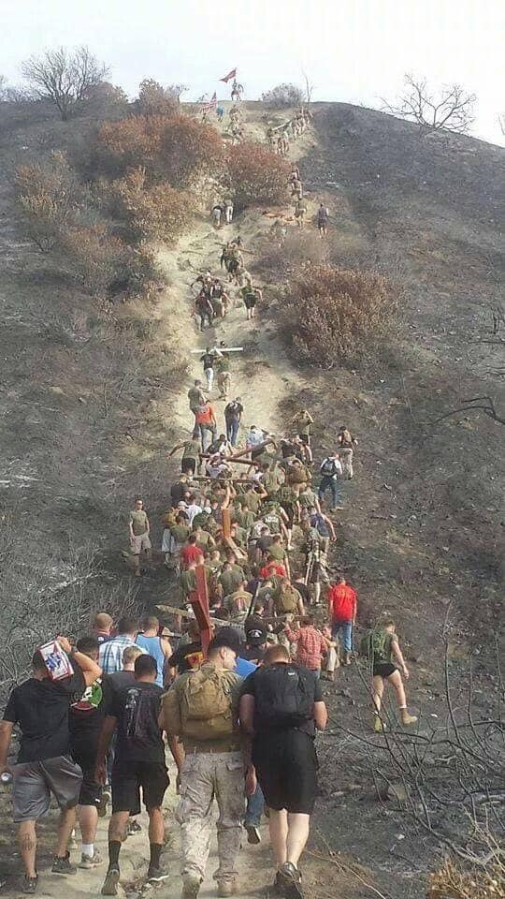

(The story behind the pic - dateline 2014): This picture shows Marines from the "Fighting Fifth" replacing the crosses that sit atop '1st SGT’s Hill' in Camp San Mateo, Camp Pendleton, CA. In 2014 a fire ravaged the hills surrounding Camp San Mateo and these crosses memorializing the Marines KIA were threatened and surely would have been lost completely if it were not for the courage of a few Marines who thought fast. While the fire raged up the hill and nearly surrounded the crosses. These few Marines took their trucks up the side hill and removed the crosses to safety. Days later and after the fire had been stopped, the Marines returned the crosses that each hold their fallen brothers names and re-established them at their place of honor and rest. In pure US Marine fashion it would have been too easy to drive them back up that hill. But they said, "Lets climb them back up and honor them right!" This my friends is what Memorial Day is all about!

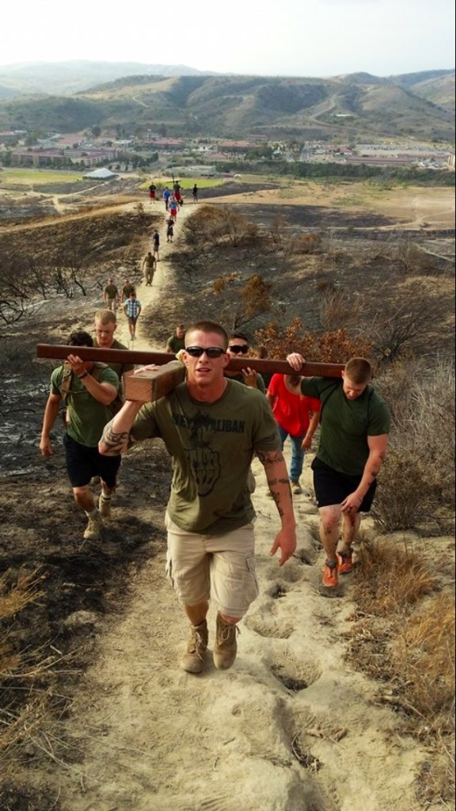

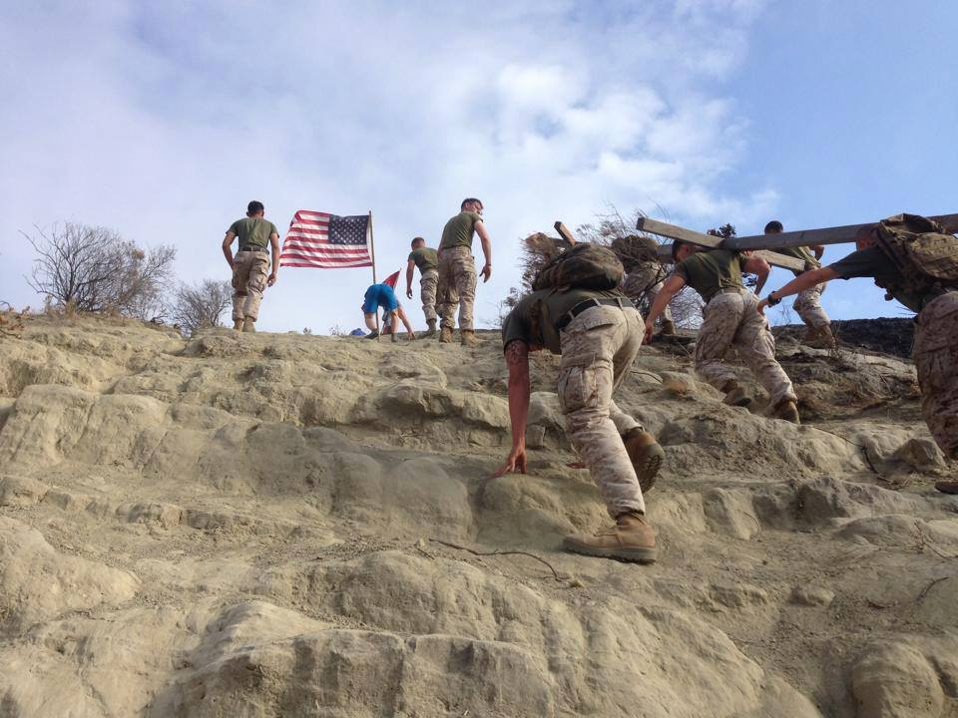

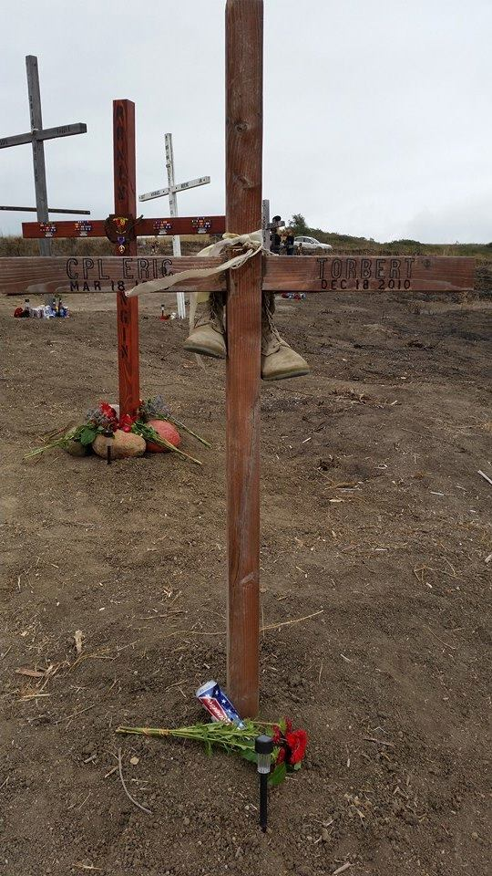

Semper Fi

**The Virus 2020**

The dark abyss of fear and aloneness engulfs me

And runaway thoughts of losing my beloved consume me.

I am unable to see, touch, or embrace him

And my eyes may never meet his again.

Emergency, admission, isolation

He is there and I am here - alone.

Loved ones and countless friends

Raise prayers of healing, support, and love.

Lifting us and carrying us

Through this new and terrifying time.

They come bringing meals, groceries, cookies

And chocolate - mouthwatering, soothing chocolate.

Calls, emails, texts, and cards by well wishers

Inundate and overwhelm my senses.

They move him to ICU today

With the possibility of a ventilator.

Oh no, my love, fight this evil thing with everything you have

Please come home to me.

Days melt into days, and one week into another

And ‘tho still very sick, he is getting better.

Today is Good Friday, the sun is shining

And the love of my life will be home soon.

Ah, there he is with unkempt hair and face unshaved

Pulling an oxygen tank behind him up the walk.

In all the sixty years we’ve had together

He has never looked so beautiful.

Easter will come on Sunday

With its promise of new life and rebirth.

Thank you, Lord, thank you!

Alleluia, Amen

Published by permission of Linda Whatley, wife of Vietnam War Veteran, Cy Whatley USN, who survived the Covid-19 virus!

**Preserving the Legacy**

Submitted by John Vargas

The photo below was taken at about 8:30 AM on the morning of April 2, 1942 as HORNET (CV 8) began a 16 day voyage into history from NAS Alameda. The ship passed under the Golden Gate Bridge at 0848 hours. April 18th, 2020 marks the 78th anniversary of the Doolittle Raiders first strike on Japan by U.S. forces in WWII.

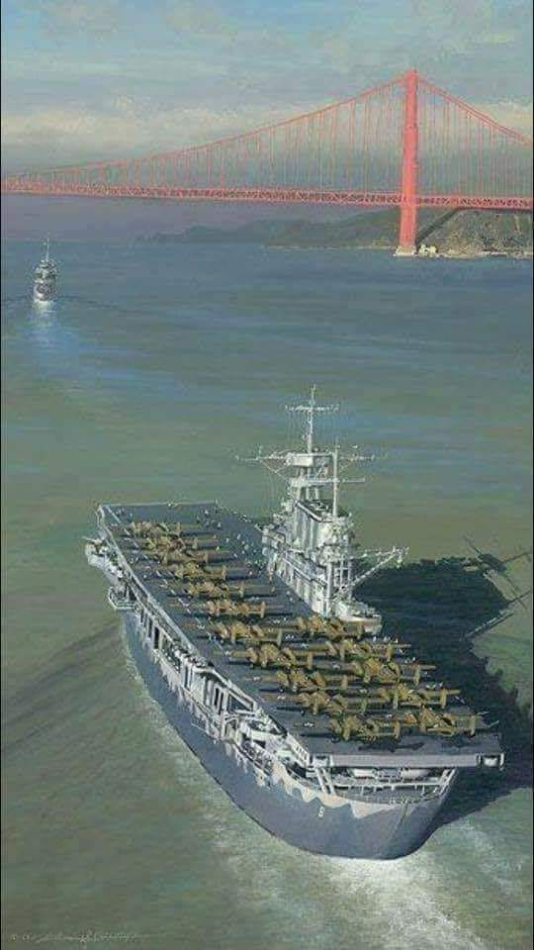

**Bring Our Heroes Home Act - The Fine Art of Declassification**

**The Number: 81,905**

That’s the Number of unresolved Missing in Action/Unaccounted for cases still on the Books of the Defense

Prisoner of War/Missing in Action Accounting Agency (DPAA) today. A vast number of these cases are still wrapped up under the cloak of ‘classified’ even though there has been multiple Executive Orders issued from the Commander-in-Chief and at least one Bill from Congress ordering Federal Government Agencies to purge their files and present these POW/MIA related files to the Public or show evidence why it should remain Classified.

A Bill has been re-introduced on the Floor of Congress (House H.R. 5646 – Senate S 2794) entitled “Bring Our Heroes Home Act” and it has the right amount of ‘accountability’ as well as ‘liability’ in it. The Bill needs to be very detailed on the responsibility as well as the liability to ensure action by all parties holding classified files pertaining to any/all of the case files being held by DPAA. This mission (accountability) should/could come to an end in the next 20 years with the institution of this legislation. Without it, we are on track for another 20 years to complete the Mission.

We NEED your Help! Take time to contact your Senators' offices. Let them know you want them to support this Bill. (Sen. Blumenthal has cosponsored this bill) Let us work together to give the 81,905 families a chance to get answers in their lifetime!

**Father’s Day**

Submitted by Suzanne Segona

The Vietnam Veterans Memorial Fund (vvmf.org) sponsors a program to honor those who return home and have lost their lives related to their service in Vietnam. Although their names are not eligible for inscription on the Wall, they are remembered in a Virtual Honor Roll.

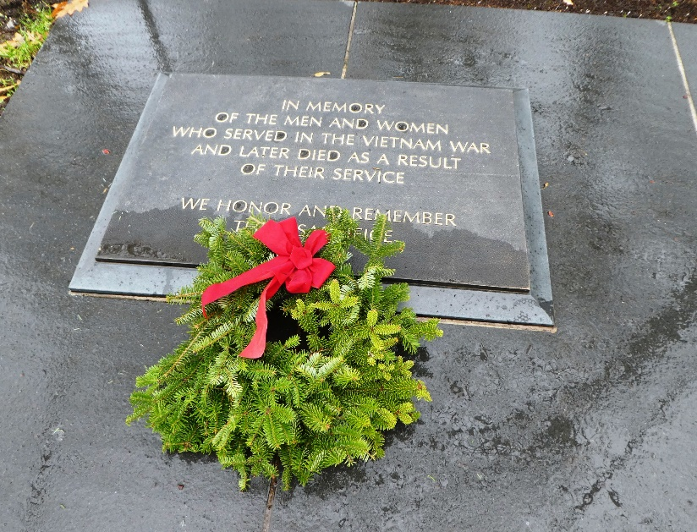

The plaque is placed near the 3 Service Men statue. A ceremony is normally done over Father’s day weekend. The 2020 honorees will be recognized in a ceremony that has been moved to September.

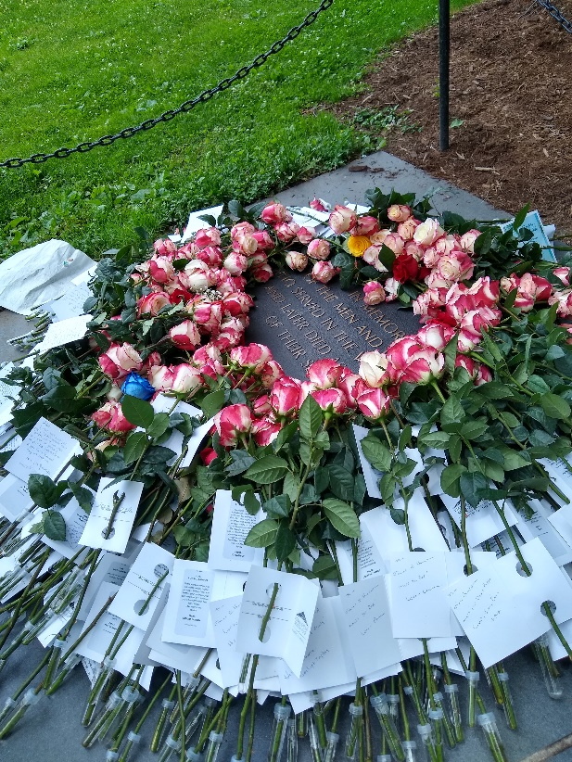

Photo taken in the 2019 ceremony!

Please contact vvmf.org for the criteria and application. They are accepting applications for the 2021 ceremony that will hopefully return to Father’s day weekend.

**Black Sedan**

One of parents and spouses most terrifying fears,

Has haunted many people for many years.

When we have loved ones overseas,

Many of us spend time on our knees.

We pray to our God Almighty above,

That He will spare the ones we love.

They are the men and women that serve our nation,

They do it as volunteers at their military station.

They stand in harm’s way on foreign soil,

It is dangerous, dirty work requiring much toil.

They put their life on the firing line,

Sometimes death is as thin as a dime.

And moms, dads, and siblings wait,

They hope and pray they don’t have a date.

A date when the black sedan stops out front of their door,

A military officer steps out and walks solemnly for sure.

They carry a message from the Commander-in-Chief,

It is written with tenderness and grief.

The letter opens with, “It is with deep regret,”

No need to read further, the tears flow sure as a bet.

You stare at the officer; there is a tear in his eye,

He knows that your child didn’t have to die.

They could have stayed home and let others carry on,

But they knew in their heart their friends had gone.

And they wanted to do their part for our nation,

And off they went to the receiving station.

And the last thing they said when they got into the recruiting van,

Don’t worry mom and dad; you won’t see the black sedan.

God bless our military men and women!

ROTRUCK – ‘07

***Light Side***

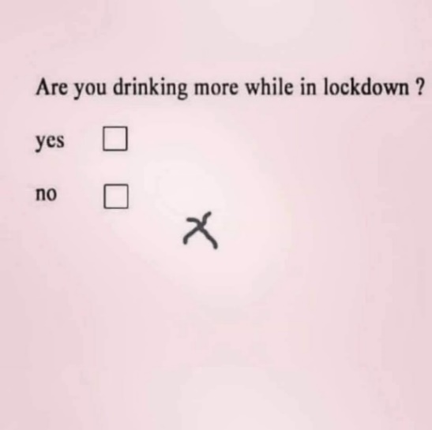



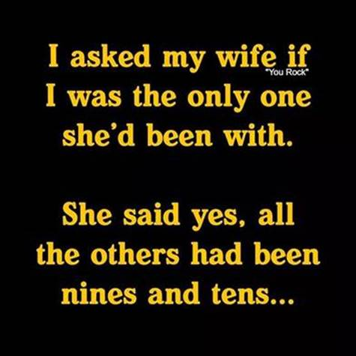

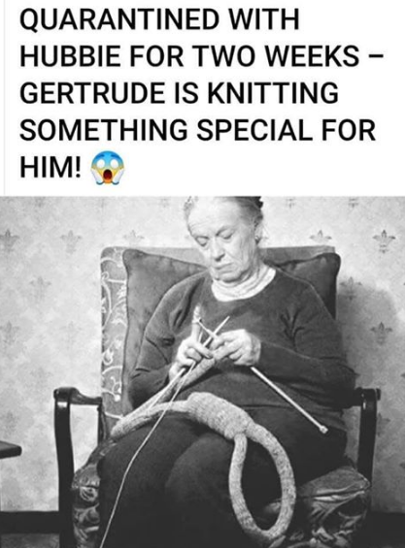

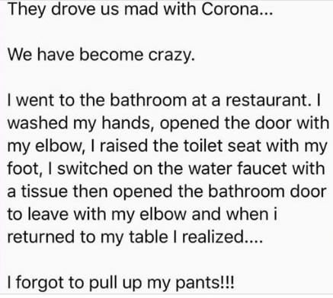



**HOME SCHOOLING FOR SENIORS**

The answers are printed below, (after the Light Side) but don't cheat! Answer as many as you can.

1. After the Lone Ranger saved the day and rode off into the sunset, the grateful citizens would ask, “Who was that masked man?” Invariably, someone would answer, “I don't know, but he left this behind.” What did he leave behind?\_\_\_\_\_\_\_\_\_\_\_\_\_\_.

2. When the Beatles first came to the U.S. In early 1964, we all watched them on The \_\_\_\_ \_\_\_\_\_\_\_\_\_\_\_ Show.

3. 'Get your kicks, \_\_ \_\_\_\_\_\_\_\_\_ \_\_\_\_\_\_\_.'

4. 'The story you are about to see is true. The names have been changed to \_\_\_\_\_ \_ \_\_\_\_\_.'

5. 'In the jungle, the mighty jungle, \_\_\_\_ \_\_\_\_ \_\_\_\_ \_\_\_\_.'

6. After the Twist, The Mashed Potato, and the Watusi, we 'danced' under a stick that was lowered as low as we could go in a dance called the ‘\_\_\_\_\_.'

7. Nestle’s makes the very best.... \_\_\_\_\_\_\_\_\_.'

8. Satchmo was America's 'Ambassador of Goodwill.' Our parents shared this great jazz trumpet player with us. His name was \_\_\_\_\_\_ \_\_\_\_\_\_\_\_\_\_\_.

9. What takes a licking and keeps on ticking? \_\_\_\_\_\_\_.

10. Red Skeleton's hobo character was named \_\_\_\_\_\_ \_\_\_ \_\_\_\_\_\_\_\_ and Red always ended his television show by saying, 'Good Night, and '\_\_\_\_\_\_\_\_ \_\_\_\_\_\_\_\_

11. Some Americans who protested the Vietnam War did so by burning their \_\_\_\_\_\_ \_\_\_\_\_\_\_.

12. The cute little car with the engine in the back and the trunk in the front was called the VW. What other names did it go by? \_\_\_ & \_\_\_\_\_\_\_.

13. In 1971, singer Don MacLean sang a song about, 'the day the music died.' This was a tribute to \_\_\_\_\_\_\_ \_\_\_\_\_\_\_\_\_\_\_\_.

14. We can remember the first satellite placed into orbit. The Russians did it. It was called \_\_\_\_\_\_\_\_\_\_.

15. One of the big fads of the late 50's and 60's was a large plastic ring that we twirled around our waist. It was called the \_\_\_\_\_\_ \_\_\_\_\_\_\_.

16. Remember LS/MFT \_\_\_\_\_ \_\_\_\_\_/\_\_\_\_\_ \_\_\_\_\_ \_\_\_\_\_?

17. Hey Kids! What time is it? It's \_\_\_\_\_ \_\_\_\_\_\_ \_\_\_\_\_!

18. Who knows what secrets lie in the hearts of men? Only The \_\_\_\_\_ Knows!

19. There was a song that came out in the 60's that was "a grave yard smash". Its name was the \_\_\_\_\_\_ \_\_\_\_\_\_!

20. Alka Seltzer used a "boy with a tablet on his head" as its Logo/Representative. What was the boy's name? \_\_\_\_\_\_\_\_

Some funnies from Tom Worsen (Oops – Werzyn)





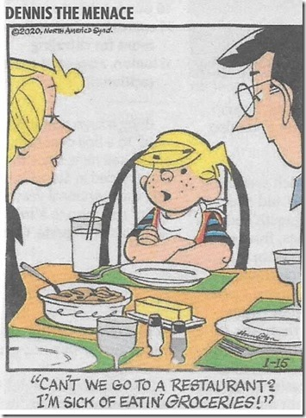

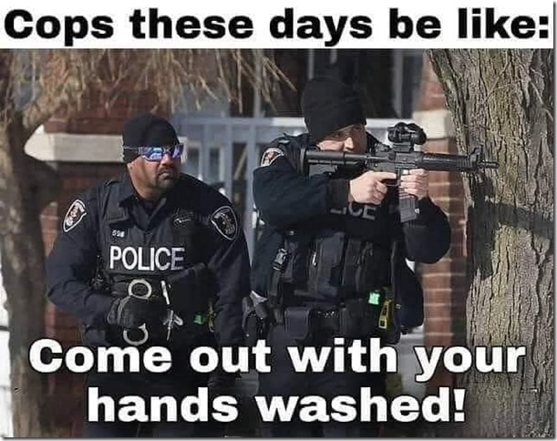

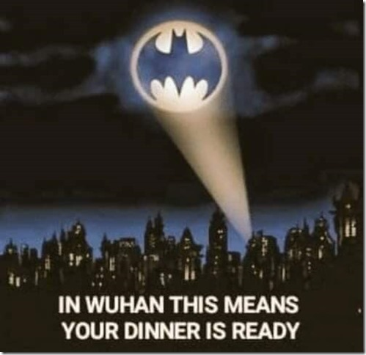







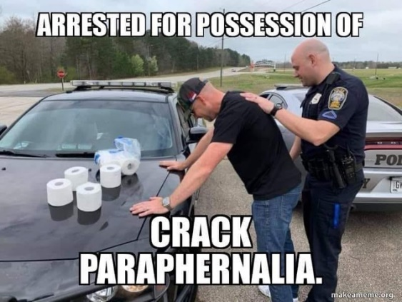

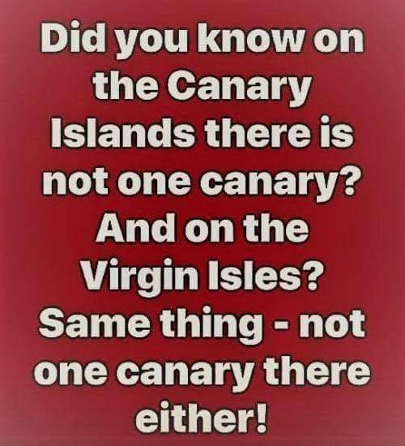

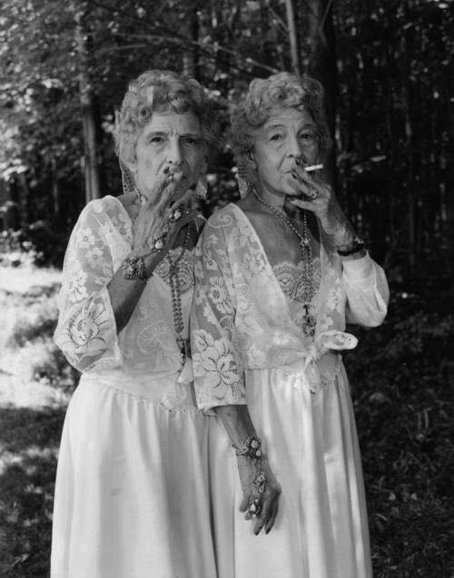

**Protect your Cigarette**

From: Lou Zoghby, WWII Veteran

Jane and Arlene are outside their nursing home, having a drink and a smoke, when it starts to rain. Jane pulls out a condom, cuts off the end, puts it over her cigarette, and continues smoking.

Arlene: What in the hell is that?

Jane: A condom. This way my cigarette doesn't get wet.

Arlene: Where did you get it?

Jane: You can get them at any pharmacy.

The next day, Arlene hobbles herself into the local pharmacy and announces to the pharmacist that she wants a box of condoms.

The pharmacist, obviously embarrassed, looks at her kind of strangely (she is, after all, over 80 years of age), but very delicately asks what size, texture, brand of condom she prefers.

'Doesn't matter Sonny, as long as it fits on a Camel.'

The pharmacist fainted!

ANSWERS:

1. The Lone Ranger left behind a silver bullet.

2. The Ed Sullivan Show

3. On Route 66

4. To protect the innocent.

5. The Lion Sleeps Tonight

6. The limbo

7. Chocolate

8. Louis Armstrong

9. The Timex watch

10. Freddy, The Freeloader and 'Good Night and God Bless.'

11. Draft cards (Bras were also burned. Not flags, as some have guessed)

12. Beetle or Bug

13. Buddy Holly

14. Sputnik

15. Hoola-hoop

16. Lucky Strike/Means Fine Tobacco

17. Howdy Doody Time

18. Shadow

19. Monster Mash

20. Speedy

***Trivia Answer***

**Hooyah**: The official word of tadpoles going through BUD/s (BUD – Basic Underwater Demolition) and the Navy SEALs (although not used much after BUD/s.) Can be used as an acknowledgement “do you understand? Hooyah.” A greeting “Hooyah Lt. Dan!” or a battle cry “Hooyah!”

**Upcoming Events of Interest**

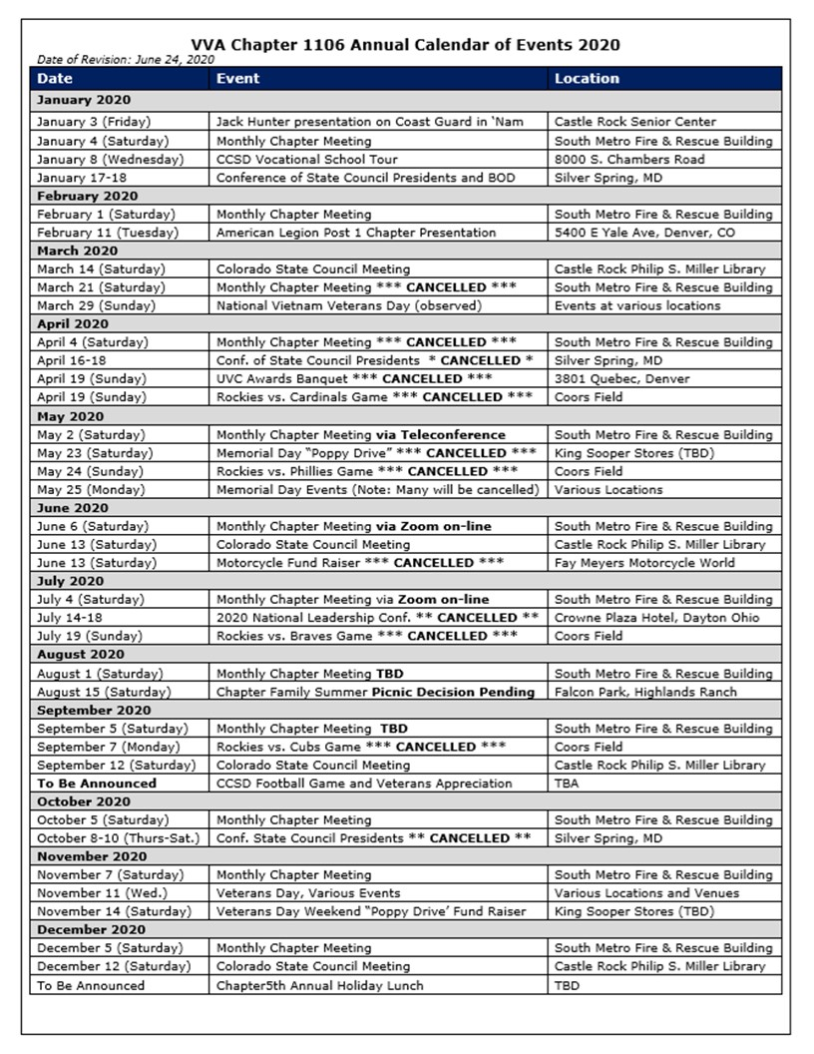

**FRIENDS OF CHAPTER 1106**

|  |  |
| --- | --- |
| **South Metro Denver Fire & Rescue**  9195 E Mineral Ave  Centennial, CO 80112 | **American Legion Post 1260**  **E:\Documents\ALP1187\images\AmericanLegion_logo.jpg** |
| **Spradlin Printing, Inc.**  11903 S. Parker Road Parker, CO 80134 |  |
| American Family Insurance  3989 E. Arapahoe Road #20  Centennial, CO 80122  720-361-0155 | A FULL-SIZE REPLICA OF THE HONOR BELL  **The Honor Bell Foundation**  PO Box 1432  Englewood CO 80150  720.282.9182  [www.honorbell.org](http://www.honorbell.org/) |
| 9137 E Mineral Cir Ste 100  Englewood, CO 80112-3422 | Logo of The Home Depot  **Home Depot Foundation**  8477 S Yosemite St  Lone Tree, CO 80124 |
| King Soopers logo.svg  King Soopers  9551 S. University Blvd., Highlands Ranch, CO 80126 | http://www.cruisin1430.com/sites/g/files/giy711/f/KEZW_Header_Large_Logo_0.png  **STUDIO 1430 Main Office:** 4700 South Syracuse Street, Suite 1050 Denver, CO 80237 |
| https://scontent.fapa1-2.fna.fbcdn.net/v/t31.0-8/10575197_682186265194110_4051472928662048560_o.jpg?oh=2630b186dcf3a20f1d7fc8fa25e0a5ba&oe=5A17C4AB  **Military Order of Purple Heart**, Chapter 1041, Arvada, CO | ZILLOW GROUP  10771 E. Easter Ave  Centennial CO 80112 |
| American Home Agents  Brian Karsh, Broker Associate  720-327-1562 | PARKER MEDICAL  SUPPLY STORE  9845 S Parker Rd  . Parker, CO 80134  303-840-4444 |