**Inside this issue:**

Notes from the President

[Member Feature](#Memberfeature)

[Military Trivia](#Militarytrivia)

[Guest Speaker](#Guestspeaker)

[Membership](#Membership)

[Board of Directors/Officers](#Boardofdirectors)

[Working Committees](#Workingcommittees)

[Meetings/Events Calendar](#Meetingsevents)

[Announcement Corner](#Announcementcorner)

[Books/Articles Published by Mbrs.](#Booksarticles)

[From the Editor](#Fromtheeditor)

[Light Side](#Lightside)

[Trivia Answer](#Triviaanswer)

***Editor’s Note:***

**Notice:**

If you have moved or changed your address, PLEASE notify us immediately! Contact: Dave Lyons, Membership Chair

E-mail: [Snoyldavid@centurylink.net](mailto:Snoyldavid@centurylink.net)

Phone:  303 690 8776

###### COPYRIGHT NOTICE: In accordance with Title 17 U.S.C. Section 107, any copyrighted material in this newsletter is distributed under fair use without profit or payment to those who have expressed a prior interest in receiving the included information for nonprofit use and educational purposes only.

This version of the newsletter is in Microsoft Document (.DOCX) format so that the links will work. Put your cursor over the link, depress your Control Key (ctrl) and depress your left mouse button and it will take you to the listed link position. PDF format, the links will not work.

The comments and editorial input does not necessarily reflect the opinion of the membership of our chapter. I would appreciate any feedback that you might have, items you liked or if you find offensive or derogatory in anyway. ([bobrotruck73@gmail.com](mailto:bobrotruck73@gmail.com)) Thank you for allowing me to be your editor.

***Notes from the President***

Lee White

HAPPY NEW YEAR & WELCOME TO 2019

On October 20, 2018, VVA National Board of Directors made a motion and was accepted to have only one membership level – LIFETIME

All three-year memberships were converted to LIFETIME by National Membership Department, at no cost. All one-year memberships will expire unless members renew for LIFETIME. This opens a great opportunity to increase membership, since LIFETIME MEMBERSHIP IS ONLY $50.00!!

As we begin a new year, I would ask all current members to “SPREAD THE WORD” and ask new potential Vietnam Era veterans to become members of VVA Chapter 1106.

Our VVA Chapter 1106 was very successful in 2018 in carrying out our multiple missions of serving veterans in need. For the upcoming year, as president of VVA Chapter 1106. I ask for members who have a little extra time to contribute, and become involved with some of our committees and programs.

Looking forward for a great and productive 2019. THANK YOU!!!

***“Member Feature”***

Tony Nickerson, Sergeant, U.S. Army – 1966 – 1969. I was stationed at Ft. Huachuca, AZ, Schwein Furt, Germany, Tay Neighn & Cu Chi, Vietnam. I was awarded the Purple Heart, European & Asia Ribbons, Company Commendation Ribbons, Expert Rifle (M-14) badge, and Combat Infantry Badge. My most memorable experiences were escorting service members to their final resting place. Playing on a Company Basketball Team that won the European Christmas Championship. Playing basketball against the Harlem Globetrotters. The Germany missile crisis. Being a Scout Dog Handler in Vietnam and serving as a Radio Announcer for the Armed Forces Services Network. I am a Colorado Archery Champion, and Seven State Regional Champion. Also Colorado Pistol Team champions on various police Departments. Last year as Post Commander VFW Post 9644, we received a national award for Community Service for Veterans. I feel the chapter provides service to each member by listening and trying to understand each member’s concerns – personal or otherwise. Our chapter needs to nourish family activities and look at activities to raise money for the chapter.

***Military Trivia***

**BOHICA?**

[Click here for end of the Newsletter Trivia Answer](#Triviaanswer)

***Special Guest - November***

Ms. Alycia Carmin and Mr. Kelly Carmin came from the Quilts of Valor organization to present quilts to some of our members. These Quilts are made by quilters all over Colorado, with parts from across the USA. The purpose of these quilts is to provide a “tangible hug” of thanks to veterans and to wrap veterans in the love of the quilters in thanks for their service to our country. Each quilt was accompanied by a pillowcase made by Colorado high school students and a written history of each quilt.

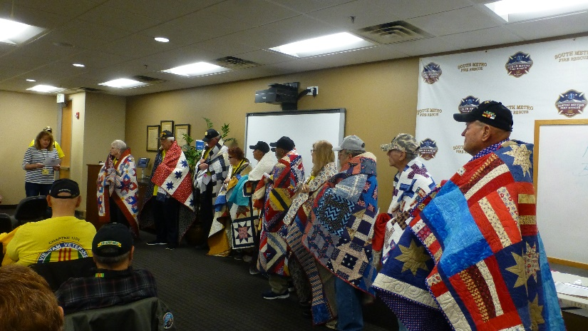

Ms. Carmin seemed to find quilts that had custom made themes for the veteran who received the quilt. She presented each quilt in a very heart-warming manner to each veteran. Veterans of VVA Chapter 1106 receiving a Quilt of Valor today included:

Jack Hunter, Ted Hanfelder, Donna Chaney, Milt Omoto, John Williams, Gary Turks, Pattie Ehline, Bob Rotruck, Sonny Gorsuch, Robert Senatore, and Peggy Kelly.

***Special Guest – December***

Georgia Gerard, MSW, LCSW, Social Worker - Rocky Mountain MIRECC (Mental Illness Research, Education and Clinical Centers)

Biography: Georgia obtained a Master of Social Work degree from the University of Denver with a focus on family systems in 2012. Her previous experience focused on child welfare at the Denver Department of Human Services as well as medical social work at Swedish Hospital. Georgia joined the MIRECC in 2012 and has filled the role of Research Assistant for various projects, Co-Investigator and is currently a study clinician.

The Rocky Mountain MIRECC model of Therapeutic Risk Management of the Suicidal Patient is a clinically and medicolegally informed model for the assessment and management of suicide risk. It involves three main components:

* Augmentation of clinical risk assessment with structured instruments
* Risk stratification with respect to both severity and temporality
* Collaborative development of a safety plan

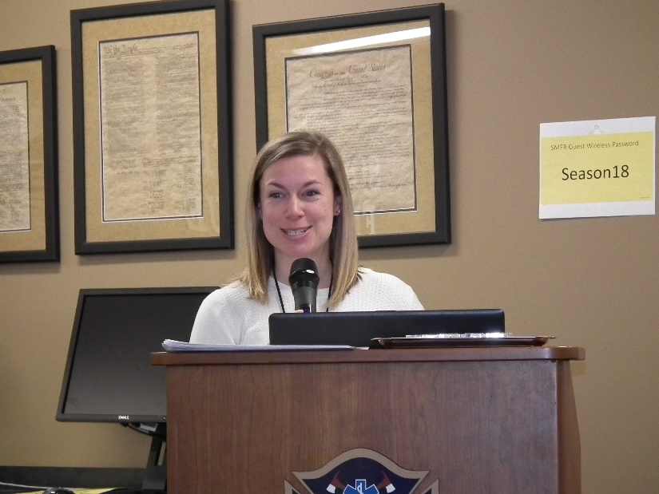

Georgia Gerard

MIRECCs and CoEs (Centers of Excellence) Mission were created to generate new knowledge about the causes and treatments of mental disorders, apply new findings to model clinical programs, and widely disseminate new findings through education to improve the quality of veterans’ lives and their daily functioning in their recovering from mental illness.



<https://www.veteranscrisisline.net/>

***Membership!***

VVA Chapter 1106 Membership: (12-16-2018)

VVA  -  126

AVVA -   27

Total: 153

**Welcome New Lifetime Members:**

Ernest Ledvina

Larry Collins

John Powell

Richard Lewis

Gary Palka

Bruce Arndt

Jay Quiring

**Welcome new AVVA Member:**

Linda Croce

***Board of Directors/Officers***

Lee White - President

Bob Easter - Vice-president

Joe Plant - Treasurer

Glen Payne - Secretary

Board Members - Milt Omoto, Patti Ehline, Dave Lyons, Tom Werzyn

John Vargas - Sergeant-at-Arms

***Special Chapter Positions***

Chaplain – Garry Turks

Government Affairs – Tony Nickerson

***Working Committees***

Agent Orange/PTSD – Patti Ehline

Color Guard – Tony Nickerson - Command Sergeant, Dave Lyons, Don McNeely, Dan Green, Clarence Rebolledo, Robert Senatore, Ron Smith, Bob Larson

Membership – Dave Lyons – Chair, Lee White, Tom Werzyn

Mental Health: Patti Ehline, Warren Harrison, Joe Plant

Newsletter Editor - Bob Rotruck

Fundraising/Grants - Milt Omoto

Marketing/Media/Events – Tom Werzyn

POW/MIA – Gary Meyers

Webmaster – Bob Rotruck

Women Veterans - Patti Ehline

Scholarship Program - Mike Karsh – Co-Chair, Jim Marcille – Co-Chair, John Vargas, Glen Payne, Brian Karsh (supporter)

Veteran Emergency Assistance Committee - Joe Plant, Lee White, Dave Lyons

Speakers Bureau – Bob Easter, Glen Payne, Bob Mallin, Tom Werzyn

Social – John Vargas, Barry Fiore, Glen Payne, Milt Omoto

**Meetings/Events Calendar - 2018**

January 5 - VVA Chapter 1106 Monthly Membership Meeting

February 2 - VVA Chapter 1106 Monthly Membership Meeting

January 10-12, 2019 - Conference of State Council Presidents Meeting - Silver Spring, MD

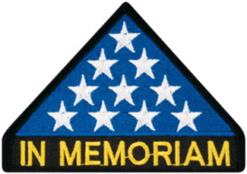

***In Memoriam***

**George Herbert Walker Bush**, the 41st President of the United States, passed away November 30, at the age of 94. We at Beyond Band of Brothers would like to pay our respects to him by recounting the story of his wartime service and his near-fatal encounter in the Pacific.

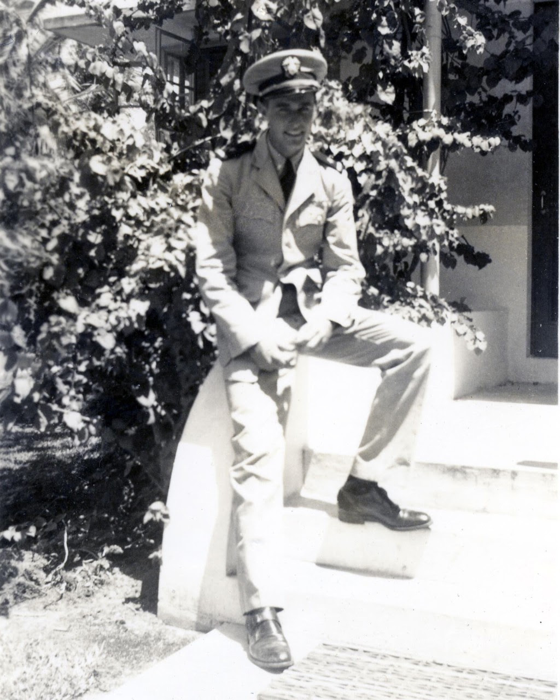

George H. W. Bush - 1942

When Japan attacked Pearl Harbor, Bush, only 17 and a half at the time, was caught up in the surge of patriotism sweeping the country. He was so eager to fight that at first he even considered joining the Royal Air Force in Canada rather than the U.S. military, since that was apparently a quicker way of seeing action. He was, however, also awed by the grandeur and camaraderie of the U.S. Navy, so he eventually decided to enlist as a naval aviator. On his last Christmas trip home before donning a uniform, he met his future wife, Barbara Pierce.

He was commissioned as a Naval Reserve ensign three days before his 19th birthday, making him the youngest American naval aviator at the time. In September 1943, he was assigned to Torpedo Squadron 51 (VT-51) aboard the USS San Jacinto, where his lankiness earned him the nickname “Skin.”

VT-51 flew Grumman TBF Avengers, one of the best torpedo bombers of the war. The Avenger had a distinctive look thanks to its fold-up wings, similar to the ones used by the Grumman F6F Hellcat, which allowed more planes to be carried onboard. It was rugged, stable, had a long range and powerful radios. The radio system was so bulky it had a separate “tunnel” inside the craft for repair access. Avenger pilots noted that she flew like a truck, for better or worse. The plane was nicknamed “turkey” by escort pilots due to its size and poor maneuverability. It could carry a single 2,000lbs torpedo or four 500lbs bombs to attack ground targets.

On September 2, 1944, Lieutenant Bush flew one of four Avengers in an attack on the Japanese-held island of Chichijima, some 500 miles south-southeast of Japan and 150 miles north of Iwo Jima. Though the island is a mere 9 square miles in size, it had strategic importance. The long-range radio stations atop its two mountains made it an important relay in the Japanese communications network in the Pacific and it also served as a supply base between Japan and the Bonin Islands to the south. Though the island was never captured during the war, it became the target of frequent bombing attacks like the one Bush flew in.

On September 2, 1944 the attacking Avengers came under heavy anti-aircraft fire. Bush’s plane was hit by flak, setting the engine on fire. Undaunted, they released their bombs over one of the radio stations and hit it, then flew away from the islands. After several miles, the cockpit was flooded by smoke, the wings were engulfed in flames and Bush was sure the plane was going to explode. The Avenger’s cockpit is physically separated from the other crewmen, so he used the radio to order his comrades to bail out. One of them didn’t make it; the other jumped but his parachute failed to open. Bush started climbing out of the cockpit but the wind pulled him out and slammed him against the tail of the aircraft, giving him a bruised eye and a gash on the head.

Once he hit water, Bush swam to the plane’s rubber life raft and climbed in it. He noticed the currents were taking him back towards Chichijima, so he started paddling with his arms away from the island to avoid capture and likely execution. He didn’t know at the time but other aircrew shot down and captured during the operation were beaten, tortured and killed.

Bush was spotted by several U.S. fighter planes, who started circling to protect him from Japanese capture attempts. Waiting for rescue and vomiting after drinking seawater during his splashdown, he thought of the letter he sent home to Barbara just the day before, mentioning that all was well. After four hours, he was picked up by the USS Finback, a submarine on lifeguard duty in the area.

Bush returned to the San Jacinto in November and continued participating in operations in the Philippines, flying 58 missions before being transferred to a training wing for torpedo bomber crews. He was honorably discharged from the U.S. Navy one month after Japan’s surrender.

We dedicate this article to the memory of George Herbert Walker Bush.

Article submitted by: Lee White



As of: 12/14/2018

Total Funeral Homes Visited - 2,306

Cremains Found - 18,628

Veterans Cremains Identified - 4,103

Veterans Interred - 3,744

**Special Presentations**

Larry Bull, Director of Cherry Creek School District, holding a “Thank You” award. It was presented to him by Lee White, VVA 1106 Chapter President. This was awarded to Mr. Bull for his overall leadership and his ongoing assistance to all Military Veterans and our Chapter.

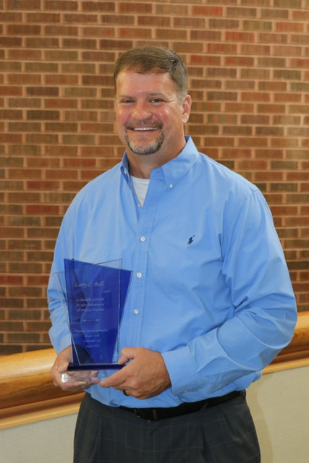

Larry Bull

**Vietnam War 50th Anniversary pins awarded by Suzanne Sigonia.**

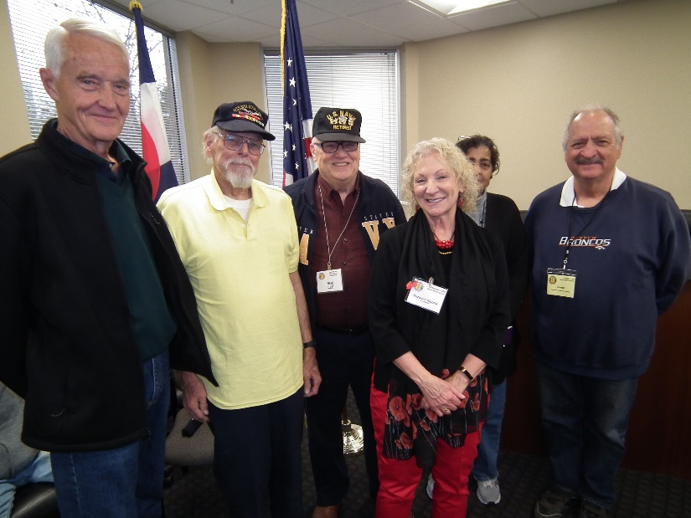

Jim Hemphill, Gary Steinhoff, Bob Lee, Suzanne Sigonia, Viola Nathan, Al Hardt

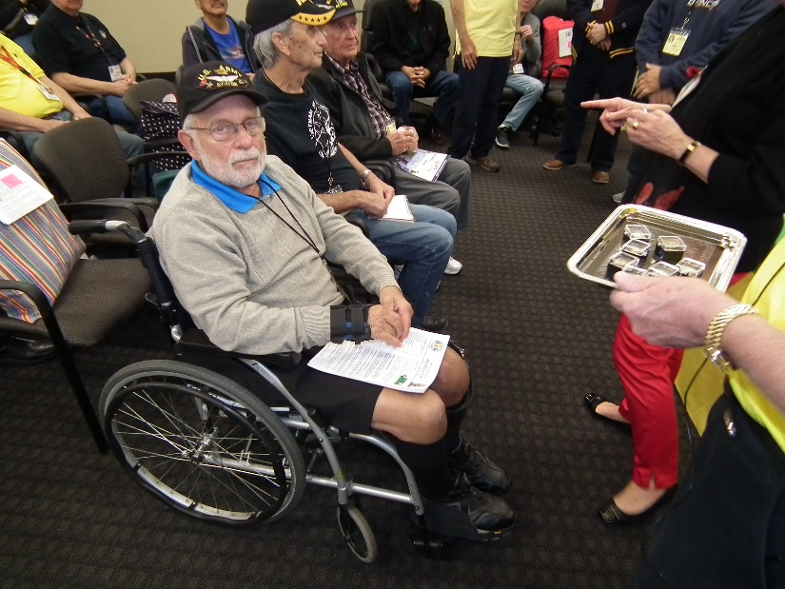

Jim Bishop

**24th Aurora Veterans Salute**

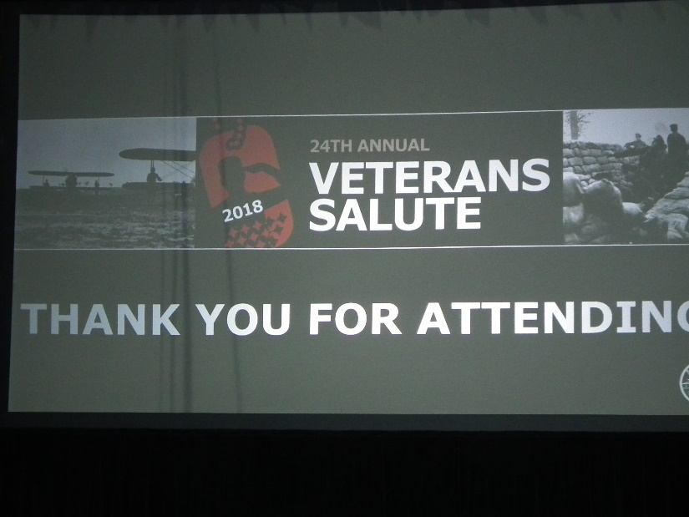

Thanks to the City of Aurora for again hosting a wonderful event for veterans. The primary topic for this event was World War 1 since November 11th, 2018 was the anniversary of 100 years since the end of WW1.

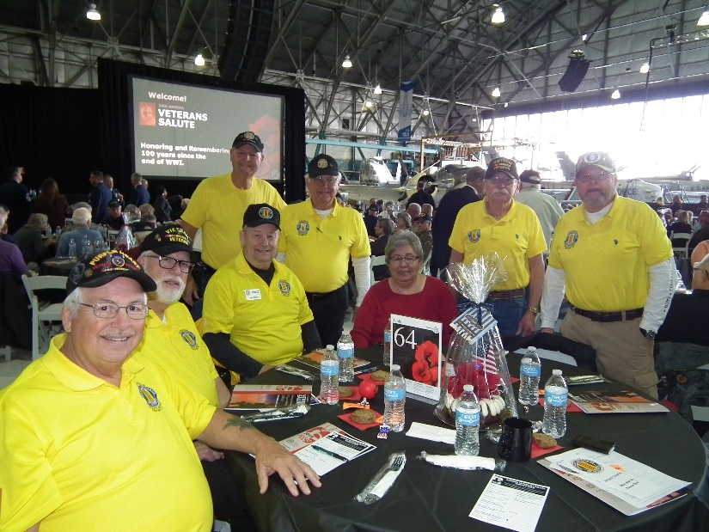

Our Chapter table seated L to R: Tony Nickerson, Dave Lyons, and Joe & Dora Plant. Standing L to R Bob Rotruck, Tom Werzyn, Bob Easter, and Ron Smith

There was some great entertainment as well as three lovely ladies bringing back memories of the Great War time era songs.

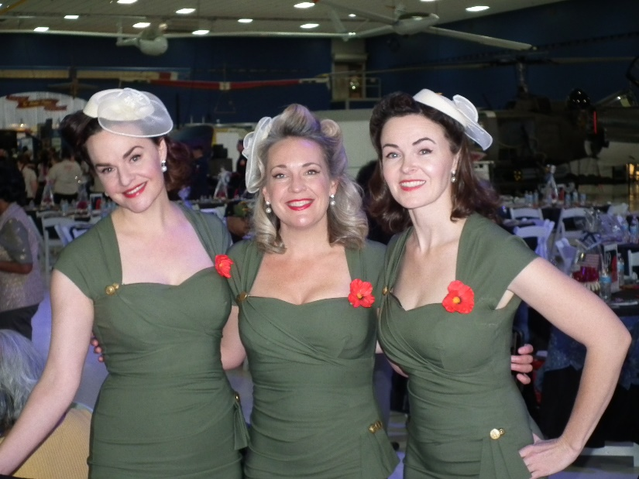Denver Dolls

**November 10th Poppy Drive**

Our chapter participated at four locations: King Soopers - Iliff & Buckley (LZ1); King Soopers - Buckley & Quincy (LZ2); King Soopers - Smokey Hill & E-470 (LZ3) and Walmart - Parker (LZ4)

Landing Zones

* 1 $820.00 Team Members: Joe Plant, Jerry Leichti, Kari Leichti, Rob Senatore
* 2 $1208.50 Team Members: Dave Lyons, Mike Sizemore, Clarence Rebolledo, Dan Green
* 3 $1996.02 Team Members: Tom Werzyn, Bob Easter, Tony Croce, Linda Croce, Ron Smith, Milt Omoto
* 4 $1604.30 Team Members: Lee White, Mike Karsh, Tony Nickerson, Ted Hanfelder, Roger Lanphier, Gary Bentzen

GRAND TOTAL: $5629.32

**From Patti and Suzanne**

Join us in Washington, DC at the Vietnam Veterans Memorial as we celebrate the 25th Anniversary of the dedication of the Vietnam Women's Memorial. Plans are underway for a series of events to commemorate this extraordinary landmark event. Official events began on Saturday the 10th of November. The Embassy Suites, Downtown on 22nd Street between M and N Streets NW will be the host hotel. This is the same hotel that was used for the 20th Anniversary.

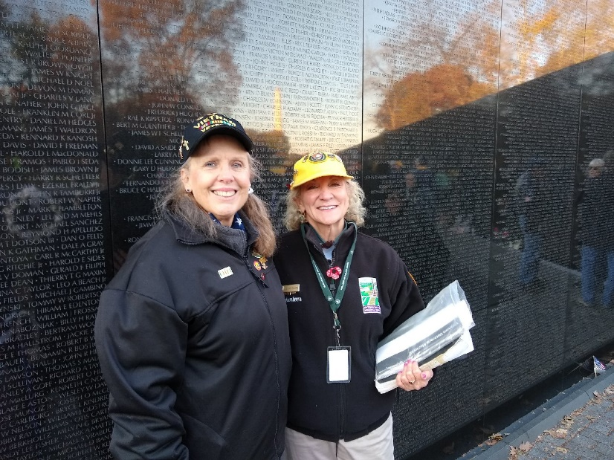

Photo by: Joe Natividad – Patti Ehline and Suzanne Segonia

Candlelight Ceremony at the Vietnam Women's Memorial on the National Mall Sunday November 11th 9am – 12pm: Story Telling at the Vietnam Women’s Memorial: In “Their Own Words”

**World War Eleven**

Young people cannot learn from history anymore because for many years history has not been a required subject in secondary schools. This is a recent true story:

Theodore "Dutch" J. Van Kirk was the navigator on the “Enola Gay" when it dropped the bomb at Hiroshima, Japan, and now is the last surviving crew member......what follows below really happened.

Dutch was recently asked to speak at a grammar school. The young teacher introduced him by saying the speaker was a veteran of **World War Eleven** (as in WWII). Dutch stood up and walked out of the school without saying a word. End of story. GOD HELP US

**Air Force Academy Honors Vietnam Veterans**

On November 10, 2018, a member of each branch of service was honored during halftime of the Air Force Falcons/New Mexico Lobos football game. Each person received the 50th Vietnam Anniversary Pin from either an Air Force General or Colonel. Facing the awardees Left to Right the branches were: Air Force, Army, Coast Guard, Marine Corps, Navy, and Air Force POW.

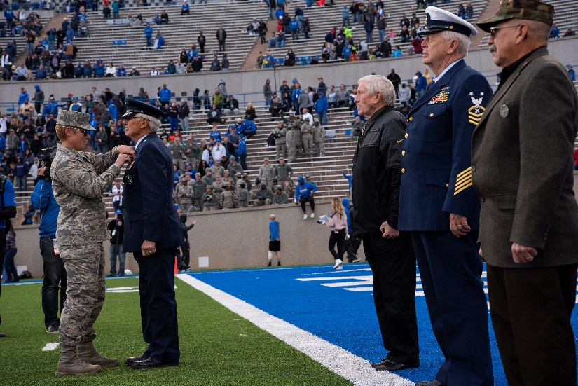

Brig Gen Ruben “Randy” Cubero - Air Force

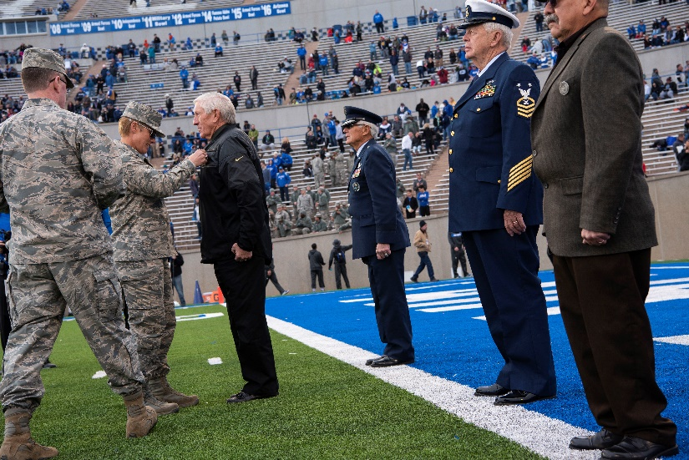

Army

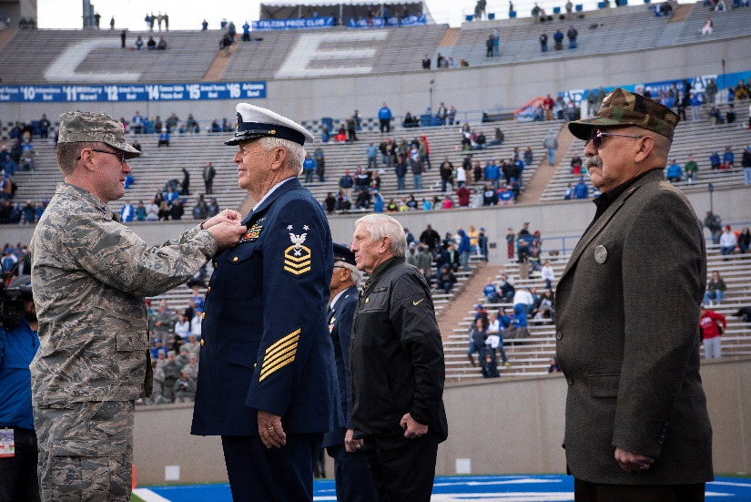

Master Chief Jack Hunter - Coast Guard

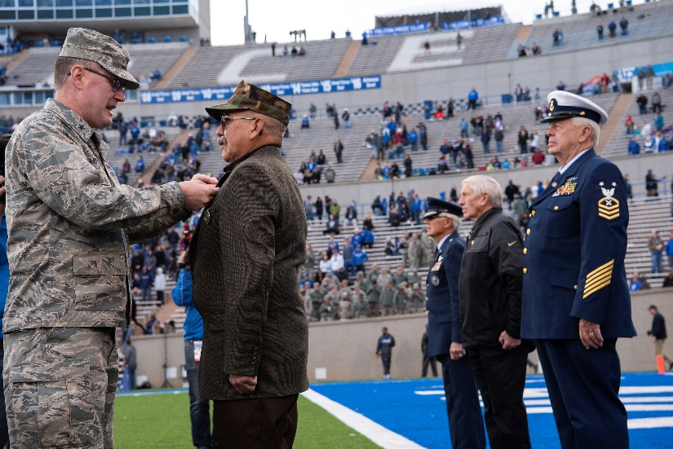

CMSGT Pat Mesa - Marine Corps

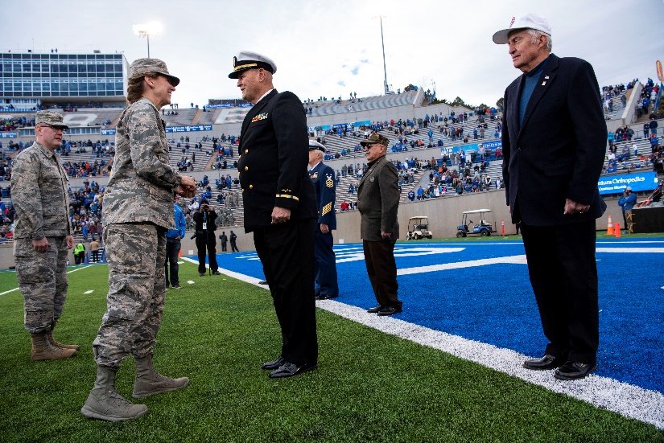

CWO3 Bob Rotruck - Navy

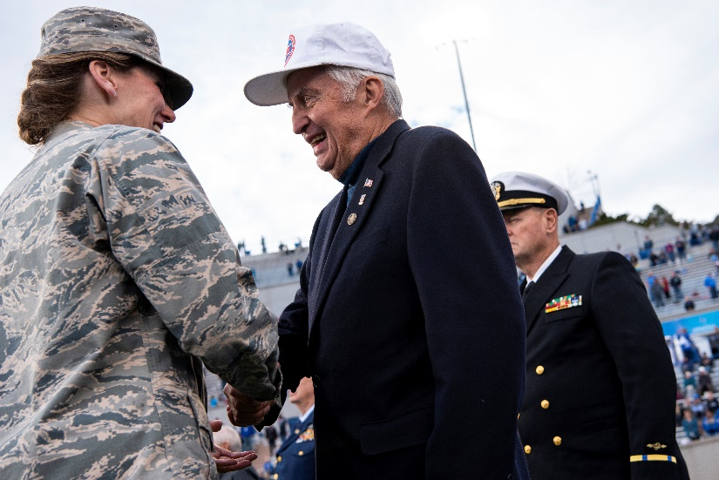

Air Force former POW

(Editor’s note: I did not have all of the names of the recipients other than Jack Hunter, - USCG, Pat Mesa – USMC, and myself – USN.)

**Veterans Day – Nov 11th – Honor Bell**

Dave Lyons and Joe Dempsey tolled the bell on a very chilly Veterans Day at Fort Logan National Cemetery.

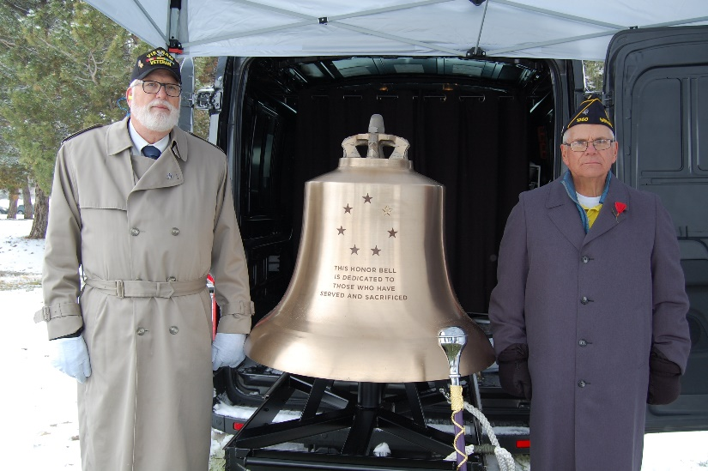

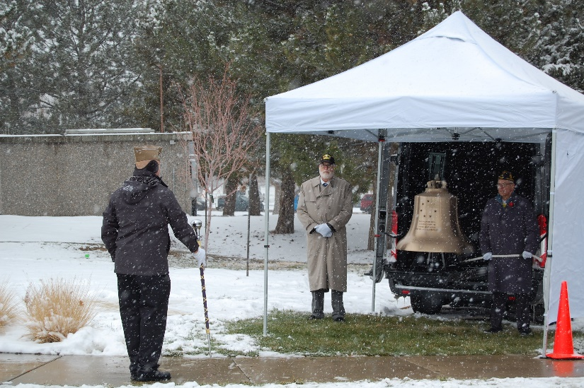

**2018 End of Year Holiday Brunch**

WOW!! What a great turnout for our year end gala at the Golden Corral in Centennial, December 15th. The Chapter Social Committee did a superb job of putting the event together and the food wasn’t too shabby either. (Editor’s note: I only went back 3 times for a plate, but the last one was only dessert**s** [3 on a big plate])

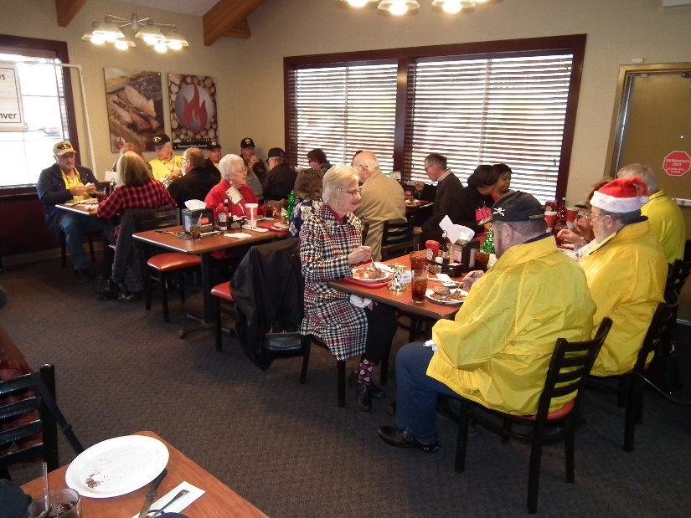

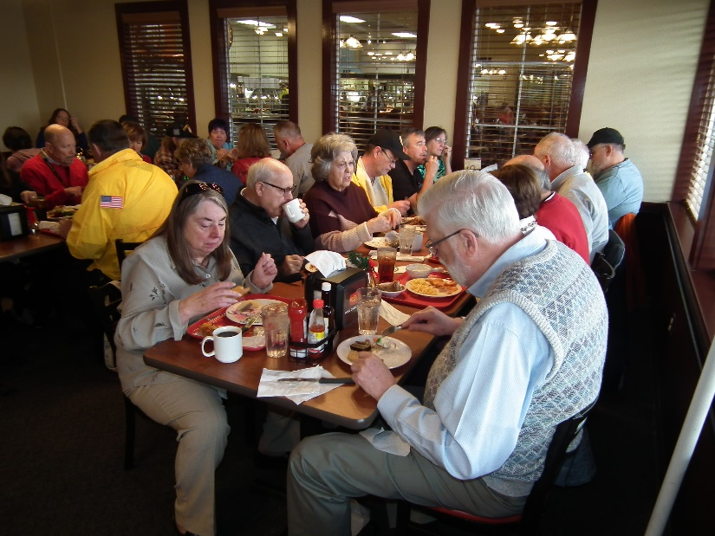

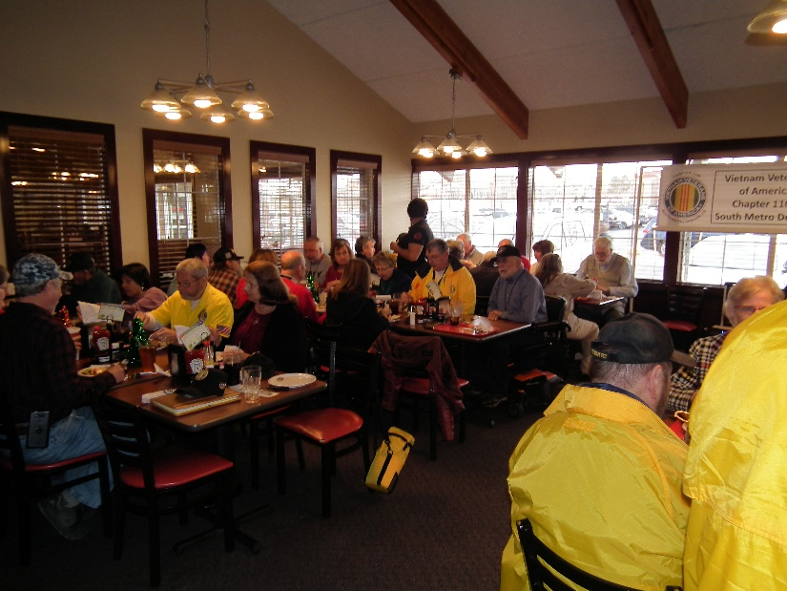

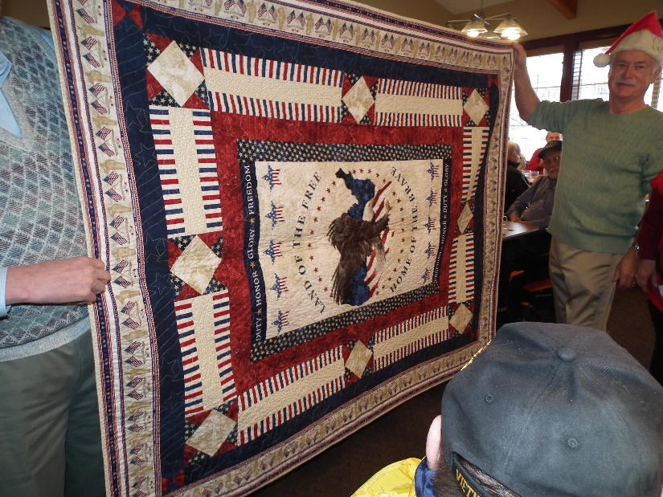

More chances were sold for this beautiful quilt.

***Announcement Corner***

**Tomb of the Unknowns Guards Begin Use of Custom M17 Pistols**

Tomb Guards from the US Army’s 3d U.S. Infantry Regiment (The Old Guard) were presented with 4 ceremonial M17 pistols at Arlington National Cemetery. These works of art were created by SIG SAUER specifically for use by the Guards.

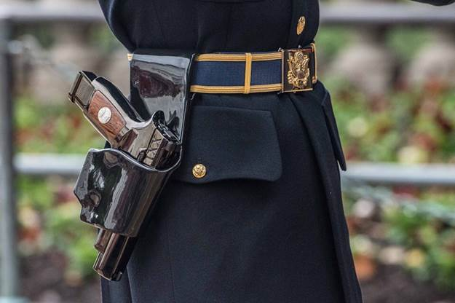

This ceremony marks the first use of the M17, which will accompany the Sentinels of the Tomb of the Unknown Soldiers as they stand guard 24 hours a day, 7 days a week, 365 days a year.

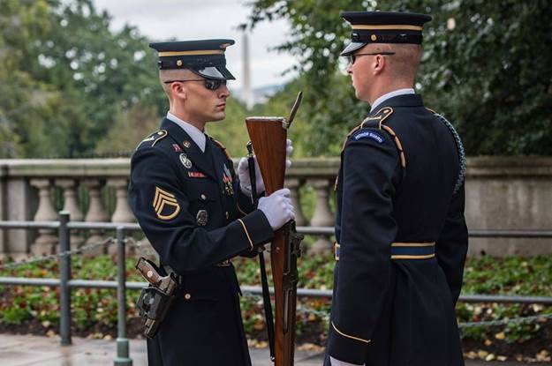

The unique distinguishing features for the M17 Tomb of the Unknown Pistols include:

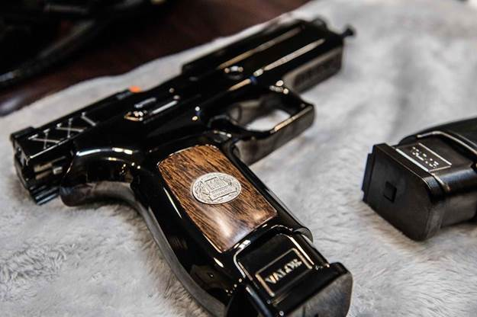

Pistol Names: each of the four pistols bears the name of Silence, Respect, Dignity, or Perseverance and is featured on the dust cover. Dignity and Perseverance represent The Sentinels Creed, and Silence and Respect represent the request to the public by Arlington National Cemetery when visiting the Tomb of the Unknown, and during the Changing of the Guard;

Custom Wood Grips: in 1921 the chosen Unknown was transported to the United States of America aboard the USS Olympia. The custom wood grips are made with wood from the USS Olympia and include the crest of the 3rd Guard, Tomb of the Unknown Soldier identification badge inset;

Cocking Serrations: XXI cocking serrations are engraved on the slide to signify the twenty-one steps it takes for the Tomb Sentinels to walk by the Tomb of the Unknowns and the military honor of a 21 Gun Salute;

Sight Plate: an engraved impression of the Greek Figures featured on the east panel of the Tomb “ Peace, Victory, and Valor “ are featured on the sight plate;

Sights: a glass insert made with marble dust from the Tomb of the Unknown fills the sights of the ceremonial pistols;

Engraved Magazines: the 21-round magazines feature an aluminum base plate engraved with the names of the Greek figures featured on the Tomb of the Unknown “ Peace, Victory, and Valor “ and include a name plate on the bottom of the magazine engraved with the Tomb Sentinel badge number.

Serial Numbers: the pistols are serialized with a unique set of serial numbers that incorporate items of significance to the Old Guard: represents line six of the Sentinels Creed, My standard will remain perfection; 02JUL37to signify the first 24-hour guard posted at the Tomb of the Unknown on July 3, 1937; 21 to signify the 21 steps it takes the Tomb Sentinels to walk by the Tomb of the Unknown, and the military honor of a 21 Gun Salute. The full series of M17 Tomb of the Unknown Soldier Pistols serial numbers are LS02JUL37A21 (Silence), LS02JUL37B21 (Respect), LS02JUL37C21 (Dignity), LS02JUL37D21 (Perseverance).

**Did you know?**

From Tom Werzyn - 2018 December calendar. (This is the only time you will see this in your lifetime)

DECEMBER 2018

|  |  |  |  |  |  |  |
| --- | --- | --- | --- | --- | --- | --- |
| S | M | T | W | T | F | S |
|  |  |  |  |  |  | 1 |
| 2 | 3 | 4 | 5 | 6 | 7 | 8 |
| 9 | 10 | 11 | 12 | 13 | 14 | 15 |
| 16 | 17 | 18 | 19 | 20 | 21 | 22 |
| 23 | 24 | 25 | 26 | 27 | 28 | 29 |
| 30 | 31 |  |  |  |  |  |

The month of December will have 5 Saturdays, 5 Sundays, and 5 Mondays. It only happens once every 823 years.

**Touch of History**

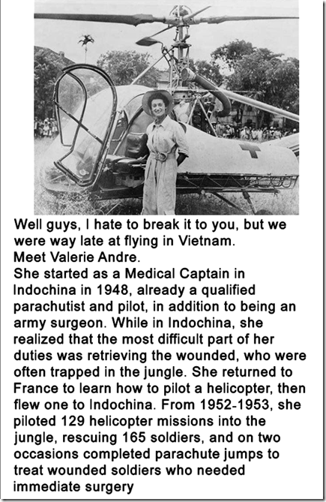

**Lots of Birthdays Celebrated at December’s Meeting**

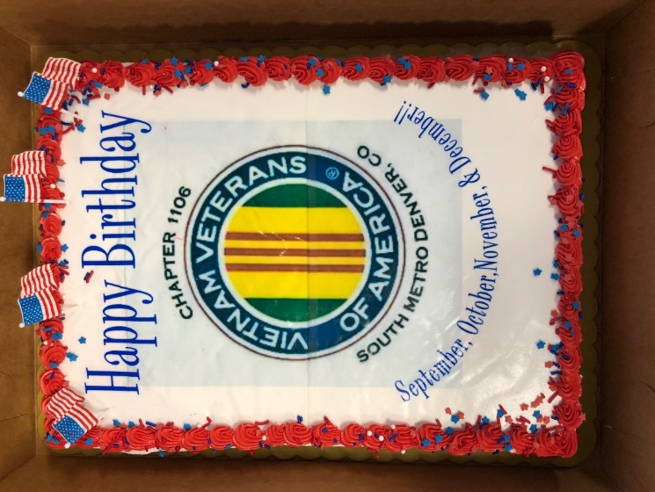

***Books/Articles Published by Members***

Submitted by Tom Werzyn

**AN ACTUAL CRAIG'S LIST PERSONALS AD**

To the Guy Who Tried to Mug Me in Downtown Savannah night before last.

Date: 2017-01-17, 1:43 am. E.S.T.

I was the guy wearing the black Burberry jacket that you demanded that I hand over, shortly after you pulled the knife on me and my girlfriend, threatening our lives. You also asked for my girlfriend's purse and earrings. I can only hope that you somehow come across this rather important message.

First, I'd like to apologize for your embarrassment; I didn't expect you to actually crap in your pants when I drew my pistol after you took my jacket. The evening was not that cold, and I was wearing the jacket for a reason. My girlfriend was happy that I just returned safely from my 2nd tour as a Combat Marine in Afghanistan.

She had just bought me that Kimber Custom Model 1911 .45 ACP pistol for my birthday, and we had picked up a shoulder holster for it that very evening. Obviously you agree that it is a very intimidating weapon when pointed at your head ... isn't it?! I know it probably wasn't fun walking back to wherever you'd come from with crap in your pants. I'm sure it was even worse walking bare-footed since I made you leave your shoes, cell phone, and wallet with me. (That prevented you from calling or running to your buddies to come help mug us again). After I called your mother or "Momma" as you had her listed in your cell, I explained the entire episode of what you'd done. Then I went and filled up my gas tank as well as those of four other people in the gas station, -- on your credit card. The guy with the big motor home took 153 gallons and was extremely grateful! I gave your shoes to a homeless guy outside Vinnie Van Go Go's, along with all the cash in your wallet. [That made his day!] I then threw your wallet into the big pink "pimp mobile" that was parked at the curb ... after I broke the windshield and side window and keyed the entire driver's side of the car. Earlier, I managed to get in two threatening phone calls to the DA's office and one to the FBI, while mentioning

President Trump as my possible target. The FBI guy seemed really intense and we had a nice long chat (I guess while he traced your number etc.). In a way, perhaps I should apologize for not killing you ... but I feel this type of retribution is a far more appropriate punishment for your threatened crime. I wish you well as you try to sort through some of these rather immediate pressing issues, and can only hope that you have the opportunity to reflect upon, and perhaps reconsider, the career path you've chosen to pursue in life. Remember, next time you might not be so lucky.

Have a good day!

Thoughtfully yours,

Semper fi,

Alex

**Why Our Veterans are America’s Heroes**

By: Kyleigh Koehler (age 12), Garrison, Montana)

VETERANS ARE THE CORE of America. They protect us from danger on land, air, and sea. Veterans give their lives and limbs for America. They have also allowed us to have the rights that we have today, such as freedom of speech and religion. Veterans remind us of the freedom that we often take for granted. They have fought for our country and independence. They fight for freedom and they sacrifice their lives for citizens of America Veterans have given American opportunities that no other country has. To be a veteran, you must have bravery and courage as well as a love for your country. Being a veterans takes sacrifice, and you must be willing to do anything for your country.

A veterans is someone who will defend America until the day they die. Veterans have and will protect our past, present, and future. Veterans believe that freedom is worth dying for. They will protect this land at any cost. They will leave their families to risk their lives if it means that they can keep their freedom.

Being a veterans is both physical and mentally demanding. While some veterans may show a clear sign of service such as a missing limb, other veterans may have scars that can’t be seen. Many veterans suffer from PTSD due to their prolonged exposure to combat. These veterans may have symptoms such as insomnia of self-destructive behavior.

Veterans are the most important part of America. A famous news reporter, Elmer Davis, once said, “This nation will remain the land of the free so long as it is the home of the brave.”

Without veterans, we would not have the freedom we have today. Without veterans, there would be no Untied States of America. ✯

*This essay was written for the National Elks Americanism Essay on why veterans are important to America. Kyleigh won second place in the nation.*

**New book published by your Editor, Bob Rotruck**

*Black World – Special Ops* is a fiction action/mystery. It is only available in e-format from Amazon (search Robert Rotruck). It can be downloaded on to a Kindle, android, or Apple tablet or a desktop computer (download the Kindle app). If you have Amazon Unlimited, you can download it for free. I am really looking forward to someone posting a review of my book. Thanks for checking it out.



Book Cover

***From the Editor!***

**From the desk of The Landlocked Sailor**

Bob Rotruck, CWO3, USN (RET)

**Never Forget**

August 8, 2010, the Douglas County Fair came to a completion on Sunday afternoon, but not without a parade first on Saturday morning. Wilcox Street in downtown Castle Rock was filled with parade watchers aged from one to one-hundred and one. There were lots of ovations, cheers, claps, whistles, and shouts at the fire trucks, policemen on motorcycles, politicians, and business owners, but the loudest and strongest accolades seem to be presented to the veterans of WW-II, Korea, Vietnam, and today’s heroes of Iraqi Freedom and Afghanistan. Some rode in vintage cars, because the sun was hot and some of those vets had already logged a lot of walking miles on beaches and in jungles on the other side of the world. Some walked behind the cars carrying signs of proclamation of “We love our vets!” The signs had the person’s branch of service and their primary service location.

One of those signs said, **Vietnam – Never Forget**. Many shouts came from the crowd, but they weren’t the disparaging shouts and profanity that was heard by returning service men and women back in the 1960’s and 1970’s. It was repeats from the sign – we will **never forget** and thank you for your service. We love you. My husband is still MIA and we will **never forget**. It was an emotional time for the people watching a local hour and a half parade, but it warmed the hearts of the participants and they smiled with appreciation. When you see a military person or recognize the visible signs that a person is a veteran take the step forward and put out your hand and just say thank you for your service to our country! You will never know how much it is appreciated unless you are the one receiving the handshake! **NEVER FORGET!**

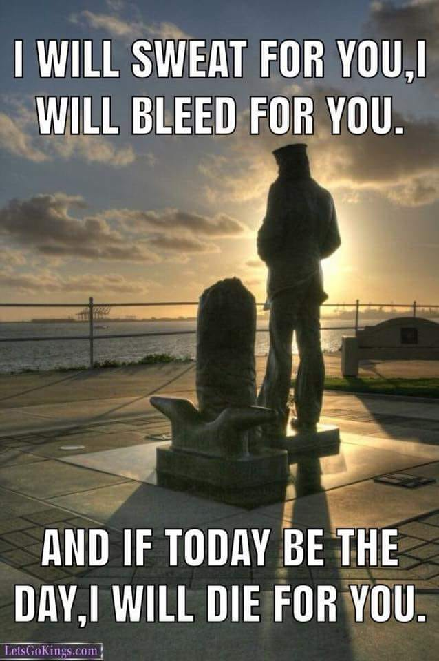

***Light Side***

**Wisdom**

You never appreciate what you have till it's gone!

**Toilet paper** is a good example.

**Never Assume, Always Ask**

His request approved, the CNN News photographer quickly used a cell phone to call the local airport to charter a flight. He was told a twin-engine plane would be waiting for him at the airport. Arriving at the airfield, he spotted a plane warming up outside a hanger. He jumped in with his bag, slammed the door shut, and shouted, “Let’s go”! The pilot taxied out, swung the plane into the wind and took off. Once in the air, the photographer instructed the pilot, 'Fly over the valley and make low passes so I can take pictures of the fires on the hillsides. ‘Why?' asked the pilot. 'Because I'm a photographer for CNN’, he responded, 'and I need to get some close-up shots.' The pilot was strangely silent for a moment, finally he stammered, 'So, what you're telling me, is .... you're NOT my flight instructor?'



**Church rules in France**

An example of French wit.

En entrant dans cette église, il est possible que vous entendiez l'appel de Dieu. Par contre, il n’est pas susceptible de vous contacter par téléphone. Merci d'avoir éteint votre téléphone. Si vous souhaitez parler à Dieu, entrez, choisissez un endroit tranquille et parle lui. Si vous souhaitez le voir, envoyez-lui un SMS en conduisant.

Translation: It is possible that on entering this church, you may hear the Call of God. On the other hand, it is not likely that he will contact you by phone. Thank you for turning off your phone. If you would like to talk to God, come in, choose a quiet place, and talk to him. If you would like to see him, send him a text while driving.

**How to use an ATM in Chicago safely!**

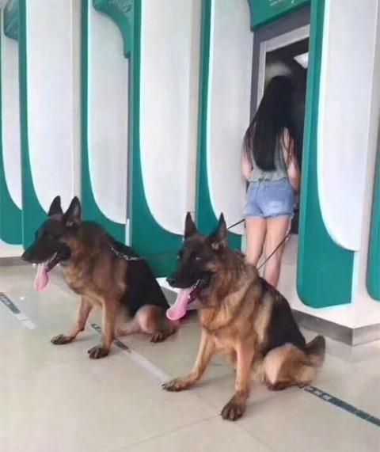

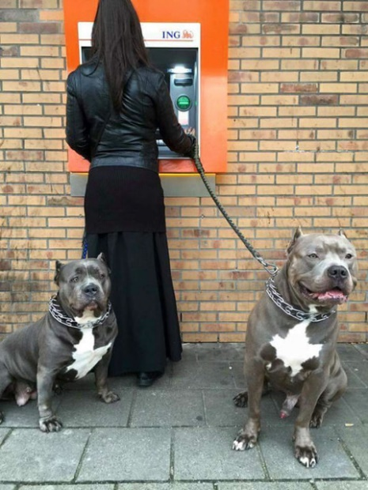

**Think Twice**

Submitted by John Vargas

The wedding ceremony came to the point where the minister asked if anyone had anything to say concerning the union of the bride and groom. The moment of utter silence was broken when a beautiful young woman carrying a child stood up. She starts walking slowly towards the minister. The congregation was aghast - you could almost hear a pin drop. The groom's jaw dropped as he stared in disbelief at the approaching young woman and child.

Chaos ensued. The bride threw the bouquet into the air and burst out crying. Then the groom's mother fainted.

The best men started giving each other looks and wondering how to save the situation.

The minister asked the woman, "Can you tell us, why you came forward? What do you have to say?"

There was absolute silence in the church.

The woman replied, "We can't hear you in the back."

**And that illustrates what happens when people are considered guilty until proven innocent.**





**Two men seek refuge from the elements at a farm house populated by but one (recently widowed) woman!**

John, who lived in the north of England, decided to go golfing in Scotland with his buddy Shawn. So they loaded up John's minivan and headed north. After driving for a few hours, they got caught in a terrible downpour so they pulled into a nearby farm and asked the attractive lady who answered the door if they could spend the night.

"I realize its terrible weather out there and I have this huge house all to myself, but I'm recently widowed," she explained, "And I'm afraid the neighbors will talk if I let you stay in my house."

“Don't worry," John said. “We'll be happy to sleep in the barn and if the weather breaks, we'll be gone at first light."

The lady agreed and the two men found their way to the barn and settled in for the night. Come morning, the weather had cleared so they got on their way and enjoyed a great weekend of golf. But about nine months later, John got an unexpected letter from an attorney. It took him a few minutes to figure it out...but he finally determined that it was from the attorney of that attractive widow he had met on the golf weekend. He dropped in on his friend Shawn and asked, "Shawn, do you remember that good-looking widow on the farm we stayed at on our golf holiday in Scotland about 9 months ago?”

"Yes, I do remember her." said Shawn.

"Did you, ‘er, happen to get up in the middle of the night, go up to the house and pay her a visit?"

"Well, um, yes." Shawn said, a little embarrassed about being found out, "I have to admit that I did."

"And did you happen to give her my name and address instead of telling her your name?"

Shawn's face turned beet red and he said, "Yeah, look, I'm sorry, buddy I'm afraid I did. Why do you ask?"

"She just died and left me everything." (Didn't expect that did you?)

(Submitted by: John Vargas)

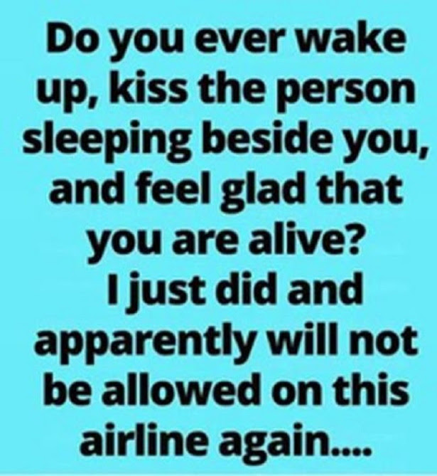

**Unpaid Baby Sitters!**

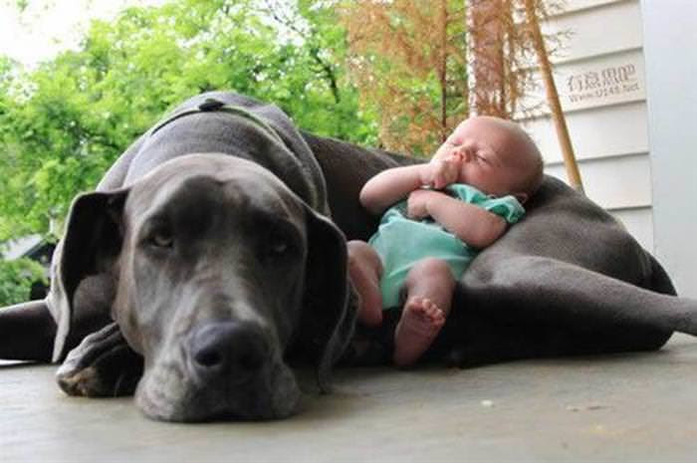



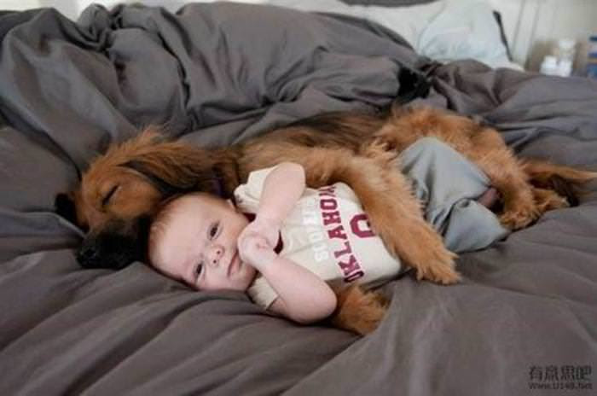

***Trivia Answer***

**BOHICA** – **B**end **O**ver, **H**ere **i**t **C**omes **A**gain

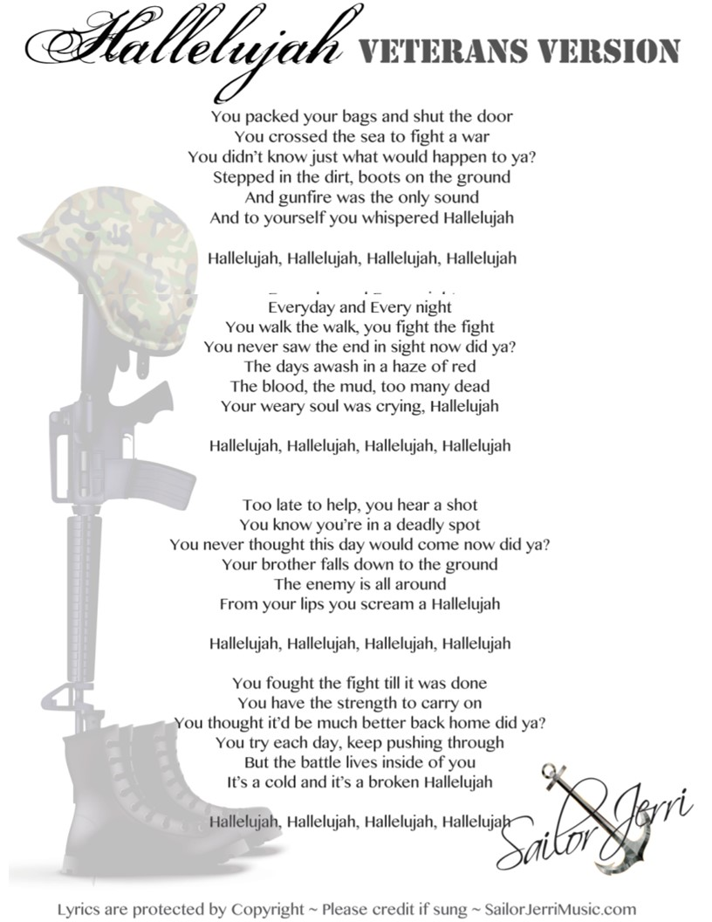

**FRIENDS OF CHAPTER 1106**

|  |  |
| --- | --- |
| **ERC Management, LLC**  791 Southpark Dr., Suite 600  Littleton, CO 80120  [720.328.3299](tel:720.328.3299)  [www.FreddysUSA.com](http://www.freddysusa.com/) | |
| **Panera Bread**  9579 S. University Blvd. Highlands Ranch, CO 80126  720-348-1112 | **American Legion Post 1260**  **E:\Documents\ALP1187\images\AmericanLegion_logo.jpg** |
| **Spradlin Printing, Inc.**  11903 S. Parker Road Parker, CO 80134 | **South Metro Denver Fire & Rescue**  9195 E Mineral Ave  Centennial, CO 80112 |
| Monthly Membership Meetings VISITORS ARE ALWAYS WELCOME!   3rd Saturday of each month at 10:00a.m.   Our meetings are held at: [VFW Post 2461](http://www.vfwpost2461.com/) 1350 S Broadway, Denver, CO 80210 | A FULL-SIZE REPLICA OF THE HONOR BELL  **The Honor Bell Foundation**  PO Box 1432  Englewood CO 80150  720.282.9182  [www.honorbell.org](http://www.honorbell.org/) |
| 9137 E Mineral Cir Ste 100  Englewood, CO 80112-3422 | Logo of The Home Depot  **Home Depot Foundation**  8477 S Yosemite St  Lone Tree, CO 80124 |
| King Soopers logo.svg  King Soopers  9551 S. University Blvd., Highlands Ranch, CO 80126 | http://www.cruisin1430.com/sites/g/files/giy711/f/KEZW_Header_Large_Logo_0.png  **STUDIO 1430 Main Office:** 4700 South Syracuse Street, Suite 1050 Denver, CO 80237 |
| https://scontent.fapa1-2.fna.fbcdn.net/v/t31.0-8/10575197_682186265194110_4051472928662048560_o.jpg?oh=2630b186dcf3a20f1d7fc8fa25e0a5ba&oe=5A17C4AB  **Military Order of Purple Heart**, Chapter 1041, Arvada, CO | Golden Corral  **Golden Corral**  15775 E. Arapahoe Rd  Centennial, CO 80016 |